Student Transportation
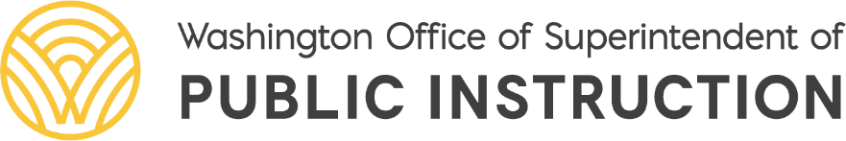
Old Capitol Building
PO BOX 47200
Olympia WA 98504-7200
Phone: (360) 725-6120 TTY: (360) 664-3631
http://www.k12.wa.us/transportation

VERIFICATION OF RIDERSHIP DATA SUBMITTED
School Year 2022–23
Fall Report Period

School District or ESD Name: Date Completed:

Name of individual verifying completion of reports:

For the 2022–23 school year, the following data is being submitted for the Fall transportation reporting requirements. Each school district should retain a copy of all documentation for all reports submitted. The due date for the Fall 2022–23 School Year report is October 31, 2022. Submit this form to the Regional Transportation Coordinator (RTC). See OSPI Bulletin 054-22 for RTC contact information.

Student Count Period (Three consecutive school days)

Day One Date Total Student Count Day One

Day Two Date Total Student Count Day Two

Day Three Date Total Student Count Day Three

Total daily student counts should consist of the basic program student count, minus the walk area student count, plus the transit student count, plus the total special program student count.

Eliminate the highest student count day; eliminate the lowest student count day; the remaining count day is the district “Reported Student Count Day” which is: Month Day , Year .

The following reports are submitted using the Student Transportation Allocation Reporting System (STARS) online reporting system. Please see the Detailed Guidance for instructions on completing the report requirements.

1. Student Count Report (The STARS Grand Total should match the student count from the Reported Student Count Day (above)).

2. School Bus Route and Bus Stop Location Report (check one)
Route changes were made since the previous report period and have been checked for accuracy.
OR
No Route changes have been made since the last report period.

3. Non-High District Report (only if district is non-high).

4. District Car Mileage Report (estimate for current school year, even if reporting zero miles).

5. Prior School Year Annual School Bus Mileage Report (2021–22 School Year data)

6. Prior School Year Annual McKinney-Vento Homeless Transportation Report (2021–22 School Year data)

7. Prior School Year Annual School Transportation Fuel Report (2021–22 School Year data)

The following report is submitted using the 1799 Online School Bus Driver Database. For additional instructions, see OSPI Bulletin 000-22.

8. Annual School Bus Driver Compliance Verification Report.

TRANSPORTATION ADMINISTRATOR’S NAME

