SAMPLE – This is an example tool for school/district personnel to use in gathering input from parents on how Title I Parent and Family Engagement (PFE) money should be spent. Ideally, the PFE budget and the parent and family engagement policy should be revised together, as the policy drives the budget.

Parent and Family Engagement

Budget Survey

[School Name]
[Local Educational Agency or District]
[Date]

Dear Parents,

We value your input! As a parent of a child who receives Title I services in our school, you have the right to give input about how the school district budgets and spends its Title I Parent and family engagement money. Over the last few weeks, our school held various meetings with parents to revise our school’s parent and family engagement policy for next school year. We hope you had the chance to participate in one of these meetings. In the meetings, we discussed the following:

- Parents stated that they like having a district parent coordinator who is a liaison for them and provides parent engagement opportunities at the school.
- Parents have asked for a place at the school where they could meet and learn how to better support their child’s learning.
- Parents asked for more resources on how to help their child at home.
- Parents would like to have a workshop on helping their child with math.

We have $30,000 in the Title I Parent and Family Engagement budget. Last year, we spent the money this way:

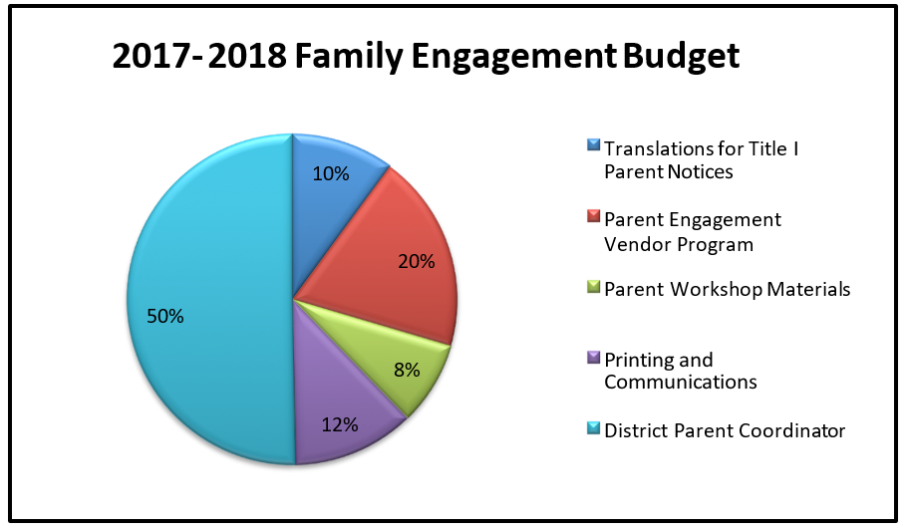

This year, given our parents’ request to have a space where they could meet and learn how to better support their child’s learning, we would like to create a parent resource center at the school. Therefore, we would like to stop using the 123 Vendor Program and use that money towards supplies and materials for the parent resource center. We would like to spend the Title I Parent and family engagement budget this way:

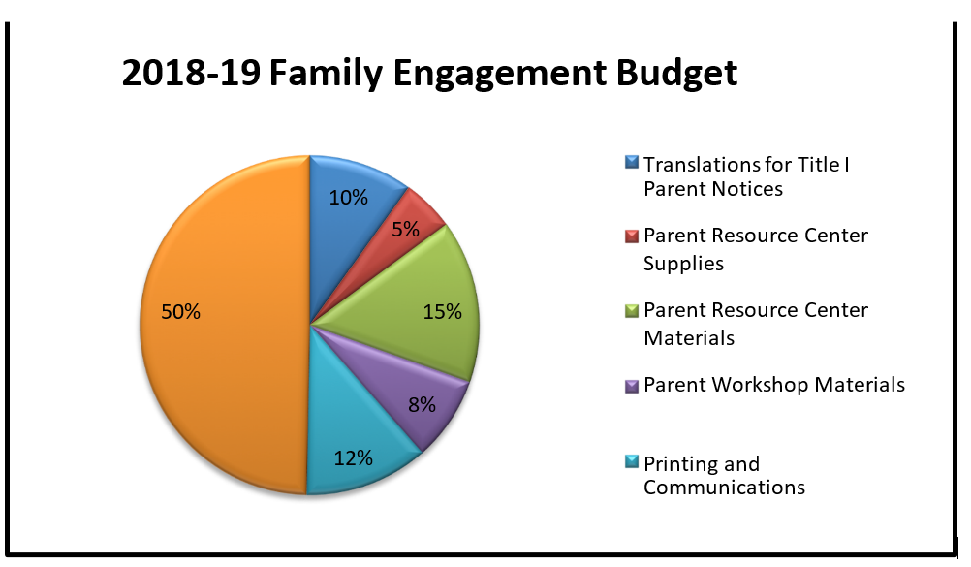

Do you agree with how we have budgeted parent and family engagement funds for this school year?

- Yes
- No, if no, why not?

Do you have any other suggestions for the use of funds? These will be taken into consideration for this school year and future school years.

Please return this from to your child’s teacher, or drop it by the school office by April 30, 2015. If you have further questions, please feel free to contact [contact name], [school district’s name] Title I, Part I Coordinator, at (XXX) 222-­‐2222 or [insert email here].

Thank you for taking the time to complete this very important survey.
Your feedback is greatly valued and sincerely appreciated.

