CAREER AND COLLEGE DEVELOPMENT

LESSON 12-16 CAREER BRIDGE

LEARNING GOALS/OUTCOMES

- Students will identify a potential career of interest.
- Students will identify and research at least one postsecondary program that could prepare them for a career of interest.

MATERIALS NEEDED

- Student Handouts:
- Career Bridge Worksheet
- Family Handouts:
- About Washington’s Career Bridge
- Computer with internet access so students can view the Career Bridge site www.careerbridge.wa.gov

CLASSROOM ACTIVITIES

- Introduction. Students should be familiar with Career Bridge from last year. They will get to revisit and explore new options and information this year. Encourage them to log in outside of class as well to this great free resource.

- Identify student career interests. Divide students into small groups. In their groups, have each student take out a pen and a piece of paper and quickly jot down at least three careers that seem interesting to them. They might list doctor, firefighter, accountant, computer technician, teacher, or any other career of interest. Ask the students to discuss their lists with their groups. Then ask each group to report out.

Then ask students if they know what type of postsecondary education they will need for the careers they’ve listed. Some students may already have started researching postsecondary programs. But some students may need more help. Tell them that today they are going to learn about postsecondary programs in Washington State that can help them reach their career goals.

- Identify postsecondary programs. Distribute the Career Bridge Worksheet. Then, with each student at a computer, have students visit the Career Bridge at www.careerbridge.wa.gov. Help students follow the directions on the worksheet to enter a potential career goal and identify at least one postsecondary program that could help them realize that goal. Have students share their results. Encourage them to use Career Bridge at home to learn more about postsecondary programs around the state.

- Discuss students’ Career Bridge results. After students have completed their worksheets, and with their results still on their screens, ask for several volunteers to share one or two of the postsecondary training programs that were identified for them. Are any of them located nearby? Have students heard of – or visited – any of them? Discuss how students could learn more about a postsecondary program:
- They could visit the web site of the postsecondary program;
- They could request more information; or
- They could arrange to visit in person

- Going Deeper: Learn more about a postsecondary program. On their worksheets, students copied down the URL for one of the postsecondary training programs identified for them. Ask them to go to that web site now, either by clicking on the link from Career Bridge or by typing in the new URL.

Have them spend some time on the postsecondary web site, learning more about programs and admission requirements. Then have them request more information. For most schools, there will be a link to request more information in the “Enrolling” or “Admissions” section of the web site. Help students find how they can request information. This will alert the school that they are interested, and they will soon receive a view book or brochure in the mail.

STUDENT PRODUCTS

- Completed Career Bridge Worksheet

ADDITIONAL RESOURCES AND OTHER INFORMATION

- EXPLORATION OPPORTUNITIES
- Hold a Career Fair. Invite community members from different careers to visit your school and share information about their careers with your students.

Having the chance to meet people from different careers can be a great way for students to learn more about careers and career clusters that are interesting to them. If you wish, share the About Washington’s Career Bridge Family Handout with students or their families so that they can continue their explorations at home.

- Discuss the connection between interests and courses. Your school counselors might wish to discuss each student’s postsecondary interests and relate those interests to course choices during the remainder of high school.

They can also give students information about the admissions timeline to ensure students take the required exams and begin the application process in a timely manner.

- Washington’s Career Bridge
www.careerbridge.wa.gov
A free, searchable online database of over 5,000 Washington education programs, labor market data on which jobs are growing in Washington and what they pay, and a quiz that helps students determine their skills and abilities, and how they connect to careers.

- Washington State Workforce Training and Education Coordinating Board
www.wtb.wa.gov
Information about workforce programs, legislative reports and state and regional plans.

- The Washington State Workforce Training and Education Coordinating Board’s
Where Are You Going? 2010-2012 Career Guide (PDF) can be found at:
http://wtb.wa.gov/CareerGuide.asp

ALIGNMENT WITH STANDARDS

- Essential Academic Learning Requirements Grades 9/10 Grade Level Expectations: This lesson is aligned with Communication 1.1.1 and Writing 2.2.1 and 2.4.1. Students will use listening strategies appropriate for a career setting, demonstrate their understanding of different purposes for writing, and produce career-appropriate documents.
- Common Core State Standards Grades 11-12: This lesson is aligned with English Language Arts Speaking and Listening 1a and Writing 4 and 10. Students will use online sources to identify potential careers areas of interest and to research postsecondary information. They will produce clear, career-appropriate writing.
- American School Counselor Association National Standards: This lesson is aligned with ASCA Career A2.7, B1.5, and B2. Students will demonstrate a positive attitude toward work and learning and will use online sources to gain career and postsecondary information.

CAREER AND COLLEGE DEVELOPMENT

LESSON 12-16 STUDENT HANDOUT

CAREER BRIDGE WORKSHEET

Name: _________________________________

What do you want to do with your life? No matter what your career goal, Washington State’s Career Bridge can help you find an education or training program after high school to reach that goal. This exercise will help you sample Career Bridge with one possible career goal. Here’s what to do:

- Visit the Career Bridge at www.careerbridge.wa.gov. 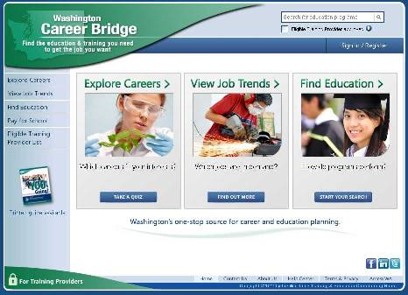

- Click on “Find Education” the home page (see arrow at right).

- Next, enter a job title or school name into the search box

- Looking for a program that’s close to home or offered online? Click on “More Search Options,” just below the search box to get more specific results.

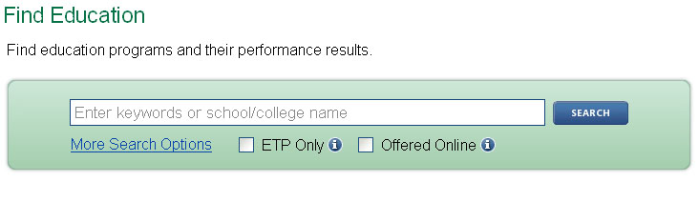
This takes you to Advanced Search for Education and lets you drill down to programs that meet your requirements.

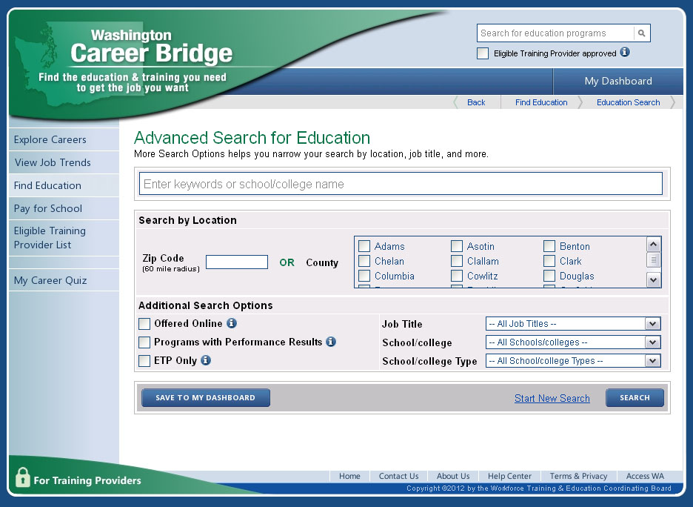

- Search by location, including county or zip code, or fine tune your search further by selecting a job title from the drop down box, selecting a particular school or viewing online programs, among other options.

- Now click the blue “search” button and view available programs. Once you get your search results, click on a link and get details on individual education programs.

A possible career. What have you learned about a possible postsecondary program?

The job title you listed:

Choose one of the results shown on your results screen and copy the information that appears:

Program Name:

Training Provider Name:

Locations: Length:

Click on the training provider name and copy its web site URL:

CAREER AND COLLEGE DEVELOPMENT

LESSON 11-14 FAMILY HANDOUT

ABOUT WASHINGTON’S CAREER BRIDGE

What does your student want to do? One way to answer that question is to help your student learn more about education programs after high school that prepare them for different types of careers. Washington’s Career Bridge can help.

INTRODUCING CAREER BRIDGE

Career Bridge was developed to help students and adults reach their career goals. Career Bridge is a one-stop, searchable database of education and training programs throughout Washington State. It includes:

- Average earnings and employment outlooks for a wide range of career choices.

- Information on hot jobs for the future and the training students will need.

- Details on more than 5,000 education programs from around the state at public two- and four-year colleges and universities, private career schools, and apprenticeships.

- Performance results for many programs, giving you and your student a free “consumer reports” on a variety of education programs so you know how many students completed a program, if they got a job and how much were they paid.

Career Bridge was created by Washington’s Workforce Training and Education Coordinating Board, a partnership of labor, business and government dedicated to helping Washington residents obtain and succeed in family-wage jobs, while meeting employers' needs for skilled workers.

EXPLORE CAREER BRIDGE TODAY!

The next several years are very important. Your student will finish high school and begin adult life. Because most jobs today require education beyond high school, it is absolutely crucial that your student understand the education and training needed for their career goals.

Career Bridge can help by providing information on postsecondary training programs around the state for a wide range of career areas. Using Career Bridge, students can explore different careers and different education programs and find everything they need to take their next steps, including financial aid and scholarship information in the “Pay for School” area of the website. Visit Washington’s Career Bridge today at www.careerbridge.wa.gov.

