8.NS.A

Know that there are numbers that are not rational, and approximate them by rational numbers.

- Determine for each expression whether it represents a rational number or an irrational number.
Number | Rational | Irrational
3.5 $×$ 10^{–3}
$$\frac{\sqrt{81}}{5}$$
(3$π$)²
$$7\sqrt{2}$$

- Which interval contains the value of $7\sqrt{5} -2\sqrt{5}$?
A. between 4 to 5
B. between 5 to 6
C. between 11 to 12
D. between 15 to 16
- Order these four expressions from least value to greatest value.
10 $π$² 1.34 $×$ 10² 90 $\sqrt{7024}$

- Write the repeating decimal $0.8\overline{2}$ as a fraction. Use only whole numbers for the numerator and denominator.

- Marvin knows the formula for the area of a circle is A = $π$r². He claims that because $π$ is an irrational number, the area of all circles are irrational. Do you agree or disagree with Marvin’s claim? If you agree, explain why. If you disagree, provide a counterexample.

- Plot a point on the number line to approximate the value of $3\sqrt{7}$ to the nearest tenth.
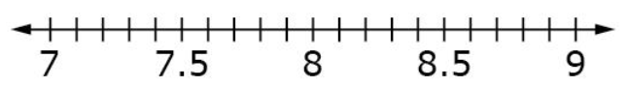
- Write the fraction $\frac{16}{30}$ as a decimal.

Teacher Material

8.NS.A

Know that there are numbers that are not rational, and approximate them by rational numbers.

Question | Claim | Key/Suggested Rubric
1 | 1 | 1 point:  Number Rational Irrational  3.5 $×$ 10^{–3} x  $$\frac{\sqrt{81}}{5}$$ x  (3$π$)² x  $$7\sqrt{2}$$ x
2¹ | 1 | 1 point: Selects C
3 | 1 | 1 point: Orders$\sqrt{7024}$, 90, 10 $π$², 1.34 $×$ 10²
4¹ | 1 | 1 point: $\frac{74}{90}$, or equivalent fraction
5² | 3 | 1 point: Provides an explanation for agreeing OR a counterexample for disagreeing. Example 1: I agree because when the radius is any rational number, then the radius squared is also a rational number. And a rational number time $π$ is an irrational number. Example 2: I disagree because when the radius is $\frac{4}{\sqrt{π}}$, then the area of the circle is 16, which is rational.
6¹ | 1 | 1 point: 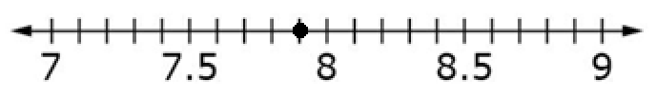
7² | 1 | 1 point: $0.21\overline{6}$

From Smarterbalanced.org. Grade 8, Claim 1, Target A Item Specifications. Internet. Available from http://www.smarterbalanced.org/smarter-balanced-assessments/; accessed 11/2015.
Adapted from the Mathematics K–12 Learning Standards. Internet. Available from http://www.k12.wa.us/Mathematics/Standards.aspx; accessed 11/2015.

