4.G.A
Identify lines and angles, and classify shapes by properties of their lines and angles.

1. Draw line segment CD on the graph.
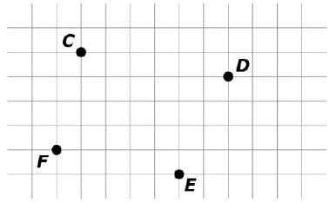
2. Put an X in the box that matches each figure with its description. Each figure may be matched to more than one description.

 | Has at least one right angle | Has at least one pair of perpendicular sides | Has at least on pair of parallel sides
Rectangle
Rhombus
Parallelogram

3. This chart shows one way to classify quadrilaterals. Draw a quadrilateral that belongs in the box labeled “Has Exactly One Right Angle.”
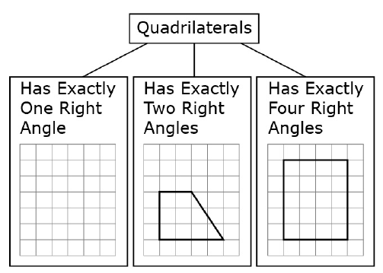

4. Draw all the lines of symmetry for the shapes.
If there are no lines of symmetry, write None in the shape.

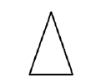

5. Use the following directions to draw and label objects in the space below.
a. Draw and label two points: A and B.
b. Use a straightedge to draw $\overline{AB}$.
c. Draw a new point that is not on $\overline{AB}$. Label it C.
d. Draw $\vec{BC}$.
e. Draw a new point that is not on $\overline{AB}$ or $\overset{⃑}{BC}$. Label it D.
f. Draw $\overset{⃡}{AD}$.
g. Identify angle DAB by drawing an arc to indicate the position of the angle.
h. Identify another angle by referencing points that you have already drawn. _________

Teacher Material
4.G.A
Identify lines and angles, and classify shapes by properties of their lines and angles.

Question | Claim | Key/Suggested Rubric
1 | 1 | 1 point:  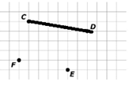
2¹ | 1 | 1 point:  Has at least one right angle Has at least one pair of perpendicular sides Has at least on pair of parallel sides  Rectangle X X X  Rhombus X  Parallelogram X
3¹ | 1 | 1 point: Answers may vary.  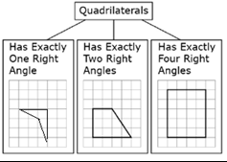
4 | 1 | 1 point:  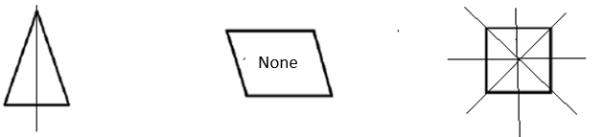
5 | 1 | 1 point: Drawings may vary.  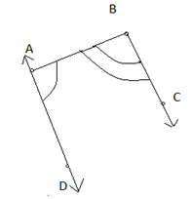  Another angle is angle ABC.

From Smarterbalanced.org. Grade 4, Claim 1, Target L Item Specifications. Internet. Available from http://www.smarterbalanced.org/smarter-balanced-assessments/; accessed 11/2015.
From Smarterbalanced.org. Grade 4, Claim 1, Target L Item Specifications. Internet. Available from http://www.smarterbalanced.org/smarter-balanced-assessments/; accessed 11/2015.
From EngageNY.org of the New York State Education Department. Grade 4 Mathematics Module 4, Topic A, Lesson 1. Internet. Available from https://www.engageny.org/resource/grade-4-mathematics-module-4-topic-lesson-1; accessed 11/2015.

