3.MD.A

Solve problems involving measurement and estimation of intervals of time, liquid volumes, and masses of objects.

1. A music class starts at 1:32 p.m. and ends at 2:55 p.m. Write the length, in minutes, of the music
class.

2. Harold buys 2-liter bottles of juice for a picnic. He buys 8 bottles. How many liters of juice did
Harold buy?

3. A piece of celery has a mass of 48 grams. A carrot has a mass of 35 grams more than the piece
of celery. What is the mass of the carrot?

4. Plot a point on the number line for the times shown on the clocks below. Then draw a line to
match the clocks to the points.
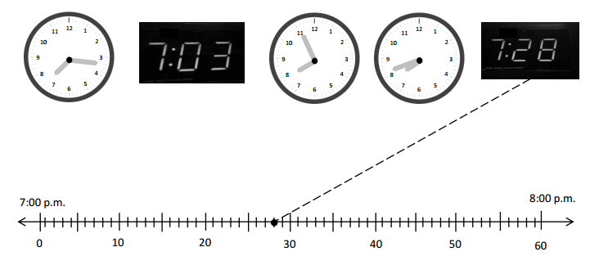

5. Cole read his book for 25 minutes yesterday and for 28 minutes today. How many minutes did
Cole read altogether? Model the problems on the number line and write an equation to solve.

Equation: Cole read for _____minutes.

6. Nessa tells her brother that 1 kilogram of rice weighs the same as 10 bags containing 100 grams
of beans each. Do you agree with her? Explain why or why not.

Teacher Material
3.MD.A
Solve problems involving measurement and estimation of intervals of time, liquid volumes, and masses of objects.

Question | Claim | Key/Suggested Rubric
1 | 1 | 1 point: 83 minutes
2¹ | 1 | 1 point: 16 liters
3¹ | 1 | 1 point: 83 grams
4 | 2 | 1 point:  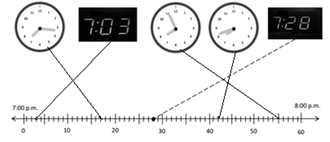
5 | 4 | 3 points: Draws a model, writes an equation, and writes 53.  25 + 28 = m and Cole read for 53 minutes.  2 point: Does two of the following: Draws a model, writes an equation, or writes 53.  1 point: Does one of the following: Draws a model, writes an equation, or writes 53 OR writes an incorrect equation but following though in solving it correctly.
6 | 3 | 1 point: I do agree. There are 1000 grams in a kilogram and 10 x 100 = 1000 so the 10 bags weight 1 kilogram.

From Smarterbalanced.org. Grade 3, Claim 1, Target G Item Specifications. Internet. Available from http://www.smarterbalanced.org/smarter-balanced-assessments/; accessed 11/2015.
From EngageNY.org of the New York State Education Department. Grade 3 Mathematics Module 2, Topic A, Lesson 3. Internet. Available from https://www.engageny.org/resource/grade-3-mathematics-module-2-topic-lesson-3; accessed 11/2015.
From EngageNY.org of the New York State Education Department. Grade 3 Mathematics Module 2, Topic A, Lesson 5. Internet. Available from https://www.engageny.org/resource/grade-3-mathematics-module-2-topic-lesson-5; accessed 11/2015.
From EngageNY.org of the New York State Education Department. Grade 3 Mathematics Module 2, Topic B, Lesson 7. Internet. Available from https://www.engageny.org/resource/grade-3-mathematics-module-2-topic-b-lesson-7; accessed 11/2015.

