Team-Initiated Problem Solving (TIPS II)
www.pbis.org
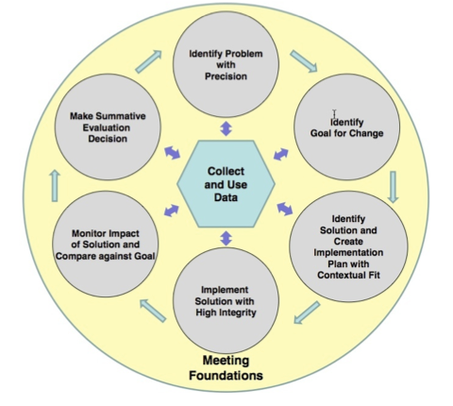  University of Oregon:  Rob Horner (robh@uoregon.edu) Anne Todd (awt@uoregon.edu)  University of NC at Charlotte:  Bob Algozzine (rfalgozz@uncc.edu); Kate Algozzine (kmalgozz@uncc.edu);  Dale Cusumano (dale.cusumano@unc.edu); Angela Preston (angela12@email.unc.edu) | 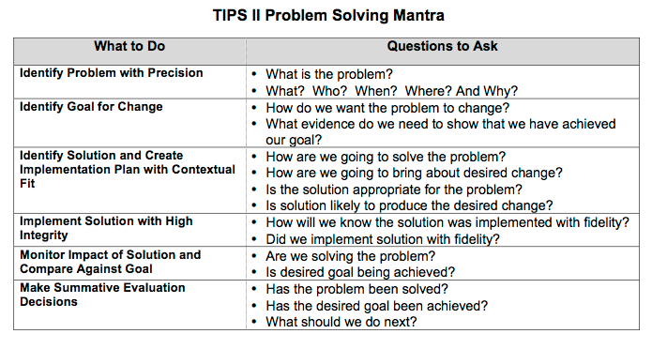
TIPS Readiness Checklist

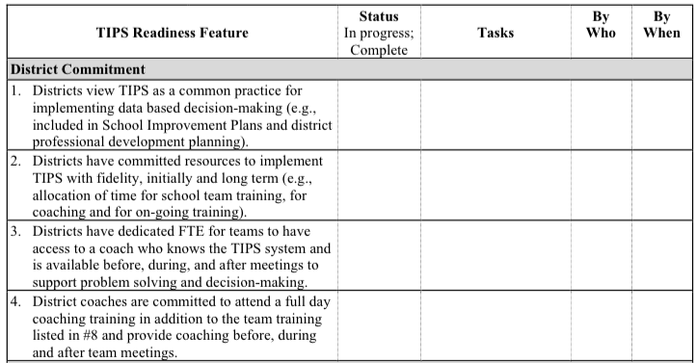  Continued in next column. | 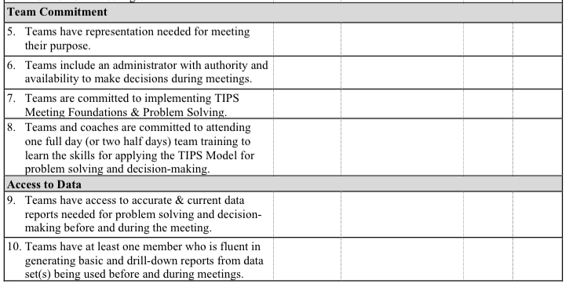

TIPS Fidelity Checklist (TIPS-FC) -BRIEF

Directions: Use the TFC items below as a progress-monitoring tool for planning, implementing, and sustaining best practice meeting foundations and data based problem solving. The first 9 items on the left measure the status of meeting foundations, while items 10 through 18 on the left measure the thoroughness of the team’s problem-solving processes, as exemplified by the TIPS model. Each item is scored on a 0 to 2 scale with 0 = not started; 1 = partial; and 2 = full implementation. A criterion for partial implementation is provided on this shortened version. If a team exceeds the criteria, they should score a “2” for the item. If they do not meet the criteria described as a “1” a score of 0 should be entered. Please refer to your full TIPS Fidelity Checklist (TIPS-FC) for more detailed scoring. Once scored, sum the two areas as separate score areas (Meeting Foundations and Problem Solving) and then divide this by the total possible (18). TIPS has been implemented with fidelity when the team scores 85% on Problem Solving AND 85% on Problem Solving.
Meeting Foundations |  |  |  | Problem Solving
Item | Criteria for Median Score of 1 | Score |  | Item | Criteria for Median Score of 1 | Score
- Primary and backup individuals are assigned to defined roles and responsibilities of Facilitator, Minute Taker, and Data Analyst. | 1= Some primary and backup individuals are assigned to the defined roles and responsibilities of Facilitator, Minute Taker, and Data Analyst. |  |  | 10. Team uses TIPS Meeting Minutes form or equivalent*. | 1= Team uses part of TIPS Meeting Minutes form or equivalent*.
- Meeting participants have the authority to develop and implement problem-solving solutions. | 1= Meeting participants have the authority to develop but not implement problem solving solutions. |  |  | 11. Status of all previous solutions was reviewed. | 1= Status of some previous solutions was reviewed.
- Meeting started on time. | 1 = Meeting stated less than 10 minutes late. |  |  | 12. Quantitative data were available and reviewed. | 1= Quantitative data were available but not reviewed.
- Meeting ended on time, or members agreed to extend meeting time. | 1 = Meeting ended 10 minutes over scheduled time. |  |  | 13. A least one problem was defined with precision (what, where, when, by who, why, how often). | 1= At least one problem is defined but lack one or more precision elements.
- Team members attend meetings promptly and regularly. | 1 = Although team members (with exception of administrator) attend meetings regularly, they are not always prompt and/or they leave early. |  |  | 14. All documented active problems have documented solutions. | 1 = Some documented active problems (s) have documented solutions.
- Public agenda format was used to define topics and guide meeting discussion and was available for all participants to refer to during the meeting. | 1= Public agenda format was not used to define topics and guide meeting discussion but agenda was available for participants to refer to during the meeting. |  |  | 15. A full action plan (who, what, when) is documented/used for at least one documented solution. | 1= Partial action plan is documented for at least one documented solution.
- Previous meeting minutes were present and available during meeting. | 1= Previous meeting minutes were present but not reviewed at start of the meeting. |  |  | 16. Problems that have solutions defined have a goal defined. | 1= Some problems that have solutions defined have a goal defined.
- Next meeting was scheduled by the conclusion of the meeting. | 1= Next meeting was referred to but not scheduled. |  |  | 17. A fidelity of implementation measure is documented/used for each solution, along with a schedule for gathering those data. | 1= Fidelity measure and schedule are defined and documented for some solutions.
- Meeting Minutes are distributed to all team members within 24 hours of the conclusion of the meeting. | 1= Meeting minutes are distributed to all team members but not within 24-36 hours of the meeting. |  |  | 18. A student social/academic outcome measure is documented for each problem, along with a schedule for gathering those data. | 1= Measure and regular schedule for student behavior /performance are documented for some solutions.
Meeting Foundations Total Score |  |  |  | Problem Solving Total Score
Percentage (out of 18) |  |  |  | Percentage (out of 18)

[INSERT LOGO HERE]
_______________ Team Meeting Minutes |  |  |  |  |  | School:
 | . | Date | Time (begin and end) | Location | Facilitator |  | Minute Taker |  | Data Analyst
 | Today’s Meeting
 | Next Meeting

Team Members & Attendance (Place “X” to left of name if present)
.
.

Today’s Agenda Items: |  |  |  | Agenda Items for Next Meeting
1. |  | 4. |  | 1.
2. |  | 5. |  | 2.
3. |  | 6. |  | 3.

Monitoring Implementation Fidelity
Measures/ Basic Reports |  | Data Collection Schedule |  |  | Goal and Current Scores
Measure: Tiered Fidelity Inventory (TFI).  Fidelity Checklists at each Tier (define here)  Basic Reports: TFI subscale Report  Rating Scales-staff perception |  | Full TFI fall & spring. (dates go here)  TFI-Focus Tier, I, II, III completed mid-year  (date goes here)  Rating scale at least twice a month |  |  | Goal: Aim for 70% on TFI  Current Scores  Tier I = Tier II = Tier III =
Progress Monitoring: Student Outcomes
Tier I  Measure: SWIS  Basic Reports: SWIS Use Average Per Day Per Month Report, Referrals by Student Report | ODRs are collected daily and entered into SWIS at least twice a week |  | Average per day per month & Comparison to national media | Trends and Peaks  Increasing or decreasing trend? Any month(s) have higher frequency | % of students with 0-1 major ODR  Aim for 80-85% | % of students with 2-5 major ODRs  Aim for 10-15% | % of students with 6+ major ODRs  Aim for 1=5%
Tier II  Measure: CICO-SWIS  Basic Reports:  I-SWIS School Wide Report (includes CICO Summary) | Daily Point Cards are collected daily. Data are entered into CICO-SWIS at least twice a week |  | Students being served with Tier 2 support | N =  % of enrollment = | Progressing  (all good)  N = | In First Two Weeks  N = | Students of Concern
Tier III  Measure: I-SWIS  Basic Reports: I-SWIS School Wide Report | Data are entered into I-SWIS student file  at least 3 times a week |  | Students being served with Tier 3 support | N=  % of enrollment = | Progressing  (all good)  N = | In First Two Weeks  N = | Students of Concern

Problem Solving Process

Date of Initial Meeting: |  |  |  |  | Date(s) of Review Meetings
Brief Problem Description (e.g., student name, group identifier, brief item description):
Precise Problem ➔  Statement  What? When? Where? Who? Why? How Often? | Goal and ➔  Timeline  What? By When? | Solution ➔  Actions  By Who? By When? | Identify Fidelity ➔  and Outcome Data  What? When? Who? | I  M  P  L  E  M  E  N  T  S  O  L  U  T  I  O  N  S | Did it work?  (Review current levels and compare to goal)  ⬇
 |  |  | What fidelity data will we collect?  What? When? Who? |  | Fidelity Data:  Level of Implementation  Not started  Partial implementation  Implemented with fidelity  Stopped  Notes: | Outcome Data (Current Levels):  Comparison to Goal  Worse  No Change  Improved but not to goal  Goal met  Notes:
What outcome data will we collect?
What? When? Who?
Current Levels: |  |  |  |  | Next Steps
Continue current plan
Modify plan
Discontinue plan
Other
Notes:

Notes:

[Paste new problem table(s) as needed]

Organizational/Housekeeping Task List
Item | Discussion | Decisions and Tasks | Who? | By When?
.
.
.

Evaluation of Team Meeting (Mark your ratings with an “X”) | Our Rating
 | Yes | So-So | No
1. Was today’s meeting a good use of our time?
2. In general, did we do a good job of tracking whether we’re completing the tasks we agreed on at previous meetings?
3. In general, have we done a good job of actually completing the tasks we agreed on at previous meetings?
4. In general, are the completed tasks having the desired effects on student behavior?

Tier 1 Coordination & Problem Solving Team Meeting Minutes  (Completed Minutes for Tier I Team Meeting Video) |  |  |  |  | School: | Park Elementary
 | Date | Time (begin and end) | Location | Facilitator | Minute Taker | Data Analyst
Today’s Meeting | Jan 18 | 3:00-4:00 | Conference room | Anne | Erin | Katie
Next Meeting | Feb 14 | 3:00-4:00 | Conference room | Anne | Erin | Katie

Team Members & Attendance (Place “X” to left of name if present)
x | Anne | x | Katie | x | Eoin | X | Nad
x | Erin | x | Cody | x | Rhonda

Today’s Agenda Items: |  |  |  | Agenda Items for Next Meeting
1. | Review previous meeting minutes | 3. | Organizational Housekeeping items | 1.
2. | Systems Overview Update + 2nd-5th grade class defiance | 4. | Math benchmark data-4th grade | 2.
3. | Bus 512 update | 5. | Meeting Evaluation | 3.

Systems Overview
Overall Status Tier/Content Area | Measure Used | Data Collection Schedule | Current Level/Rate
MTSS: Fidelity of Implementation | Tiered Fidelity Inventory | Nov., Feb., April | Tier I= 75% Tier II= 62% Tier III= 55% (goal =70%)  Measured previous Nov
SW Office Discipline referrals | SWIS | Monthly | .55 per day (goal is .22/day)
Reading | DIBELS- Benchmark | Fall, Winter, Spring | Fall: 3rd-78%, 4th-74%, 5th- 70% at or above grade level  Winter:
Math | AimsWeb Benchmark- MCOMP | Fall, Winter, Spring | Fall: 3rd-81%, 4th-72%, 5th- 79% at or above grade level  Winter: decrease since fall for 5 students

Problem Solving Process

Date of Initial Meeting: Dec. 11 |  |  |  |  | Date(s) of Review Meetings: Jan 18
Brief Problem Description (e.g., student name, group identifier, brief item description): 4th graders MCOMP group
Precise Problem ➔  Statement  What? When? Where? Who? Why? How Often? | Goal and ➔  Timeline  What? By When? | Solution ➔  Actions  By Who? By When? | Identify Fidelity ➔  and Outcome Data  What? When? Who? | I  M  P  L  E  M  E  N  T  S  O  L  U  T  I  O  N  S | Did it work?  (Review current levels and compare to goal)  ⬇
Fourth and fifth graders on bus 512 have recent spike in physical aggression and inappropriate language ODRs on bus ride after school since coming back from winter break. Bus driver believes it’s because they are fighting over who sits in the back seats. | Fewer than 1 ODR per week by February 1 on bus 512,  Fewer than 2 ODRs per month by March 1 on bus 512. | Assign seats on bus 512 and explain bus bucks- Rhonda meet with bus driver by Jan 25  Start new assigned seats and bus bucks Jan 28  Encourage bus driver to double value of bus buck when students are respectful (1-2 times per route, unpredictable schedule)  Parent letter, Rhonda by Jan 28. | What fidelity data will we collect?  What? When? Who? |  | Fidelity Data:  New seats assigned but not used on bus yet  Not started bus bucks  Level of Implementation  Not started  Partial implementation  Implemented with fidelity  Stopped  Notes:  Teachers need more time to review bus rules, will finish this week.  Bus driver will start new seats tomorrow and meet on bus bucks on Wednesday. | Outcome Data (Current Levels):  16 ODRs Jan 3-15 (about 3 per day)  Comparison to Goal  Worse  No Change  Improved but not to goal  Goal met  Notes:
Teachers- ballot cards in office
by Jan 15- facilitator collect for next meeting

Rhonda- meet with bus driver, email facilitator after they meet
Rhonda send parent letter
What outcome data will we collect?
What? When? Who?
 |  |  | ODR reports, Feb 14, Mrs. Kennedy
Current Levels: |  |  |  |  | Next Steps
Dec = ODRs 44 (11 school days (about 4 per day)  Jan 4-15 (10 school days) = ODRs 36 (about 3.6 per day) different students all in 4th-5th grade |  |  |  |  | Continue current plan  Modify plan  Discontinue plan  Other  Notes:

Organizational/Housekeeping Task List
Item | Discussion | Decisions and Tasks | Lead Person | Complete By
2nd-5th grade classroom defiance problem | Met goal last month (1.7 per day) | 1.6 per day currently: celebrate!  Plan booster for start of spring term | Tier I Team | March 15
4th Grade MCOMP Scores | Five 4th graders MCOMP scores decreased between fall and winter where they scored in the at-risk range  Goal: 52 by June  Current Levels: JY- 26 EA- 27  FO- 27 BN- 26 AA- 28 | Add to 4th grade level team meeting to define problem with precision & plan of support | Erin | Jan 20
Implementation Surveys | Staff say they are fine with the fidelity check system | Update fidelity check board  Summarize data  Report data to other teams | Rhonda | Jan 20  Jan 20  Jan 20 & 28
School Newsletter | Need Winter edition | Update data, activities  Post on website  Distribute hard copy to classrooms | Anne | Feb 1
District Leadership Team | Need to share the systems overview data at March Leadership Team meeting | Create a systems implementation and status update | Katie | March 1
Staff Meeting Report | Need a rotation schedule for reporting  Need to report  - fidelity of implementation data  - current status & outcome data | Subgroup to create a template and reporting schedule  Report at Feb Staff meeting | Cody | Feb 15
Tiered Fidelity Inventory | We are scheduled to complete in the Winter | Extend Feb meeting and complete TFI then | Anne | Feb 14
Winter Break Celebrations | Usually do a SW assembly first of Jan, a Recess Rodeo, Pajama Day | Assembly: Feb 6 2-2:30  Recess Rodeo: Jan 10- schedule to be distributed  Pajama Day: Jan 31 | Anne  Cody  Katie | Feb 6  Jan 10  Jan 31

Evaluation of Team Meeting (Mark your ratings with an “X”) | Our Rating
 | Yes | So-So | No
1. Was today’s meeting a good use of our time? | X
2. In general, did we do a good job of tracking whether we’re completing the tasks we agreed on at previous meetings? | X
3. In general, have we done a good job of actually completing the tasks we agreed on at previous meetings? |  | X
4. In general, are the completed tasks having the desired effects on student behavior? | X

Tier I Coordination and Problem Solving Team Meeting Foundations

Tier I Team Purpose | Team Agreements
- Develop and implement Tier I systems & interventions for academic and social success  - Monitor fidelity of implementation of Tier I systems & supports  - Monitor academic and social progress for all students  - Screen, select, & refer students in need of Tier II & III supports | Respect  - Before meeting:  - complete tasks, inform facilitator of absence/tardy, avoid side talk  - Start and end meeting on time  - During meeting:  - avoid side talk, stay focused  - Maintain confidentiality  Relevance  - Question implementation fidelity  - Make data based decisions to define precision statements  - what, where, when, who, why & how often  Reality  - Think about feasibility, social acceptability, & contextual fit

Team Members
 | Facilitator | Minute Taker | Data Analyst | Administrator | Others
Primary | Anne | Erin | Katie | Rhonda | Nad
Back Up | Eoin | Katie | Cody | Troy

Team Meeting Schedule
When | Where | Start/End Time | Meeting Minute Location
3rd Mondays | Conference Room | 3:00-4:00 | Shared File

 | Question | Data Collection &  Data Entry Schedule  What, Who & When | Report Generation  What, Who & When
Fidelity of Implementation | 1.Are systems of support in place and being implemented as planned? | Tiered Fidelity Inventory, Team, Sept-Feb-May | Online subscale and by item reports, DA, Sept-Feb-May
Student Outcomes | 2.How many months are problem levels at or below the national median or expected for each grade? | SWIS  DA, weekly | Average/day/month  DA monthly meetings
 | 3.Is there a gradual increase or decrease in problem levels across a 4-month period of time?
 | 4.Are there peaks in problem levels or dips in academic data that are 15-20% higher/lower?
 | 5.Are Tier I interventions working for 80-85% of students? What percentage of students are receiving Tier II and Tier III supports? |  | Referrals by student report
 | 6.Do any students need Tier II or Tier III supports?

Critical Features of Meeting Minutes
--Include these Critical Features if TIPS Meeting Minutes are modified--
Meeting Minutes serve as documentation and guidance for decisions made during problem-solving and/or coordination/planning team meeting includes sections and prompts to guide and prompt recording of relevant, accurate, and succinct information across the following areas:

Meeting Demographics: Information related to meeting logistics, roles, agenda, and announcements
Critical Information to Document
- Roles, Agenda Items, and Announcements (if appropriate)
  - Current Meeting date, time, and location including Role/Assignments
  - Next Meeting date, time, location, Role/Assignments (if rotating), potential agenda items
  - Regular team member list and/or documentation of meeting participants

Overall Systems Status Update: Information and data related to team purpose or goals regarding the fidelity with which curriculum and practices are being implemented
Critical Information to Document
- Implementation Fidelity (e.g., measure used, schedule for data collection and review)
- Big Picture Outcomes (e.g., measure used, schedule for data collection and review)

Problem-Solving, Action Planning, and Evaluation: Data-based decision making regarding targeted problems reported
Critical Information to Document
- Problem to be addressed (e.g., group/individual social, academic, mental health problems, goal met/fade or graduate supports)
- Problem Statement that includes who, what, where, when, why, and how often
- Goal or target (what will change, by how much/to what level, by when)
- Solution actions and plans (what will happen, who will do it, by when)
- Plan for gathering fidelity and outcome data (what, who, by when)
- Evaluation of impact of solutions with current level, comparison to goal and next steps

Organization and Housekeeping Items: Tasks that are completed as part of the ongoing cycle of coordination, development, implementation and evaluation of systems and procedures related to readiness, sustainability and day to day operations
Critical Information to Document
- General announcements, systems-level action tasks, other logistical decisions
- Communication actions to inform appropriate stakeholders of progress and/or decisions (e.g., administrator, other teams, family/community, all or specific staff members)

Meeting Assessment/Evaluation: Process to self-evaluate whether the meeting was efficient and effective in its assigned mission or task(s).
Critical Information to Document
- Was meeting a good use of time?
- Were tasks implemented with fidelity?
- Are efforts benefitting students?

Helpful and Optional Enhancements
- Provide specific prompts (what, where, who, when, why, current levels, etc.)
- Provide specific areas (section) for each type of item and critical information
- Add roles for time keeper, snacks for meeting, as needed
- Create a general sequence for agenda items: a) Review agenda and previous Meeting Minutes, b) Overall Systems Update (when applicable), c) Problem Solving, d) Housekeeping Tasks, and e) Evaluation of Meeting

Team Roles and Responsibilities

Facilitator Responsibilities | . | Data Analyst Responsibilities
- Before meeting, provides agenda items to Minute Taker  - Starts meeting on time  - Determines date, time, and location of next meeting  - Manages the “flow” of meeting by adhering to the agenda  - Prompts team members (as necessary) with the TIPS problem-solving “mantra”  - Do we have a problem?  - What is the precise nature of the problem?  - Why does the problem exist, and what can we do about it?  - For problems with existing solution actions  - What is the implementation status of our solution actions - Not Started? Partially implemented? Implemented with fidelity? Stopped?  - What will we do to improve implementation of our solution actions?  - Are implemented solution actions “working” (i.e., reducing the rate/frequency of the targeted problem to our Goal level)?  - Is active participant in meeting |  | - Before meeting (items a-c to appear in written Data Analyst’s Report)  - Describes potential new problems with precision (What, Who, Where, When, Why)  - Provides data (e.g., SWIS Big 5, Custom Reports) concerning the frequency/rate of precisely-defined potential new problems  - Provides update on previously-defined problems (i.e., precise problem statement, goal & timeline, frequency/rate for most recently-completed calendar month, direction of change in rate since last report, relationship of change to goal)  - Distributes Data Analyst’s Report to team members  - Asks Facilitator to add potential new problems to agenda for meeting  - At meeting  - Leads discussion of potential new problems  - Responds to team members’ questions concerning content of the Data Analyst’s Report; produces additional data on request (e.g., additional Custom Reports)  - Is active participant in meeting
.
Minute Taker Responsibilities |  | Team Member Responsibilities
- Before meeting  - Collects agenda items from Facilitator  - Prepares TIPS Meeting Minutes agenda form, including content from Data Analyst’s Report, as appropriate  - Prints copies of the TIPS Meeting Minutes form for each team member, or is prepared to project form via LCD  - At meeting, asks for clarification of tasks/decisions to be recorded on TIPS Meeting Minutes form, as necessary  - Is active participant in meeting  - After meeting, disseminates copy of completed TIPS Meeting Minutes form to all team members within 24 hours |  | - Before meeting, recommends agenda items to Facilitator  - At meeting, responds to agenda items and  - Analyzes/interprets data; determines whether a new problem exists  - Ensures new problems are defined with precision (What, Who, Where, When, Why) and accompanied by a Goal and Timeline  - Discusses/selects solutions for new problems  - For problems with existing solution actions  - Reports on implementation status (Not Started? Partially implemented? Implemented with fidelity? Stopped?  - Suggests how implementation of solution actions could be improved  - Analyzes/interprets data to determine whether implemented solution actions are working (i.e., reducing the rate/frequency of the targeted problem to Goal level)?  - Is active participant in meeting

Solution Action Elements | Possible Generic Solution Actions
Prevent What can we do to prevent the problem? | Adjust physical environment.  Define & document expectations and routines.  Assure consistent & clear communication with all staff.
Teach What do we need to teach to solve the problem? | Explicit instruction linked to school wide expectations.  Teach what to do, how to do it and when to do it.  Model respect .
Reward What can we do to reward appropriate behavior? | Strengthen existing school wide rewards.  Include student preferences.  Use function-based reinforcers
Extinguish What can we do to prevent the problem behavior from being rewarded? | Use ‘signal’ for asking person to ‘stop’.  Teach others to ignore (turn away/look down) problem behavior.
Correct What will we do to provide corrective feedback? | Intervene early by using a neutral, respectful tone of voice.  Label inappropriate behavior followed by what to do  Follow SW discipline procedures
Safety Do we need additional safety precautions? | Separate student from others if he/she is unable to demonstrate self-control.  Make sure adult supervision is available.

Precise Problem Statement Goal Statement

Brainstorming and Planning Solution Actions
Element | Solution Idea | Does Solution Idea Align with Precision Statement? | Will it have a high, medium or low Impact? | Will it be Feasible?
Prevent
Teach
Reward
Extinguish
Correct
Safety

