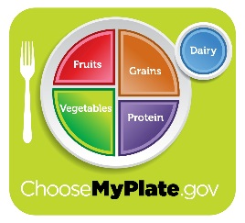

**FRUITS**

**VEGETABLES**

**For a meal, choose 3 - 5 colors including at least ½ Cup of Fruits or Vegetables & at least 2 other food groups**

**TODAY’S MENU**

**GRAINS**

**PROTEIN**

**MILK**

**GRAINS**