

Meet Jane Doe

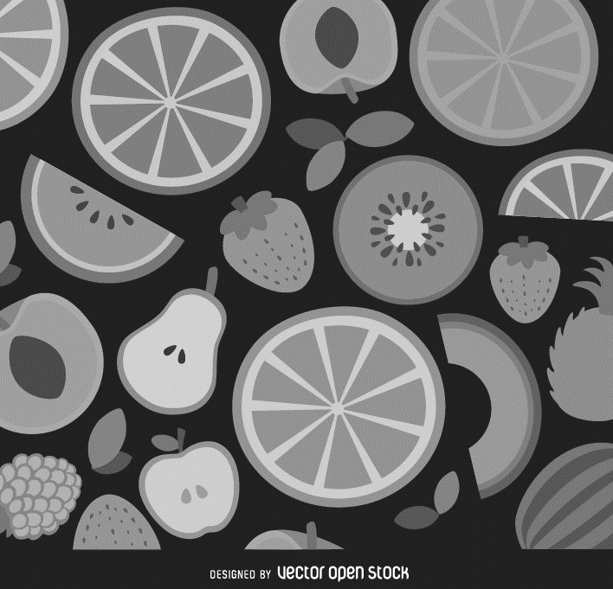

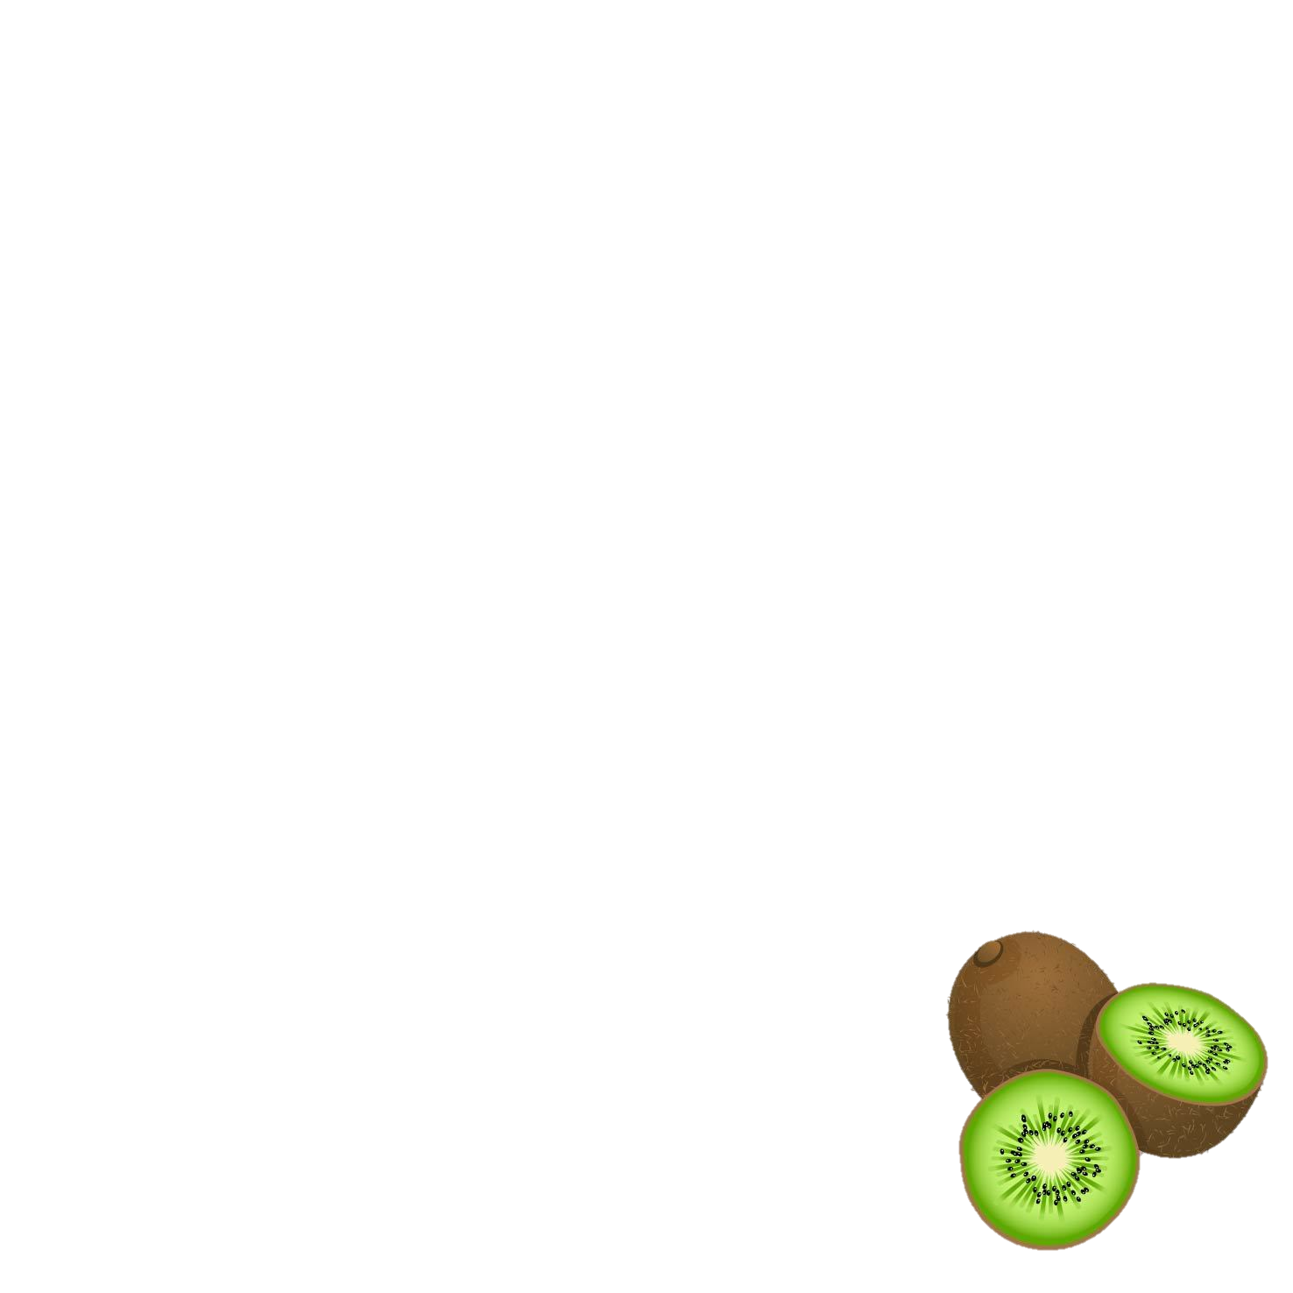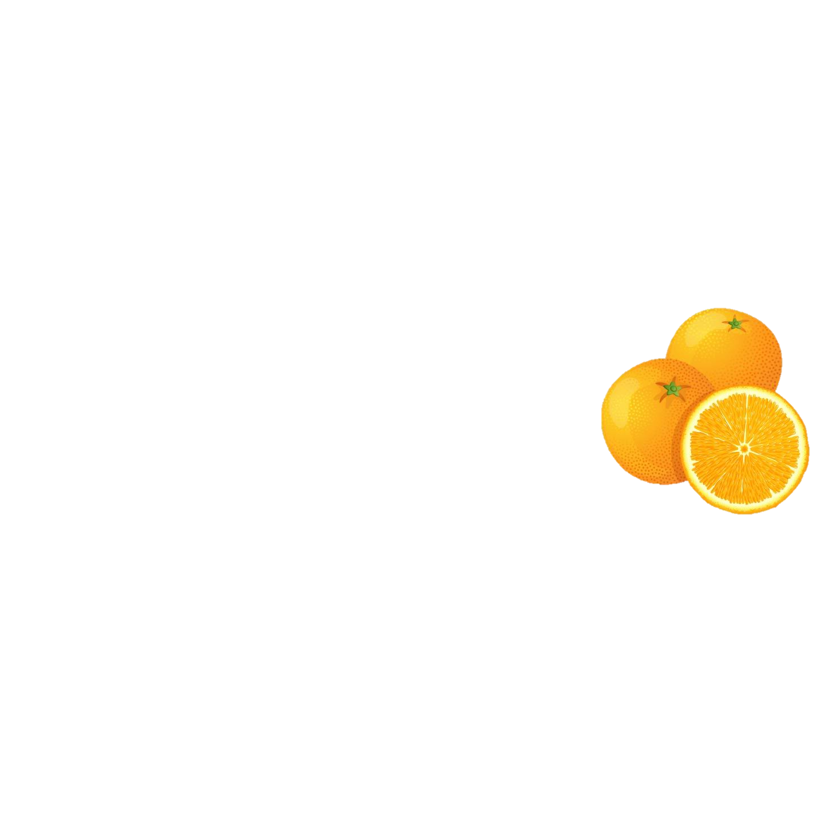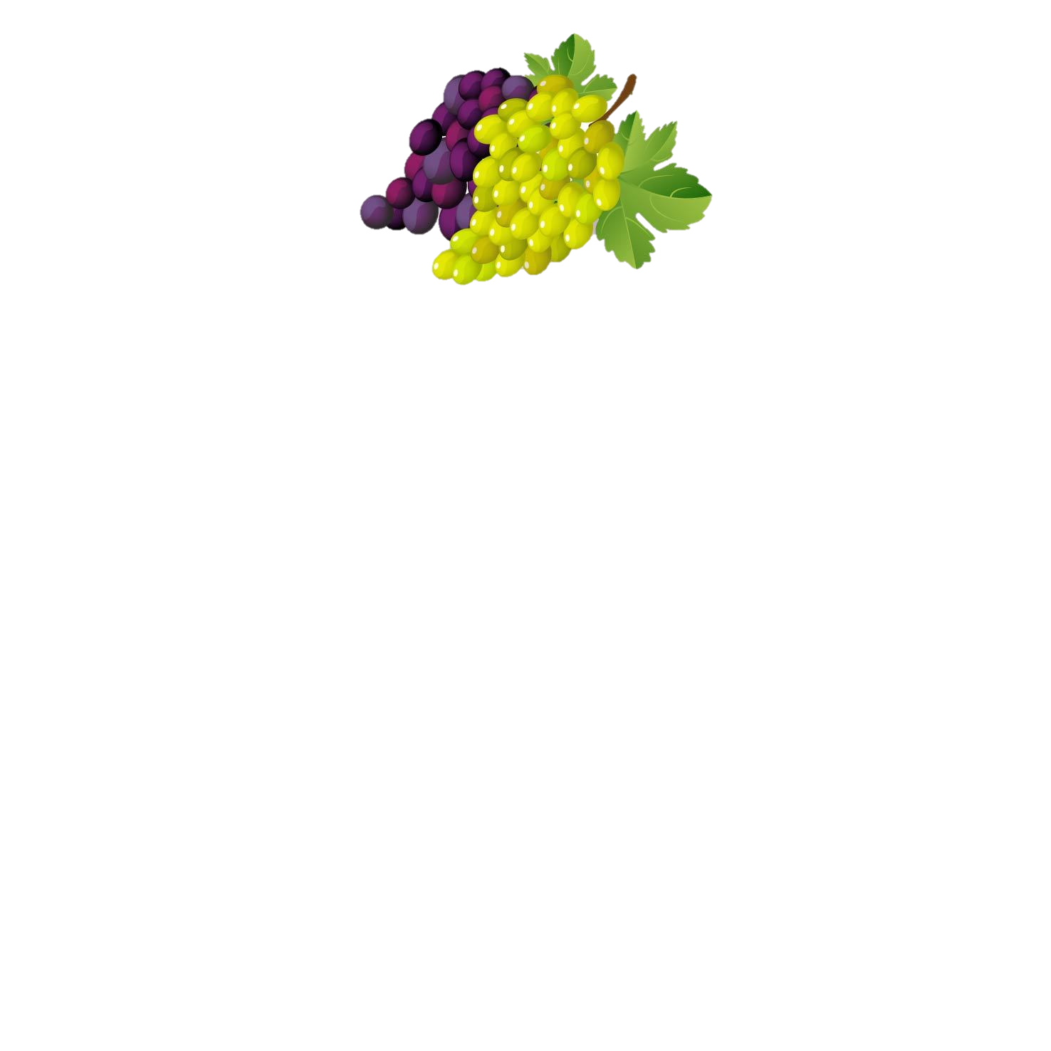

This material was adapted from a resource funded by USDA's Supplemental Nutrition Assistance Program. All graphics are free to share and use, from vectoropenstock.com. USDA is an equal opportunity provider and employer.

**Prompt #4:**

*Answer*

**PHOTO HERE**

**Prompt #3:**

*Answer*

**Prompt #2:**

*Answer*

**SMILING HEADSHOT PHOTO HERE**

**Prompt #1:**

*Answer*

This material was adapted from a resource funded by USDA's Supplemental Nutrition Assistance Program.