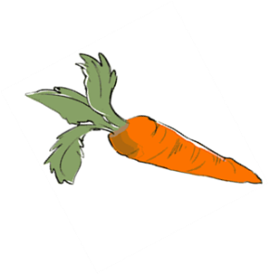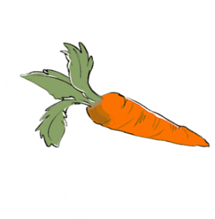

**Fruit and Vegetable**

**Naming Contest**

Name: _______________________________

What grade are you in? __________________

*Write your creative name ideas next to each fruit and vegetable listed below. The most creative names will be featured on the school menu and in the lunchroom.*

**Carrots**  _________________________

**Celery** _________________________

**Broccoli**  _________________________

**Apple Slices** _________________________

**Orange Slices** _________________________

**Spinach** _________________________

**Cauliflower**  _________________________

**Fruit and Vegetable**

**Naming Contest**

Name: _______________________________

What grade are you in? __________________

*Write your creative name ideas next to each fruit and vegetable listed below. The most creative names will be featured on the school menu and in the lunchroom.*

**Carrots** _________________________

**Celery**  _________________________

**Broccoli** _________________________

**Apple Slices** _________________________

**Orange Slices** _________________________

**Spinach** _________________________

**Cauliflower** _________________________

**Fruit and Vegetable**

**Naming Contest**

Name: _______________________________

What grade are you in? __________________

*Write your creative name ideas next to each fruit and vegetable listed below. The most creative names will be featured on the school menu and in the lunchroom.*

**Carrots**  _________________________

**Celery** _________________________

**Broccoli** _________________________

**Apple Slices** _________________________

**Orange Slices** _________________________

**Spinach** _________________________

**Cauliflower**  _________________________

**Fruit and Vegetable**

**Naming Contest**

Name: _______________________________

What grade are you in? __________________

*Write your creative name ideas next to each fruit and vegetable listed below. The most creative names will be featured on the school menu and in the lunchroom.*

**Carrots** _________________________

**Celery**  _________________________

**Broccoli** _________________________

**Apple Slices** _________________________

**Orange Slices** _________________________

**Spinach**  _________________________

**Cauliflower** _________________________