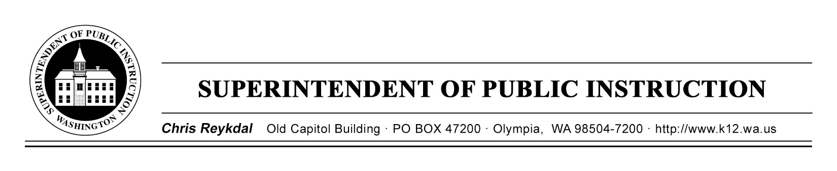

September 3, 2019 ( ) Action Required
(X) Informational
BULLETIN NO. 061-19 STUDENT TRANSPORTATION

TO: Educational Service District Superintendents
School District Superintendents
School District Assistant Superintendents for Business and/or Business Managers
School District Transportation Administrators
Regional Transportation Coordinators

FROM: Chris Reykdal, Superintendent of Public Instruction

RE: 2019–20 State Accepted Quotes for School Bus Categories

CONTACT: Patti Enbody, 360-725-6122, patti.enbody@k12.wa.us
Agency TTY: 360-664-3631

PURPOSE/ BACKGROUND
The school bus purchase prices available through the state quote system are established each year from competitive price quotes in each school bus category submitted by Washington school bus vendors.

For your convenience, the accepted quotes for each school bus category with the corresponding vendor are provided in Attachment 1. These price quotes are in effect for the 2019–20 school year (September 1, 2019, through August 31, 2020). The prices shown do not include sales tax. The contact information for the vendors is provided:

Vendor/Company Phone Number
Bryson Sales and Service of WA 1-877-882-7976
Northwest Bus Sales, Inc. 1-800-231-7099
RWC Group 1-602-377-4401
Schetky Northwest Sales, Inc. 1-800-255-8341

RCW 28A.160.195 allows any school district or educational service district (ESD) to purchase school buses directly from any vendor submitting an accepted bid without using a competitive bid process. All accepted state price quotes (including specifications and prices for district supported options) are available online at 2019-20 State Quote Specifications.

A separate bulletin will be issued mid-September explaining the reimbursement process and will also provide information related to replacement and depreciation systems.

BULLETIN No. 061-19 ST
Page 2
September 3, 2019

Districts or ESDs also have the option to purchase a school bus from any vendor by following the standard school bus bid process. Those districts wishing to do so must:

- Use the vendor bid proposal form (Form SPI 1400) available online at School Bus Forms.

- Follow “a comparable competitive bid process based on the lowest price quote based on similar bus categories.”

- Submit to the Office of Superintendent of Public Instruction (OSPI), Student Transportation, a summary of all bids, including the type of bus, base cost, school district requirements or vendor alternate cost, total adjusted cost, and the name of the dealer submitting each bid.

- Submit a school bus acquisition form (Form SPI 1020A), the original Washington State Patrol initial inspection report, a copy of the seller’s invoice, a copy of the school district’s warrant or conditional sales contract, and a copy of the complete successful vendor bid proposal package.

INFORMATION AND ASSISTANCE
Other questions concerning this bulletin may be directed to Patti Enbody, Program Supervisor for Student Transportation, at 360-725-6122, or at patti.enbody@k12.wa.us. The agency TTY number is 360-664-3631.

This information is also available on OSPI’s Bulletins website.

Jamila B. Thomas
Chief of Staff

T.J. Kelly
Chief Financial Officer
Financial Resources

Patti Enbody
Director
Student Transportation and
Traffic Safety Education

CR:kmk

Attachment 1 – State Accepted Quotes (2019–20)

OSPI provides equal access to all programs and services without discrimination based on sex, race, creed, religion, color, national origin, age, honorably discharged veteran or military status, sexual orientation, gender expression, gender identity, disability, or the use of a trained dog guide or service animal by a person with a disability. Questions and complaints of alleged discrimination should be directed to the Equity and Civil Rights Director at 360-725-6162/TTY: 360-664-3631; or P.O. Box 47200, Olympia, WA 98504-7200; or equity@k12.wa.us.

