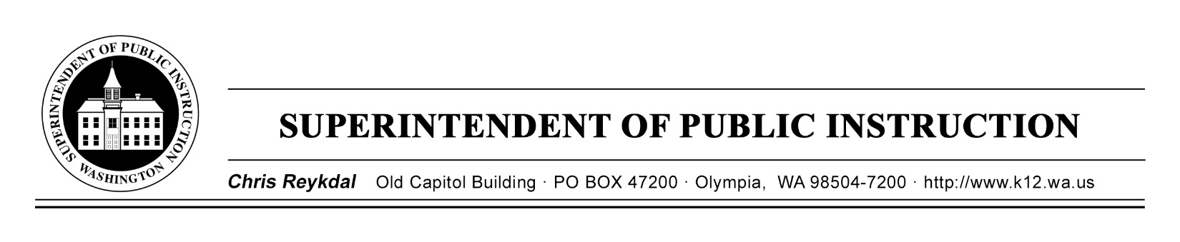

March 19, 2019 ( ) Action Required
( X ) Informational

BULLETIN NO. 015-19 STUDENT TRANSPORTATION

TO: Educational Service District Superintendents
Chief School District Superintendents
Assistant Superintendents for Business and/or Business Managers
School District Transportation Administrators
Regional Transportation Coordinators

FROM: Chris Reykdal, Superintendent of Public Instruction

RE: School Transportation Relative Efficiency Ratings

CONTACT: Patti Enbody, Interim Director, 360-725-6122, patti.enbody@k12.wa.us

PURPOSE/BACKGROUND

Associated with the implementation of the Student Transportation Allocation Reporting System (STARS) is the use of the reported data to provide a relative efficiency rating of school district transportation operations. This system was developed in accordance with Revised Code of Washington (RCW) 28A.160.117 and requires the Office of Superintendent of Public Instruction (OSPI) to provide an efficiency review of those districts with relative efficiency ratings less than 90 percent to be performed by the Regional Transportation Coordinators (RTCs), in order to assist school districts in identifying methods of increasing the efficient use of state resources. No later than December 1 of each year, OSPI is required to report to the Washington State Legislature the efficiency ratings, the results of these efficiency reviews and any actions taken by school districts to improve the efficiency of their transportation operations.

Attachment 1 is a listing of each school district’s efficiency rating based on the reported transportation data and expenditures for the 2017–18 school year. The workbook also provides the prior school year ratings on separate worksheets. For each school district, the STARS Efficiency Detail Report is provided online at Student Transportation under the “STARS Efficiency Ratings” tab. This report shows a list of the efficiency cohort districts and weighting values for each school district with a relative efficiency rating less than 100 percent.

Also available on the same page, under the “Efficiency Ratings” section are copies of the reports the RTCs submitted for their prior efficiency reviews. The overview section of these reports provides a description of the efficiency rating process as well as other information that will assist any school district in the evaluation of their transportation operations.

Contact information for the regional transportation coordinators is provided on the next page:

BULLETIN NO. 015-19 ST
Page 2
March 19, 2019

Region 1 (ESD 112 & Capitol Region 113)  Rodney McKnight  ESD 112  2500 NE 65th Avenue  Vancouver, WA 98661-6812  360-952-3595  rodney.mcknight@esd112.org | Region 2 (Olympic ESD 114 & PS ESD 121)  Mike Shahan  Puget Sound ESD 121  1282 Valentine Ave SE  Pacific, WA 98047  253-778-7955, or 1-800-664-4549 ext. 7955  mshahan@psesd.org
Region 3 (NW ESD 189)  Mark Dennis  Northwest ESD 189  1601 “R” Avenue  Anacortes, WA 98221  360-299-4008  mdennis@nwesd.org | Region 4 (ESD 105, NC ESD 123, & ESD 171)  Dan Payne  ESD 105  33 S. Second Avenue  Yakima, WA 98902  509-454-3105  dan.payne@esd105.org
Region 5 (NEWESD 101)
Chris Jose
ESD 101
4202 South Regal
Spokane, WA 99223-7738
509-789-3558
cjose@esd101.net

INFORMATION AND ASSISTANCE

Other questions concerning this report may be directed to Patti Enbody, Interim Director for Student Transportation, at 360-725-6122 or patti.enbody@k12.wa.us. The OSPI TTY number is
360-664-3631.

This bulletin is also available on OSPI’s Bulletins and Memoranda website.

Jamila B. Thomas
Chief of Staff

T.J. Kelly Patti Enbody
Interim Chief Financial Officer Interim Director
Financial Resources Student Transportation

CR:kmk

Attachment 1 – School District Transportation Efficiency Ratings

OSPI provides equal access to all programs and services without discrimination based on sex, race, creed, religion, color, national origin, age, honorably discharged veteran or military status, sexual orientation, gender expression, gender identity, disability, or the use of a trained dog guide or service animal by a person with a disability. Questions and complaints of alleged discrimination should be directed to the Equity and Civil Rights Director at 360-725-6162/TTY: 360-664-3631; or P.O. Box 47200, Olympia, WA 98504-7200; or equity@k12.wa.us.

