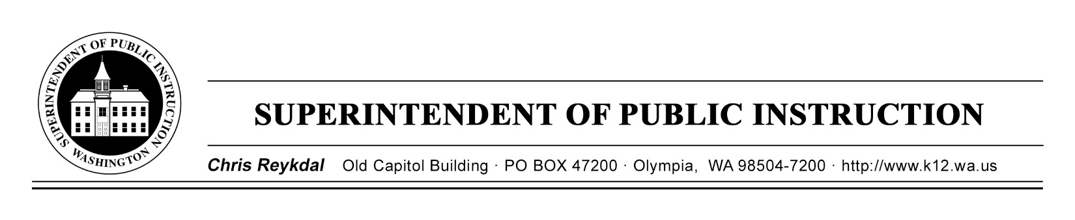

February 26, 2019 ( ) Action Required
( X ) Informational

BULLETIN NO. 008-19 STUDENT TRANSPORTATION

TO: Educational Service District Superintendents
Chief School District Superintendents
School District Assistant Superintendents for Business and/or
Business Managers
School District Transportation Administrators
Regional Transportation Coordinators

FROM: Chris Reykdal, Superintendent of Public Instruction

RE: Student Transportation Operation Allocation 2018–19

CONTACT: Patti Enbody, Interim Transportation Director,
360-725-6122, patti.enbody@k12.wa.us

PURPOSE/BACKGROUND

The purpose of this bulletin is to inform school districts of the calculation and distribution of their student transportation operations allocation for the 2018–19 school year. Allocation payments for September, October, November, December, and January were made in accordance with Revised Code of Washington (RCW) 28A.510.250, based on each district’s Student Transportation Allocation Reporting System (STARS) allocation for the 2017–18 school year.

The STARS calculation process uses a regression analysis to determine the expected cost of operating school district transportation service based on the individual school district’s characteristics. For the 2018–19 school year, the regression analysis used the Fall, Winter, and Spring student counts and route data from the 2017–18 school year and the 2017–18 school year transportation expenditure data from each district’s Form F-196 to determine the coefficients used in the funding calculation. The initial funding amount is then calculated using each district’s reported data from Spring 2018, Fall 2018, and Winter 2019. This initial amount is compared to the school district’s prior year expenditures, and the lesser of these two values is selected.

A summary of the student transportation operation allocation for each district is attached to this bulletin. The summary shows the calculated allocation and the amount of any funding adjustment.

BULLETIN NO. 008-19 ST
Page 2
February 26, 2019

The details of the STARS calculation including all adjustments is available online at the Office of Superintendent of Public Instruction’s (OSPI) Student Transportation Allocation Reporting System’s website. Select the link marked “STARS Funding Reports.” There is a drop down list of district “Operations Allocation Detail Report 1026A.” On the same page, in the “Reference Material” section, a detailed description of the 1026-A Report provides a step-by-step explanation of the STARS calculation.

Details of district reported data are provided in the following STARS reports: the Student Detail Report, the Route Summary Report, the Bus Summary Report, and the Route Detail Report. These reports are available in the reports tab within the STARS Educational Data System (EDS) and on OSPI’s Student Transportation STARS website (link shown above) under “Quarterly Reports”. All of these reports are combined into a single PDF file name starting with the report period and then “District Detail Report”. These reports are available in a drop down menu.

Please contact your regional transportation coordinator if you find any errors with the data displayed on your Report 1026-A, or if you have questions regarding the calculation. Their contact information is provided below:

Region 1 (ESD 112 & Capitol Region 113)  Rodney McKnight  ESD 112  2500 NE 65th Avenue  Vancouver, WA 98661-6812  360-952-3595  rodney.mcknight@esd112.org | Region 2 (Olympic ESD 114 & PS ESD 121)  Mike Shahan  Puget Sound ESD 121  1282 Valentine Ave SE  Pacific, WA 98047  253-778-7955, or 1-800-664-4549 ext. 7955  mshahan@psesd.org
Region 3 (NW ESD 189)  Mark Dennis  Northwest ESD 189  1601 “R” Avenue  Anacortes, WA 98221  360-299-4008  mdennis@nwesd.org | Region 4 (ESD 105, NC ESD 123, & ESD 171)  Dan Payne  ESD 105  33 S. Second Avenue  Yakima, WA 98902  509-454-3105  dan.payne@esd105.org
Region 5 (NEWESD 101)
Chris Jose
ESD 101
4202 South Regal
Spokane, WA 99223-7738
509-789-3558
cjose@esd101.net
BULLETIN NO. 008-19 ST
Page 3
February 26, 2019

INFORMATION AND ASSISTANCE

Other questions concerning this report may be directed to Patti Enbody, Interim Director for Student Transportation, at 360-725-6122 or patti.enbody@k12.wa.us. The OSPI TTY number is 360-664-3631.

This bulletin is also available on OSPI’s Bulletins and Memoranda website.

Jamila B. Thomas
Chief of Staff

T.J. Kelly
Interim Chief Financial Officer
Financial Resources

Patti Enbody
Interim Director
Student Transportation

CR:tcl

Attachment 1 – Summary of 2018-19 Operations Allocation

OSPI provides equal access to all programs and services without discrimination based on sex, race, creed, religion, color, national origin, age, honorably discharged veteran or military status, sexual orientation, gender expression, gender identity, disability, or the use of a trained dog guide or service animal by a person with a disability. Questions and complaints of alleged discrimination should be directed to the Equity and Civil Rights Director at 360-725-6162/TTY: 360-664-3631; or P.O. Box 47200, Olympia, WA 98504-7200; or equity@k12.wa.us.

