Geometry: Transformations

- Hugo drew and rotated it about point J to form 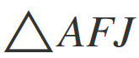, as shown.
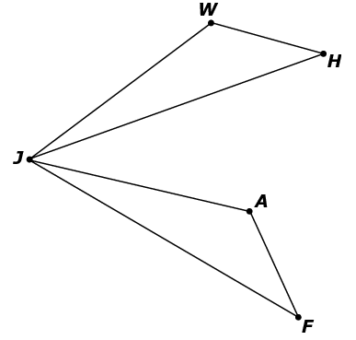
Which characteristic of rotations proves that ?
A. Rotations take line segments in to corresponding congruent line segments in
.
B. Rotations ensure that the perimeter of is equal to the perimeter of.
C. Rotations take angles in to corresponding congruent angles in.
D. Rotations ensure that the area of is equal to the area of.
- Quadrilateral ABCD was drawn on a coordinate grid.
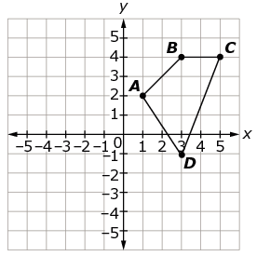
Select all transformations that result in the image of quadrilateral ABCD being located in only Quadrant II.
A. reflect over the y-axis and then translate 2 units up
B. reflect over the x-axis and then translate 2 units down
C. translate 2 units up and then translate 4 units right
D. reflect over the line ﻿y = −﻿x and then translate up 1 unit
E. rotate 90° counterclockwise about vertex A and then translate 5 units left
F. rotate counterclockwise 180° about the point (0, 2) and translate 1 unit up
- Figure ABCD was drawn on a coordinate plane.
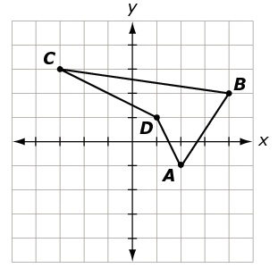
Using a ruler or straightedge, draw the image of figure ABCD after a rotation of 90° counterclockwise about the origin.
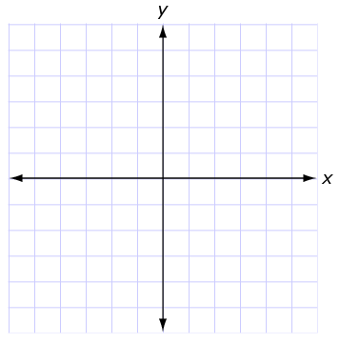

- In the diagram shown, and are congruent.
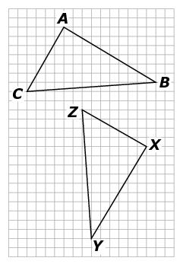
Select all the transformations or combinations of transformations that show the congruence by carrying onto .
A. rotation only
B. translation only
C. translation, then rotation
D. translation, then rotation, then reflection
- Trapezoid M”A”T”H” ﻿ is the image of figure MATH after a reflection over the y-axis followed by a rotation of 90° clockwise about the origin.

The vertices of ﻿ M”A”T”H” are M” (1, −5), ﻿A” (−3, −6), ﻿T” (−5, −3), ﻿H” (−3, 1).

Select the coordinates of figure MATH.
A. M(–1, –5), A(3, –6), T(5, –3), H(3, 1)
B. M(5, –1), A(6, 3), T(3, 5), H(–1, 3)
C. M(5, 1), A(6, –3), T(3, –5), H(–1, –3)
D. M(–5, 1), A(–6, –3), T(–3, –5), H(1, –3)

- Rotate 90° clockwise about point P.
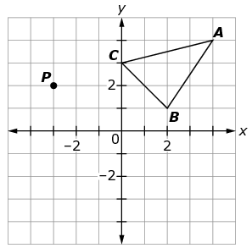
What are the coordinates of B’?
A. (2, –1)
B. (–2, –3)
C. (1, –2)
D. (–4, –3)
- Describe a sequence of transformations that would move the gray-shaded figure onto the unshaded figure.
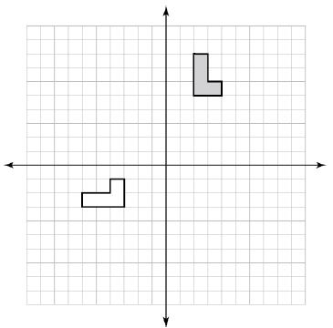

Teacher Material

G-CO.A
Experiment with transformations in the plane.

G-CO.B
Understand congruence in terms of rigid motions.

G-SRT.A
Understand similarity in terms of similarity transformations.

Question | Claim | Key/Suggested Rubric
1 | 3 | 1 point: Selects A
2¹ | 1 | 1 point: Selects A, E, and F
3¹ | 1 | 1 point:  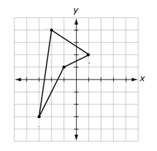  NOTE: The rotated figure does not need to include labels for the points.
4¹ | 1 | 1 point: Selects A and C
5¹ | 1 | 1 point: Selects D
6¹ | 1 | 1 point: Selects D
7 | 2 | 2 points: Answers will vary. Example 1: Rotate 90° counterclockwise about the origin. Translate right 1 and down 6. Example 2: Reflect over the line  y = –x. Then reflect over the line y = –3. Then translate 2 spaces to the right.  NOTE: A rotation must include the point, amount, and direction of rotation.  NOTE: A reflection must include the line of reflection.  NOTE: A transformation must include the direction and amount of transformation.

Adapted from the Mathematics K–12 Learning Standards. Internet. Available from http://www.k12.wa.us/Mathematics/Standards.aspx; accessed 11/2015.
Adapted from Smarterbalanced.org. Grades 11, Claim 2 Item Specifications. Internet. Available from http://www.smarterbalanced.org/smarter-balanced-assessments/; accessed 11/2015.

