Geometry: 3-Dimensional Objects

- The radius of sphere Y is twice the radius of sphere X. A student claims that the volume of sphere Y must be exactly four times the volume of sphere X because two circles with radii in a ratio of 1:2 result in areas in the ratio of 1:4.
Part A
Fill in the boxes to create one example to evaluate the student’s claim.
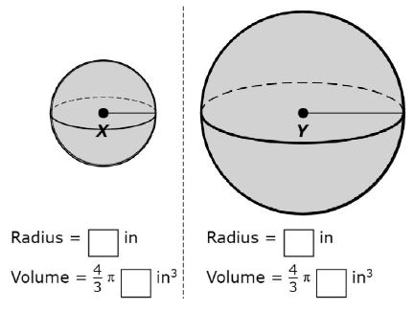
Part B
Is the student’s claim true, false, or cannot be determined?
- If the rectangle below is continuously rotated about side w, which solid figure is formed?
A. Rectangular prism
B. Pyramid
C. Cylinder
D. Cone

- The Great Pyramid of Giza was constructed as a regular pyramid with a square base. Its height is 146.5 meters. If it were a solid pyramid, the volume of bricks needed to create it would be 2,592,276 cubic meters.
What is the length of one side of its base, to the nearest meter?
A. 73
B. 77
C. 133
D. 230
- Janine is creating water-based centerpieces for each of the 30 tables at her wedding reception. She has already purchased a cylindrical vase for each table. She plans to fill each vase half way with water then add a variety of colored marble until the waterline is approximately three-quarters of the way up the cylinder. She can buy bags of 100 marbles in 2 different sizes.
List 3 additional pieces of information necessary to determine the total cost of the marbles for all of the water-based centerpieces.
Describe how Janine could gather each piece of information necessary.

- A circle with a radius of 5 was divided into 24 congruent sectors. The sectors were rearranged, as shown in the diagram below.
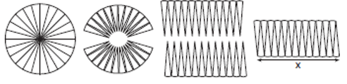
What is the value of x, to the nearest tenth?
- Which figure can have the same cross section as a sphere?
A. 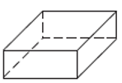
B. 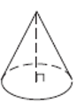
C. 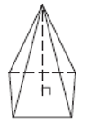
D. 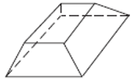

Teacher Material

G-GMD.B
Visualize relationships between two-dimensional and three-dimensional objects.

Question | Claim | Key/Suggested Rubric
1 | 3 | 1 point: Student provides radii values in a ratio of 1:2 and volume measures in the ratio 1:8 AND states the student’s claim is false.
2 | 1 | 1 point: Selects C
3² | 4 | 1 point: Selects D
4 | 4 | 2 points: Identifies 3 additional pieces of information needed AND describes how those pieces of information can be gathered. Example: She would need to know the volume of water that is 1/4 of the vase. She could find this by measuring the height and radius of the base of the cylinder and using that to find the volume, then dividing that by 4. Next she would need to know the cost of one bag of marbles of each size. She can get that information at the store where they sell the marbles. Then she would need to find out the cost of all the marbles by dividing the volume of water in 1/4 of the vase by the volume of marbles in 1 bag to get the number of bags needed, then multiply that number by the cost of one bag.  1 point: Identifies 2 additional pieces of information and describes how both pieces of information can be gathered OR Identifies 3 additional pieces of information and describes how 1 of those pieces of information can be gathered.
5 | 2 | 1 point: Writes a value in the interval 15.5 to 15.7, inclusive.
6² | 1 | 1 point: Selects B.

Adapted from Smarterbalanced.org. Grades 11, Claim 3 Item Specifications. Internet. Available from http://www.smarterbalanced.org/smarter-balanced-assessments/; accessed 11/2015.
From EngageNY.org of the New York State Education Department. Annotated items from the Geometry Common Core Regents Exam. Internet. Available from http://www.nysedregents.org/geometrycc/815/geomcc82015-exam.pdf accessed Nov 2015.
https://www.illustrativemathematics.org/content-standards/HSG/GMD/A/3/tasks/514 accessed on November 1, 2015, is licensed by Illustrative Mathematics under CC BY-NC-SA 4.0.
From EngageNY.org of the New York State Education Department. Annotated items from the Geometry Common Core Regents Exam. Internet. Available from http://www.nysedregents.org/geometrycc/615/geomcc62015-examw.pdf; accessed Nov 2015.

