Geometry: Proofs

1. Consider the two triangles shown  
     
   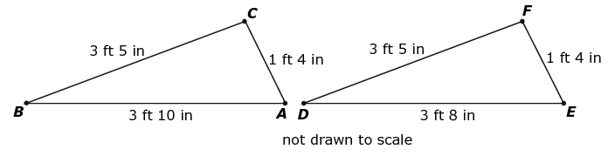  
   **Part A**Write an inequality that shows the relationship between and .  
     
   **Part B**Write an inequality that shows the relationship between and .
2. Quadrilateral *ABCD* is a parallelogram. Jaleel is trying to prove that both pairs of   
   opposite sides of Quadrilateral *ABCD* are congruent.  
     
   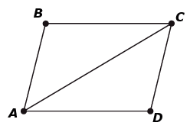  
     
   Complete the proof.

| **Statement** | **Reason** |
| --- | --- |
| Quadrilateral *ABCD* is a parallelogram | Given |
| Line segment A B is parallel to line segment C Dand Line segment B C is parallel to line segment A D | Definition of parallelogram |
|  |  |
| $$\overline{AC} ≅ \overline{CA}$$ | Reflexive property |
|  | If two lines are parallel, Alternate Interior Angles are congruent |
|  | Angle-Side-Angle (ASA) |
| $\overline{AB} ≅ \overline{CD}$ and $\overline{BC} ≅ \overline{AD}$ | Corresponding parts of congruent triangles are congruent |

1. A student in a Geometry class was given this diagram of quadrilateral *CDEF*.  
     
   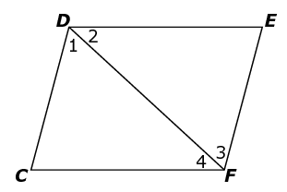  
     
   In the diagram:

$\overline{DE} ≅ \overline{CF}$

$\overline{DC} ≅ \overline{EF}$

The student wants to prove quadrilateral *CDEF* is a parallelogram.  
  
Six reasons are shown, labeled 1 through 6.

1. Definition of parallelogram
2. Given
3. Side-Side-Side (SSS)
4. Reflexive property of equality
5. Alternate interior angles are equal, so lines are parallel
6. Corresponding parts of congruent triangles are congruent

Use the numbers 1 through 6 in the appropriate order to prove quadrilateral *CDEF* is a parallelogram.

| **Statement** | **Reason** |
| --- | --- |
| and |  |
|  |  |
| Triangle C D F is congruent to triangle E F D |  |
| and |  |
| Line segment C D is parallel to line segment F Eand Line segment D E is parallel to line segment C F |  |
| *CDEF* is a parallelogram |  |

1. Given: $\overline{MT}$ bisects 

$\overline{MA} ≅ \overline{MH}$

Prove: $\overline{AT} ≅ \overline{TH}$  
  
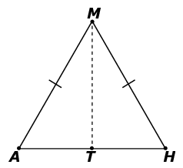  
  
Six statements and reasons are shown, labeled 1 through 6.

1. 
2. 
3. Side-Angle-Side (SAS)
4. Side-Side-Side (SSS)
5. Symmetric property of equality
6. Reflexive property of equality

Use numbers 1 through 6 to complete the proof in the table.

| **Statement** | **Reason** |
| --- | --- |
| $\overline{MT}$ bisects | Given |
| $$\overline{MA} ≅ \overline{MH}$$ | Given |
| $$\overline{MT} ≅ \overline{MT}$$ |  |
|  | Definition of angle bisector |
| Triangle M T A is congruent to triangle M T H |  |
|  | Corresponding parts of congruent triangles are congruent |

1. A student in a Geometry class made this claim:  
     
   “If two lines are cut by a transversal, then alternate interior angles are congruent.”  
     
   **Part A**Draw a diagram that shows two lines cut by a transversal with alternate interior angles that   
   **are** congruent **or** circle “None” if there is not a situation that supports the student’s claim.  
     
     
     
   **Part B**Draw a diagram that shows two lines cut by a transversal with alternate interior angles that  
   are **not** congruent **or** circle “None” if the student’s claim is always true.  
     
   
2. The line through *A* and *B* intersects the line through *C* and *D* at point *P*, as shown in the figure.  
     
   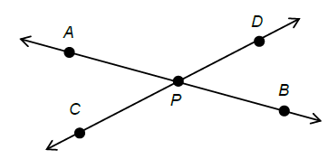  
     
   Prove that angle *APC* is congruent to angle *BPD*.

**Teacher Material**

G-GPE.B

Use coordinates to prove simple geometric theorems algebraically

G-CO.C

Prove geometric theorems

G-SRT.B

Prove theorems involving similarity

| **Question** | **Claim** | **Key/Suggested Rubric** |
| --- | --- | --- |
| 1[1] | 1 | **2 points:**  > , or equivalent AND  < , or equivalent. **1 point:**  > , or equivalent OR  < , or equivalent. |
| 21 | 3 | **1 point:**   | **Statement** | **Reason** | | --- | --- | | Quadrilateral *ABCD* is a parallelogram | Given | | Line segment A B is parallel to line segment C Dand Line segment B C is parallel to line segment A D | Definition of parallelogram | |  | If two lines are parallel, Alternate Interior Angles are congruent, or equivalent | |  | Reflexive property | | , or equivalent | If two lines are parallel, Alternate Interior Angles are congruent | | Triangle B A C is congruent to triangle D C A, or equivalent | Angle-Side-Angle (ASA) | | and $\overline{BC} ≅ \overline{AD}$ | Corresponding parts of congruent triangles are congruent | |
| 3[2] | 3 | **1 point:**   | **Statement** | **Reason** | | --- | --- | | and | 2 | |  | 4 | | Triangle C D F is congruent to triangle E F D | 3 | | and | 6 | | Line segment C D is parallel to line segment F Eand Line segment D E is parallel to line segment C F | 5 | | *CDEF* is a parallelogram | 1 | |
| 42 | 3 | **1 point:**   | **Statement** | **Reason** | | --- | --- | | bisects | Given | |  | Given | |  | 6 | | 2 | Definition of angle bisector | | Triangle M T A is congruent to triangle M T H | 3 | |  | Corresponding parts of congruent triangles are congruent | |
| 5[3] | 3 | **2 points:** Provides a diagram of two parallel lines cut by a transversal AND a diagram of two non-parallel lines both intersected by a third line. **Example:**  A 14 by 6 grid. Two red, vertical, parallel line segments are drawn near the center of the grid. A red, diagonal line segment is drawn instersecting both vertical, parallel line segments.  A 14 by 6 grid. One red, vertical line segment is drawn near the left side of the grid. Another red, diagonal line segment is drawn near the right side of the grid that does not intersect with the red, vertical line segment. A third red, diagonal line segment is drawn instersecting both other line segments.  **1 point:** Provides a diagram of two parallel lines cut by a transversal OR a diagram of two non-parallel lines both intersected by a third line. |
| 6[4] | 3 | **2 points:** Provides a complete proof in any form (two-column, paragraph, using transformations, etc.) **Example 1:** Lines *AB* and *CD* intersect like they said at point *P*. This means angle *APB* is a straight angle of 180° by definition. The same is true of angle *CPD*. So angle *CPA* plus angle *APD* equals 180° because they are non-overlapping angles that form angle *CPD*. Same is true for angles *APD* and *DPB* since they are non-overlapping angles that form angle *APB*.Since angle *APD* is congruent to itself by the reflexive property, and angle *CPA* plus angle *APD* equals angle *APD* plus angle *DPB* since they both equal 180°, angle *APC* equals angle *DPB* by substitution. **Example 2:** Line *CD* passes through point *P*, as given. A rotation of 180° of point *D* about point *P* maps *D* onto ray *PC* because line *CD* forms a straight angle. The same is true for point *B*; a rotation of 180° of point *B* about point *P* maps *B* onto ray *PA*. Since point *D* can be anywhere on ray *PD*, and likewise for point *B* on ray *PB*, a rotation of the point has the same effect as a rotation of the entire ray. So a simultaneous rotation of rays *PD* and *PB* 180° in the same direction map rays *PD* and *PB* onto rays *PC* and *PA* respectively. And since rotations maintain angle measures, angle *APC* is congruent to angle *BPD*.  **1 point:** Provides a partial proof that has 1 or 2 errors or omissions. |

1. Adapted from the Mathematics K–12 Learning Standards. Internet. Available from <http://www.k12.wa.us/Mathematics/Standards.aspx>; accessed 11/2015.
2. Adapted from the Mathematics K–12 Learning Standards. Internet. Available from <http://www.k12.wa.us/Mathematics/Standards.aspx>; accessed 11/2015.
3. Adapted from Smarterbalanced.org. Grades 11, Claim 3 Item Specifications. Internet. Available from <http://www.smarterbalanced.org/smarter-balanced-assessments/>; accessed 11/2015.
4. Adapted from Smarterbalanced.org. Grades 11, Claim 3 Item Specifications. Internet. Available from <http://www.smarterbalanced.org/smarter-balanced-assessments/>; accessed 11/2015.