8.EE.C

Analyze and solve linear equations and pairs of simultaneous linear equations.

- Select all equations that have no solution.
A. 2 + 3x – 1 = 3x
B. 6(4 –x) = –6x + 24
C. 5x + $\frac{1}{3}$(54 – 2x) = 28 – $\frac{2}{3}$x
D. 2(–1 + 2x) = –2(–4 – 2x)
- Alysha solved the linear equation 2x – 3 − 9x = 14 + x − 1. Her work is shown. When she checked her answer, the left side of the equation did not equal the right side. Find and explain how to correct Alysha’s error, and then solve the equation correctly.
2x – 3 − 9x = 14 + x – 1
– 3 − 7x = 13 + x
− 7x = 16 + x
− 6x = 16
x = –$\frac{16}{6}$

- Given the graph of a system of linear equations shown, is there a solution to the system that we cannot see on this portion of the coordinate plane? That is, will the lines intersect somewhere on the plane not represented in the picture? Explain why or why not.
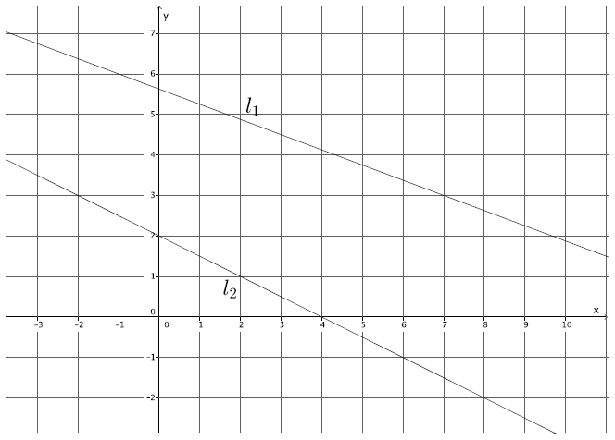

8.EE.C

Analyze and solve linear equations and pairs of simultaneous linear equations.

- Efrain and Fernie are each taking road trips to the Grand Canyon. Efrain travels at an average of 45 miles per hour for the entire trip. Fernie averages 60 miles per hour throughout the trip. Fernie and Efrain left from the same location, but Efrain left at 8 a.m. and Fernie left at 11 a.m. Will Fernie ever catch up to Efrain? If so, approximately when? Explain your reasoning.

- The measure of one angle is 11 more than 4 times a number. The measure of another angle is 2 times the first angle’s measure. The sum of the measures of the angles is 195°. What is the measure, in degrees, of each angle.

- What value of x makes the equation –2(x – 15) = 27 – 7x true?

- Two linear equations are graphed on the same coordinate plane. Write an ordered pair to estimate the solution to the system of linear equations formed.
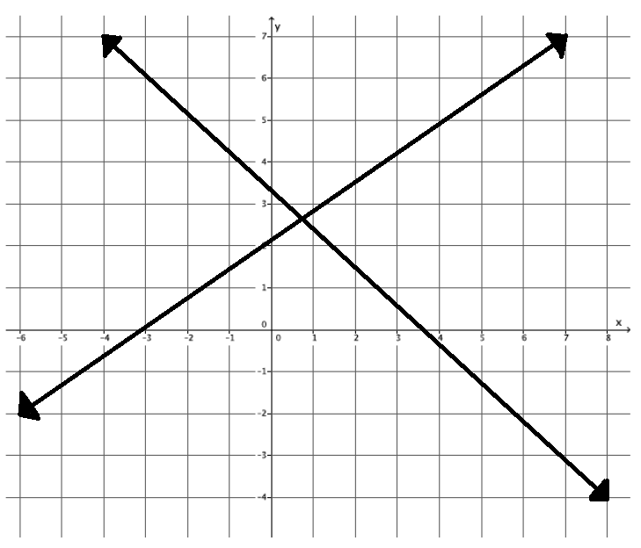
- A system of two linear equations has exactly one solution. One equation is 2x – 4y = 3. Write an equation that would make this system have exactly one solution.

Teacher Material

8.EE.C

Analyze and solve linear equations and pairs of simultaneous linear equations.

Question | Claim | Key/Suggested Rubric
1 | 1 | 1 point: Selects A and D
2 | 3 | 2 points: Identifies and explain the error AND x = –2. Example: From the third to the fourth line is her error. She should have subtracted x from both sides, but she added x to the left side instead of subtracting it. The correct answer is x = –2.  1 point: Identifies and explain the error OR x = –2
3 | 3 | 1 point: Identifies there is a solution to the system AND explains why. Example: Yes, there is a solution because the slopes of the lines are not equal. So they have to intersect somewhere on the plane.
4 | 4 | 1 point: Answers will vary. Example 1: Yes, at 8 p.m. Fernie will catch up to Efrain because they will have both traveled 540 miles by that time. Example 2: It depends on how far they are from the Grand Canyon. If they are more than 540 miles, then they will catch up at 8 p.m. If they are less than 540 miles, it will be however long it takes Fernie to get there.
5² | 2 | 1 point: 65 AND 130
6¹ | 1 | 1 point: –$\frac{3}{5}$, or equivalent
7² | 1 | 1 point: Writes an ordered pair with an x-value in the interval 0.5 < x < 1 and a y-value in the interval 2.5 < y < 3. Example: (0.75, 2.6)
8 | 1 | 1 point: Answers will vary. NOTE: Equations may be written in any form but must represent a line with a slope other than$\frac{1}{2}$. Example: 2x – 5y = 3

From Smarterbalanced.org. Grade 8, Claim 1, Target D Item Specifications. Internet. Available from http://www.smarterbalanced.org/smarter-balanced-assessments/; accessed 11/2015.
Adapted from the Mathematics K–12 Learning Standards. Internet. Available from http://www.k12.wa.us/Mathematics/Standards.aspx; accessed 11/2015.
From EngageNY.org of the New York State Education Department. Grade 8 Mathematics Module 4, Topic D, Lesson 26. Internet. Available from https://www.engageny.org/resource/grade-8-mathematics-module-4-topic-d-lesson-26; accessed 11/2015.
From EngageNY.org of the New York State Education Department. Grade 8 Mathematics Module 4, Topic D, Lesson 24. Internet. Available from https://www.engageny.org/resource/grade-8-mathematics-module-4-topic-d-lesson-24; accessed 11/2015.
Adapted from Smarterbalanced.org. Grade 8, Claim 1, Target D Item Specifications. Internet. Available from http://www.smarterbalanced.org/smarter-balanced-assessments/; accessed 11/2015.

