4.MD.A

Solve problems involving measurement and conversion of measurement from a larger unit to a smaller unit.

1. Decide whether each measurement is equal to 5 yards. Select Yes or No for each measurement by putting an X in the correct column.
 | Yes | No
180 inches
27 inches
15 feet

2. What is the length, in millimeters, of the ribbon?
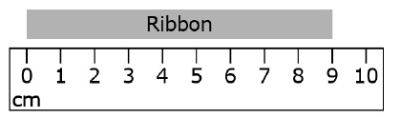
3. Use the diagram of the rectangle to solve the problem. The perimeter of the rectangle is 192 inches. What is the length, in inches, of the unknown side?

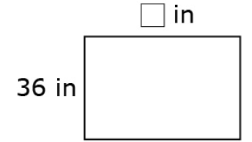

4. Enya walked 2 km 309 m from school to the store. Then, she walked from the store to her home. If she walked a total of 5 km, how far was it from the store to her home?

5. The table below shows the weight of three dogs. What is the difference in weight between the heaviest and lightest dog?
Dog | Weight
Lassie | 21 kg 249 g
Riley | 23 kg 128 g
Fido | 21,268 g

6. Gabe built a toy tower that measured 1 m 78 cm. After building some more, he measured the tower, and it was 82 cm taller. How tall is his tower now?
- Draw a tape diagram to model this problem.
- Write an equation that can be used to solve this and then the answer to the question.

Teacher Material
4.MD.A
Solve problems involving measurement and conversion of measurement from a larger unit to a smaller unit.

Question | Claim | Key/Suggested Rubric
1 | 1 | 1 point:  Y  N  Y
2¹ | 1 | 1 point: 90 millimeters
3¹ | 1 | 1 point: 60 inches
4 | 2 | 1 point: Strategies may vary.  5 km – 2 km 309 m = 4 km 1000 m – 2 km 309 m = 2 km 691 m  It is 2 km 691 m from the store to Enya’s home.
5 | 2 | 1 point: Strategies may vary.  23 kg 128 g – 21 kg 249 g = 23,128 g – 21,249 g = 1879 g OR 1 kg 879 g  The biggest dog is Riley and the smallest is Lassie.
6² | 4 | 3 points: 1) Draws a tape diagram, 2) writes an equation, and 3) writes 260 cm or 2 m 60 cm.  1 m + 78 cm + 82 cm  (Not exactly to scale. Tapes can be drawn in many ways.)  1 m 78 cm + 82 cm = t  178 + 82 = 260 cm or 2 m 60 cm  2 points: Completes two of the three tasks.  1 point: Completes one of the three tasks.  0 points: Does not complete any of the three tasks correctly.

From Smarterbalanced.org. Grade 4, Claim 1, Target I Item Specifications. Internet. Available from http://www.smarterbalanced.org/smarter-balanced-assessments/; accessed 11/2015.
From EngageNY.org of the New York State Education Department. Grade 4 Mathematics Module 2, Topic A, Lesson 1. Internet. Available from https://www.engageny.org/resource/grade-4-mathematics-module-2-topic-lesson-1; accessed 11/2015.
From EngageNY.org of the New York State Education Department. Grade 4 Mathematics Module 2, Topic A, Lesson 2. Internet. Available from https://www.engageny.org/resource/grade-4-mathematics-module-2-topic-lesson-2; accessed 11/2015.

