3.G.A
Reason with shapes and their attributes.

1. Circle all of the shapes that appear to be parallelograms.
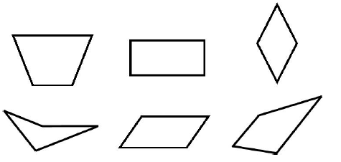

2. Draw the figures on the left under each column or columns where they belong. A figure may belong to more than one category or to none of these categories.

 | Quadrilaterals | Rectangles | Has at Least 4 Angles
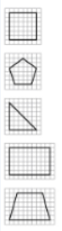

3. Draw a quadrilateral that is not a rhombus or a rectangle.

4. Figure A is divided into equal squares. One square is shaded gray. What is the fraction that is equal to the gray-shaded area of Figure A?
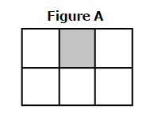
Teacher Material
3.G.A
Reason with shapes and their attributes
Question | Claim | Key/Suggested Rubric
1 | 1 | 1 point:  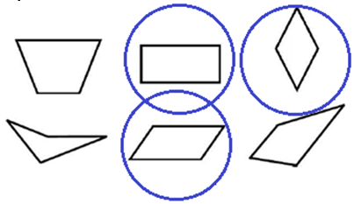
2¹ | 1 | 2 points: Draws 8 or 9 figures in the correct columns  Quadrilaterals: square, rectangle, trapezoid  Rectangles: square, rectangle  Has at least angles: square, pentagon, rectangle, trapezoid  1 point: Draws 5, 6 or 7 figures in the correct columns
3¹ | 1 | 1 point: See student drawing.
4¹ | 1 | 1 point: $\frac{1}{6}$

From Smarterbalanced.org. Grade 3, Claim 1, Target K Item Specifications. Internet. Available from http://www.smarterbalanced.org/smarter-balanced-assessments/; accessed 11/2015.

