

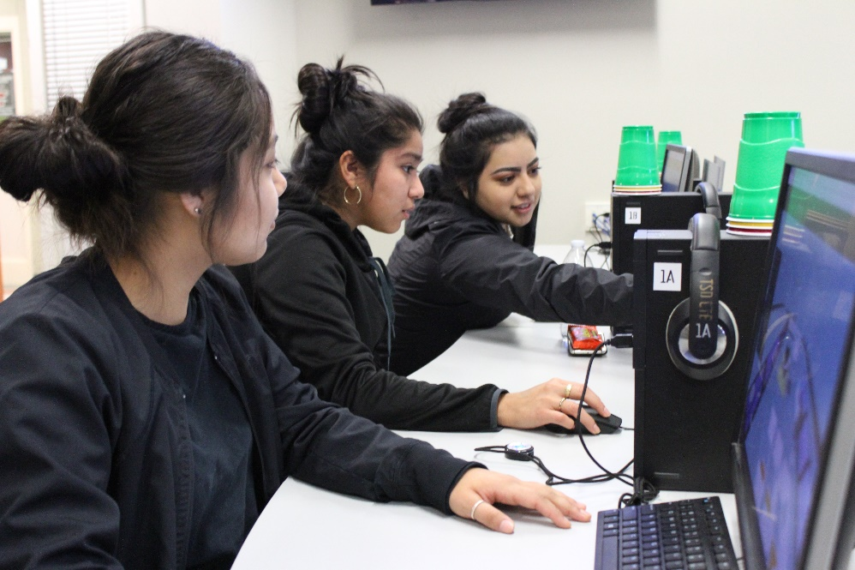**Educational Technology Learning Standards: Appendix F**

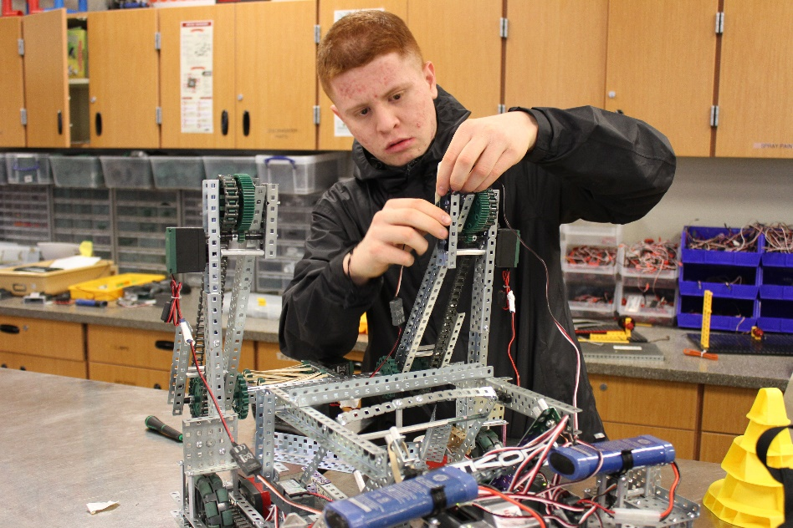

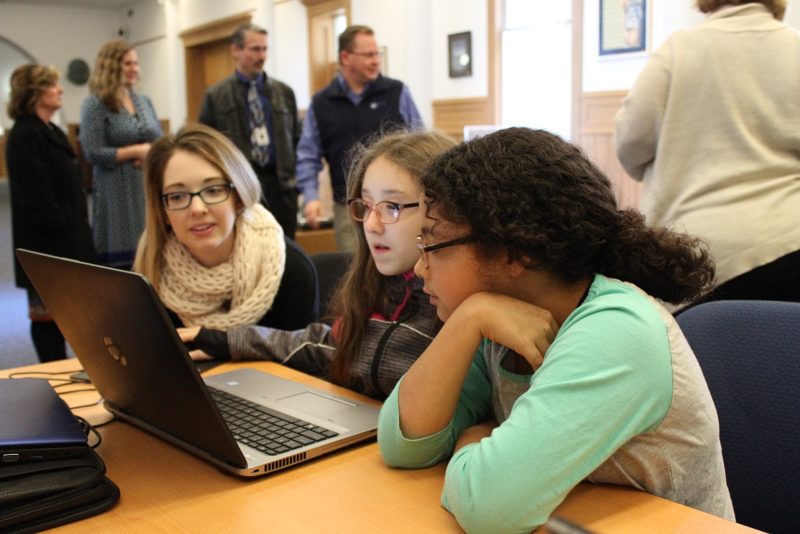

***Adopted May, 2018***

*****Photos: Toppenish High School, Sunnyside High School and OSPI, courtesy of OSPI***

# For complete K-12 Educational Technology Standards go to:

[*http://www.k12.wa.us/EdTech/Standards/default.aspx*](http://www.k12.wa.us/EdTech/Standards/default.aspx)

**Creative Commons Attribution-NonCommercial LIcense Logo (CC BY NC)
**

Except where otherwise noted, the Washington Educational Technology K–12 Learning Standards (<http://www.k12.wa.us/edtech/Standards>) by the Office of Superintendent of Public Instruction (<http://k12.wa.us/>) are licensed under a Creative Commons Attribution Non-Commercial 4.0 International License (<https://creativecommons.org/licenses/by-nc/4.0/>). All logos and trademarks are property of their respective owners.

Portions of this work are based on the 2016 International Society for Technology in Education (ISTE) Standards for Students (<https://www.iste.org/standards/for-students>) – Appendix F.

ISTE Standards for Students, ©2016, ISTE (International Society for Technology in Education), iste.org. All rights reserved.

# Appendix F – Sample Scope & Sequence

OSPI would like to acknowledge the work of Jane Miller, Director of Instructional Technology and her teams of educators at Spokane Public Schools and Federal Way Public Schools in the creation of this sample scope and sequence. Thanks also to the team of teacher-librarians at Auburn School District and others for their feedback and suggestion. The entire document is licensed Creative Commons CC-BY, to encourage continued sharing as changes and improvements are made.

In our local control state, OSPI is responsible for establishing standards, but districts are responsible for defining their own scope and sequence and selecting instructional materials. Thus, this sample scope and sequence is available for optional use by districts, and they may choose to use or adapt it, or simply use it as a template to create their own scope and sequence. The Standards Development Team strongly recommended including it as an Appendix, though, hoping to save considerable time for districts that wished to make use of it in some way.

*CC-NC (Creative Commons) logo*

**How to Use This “Technology Standards and Targets” Document**

**Grade Level Targets** summary sheet

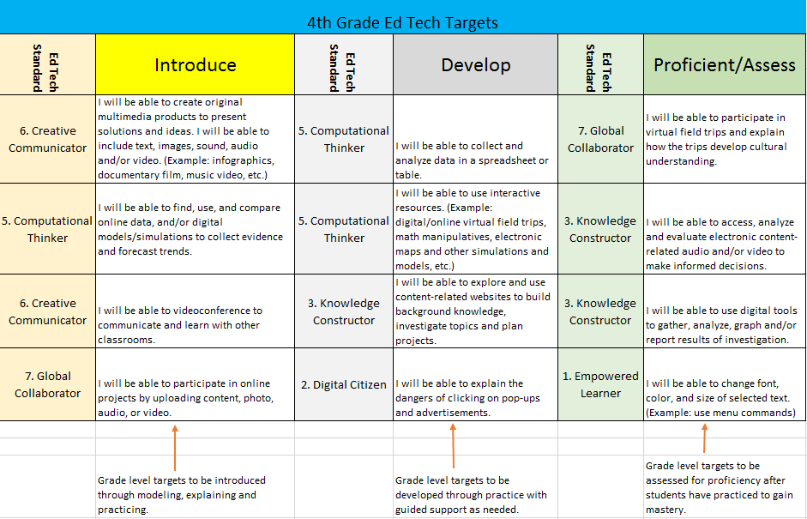

**1. Empowered Learner**

Students leverage technology to take an active role in choosing, achieving and demonstrating competency in their learning goals, informed by the learning sciences. Students:

1. articulate and set personal learning goals, develop strategies leveraging technology to achieve them and reflect on the learning process itself to improve learning outcomes.
2. build networks and customize their learning environments in ways that support the learning process.
3. use technology to seek feedback that informs and improves their practice and to demonstrate their learning in a variety of ways.
4. understand the fundamental concepts of technology operations, demonstrate the ability to choose, use and troubleshoot current technologies and are able to transfer their knowledge to explore emerging technologies.

|  |  |
| --- | --- |
|  | **Technology Targets** |
|  | I = Introduce: Skill is demonstrated, discussed, and experienced.  D = Develop: Skill is practiced, reinforced, and enhanced.  P = Proficient: Efficiently applies skills in predictable and unpredictable situations |

|  |  |  |  |  |  |  |  |  |  |  |  |  |
| --- | --- | --- | --- | --- | --- | --- | --- | --- | --- | --- | --- | --- |
|  | **K** | **1** | **2** | **3** | **4** | **5** | **6** | **7** | **8** | **9** | **10** | **11**  **12** |
| I will be able to properly use a mouse and/or touchpad: single- and double-click, drag-and-drop. | P | P |  |  |  |  |  |  |  |  |  |  |
| I will be able to use left hand on the left side of the keyboard and right hand on the right side of the keyboard simultaneously with thumb on spacebar. | I | D | P |  |  |  |  |  |  |  |  |  |
| I will be able to identify the following components: CPU/computer, monitor, mouse /touchpad, speakers, keyboard, headphones/earbuds, microphone. | I | D | P |  |  |  |  |  |  |  |  |  |
| I will be able to locate, identify and use: Enter, Escape, Spacebar, Shift, Arrows, and Backspace. |  | I | D | P |  |  |  |  |  |  |  |  |
| I will be able to demonstrate correct posture while using the keyboard. |  | I | D | P |  |  |  |  |  |  |  |  |
| I will be able to locate, identify, and use letter, number, and punctuation keys. |  | I | D | P |  |  |  |  |  |  |  |  |
| I will be able to use basic file commands. (Example: Save, Open, Print, Save As, etc.) |  | I | D | P |  |  |  |  |  |  |  |  |
| I will be able to use correct hand-finger, home row, and pairing of fingers. |  |  | I | D | P |  |  |  |  |  |  |  |
| I will be able to change font, color, and size of selected text. (Example: use menu commands or WordArt, etc.) |  |  | I | D | P |  |  |  |  |  |  |  |
| I will be able to use mouse: right-click for menus. |  |  | I | D | P |  |  |  |  |  |  |  |
| I will be able to use correct spacing between words and following punctuation. |  |  | I | D | P | P |  |  |  |  |  |  |
| I will be able to use correct technique for key striking and keying by touch. |  |  |  | I | D | P |  |  |  |  |  |  |
| I will be able to locate, identify and use Tab Key. |  |  |  | I | D | P |  |  |  |  |  |  |
| I will be able to demonstrate sustained typing for producing/publishing writing in single sitting (CCSSW.6) |  |  |  | I | D | P | P |  |  |  |  |  |
| I will be able to use cut, copy, and paste using menu. |  |  |  | I | D | P |  |  |  |  |  |  |
| I will be able to justify margins: right, left, center. |  |  |  |  | I | D | P |  |  |  |  |  |
| I will be able to highlight or hyperlink selected text. |  |  |  |  |  | I | D | P |  |  |  |  |
| I will be able to use shortcut keys. (Example: CTRL+C, CTRL+V, CTRL+P, etc.) |  |  |  |  |  |  | I | D | P |  |  |  |
| I will be able to establish and maintain a file structure for saving information on a computer, online or on external devices. |  |  |  |  |  |  | I | D | P |  |  |  |
| I will be able to explain how to correctly use district network for saving files and gaining internet access. |  |  |  |  |  |  |  |  | I | D | P |  |
| I will be able to use digital equipment effectively. Digital equipment can include: document cameras, digital still camera, digital video camera, microphones, headphones, computers, mobile devices, student response systems (clickers), microscopes, pedometers, interactive whiteboards, calculators, etc. | I | I | D | D | D | D | P |  |  |  |  |  |
| I will be able to power on and shut down; login and logout. | I | I | D | P |  |  |  |  |  |  |  |  |
| I will be able to open and close applications. | I | I | D | P |  |  |  |  |  |  |  |  |
| I will be able to turn on speakers, mute, and adjust volume using speaker icon in system tray. |  | I | D | P |  |  |  |  |  |  |  |  |
| I will be able to ask for help and/or troubleshoot common technology-related problems. (Example: disconnected cables, caps lock, num lock, etc.) |  |  | I | I | D | D | P |  |  |  |  |  |
| I will be able to troubleshoot using "Help" wizard. |  |  |  |  | I | D | P |  |  |  |  |  |
| I will be able to apply prior knowledge of digital equipment to operate unfamiliar or new equipment. |  |  |  |  |  |  |  | I | I | D | D | P |
| I will be self-reliant in searching for solutions to technology issues. |  |  |  |  |  |  |  |  |  | I | D | P |
| I will be able to add and resize graphics and text boxes in a project. (Example: clipart, photos, etc.) |  | I | D | P |  |  |  |  |  |  |  |  |
| I will be able to select appropriate programs for a multimedia product. (Example: blog, wiki, spreadsheet.) |  |  | I | D | D | D | D | P |  |  |  |  |
| I will be able to apply appropriate design and layout in common applications. |  |  |  | I | D | P |  |  |  |  |  |  |
| I will be able to add slides, pages, and tabs in common applications. |  |  |  | I | D | P |  |  |  |  |  |  |
| I will be able to add hyperlinks, apply transitions and animations in presentation software. |  |  |  |  | I | D | P |  |  |  |  |  |
| I will be able to use toolbars in common applications. |  |  |  |  | I | D | P |  |  |  |  |  |
| I will be able to use presentation software for presenting to audience: create presentation notes, adjust timing. |  |  |  |  |  | I | D | P |  |  |  |  |
| I will be able to identify and use proper file formats (Example: docx, pdf, jpeg, xlsx, etc.) |  |  |  |  |  | I | D | P |  |  |  |  |
| I will be able to use common applications to create tables, outlines. |  |  |  |  |  | I | D | P |  |  |  |  |
| I will be able to navigate to and use teacher-selected websites. | I | D | P |  |  |  |  |  |  |  |  |  |
| I will be able to use basic web-navigation skills. (Example: select browser, favorites, URLs, home page, etc.) |  |  |  | I | D | P |  |  |  |  |  |  |
| I will be able to select an appropriate online application for a given task. |  |  |  | I | D | P |  |  |  |  |  |  |
| I will be able to comment, link, post and embed information online. (Example: blog, wiki, etc.) |  |  |  |  | I | I | D | P |  |  |  |  |
| I will be able to create, upload and share multimedia projects. |  |  |  |  |  | I | I | D | P |  |  |  |
| I will be able to independently design and publish multimedia content. |  |  |  |  |  |  |  | I | D | D | P |  |
| I will be able to evaluate and select online applications for a specified use. |  |  |  |  |  |  |  |  |  | I | D | P |
| I will be able to adapt classroom technologies for individual personalized use. |  |  |  |  |  |  | I | D | P |  |  |  |
| I will be able to select technology to fit personal needs and style. (Example: Use video as another option for presenting, use online discussions, posting to blogs, etc.) |  |  |  |  |  |  |  | I | D | P |  |  |

**2. Digital Citizen**

Students recognize the rights, responsibilities and opportunities of living, learning and working in an interconnected digital world, and they act and model in ways that are safe, legal and ethical. Students:

1. cultivate and manage their digital identity and reputation and are aware of the permanence of their actions in the digital world.
2. engage in positive, safe, legal and ethical behavior when using technology, including social interactions online or when using networked devices.
3. demonstrate an understanding of and respect for the rights and obligations of using and sharing intellectual property.
4. manage their personal data to maintain digital privacy and security and are aware of data-collection technology used to track their navigation online.

|  |  |
| --- | --- |
|  | **Technology Targets** |
|  | I = Introduce: Skill is demonstrated, discussed, and experienced.  D = Develop: Skill is practiced, reinforced, and enhanced.  P = Proficient: Efficiently applies skills in predictable and unpredictable situations |

|  |  |  |  |  |  |  |  |  |  |  |  |  |
| --- | --- | --- | --- | --- | --- | --- | --- | --- | --- | --- | --- | --- |
|  | **K** | **1** | **2** | **3** | **4** | **5** | **6** | **7** | **8** | **9** | **10** | **11**  **12** |
| I will be able to understand and comply with the District Acceptable Use / Responsible Use Policy. | P | P | P | P | P | P | P | P | P | P | P | P |
| I will be able to demonstrate and define digital citizenship. | I | I | D | D | P | P |  |  |  |  |  |  |
| I will be able to show respect for opinions and work of others posted electronically. | I | I | D | P |  |  |  |  |  |  |  |  |
| I will be able to discuss and recognize danger in sharing private information online: password, name, address, phone number or picture. | I | I | I | I | D | P |  |  |  |  |  |  |
| I will be able to explain the dangers of clicking on pop-ups and advertisements. | I | I | I | I | D | P |  |  |  |  |  |  |
| I will be able to identify and report cyberbullying. |  | I | I | I | D | P | P |  |  |  |  |  |
| I will be able to meet expectations for district email. |  |  | I | I | D | D | P | P | P |  |  |  |
| I will be able to identify and describe the impact of ethical and unethical or illegal use of technology on individuals and society. |  |  | I | I | I | I | D | P |  |  |  |  |
| I will be able to describe how digital information is archived. |  |  |  | I | I | D | D | P |  |  |  |  |
| I will be able to explain copyrights, document and cite online resources, authors and content creators including Creative Commons. |  |  |  | I | I | D | P |  |  |  |  |  |
| I will be able to gather and cite sources using digital bibliography tools. |  |  |  | I | I | I | D | D | P |  |  |  |
| I will be able to create and store strong individual passwords. (Example: Strong password checker found at www.howsecureismypassword.net) |  |  |  |  | I | D | P |  |  |  |  |  |
| I will be able to actively monitor personal content (online and offline) for digital safety. |  |  |  |  |  |  | I | I | I | D | D | P |
| I will be able to explain issues involved with using copyrighted materials. |  |  |  |  |  |  | I | D | P |  |  |  |

**3. Knowledge Constructor**

Students critically curate a variety of resources using digital tools to construct knowledge, produce creative artifacts and make meaningful learning experiences for themselves and others. Students:

1. plan and employ effective research strategies to locate information and other resources for their intellectual or creative pursuits.
2. evaluate the accuracy, perspective, credibility and relevance of information, media, data or other resources.
3. curate information from digital resources using a variety of tools and methods to create collections of artifacts that demonstrate meaningful connections or conclusions.
4. build knowledge by actively exploring real-world issues and problems, developing ideas and theories and pursuing answers and solutions

|  |  |
| --- | --- |
|  | **Technology Targets** |
|  | I = Introduce: Skill is demonstrated, discussed, and experienced.  D = Develop: Skill is practiced, reinforced, and enhanced.  P = Proficient: Efficiently applies skills in predictable and unpredictable situations |

|  |  |  |  |  |  |  |  |  |  |  |  |  |
| --- | --- | --- | --- | --- | --- | --- | --- | --- | --- | --- | --- | --- |
|  | **K** | **1** | **2** | **3** | **4** | **5** | **6** | **7** | **8** | **9** | **10** | **11**  **12** |
| I will be able to access digital content (audio, video) to build background knowledge and investigate topics. | I | D | P |  |  |  |  |  |  |  |  |  |
| I will be able to use digital templates, graphic organizers and/or storyboards to record questions and plan investigations. | I | I | D | D | D | P |  |  |  |  |  |  |
| I will be able to explore and use content-related websites to build background knowledge, investigate topics and plan projects. |  |  |  | I | D | D | P |  |  |  |  |  |
| I will be able to select digital resources to organize a project or solve a problem. |  |  |  |  | I | I | I | D | P |  |  |  |
| I will be able to select and research current issues using databases and digital resources to organize a project or solve a problem. |  |  |  |  |  |  | I | I | D | D | P |  |
| I will be able to search and sort databases and use basic database search skills. |  |  |  |  |  |  |  | I | I | D | D | P |
| I will be able to gather information from research using teacher-selected, digital tools. |  | I | D | P |  |  |  |  |  |  |  |  |
| I will be able to use the Internet to locate, retrieve and organize information, recording sources. |  |  | I | D | D | D | D | D | D | P |  |  |
| I will be able to use digital search tools effectively. (Example: search engine, database, content library, etc.) |  |  |  | I | D | D | D | P |  |  |  |  |
| I will be able to gather and organize online references for a project. (Example: personal bookmarks, stored shortcuts or hyperlinks, etc.) |  |  |  |  | I | D | D | D | P |  |  |  |
| I will be able to filter search results to narrow results for given task. |  |  |  |  |  | I | D | D | D | P |  |  |
| I will be able to find, catalog and organize resources for given task. |  |  |  |  |  |  | I | D | D | P |  |  |
| I will be able to select and use an appropriate search engine or directory. |  |  |  |  |  |  |  |  |  | I | D | P |
| I will be able to use advanced search functions of search engines and databases. |  |  |  |  |  |  |  |  |  | I | D | P |
| I will continue to focus on bibliographies, references and works cited to determine relevance of sources. |  |  |  |  |  |  |  |  |  | I | D | P |
| I will be able to use digital templates and graphic organizers to analyze information. | I | D | P |  |  |  |  |  |  |  |  |  |
| I will be able to use digital tools to gather, analyze, graph and/or report results of investigation. |  |  | I | D | P |  |  |  |  |  |  |  |
| I will be able to access, analyze and evaluate electronic content-related audio and/or video to make informed decisions. |  |  | I | D | P |  |  |  |  |  |  |  |
| I will be able to evaluate digital and online sources for appropriateness and bias. |  |  |  |  |  |  | I | D | D | D | P |  |
| I will be able to use technology to explore and brainstorm solutions for real-world problems. |  |  |  |  |  |  | I | D | D | P |  |  |

**4. Innovative Designer**

Students use a variety of technologies within a design process to identify and solve problems by creating new, useful or imaginative solutions. Students:

1. know and use a deliberate design process for generating ideas, testing theories, creating innovative artifacts or solving authentic problems
2. select and use digital tools to plan and manage a design process that considers design constraints and calculated risks.
3. develop, test and refine prototypes as part of a cyclical design process.
4. exhibit a tolerance for ambiguity, perseverance and the capacity to work with open-ended problems.

|  |  |
| --- | --- |
|  | **Technology Targets** |
|  | I = Introduce: Skill is demonstrated, discussed, and experienced.  D = Develop: Skill is practiced, reinforced, and enhanced.  P = Proficient: Efficiently applies skills in predictable and unpredictable situations |

|  |  |  |  |  |  |  |  |  |  |  |  |  |
| --- | --- | --- | --- | --- | --- | --- | --- | --- | --- | --- | --- | --- |
|  | **K** | **1** | **2** | **3** | **4** | **5** | **6** | **7** | **8** | **9** | **10** | **11**  **12** |
| I will be able to find, understand, select and compare virtual simulations. |  |  |  |  |  |  |  |  |  | I | D | P |
| I will be able to explore cause & effect of a virtual simulation. |  |  |  |  |  |  |  |  |  | I | D | P |
| I will be able to select digital resources to organize a project or solve a problem. |  |  |  |  |  |  | I | D | P |  |  |  |
| I will be able to modify or create a new technology to solve a problem or meet a need. (Example: build an app, customize font size for reading, etc.) |  |  |  |  |  |  |  | I | D | D | D | P |

**5. Computational Thinker**

Students develop and employ strategies for understanding and solving problems in ways that leverage the power of technological methods to develop and test solutions. Students:

1. formulate problem definitions suited for technology-assisted methods such as data analysis, abstract models and algorithmic thinking in exploring and finding solutions.
2. collect data or identify relevant data sets, use digital tools to analyze them, and represent data in various ways to facilitate problem-solving and decision-making.
3. break problems into component parts, extract key information, and develop descriptive models to understand complex systems or facilitate problem-solving.
4. understand how automation works and use algorithmic thinking to develop a sequence of steps to create and test automated solutions.

|  |  |
| --- | --- |
|  | **Technology Targets** |
|  | I = Introduce: Skill is demonstrated, discussed, and experienced.  D = Develop: Skill is practiced, reinforced, and enhanced.  P = Proficient: Efficiently applies skills in predictable and unpredictable situations |

|  |  |  |  |  |  |  |  |  |  |  |  |  |
| --- | --- | --- | --- | --- | --- | --- | --- | --- | --- | --- | --- | --- |
|  | **K** | **1** | **2** | **3** | **4** | **5** | **6** | **7** | **8** | **9** | **10** | **11**  **12** |
| I will be able to explore and describe patterns from data in spreadsheets or tables. |  | I | D | P |  |  |  |  |  |  |  |  |
| I will be able to collect and analyze data in a spreadsheet or table. |  |  | I | D | D | D | D | D | D | P |  |  |
| I will be able to use digital tools to gather, analyze, graph and/or report results of investigation. |  |  | I | I | D | D | D | D | P |  |  |  |
| I will be able to use interactive resources. (Example: digital/online virtual field trips, math manipulatives, electronic maps and other simulations and models, etc.) |  |  |  | I | D | D | D | P |  |  |  |  |
| I will be able to find, use, and compare online data, and/or digital models/simulations to collect evidence and forecast trends. |  |  |  |  | I | D | D | P |  |  |  |  |
| I will be able to select the proper technology tools to input, select, analyze and interpret data. |  |  |  |  |  |  |  |  | I | D | D | p |

**6. Creative Communicator**

Students communicate clearly and express themselves creatively for a variety of purposes using the platforms, tools, styles, formats and digital media appropriate to their goals. Students:

1. choose the appropriate platforms and tools for meeting the desired objectives of their creation or communication.
2. create original works or responsibly repurpose or remix digital resources into new creations.
3. communicate complex ideas clearly and effectively by creating or using a variety of digital objects such as visualizations, models or simulations.
4. publish or present content that customizes the message and medium for their intended audiences.

|  |  |
| --- | --- |
|  | **Technology Targets** |
|  | I = Introduce: Skill is demonstrated, discussed, and experienced.  D = Develop: Skill is practiced, reinforced, and enhanced.  P = Proficient: Efficiently applies skills in predictable and unpredictable situations |

|  |  |  |  |  |  |  |  |  |  |  |  |  |
| --- | --- | --- | --- | --- | --- | --- | --- | --- | --- | --- | --- | --- |
|  | **K** | **1** | **2** | **3** | **4** | **5** | **6** | **7** | **8** | **9** | **10** | **11**  **12** |
| I will be able to organize objects and ideas using a document camera. | I/D | P |  |  |  |  |  |  |  |  |  |  |
| I will be able to organize objects and ideas using: digital drawing tools, digital templates and graphic organizers, brainstorming/mind mapping software. (Example: drawing apps, spreadsheet, etc.) | I | D | P |  |  |  |  |  |  |  |  |  |
| I will be able to create digital audio recordings using technology. |  | I  I | D  D | P  P |  |  |  |  |  |  |  |  |
| I will be able to modify teacher-created slides using presentation software. |  | I | D | P |  |  |  |  |  |  |  |  |
| I will be able to create original multimedia products to present solutions and ideas. I will be able to include text, images, sound, audio and/or video. (Example: infographics, documentary film, music video, etc.) |  |  |  |  | I | D | D | P |  |  |  |  |
| I will be able to combine multiple technologies to create and share products from multiple content areas. |  |  |  |  |  |  |  |  |  | I | D | P |
| I will be able to create digital products for culminating projects or inclusion in portfolios. |  |  |  |  |  |  |  |  |  | I | D | P |
| I will be able to use digital drawing tools and presentation software collaboratively to express ideas. | I | D | P |  |  |  |  |  |  |  |  |  |
| I will be able to videoconference to communicate and learn with other classrooms. |  |  | I | I | I | I | D | P |  |  |  |  |
| I will be able to collaborate and communicate virtually using shared documents and wikis. |  |  |  |  | I | I | D | P |  |  |  |  |
| I will be able to use online discussion forums to express ideas. (Example: backchannel apps) |  |  |  |  |  | I | D | D | P |  |  |  |
| I will be able to select and create an appropriate online forum for communicating and collaborating with a chosen audience. |  |  |  |  |  |  |  |  |  | I | D | P |

**7. Global Collaborator**

Students use digital tools to broaden their perspectives and enrich their learning by collaborating with others and working effectively in teams locally and globally. Students:

1. use digital tools to connect with learners from a variety of backgrounds and cultures, engaging with them in ways that broaden mutual understanding and learning.
2. use collaborative technologies to work with others, including peers, experts or community members, to examine issues and problems from multiple viewpoints.
3. contribute constructively to project teams, assuming various roles and responsibilities to work effectively toward a common goal.
4. explore local and global issues and use collaborative technologies to work with others to investigate solutions.

|  |  |
| --- | --- |
|  | **Technology Targets** |
|  | I = Introduce: Skill is demonstrated, discussed, and experienced.  D = Develop: Skill is practiced, reinforced, and enhanced.  P = Proficient: Efficiently applies skills in predictable and unpredictable situations |

|  |  |  |  |  |  |  |  |  |  |  |  |  |
| --- | --- | --- | --- | --- | --- | --- | --- | --- | --- | --- | --- | --- |
|  | **K** | **1** | **2** | **3** | **4** | **5** | **6** | **7** | **8** | **9** | **10** | **11**  **12** |
| I will be able to use digital drawing tools and presentation software collaboratively to express ideas. | I | D | P |  |  |  |  |  |  |  |  |  |
| I will be able to videoconference to communicate and learn with other classrooms. |  |  | I | I | I | I | D | P |  |  |  |  |
| I will be able to collaborate and communicate virtually using shared documents and wikis. |  |  |  |  | I | I | D | P |  |  |  |  |
| I will be able to participate in online projects by uploading content, photo, audio, or video. |  |  |  |  | I | D | P |  |  |  |  |  |
| I will be able to select and create an appropriate online forum for communicating and collaborating with a chosen audience. |  |  |  |  |  |  |  |  |  | I | D | P |
| I will be able to access content-related digital images, digital stories, audio and video to develop cultural understanding. | I | D | P |  |  |  |  |  |  |  |  |  |
| I will be able to participate in virtual field trips and explain how the trips develop cultural understanding. |  |  | I | D | P |  |  |  |  |  |  |  |
| I will be able to use digital communication tools: email, videoconference, back channels to develop and share cultural understanding. |  |  | I | I | I | D | P |  |  |  |  |  |
| I will be able to use digital maps to develop cultural understanding. |  |  |  | I | I | I | D | P |  |  |  |  |
| I will be able to research and identify global problems via websites. |  |  |  |  |  |  | I | D | P |  |  |  |
| I will be able to participate in an online community to develop cultural understanding. |  |  |  |  |  |  | I | D | P |  |  |  |
| I will be able to choose global digital content to identify a local or global issue. |  |  |  |  |  |  |  | I | D | P |  |  |
| I will be able to participate in an online community to solve a local or global issue. |  |  |  |  |  |  |  |  |  | I | D | P |