school district

career & technical education state course equivalency

 | This Certificate is Awarded to

Name
For earning credit of [equivalency credit] through [course title] at
[name of high school].
Date |  |  | 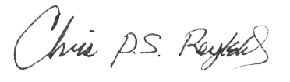
DATE |  |  | chris reykdal  State Superintendent of Public Instruction

