Enrollment Reporting Applications

User Guide

* NEW Enrollment Application
* K–3 Class Size Application (suspended for the 2020-21 school year)
* SAFS ALE Application

**Updated as of September 4, 2020**

C[Creative Common Logo](http://creativecommons.org/licenses/by/4.0/)  
School Level Enrollment Reporting User Guide by Office of Superintendent of Public Instruction is licensed under a [Creative Commons Attribution 4.0 International License](http://creativecommons.org/licenses/by/4.0/).

# **Table of Contents**

**Introduction** 1

**NEW Enrollment Application** 2

1. Accessing the NEW Enrollment Application 2
2. Available Schools 2
3. Reporting Headcount (HC) Rules 2
4. Reporting Full-Time Equivalent (FTE) Rules 3
5. File Status 3
6. Buttons and Their Actions 3
7. Reporting by Resident District and “Manage Resident Districts” Function 3
   * Adding a New Resident District Relationship 4
   * Removing a Resident District Relationship for a Specific School 5
   * Removing a Resident District 5
8. Inputting Enrollment Data 5
   * Method #1 – Manual Input 5
   * Method #2 – Upload a TXT File 7
   * Method #3 – Upload Through an FTP Process 8
   * Viewing the “Import History” Log 8
9. Revising Enrollment Files 9
10. Submitting Files and Checking Enrollment Data Accuracy by Running Validations and Edits 10
    * About Validations 10
    * About Edits 10
    * Submitting Files and Running Validations and Edits 11
11. Enrollment Reports 13
12. Running Extracts 14
13. TXT File Requirements 16
    * Filename Format 16
    * Record Layout 17
    * Screen Shots With Field Numbers 18
    * Field Number Details 20

**K–3 Class Size Application** 21

1. When to Report 21
2. What to Report 21
   * Count Day 21
   * Student Headcount 21
   * Homeroom Teacher FTE 21
3. Completing the K–3 Class Size Application 22
4. Running Reports 22

**SAFS ALE Application** 23

1. When to Report 23
2. What to Report 23
   * + ALE Program 23
     + Home District 23
     + FTE 23
     + Headcount 23
3. Accessing the SAFS ALE Application 23
4. Managing ALE Programs 24
   * + Creating New ALE Programs 24
     + Changing an ALE Program 24
     + Deleting an ALE Program 25
5. Inputting ALE Enrollment 25
6. Revising SAFS ALE Reports 27
7. Method to Check SAFS ALE Data 27

# **Introduction**

This User Guide’s purpose is to provide instructions on how to navigate the following enrollment reporting applications.

* NEW Enrollment (P223, P223H, P240, and P223S)
* K–3 Class Size (suspended for the 2020-21 school year)
* SAFS ALE

Refer to the Enrollment Reporting Handbook for specific rules on claiming students for state funding and the different categories to report. Additionally, this handbook is a good resource to answer specific enrollment reporting questions, due dates for reporting, and contact information. The most recent Enrollment Reporting Handbook can be found on the [Enrollment Reporting Instructions](https://www.k12.wa.us/policy-funding/school-apportionment/instructions-and-tools/enrollment-reporting) website.

For help with using these applications, refer first to your Educational Service District (ESD) fiscal staff.

| ESD | Name | Email | Phone |
| --- | --- | --- | --- |
| ESD 101 | Jeremy Loe | jloe@esd101.net | 509-789-3611 |
| ESD 105 | Dustin Kinley | dustin.kinley@esd105.org | 509-454-3116 |
| ESD 112 | Christy Price | christy.price@esd112.org | 360-952-3489 |
| ESD 113 | April Kaech | akaech@esd113.org | 360-464-6759 |
| ESD 113 | Jodi Spahn | jspahn@esd113.org | 360-464-6751 |
| ESD 114 | Cathie Seevers | cseevers@oesd114.org | 360-405-5837 |
| ESD 121 | Jane Murray | jmurray@psesd.org | 425-917-7778 |
| ESD 123 | Michelle Dearlove | mdearlove@esd123.org | 509-547-8441 ext 5776 |
| ESD 123 | Travis Belisle | tbelisle@esd123.org | 509-544-5773 |
| ESD 171 | Cory Milbrandt | enrollment@ncesd.org | 509-665-2632 |
| ESD 171 | Student Coordinators | enrollment@ncesd.org | 509-665-2659 |
| ESD 189 | Noreen McKinney | nmckinney@nwesd.org | 360-299-4033 |

If the ESD or the Enrollment Reporting Handbook are unable to answer your question, contact Becky McLean at OSPI at 360-725-6306 or [becky.mclean@k12.wa.us](mailto:becky.mclean@k12.wa.us).

For technical questions regarding files transmitting, confirm first with your ESD. If you need further technical assistance in uploading your files or accessing this system, contact Office of Superintendent of Public Instruction (OSPI) Customer Support at 1-800-725-4311, option 7, or [customersupport@k12.wa.us](mailto:customersupport@k12.wa.us).

# **NEW Enrollment Application**

Student enrollment is reported in the NEW Enrollment application. This application contains the electronic forms; P223, P223H, P223S, and P240.

1. **Accessing the NEW Enrollment Application**

To access the NEW Enrollment application, one of the following roles must be assigned by the District Security Manager. Note the difference for each of these roles.

* **SAFS District Enrollment User**

User with this role can:

* + View enrollment files.
  + Create, update, and revise enrollment files.
  + Run enrollment reports.
* **SAFS District Enrollment Submitter**

User with this role can:

* + View enrollment files.
  + Create, update, and revise enrollment files.
  + Run validations, edits, and submit files to ESD.
  + Manage resident districts.
  + Run enrollment reports.

Depending on the reporting entity’s size and business service practices, assignment of both roles may not be necessary. Having the “SAFS District Enrollment Submitter” role allows access to all the necessary features to submit enrollment. Large districts that use clerical staff to input the enrollment, while supervisors review and submit the enrollment, may find that assigning both roles is more appropriate.

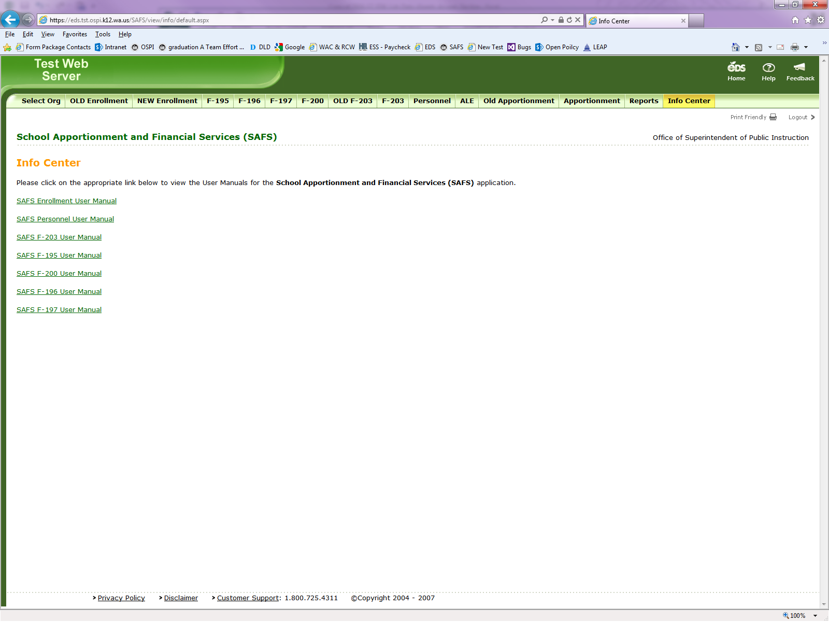After being assigned one of these roles and once logged into EDS, select “SAFS” from your list of available applications. The following will appear:

* Select **“NEW Enrollment.”**
* The **“OLD Enrollment”** selection is closed and was the application used prior to the 2016–17 school year.

1. **Available Schools**

For the NEW Enrollment application, each district, charter school, tribal compact school, and direct funded technical college will have access to their schools listed in the [EDS Education Directory](https://eds.ospi.k12.wa.us/DirectoryEDS.aspx). This is the official list of Local Education Agencies (LEA) that is used by OSPI for state and federal reporting.

There is a formal process for opening or closing schools on this official list. [Bulletin #040-20](https://www.k12.wa.us/sites/default/files/public/bulletinsmemos/bulletins2020/B040-20.pdf) issued June 1, 2020, provides details on this process and instructions for updating this directory. School changes must be requested by July 1 prior to the school year they are effective.

There is no requirement to report enrollment at each of the schools available in the NEW Enrollment application. If the school does not have students, there would be no enrollment reported for that school.

1. **Reporting Headcount (HC) Rules**

All HC is reported at a school. No student should be counted more than once in any HC fields by any district.

The following HC fields are reported at the school where the student is marked “IsPrimary.” For more information on “IsPrimary.” refer to the element C10 in the [CEDARS Data Manual](https://www.k12.wa.us/sites/default/files/public/cedars/pubdocs/2020-21CEDARSManual.pdf).

* Total K–12 HC – P223 and P223S
* Running Start (RS) HC – P223
* RS Only HC – P223
* Open Doors HC – P223
* Transitional Bilingual Instruction Program (TBIP) HC – P223
* Exited TBIP HC – P223
* Special Education HC – P223H

For the Alternative Learning Experience (ALE) HC field, report an ALE student at the school where the student receives their ALE instruction.

**Example:** A student is enrolled in a high school where they are marked “IsPrimary.” Student also takes one ALE class at the ALE school. The student’s K–12 HC is reported at the high school. At the ALE school, the student’s K–12 HC is zero but the ALE HC would be 1.

1. **Reporting Full-Time Equivalent (FTE) Rules**

A student’s FTE, exclusive of RS FTE, is reported at the school where the student attends. RS FTE should be reported at the student’s “IsPrimary” school.

1. **File Status**

The different statuses for enrollment files are described as follows:

* **“In Progress”** is a file that is at the district.
* “**Submitted by District”** is a file that has been submitted by the district and is waiting for the ESD to review and submit to OSPI.
* **“Submitted by ESD”** is a file that has been submitted by the district, reviewed and submitted by the ESD, and is waiting for OSPI to accept.
* **“Accepted by OSPI”** is a file that has been submitted by the district, reviewed and submitted by the ESD, and accepted by OSPI. Before OSPI can process the monthly enrollment, all P223 and P223H files must be in “Accepted by OSPI” status.

1. **Buttons and Their Actions**

Next to each file listed on the “List Enrollment” screen, buttons appear to the left. Below provides the action rules for the buttons that are seen by reporting entities.

* **"Submit" is seen when the file status is “In Progress.” Clicking this button will take you to the Validation/Edit page and allows you to submit the file.**
* **"Update"** **is s**een when the file status is “In Progress.” Clicking this button will allow you to edit the file.
* **"View"** **is s**een when the file status is anything other than “In Progress.” Clicking this button will allow you to view the file only and no edits can be made.
* **"Revise**" **is s**een when the file status is “Accepted by OSPI.” Clicking this button will allow you to change the file’s status to “In Progress” so that you can make revisions to the file.

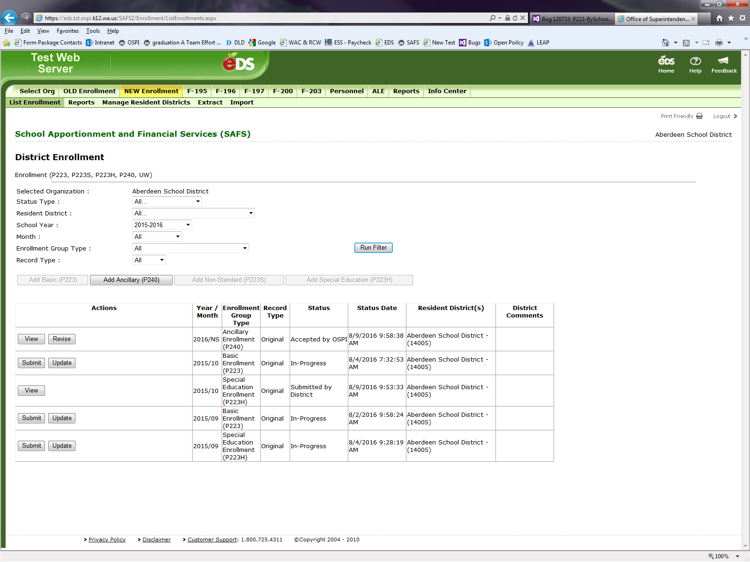

1. **Reporting by Resident District and “Manage Resident Districts” Function**

All enrollment is reported by the Resident District.

* Students that reside in the reporting school or who are attending the district through a choice transfer are reported as residents of the reporting district.
* Charter schools and tribal compact schools report all their students with the resident district of the charter school or tribal compact school.
* Students that attend a district’s school via an interdistrict agreement or a skill center consortium agreement are reported as a resident of their sending district.
* Direct-funded technical colleges report all their enrollment based on the resident district of the student.

Reporting entities use the “Manage Resident Districts” tool to add or remove resident districts. Each Resident District must have a relationship established with a district school. Resident District relationships that were created prior to the 2016–17 school year will have an established relationship with all the district’s schools. New relationships must be assigned to a specific school(s). When relationships with schools are not created, the following message will appear when trying to access a Resident District/School screen.

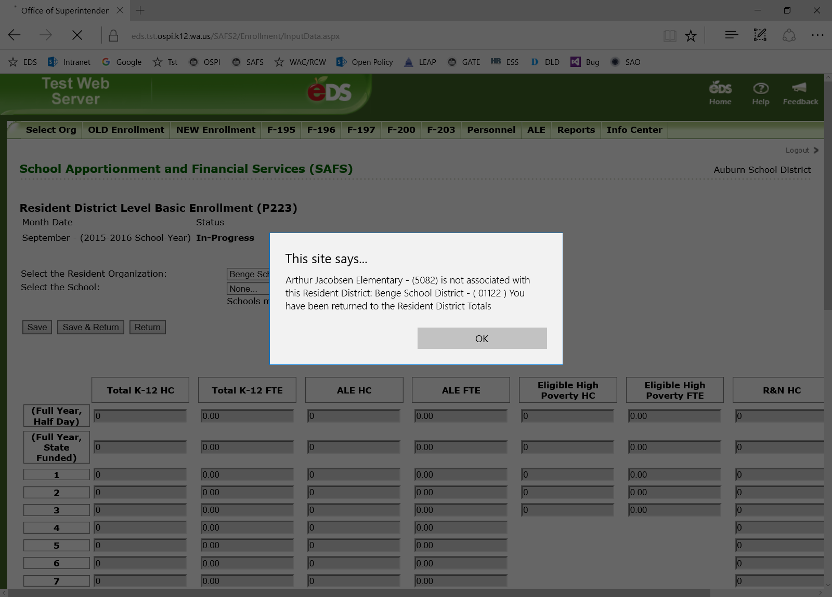

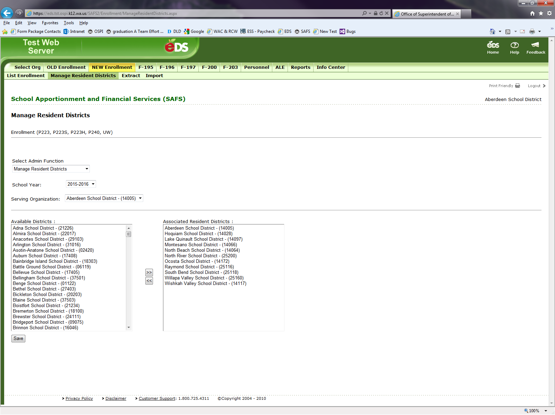Adding a New Resident District Relationship

There are two steps to add a new Resident District relationship.

**First step**, add a “Resident District.”

1. Access “Manage Resident Districts” tab.

2. In the drop-down menu, select “Manage Resident Districts.”

3. Find the new Resident District in the “Available Districts” box.

4. Click on the “>>” button.

5. Hit “Save.”

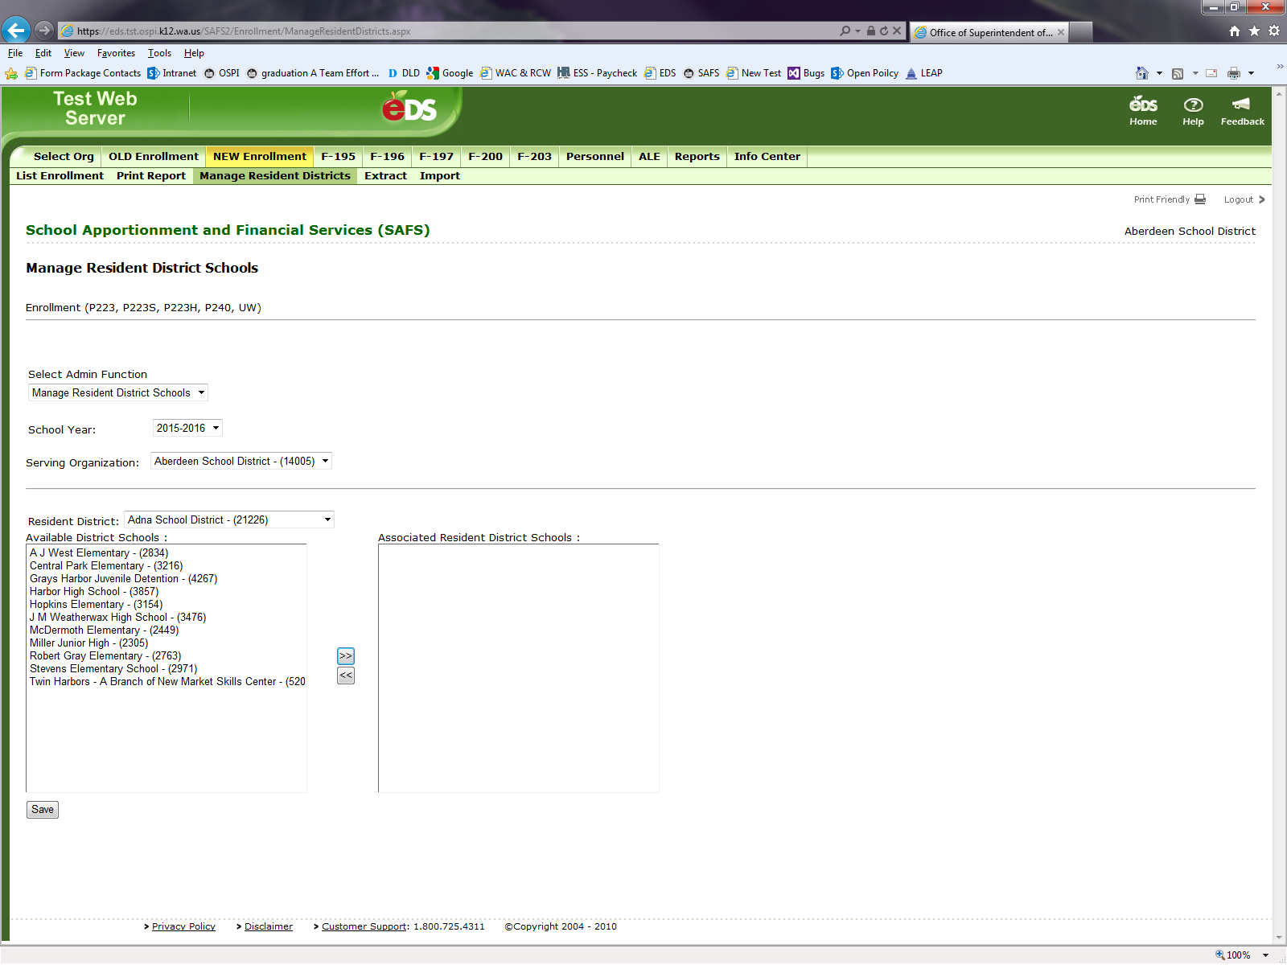

**Second step**, create a relationship with a school.

1. In the drop-down menu, select “Manage Resident District Schools.”
2. Find the new Resident District in the “Resident District” drop-down menu.
3. In the “Available District Schools” box, select the district school for the new Resident District.
4. Click on the “>>” button.
5. Hit “Save.”

To ensure that the enrollment data collected remains manageable, districts should review their existing Resident District relationships and remove any unnecessary relationships.

Removing a Resident District Relationship for a Specific School

To remove a specific school’s relationship with a Resident District:

1. In the drop-down menu, select “Manage Resident District Schools.”
2. Find the Resident District in the “Resident District” drop-down menu.
3. In the “Associated Resident District Schools” box, select the district school to be removed for this Resident District.
4. Click on the “<<” button.
5. Hit save.

Removing a Resident District

To remove a Resident District, follow these steps while referencing the previous page screen view:

1. Access “Manage Resident Districts” tab.
2. In the drop-down menu, select “Manage Resident Districts.”
3. Find the new Resident District in the “Associated Resident Districts” box.
4. Click on the “<<” button.
5. Hit save.
6. **Inputting Enrollment Data**

Reporting entities have three methods to report their enrollment data.

1. Manual Input.
2. Upload a TXT File Through the EDS WEB Tool.
3. Upload Through an FTP Process.

Method #1 – Manual Input

P223 and P223H files can be manually created once for each month. The P240 file can be create one time for the school year but at any time during the school year. The P223S file can only be created during the months of July and August.

To create a file, at the “List Enrollment” tab, click on the button for the file you wish to create.

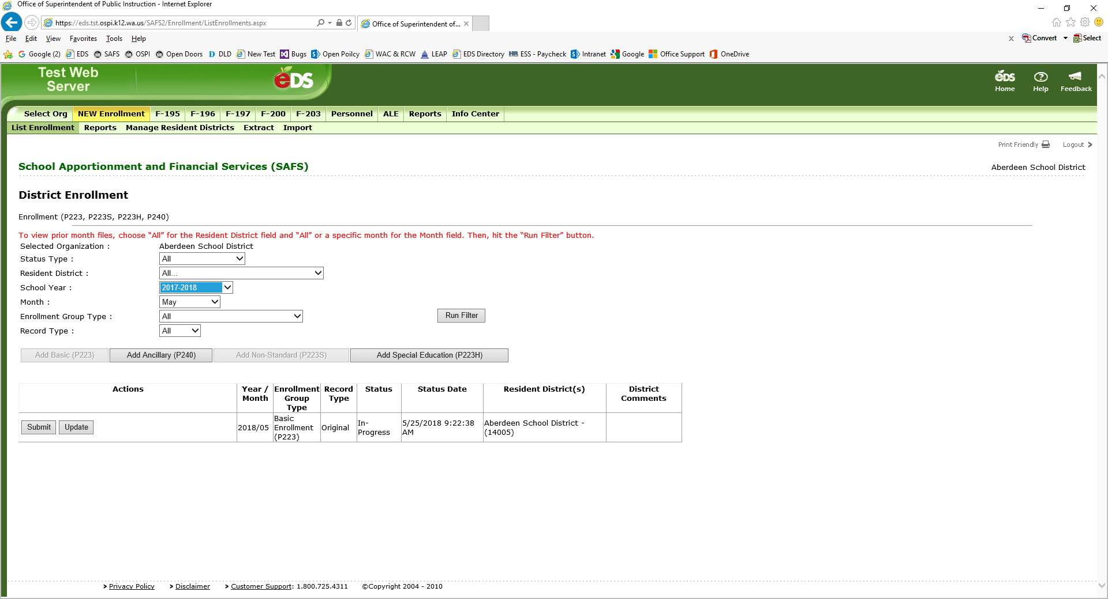

For the P223, P223H, and P223S files, when the file is created, you are taken to the “District Summary” screen where all fields are grayed out and not available to input numbers.

When a P240 file is created, you are taken to a screen where all the fields are open for inputting. Note that ancillary services reported on the P240 are not reported at the school level.

To access a school for inputting enrollment numbers, select a school from the “Select the School” drop down menu and hit the “Get District/School” button. To report enrollment for a different Resident District, select the Resident District from the “Select the Resident Organization” drop down menu and hit the “Get District/School” button.

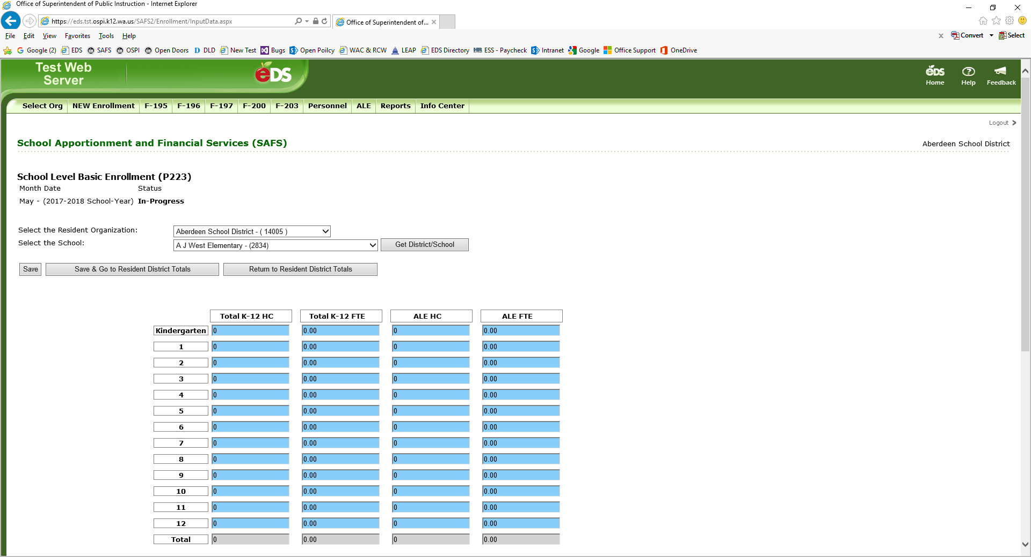

Once at the school level screen, all fields are available for inputting. Numbers can be placed in any field and the file will save. However, when submitting the file, you must run the validations on this file. Validations will check to see if the enrollment reporting rules are met. If they are not, then you will need to go back to the file and correct. For more information on Validations, refer to the NEW Enrollment Applicaton Section J of this User Guide.

Once the data is inputted for that school, the school screen must be saved. There are two options to save a file. The “Save” button ① allows you to save the school’s data and select another school or Resident District. The “Save & Go to Resident District Totals” button ② takes you to the “District Summary” page. Hitting the “Return to Resident District Totals” button ③ will not save the school’s data and takes you to the “District Summary” page.

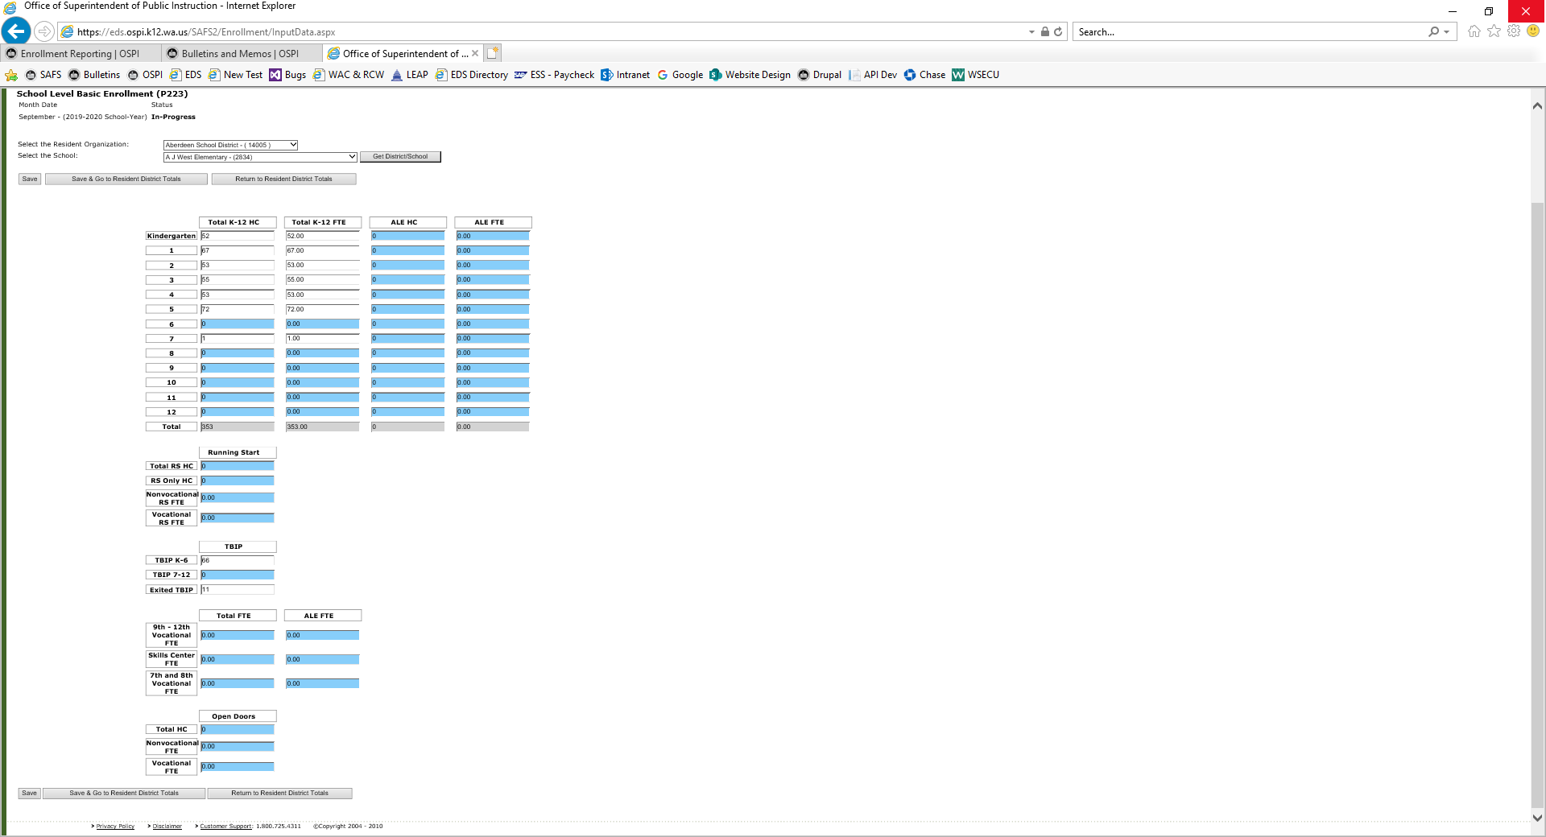

① ② ③

Once back to the “District Summary” page, this page must be saved. The “Save” button ① allows you to save the page and select another school or Resident District. The “Save & Return” button ② saves your data and takes you to the “List Enrollment” page. The “Return” button ③ will not save the file’s data and takes you to the “List Enrollment” page.

Partial view of a “District Summary” page.

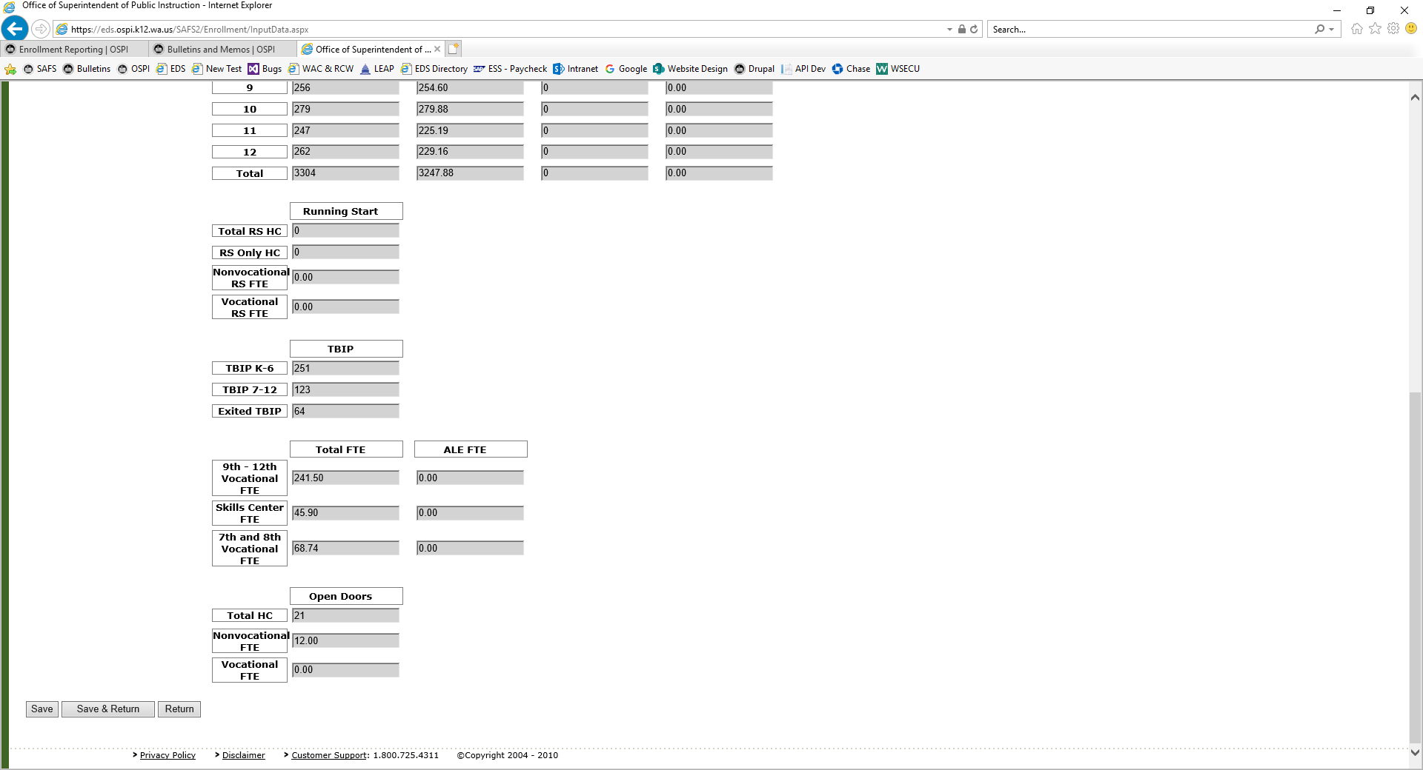

① ② ③

Method #2 – Upload a TXT File

The NEW Enrollment application allows a TXT file of the enrollment numbers to be uploaded – using the “Import” function. To successfully upload a TXT file, the file’s name must meet the Filename Format requirements and the layout of the TXT file must meet the Record Layout formatting. Below provides the steps to use the “Import” function. Refer to this User Guide’s NEW Enrollment Application Section M – TXT File Requirements for the FileName Format and the Record Layout requirements.

Note the “Import” function allows for previously submitted files to be over-written. For example, if an original September P223 has already been created, a revised September P223 TXT file can be uploaded that will overwrite the previous P223’s fields. Only the fields in the TXT file will overwrite the previous fields’ numbers. For example, a new TXT file revises the Exited TBIP fields only. By uploading the new TXT file, only the Exited TBIP fields will be over-written.

To upload a TXT File:

1. Create an “In Progress” file before uploading a TXT file.
2. To upload data for the first time, select the “Add P223,” “Add P223H,” or “Add P223S” button on the “List Enrollment” screen.
3. To revise a previously created file, select the “Revise” button next to the “Accepted by OSPI” file.
4. 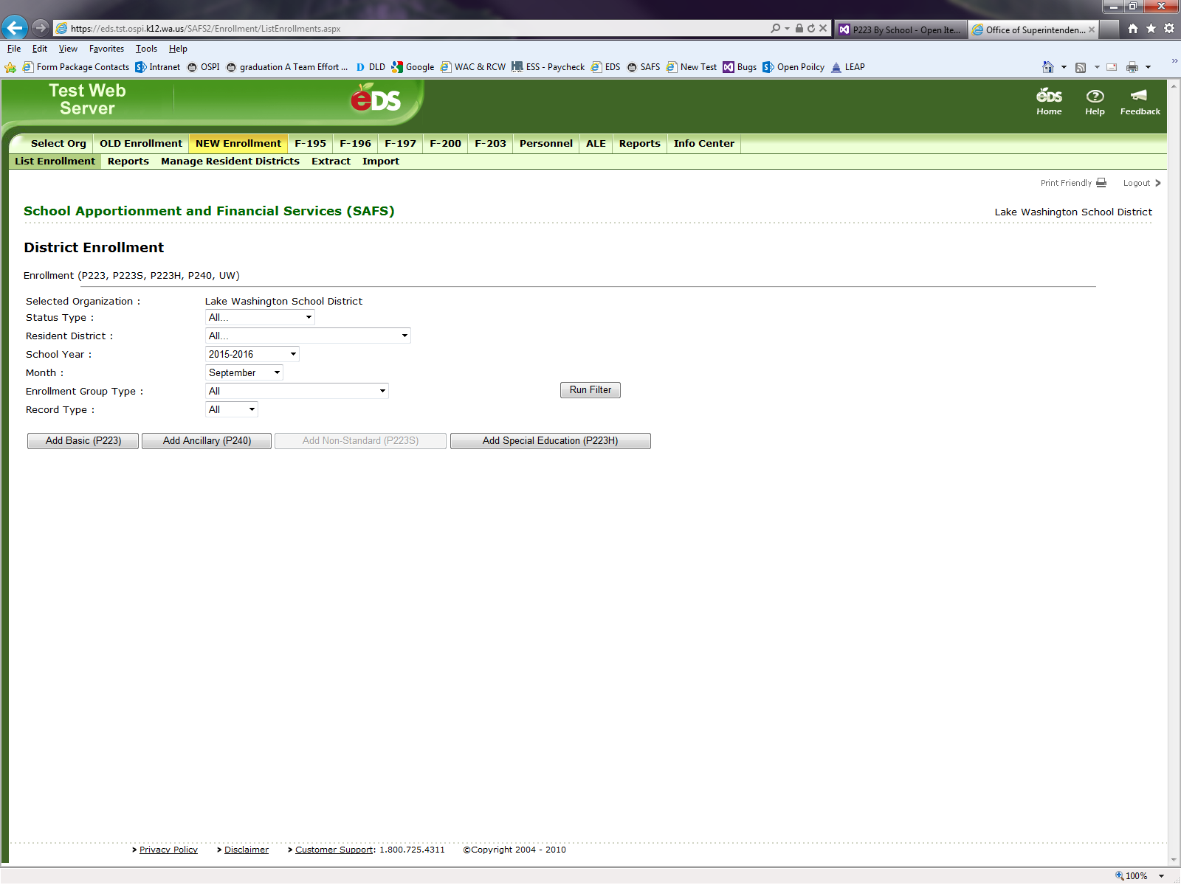Select “Import” on the second light green bar.
5. 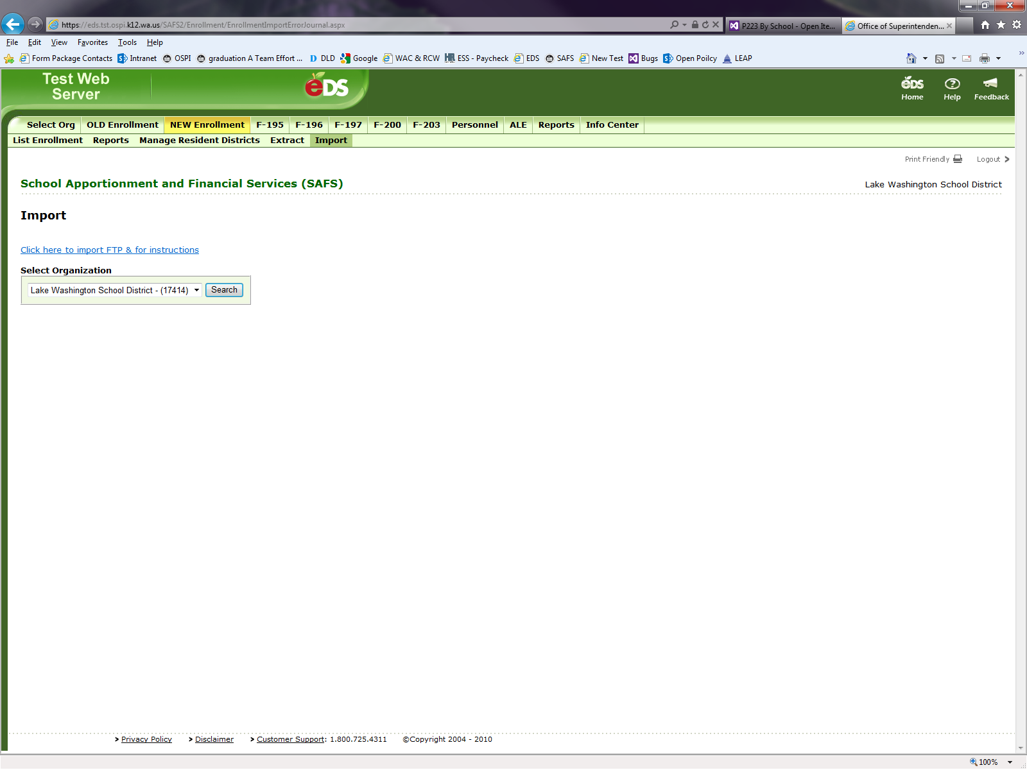Select “Click here to import FTP & for Instructions.”
6. Click on the “Browse” button and find the saved TXT file on your computer.
7. 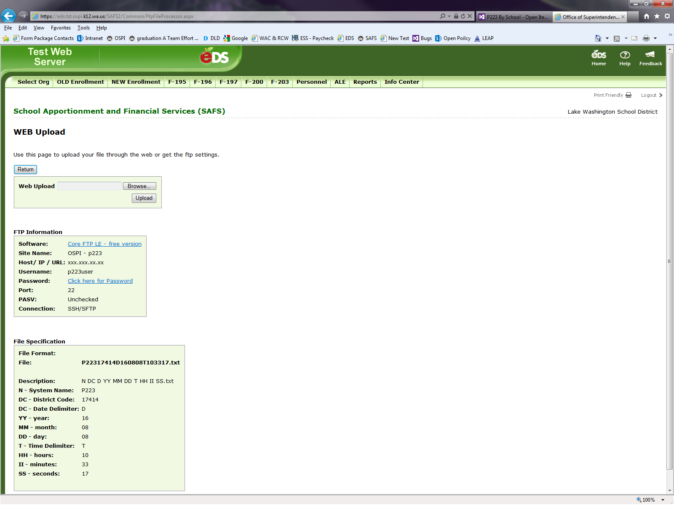Click on the “Open” button once the file is found. 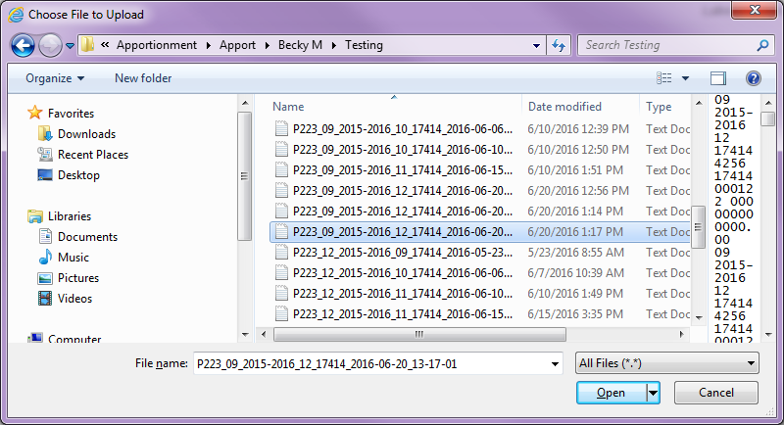
8. 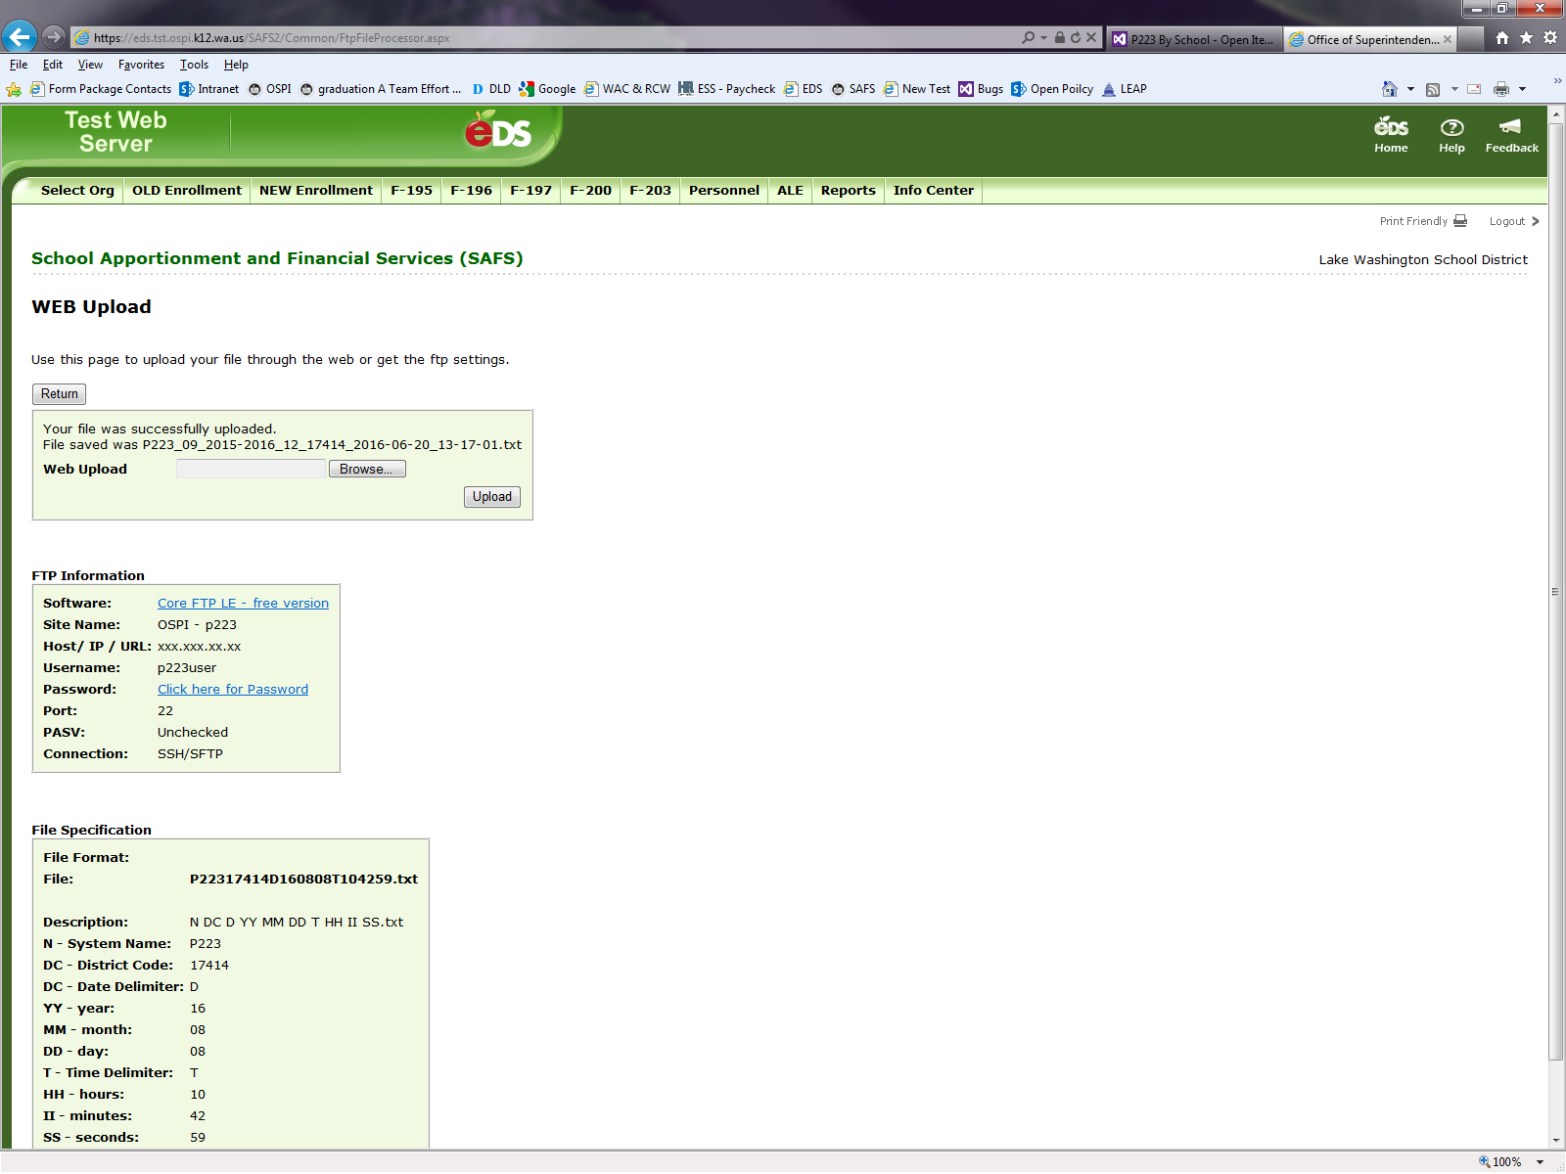Click on the “Upload” button and then “Return.”

The message displayed in the above picture (“Your file was successfully uploaded”) provides the status of the Upload process. However, the file may not have imported correctly. Refer to the guidance provided later in this section on how to view your “Import History” log to verify that the import process was successful.

Method #3 – Upload Through an FTP Process

The FTP process is a specifically designed option to submit a file from your student information system. To establish access to the NEW Enrollment FTP process and questions, contact OSPI Customer Support at [customersupport@k12.wa.us](mailto:customersupport@k12.wa.us).

**IMPORTANT** – For Method #2 and #3, data should upload within a few hours. If you do not see your data uploaded within four hours, contact Becky McLean at [becky.mclean@k12.wa.us](mailto:becky.mclean@k12.wa.us) or 360-725-6306 and she can help see what may be delaying your files from uploading.

Viewing the “Import History” Log

For Method #2 and Method #3, you can view the “Import History” log to check to see if the import was a success or if there were issues. If an uploaded file does not appear in the “Import History” log, OSPI has not received the file. Contact your student information system (i.e.; Skyward) or contact Becky McLean at [becky.mclean@k12.wa.us](mailto:becky.mclean@k12.wa.us) or 360-725-6306.

To view your “Import History” log:

1. Select “Import” on the second light green bar.
2. Select your district from the “Select Organization” drop down menu.
3. Hit the “Search” button.
4. A list of the most recently uploaded files will appear.

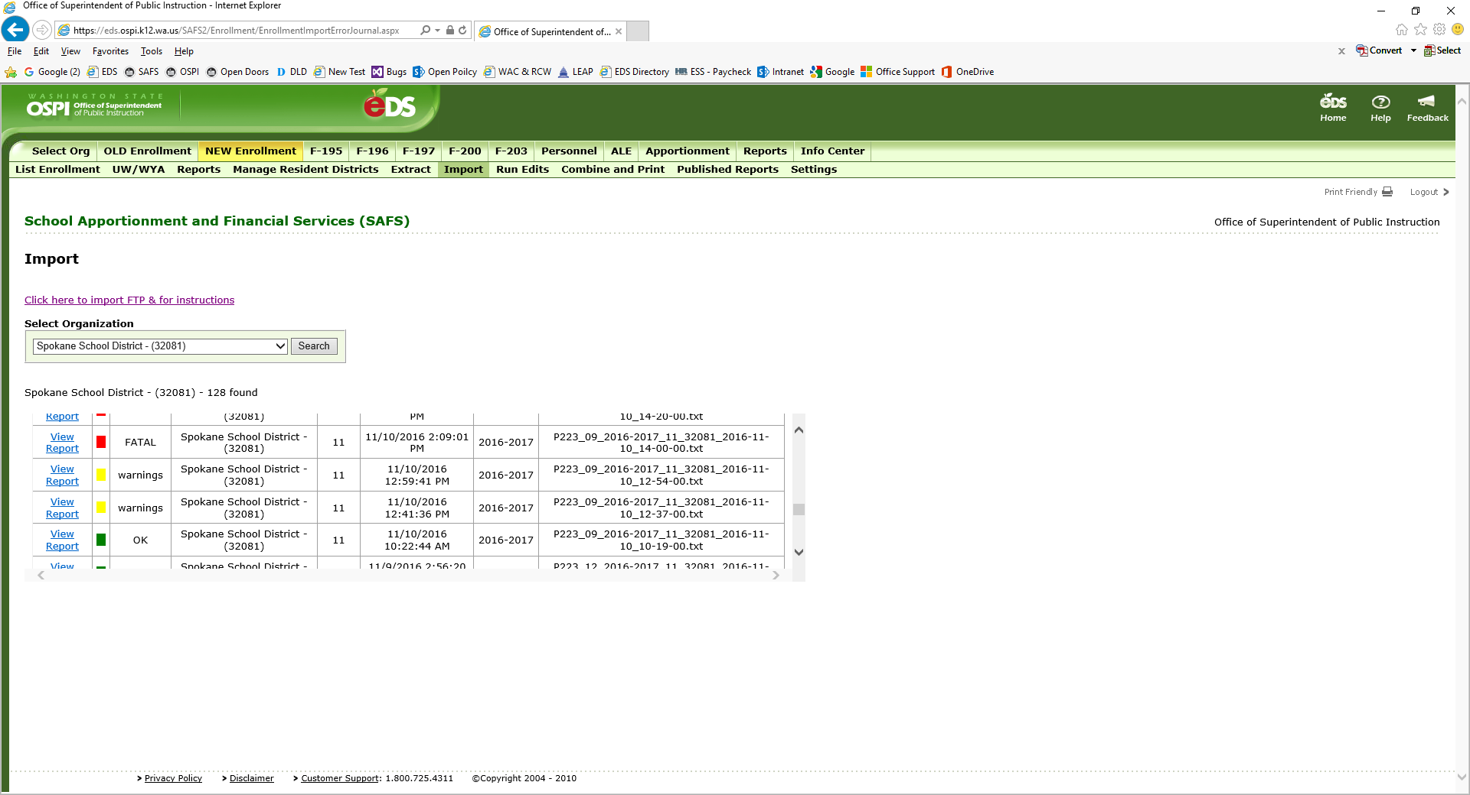

The most recently uploaded files will appear. Scrolling down will allow you to see earlier files.

* If the “*” column is Green and the “Warnings” column states “OK,” your file and all data quality checks have passed and data was added to the file.
* If the “*” column is Yellow and the “Warnings” column states “warnings,” one or more records failed the data quality checks but not in a way that prevented the processor from continuing. One reason the records may fail is due to duplicate records.
* If the “*” column is Red and the “Warnings” column states “FATAL,” an error has occurred in the uploading process. A new file may have been created depending on where the error occurred. However, the data may not appear in the file. Typically, an error occurs due to bad file formatting.

Click on “View Report” to see the issues with the file when receiving a “warnings” or “error” message.

1. **Revising Enrollment Files**

Enrollment files can be revised at any time during the current school year except when OSPI is processing the monthly enrollment. Revisions can be made manually using Method #1 or by uploading a new TXT file using Method #2 described in the NEW Enrollment Application Section H of this User Guide.

Revise a file manually, depending on the file status, either by hitting the “Revise” button (for files that are in “Accepted by OSPI” status) or by hitting the “Update” button (for files that are in “In Progress” status). For files in “Submitted by District” or “Submitted by ESD” status, contact your ESD to have an “In Progress” file returned to you.

Follow the instructions described as Method #1 in NEW Enrollment Application Section H of this User Guide, to navigate the enrollment file and to make the necessary corrections.

When using Method #2, the file that is being revised must be in “In Progress” status prior to uploading the TXT file.

1. **Submitting Files and Checking Enrollment Data Accuracy by Running Validations and Edits**

To ensure accuracy of the enrollment data reported, OSPI has built in Validations and Edits processes within the NEW Enrollment application. These processes occur when submitting a file.

About Validations

Numbers can be inputted in any field of the forms. Validations makes sure that the current month’s enrollment numbers pass the enrollment reporting rules. All Validations must be cleared before a file can be submitted. Validations occur for the P223 and P223S only. There are no Validations for the P223H or P240.

Below provides a list of Validations that are run for the P223. Note that some validations are run for each school and others check the total district’s numbers. Similar validations apply for the P223S.

Validations Run for Each School

* For each grade, Alternative Learning Experience (ALE) FTE cannot exceed the Total K–12 FTE.
* Running Start (RS) Only HC cannot exceed Total RS HC.
* RS enrollment cannot be reported for September.
* Nonvocational RS FTE plus Vocational RS FTE cannot exceed Total RS HC.
* 9th–12th Vocational ALE FTE cannot exceed 9th–12th Vocational FTE.
* 9th–12th Vocational ALE FTE plus Skill Center ALE FTE cannot exceed ALE FTE for 9th–12th grade.
* 9th–12th Vocational FTE plus Skill Center FTE cannot exceed the total of 9th–12th grade Total K–12 FTE.
* 9th–12th Vocational ALE FTE plus Skill Center ALE FTE cannot exceed the total of 9th–12th grade ALE FTE.
* Skill Center ALE FTE cannot exceed Skill Center FTE.
* 7th and 8th Vocational FTE cannot exceed 7th and 8th grade Total K–12 FTE.
* 7th and 8th Vocational ALE FTE cannot exceed ALE FTE for 7th and 8th grade FTE.
* 7th and 8th Vocational ALE FTE cannot exceed 7th and 8th grade Vocational FTE.
* Non High districts cannot report 9th–12th grade enrollment.

Validations Run on the District Total Numbers

* For each grade, Total K–12 FTE cannot exceed the Total K–12 HC.
* For each grade, ALE FTE cannot exceed the Total ALE HC.
* For each grade, ALE HC cannot exceed Total K–12 HC.
* Open Doors Nonvocational FTE plus Open Doors (OD) Vocational FTE cannot exceed Total Open Doors HC.
* Total RS HC cannot exceed the total of 11th and 12th grade Total K–12 HC.
* Skill Center enrollment cannot be reported by a non-Skill Center district.
* Open Doors enrollment cannot be reported for a non-Open Doors district.
* The total of TBIP K–6 HC, TBIP 7–9, and Exited TBIP HC cannot exceed Total K–12 HC.

About Edits

Edits compare the current file against the prior month’s “Accepted by OSPI” file and warns when the data has significantly changed. Edits are run on the P223 and P223H for the months of October through June. No Edits occur for the September P223 and P223H, the July and August P223, the P240, and P223S. Edits compare district total enrollment and do not compare enrollment by school.

The following tests occurs when Edits are run:

* + **First Test** checks the number difference between months. If the difference is more than 5 for the P223 and 3 for the P223H, then proceed to Second Test. If not, no Edit occurs.
  + **Second Test** checks to see if the number difference is more than 10%. If so, an Edit occurs. If not, no Edit occurs.

When an Edit occurs, the enrollment data must be checked and either corrected or a comment submitted detailing why the data is correct.

Submitting Files and Running Validations and Edits

Click on the “Submit” button next to the file. You are taken to the “Run Validations/RunEdits” screen. For P223 and P223S, running Validations is required.

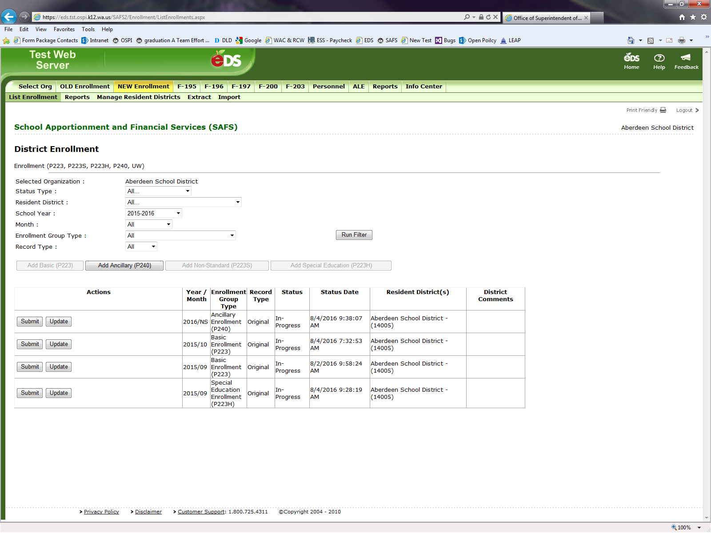

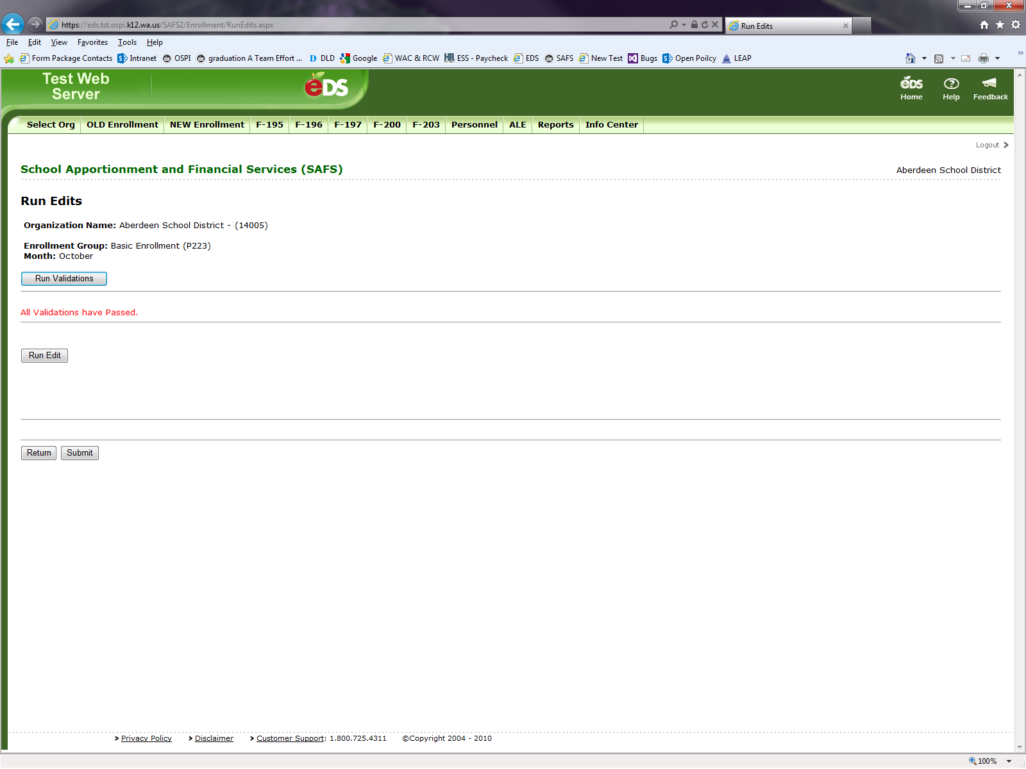Click on the “Run Validations” button. If the file passes the validation test, the message “All Validations have Passed” will appear.

If Validation errors do occur, a message stating “There are Validation Errors that need to be resolved before submitting” will appear. Remember all Validations must be cleared to proceed to running Edits and to submit a file.

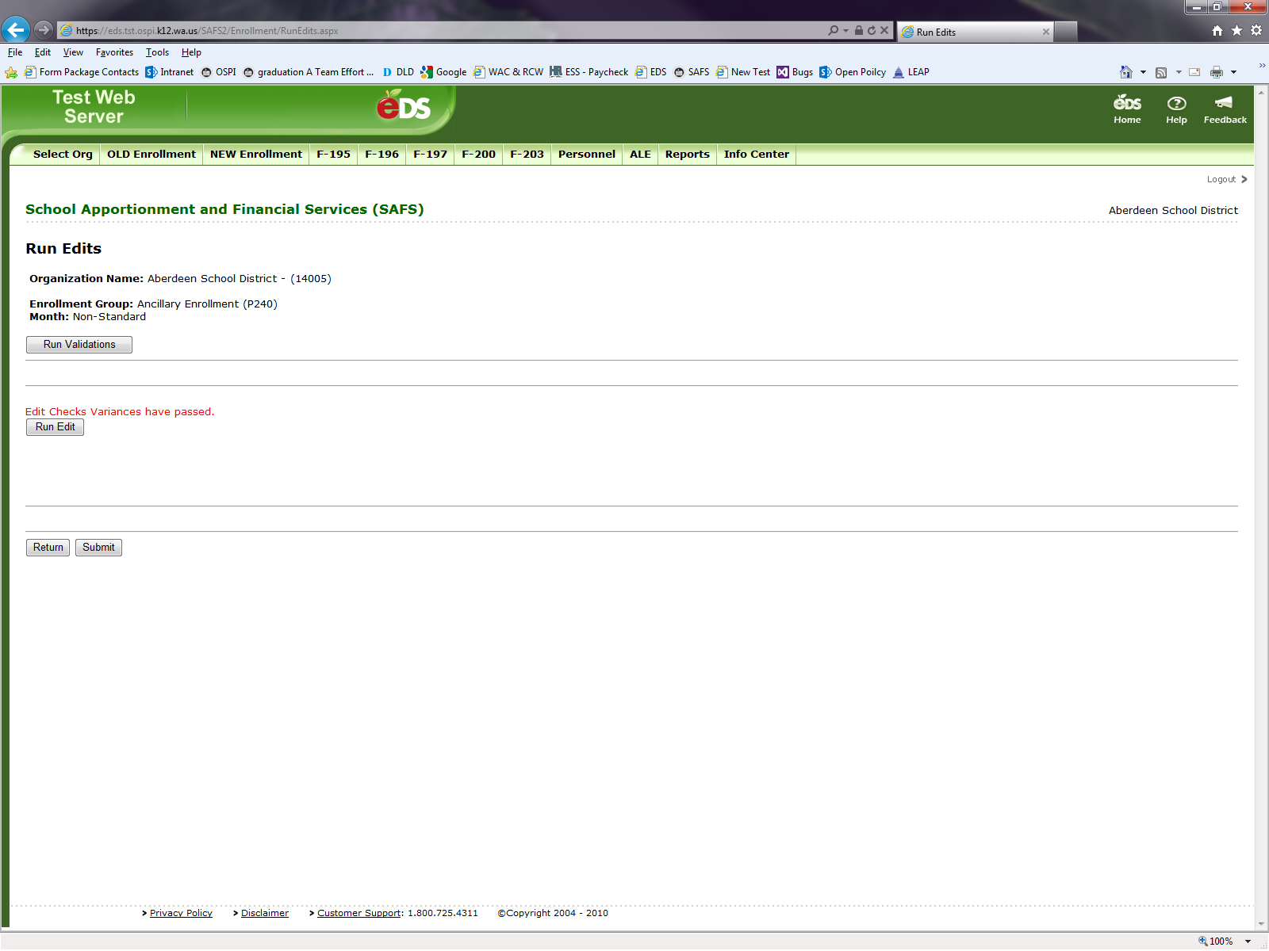The “Validation Message” box will provide a list of errors that require correcting. This list is printable by hitting the “Download Spreadsheet” button. An Excel spreadsheet will be created.

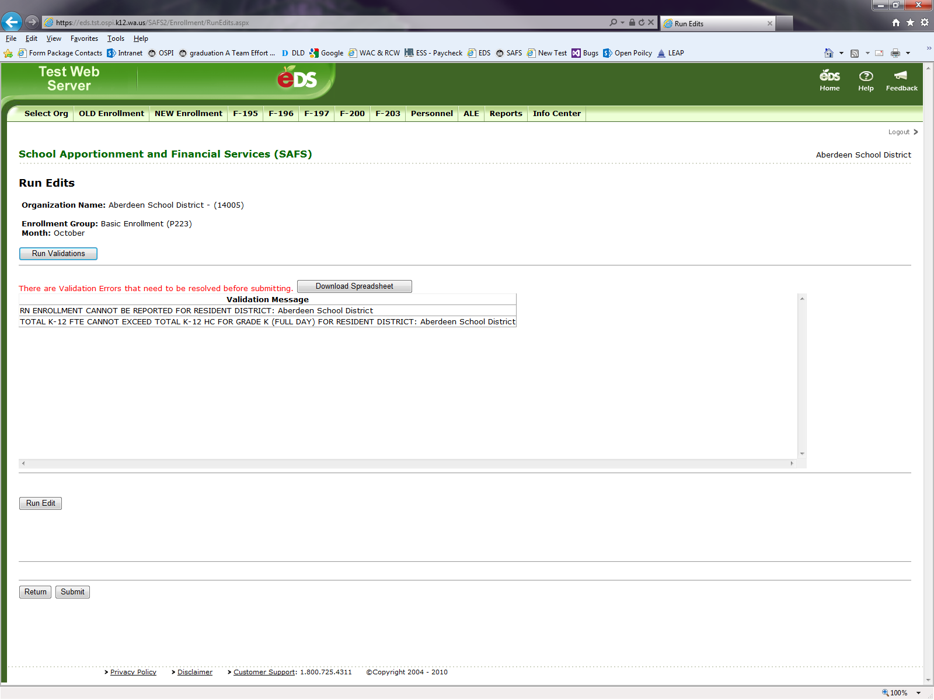

Hit the “Return” button found at the bottom of the screen to go back to the “List Enrollment” screen. Hit the “Update” button next to the file to make the necessary corrections to the file.

For October through June P223s and P223Hs, click on the “Run Edit” button for these files.



If there are no Edits, a message stating “Edit Checks Variances have passed” will appear.

If Edits do occur, the following screen will appear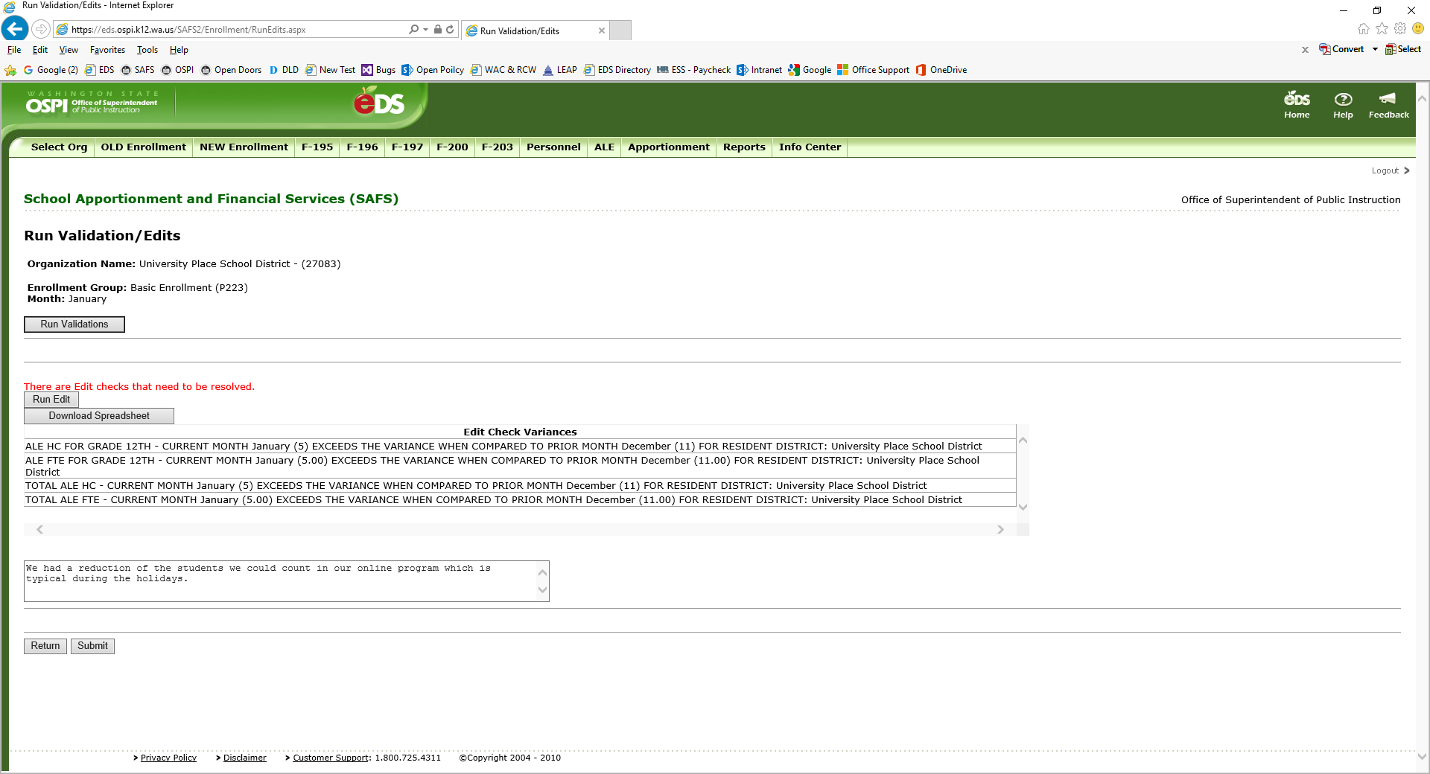.

The “Edit Check Variances” box will provide a list of Edits – areas where your enrollment numbers are significantly different than the previous month’s “Accepted by OSPI” file. The Edit process gives you a chance to verify that your numbers are correct. This list of Edits can be downloaded to an Excel spreadsheet. Click on the “Download Spreadsheet” button.

If the Edits are correct, an explanation for why the variance between months is correct must be provided in the comment box. The comment may be limited to 255 characters.

As part of the monthly enrollment process, OSPI reviews all Edits received statewide. Edits whose comments do not provide a clear explanation will be questioned and you will be asked by your ESD to provide a better explanation.

Below are examples of Great Comments, Okay Comments, and Bad Comments. Great Comments clearly state why the Edit is correct. Okay Comments may require OSPI to ask for more information. Bad Comments will require you to provide us a better explanation.

| **Great Comments** | **Okay Comments** | **Bad Comments** |
| --- | --- | --- |
| 9–12 Voc FTE count is higher this month due to a new approved art class. | New students. | No errors. |
| New quarter started for Running Start students. | Correct number of students reported. | Submit button will not populate for me until I submit a comment. |
| Increase of student enrolled in 10th and 11th grade. | Data is correct. | I clicked on the wrong button :( |

Once all Validations are passed and Edits are verified and explained, the file can be submitted by hitting the “Submit” button at the bottom of the page.

1. **Enrollment Reports**

Enrollment reports can be run in the NEW Enrollment application. However, the reports summarize the entities total enrollment and does not provide school level detail. Running an extract provides the school level detail. See Section L.

The following reports can be run by reporting entities:

* 1251 summarizes the reported P223 FTE.
* 1251H summarizes the reported P223 Headcount.
* 1735T summarizes the reported P223H Headcount
* 1251SR details the reported P223 FTE by resident district
* 1251HSR details the reported P223 Headcount by resident district
* 1735SR details the reported P223H Headcount by resident district
* 1251RS details the resident district FTE reported by serving districts.
* 1735RS details the resident district P223H Headcount reported by serving districts.

To run a report, select Report on the lower green bar. Do not select Report on the top green bar.

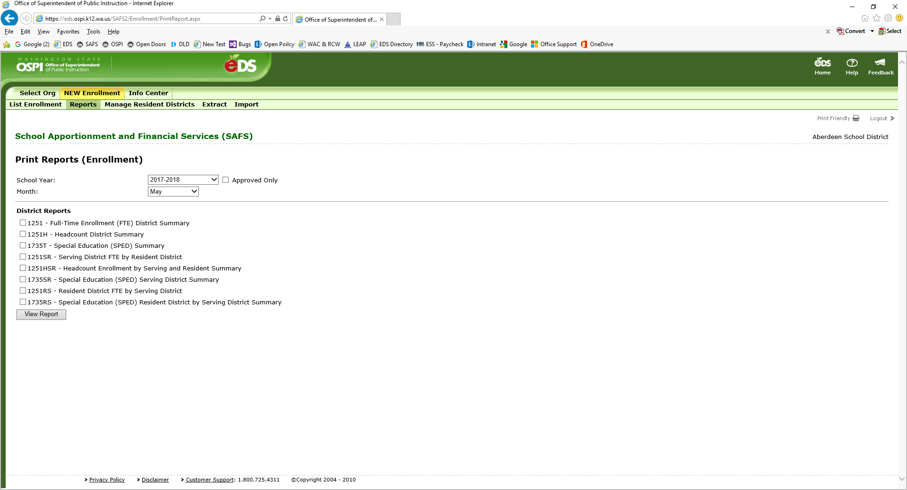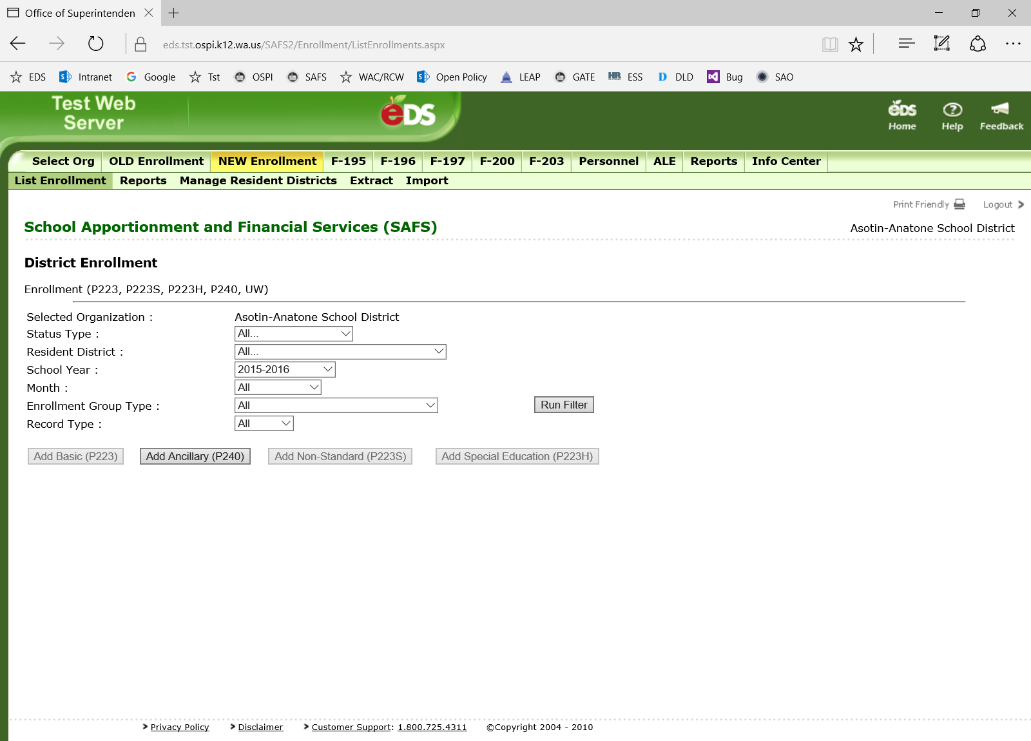

You will be taken to the following screen:

* Select a school year.
* Click the “Approved Only” box to see enrollment reported on “Accepted by OSPI” files only. Leaving this box unclicked will show first enrollment reported on files that are not “Accepted by OSPI” status.
* Select a month. The displayed month will default to the current month. By selecting an earlier month, only enrollment reported to that month will display and the average shown will be the average as of that month.
* Select the District Reports to be run.
* Hit the “View Report” button.
* After the report is run, the following will appear.
* Select “PDF” from “Select a format” drop down menu.
* Hit the “Export” button.
* 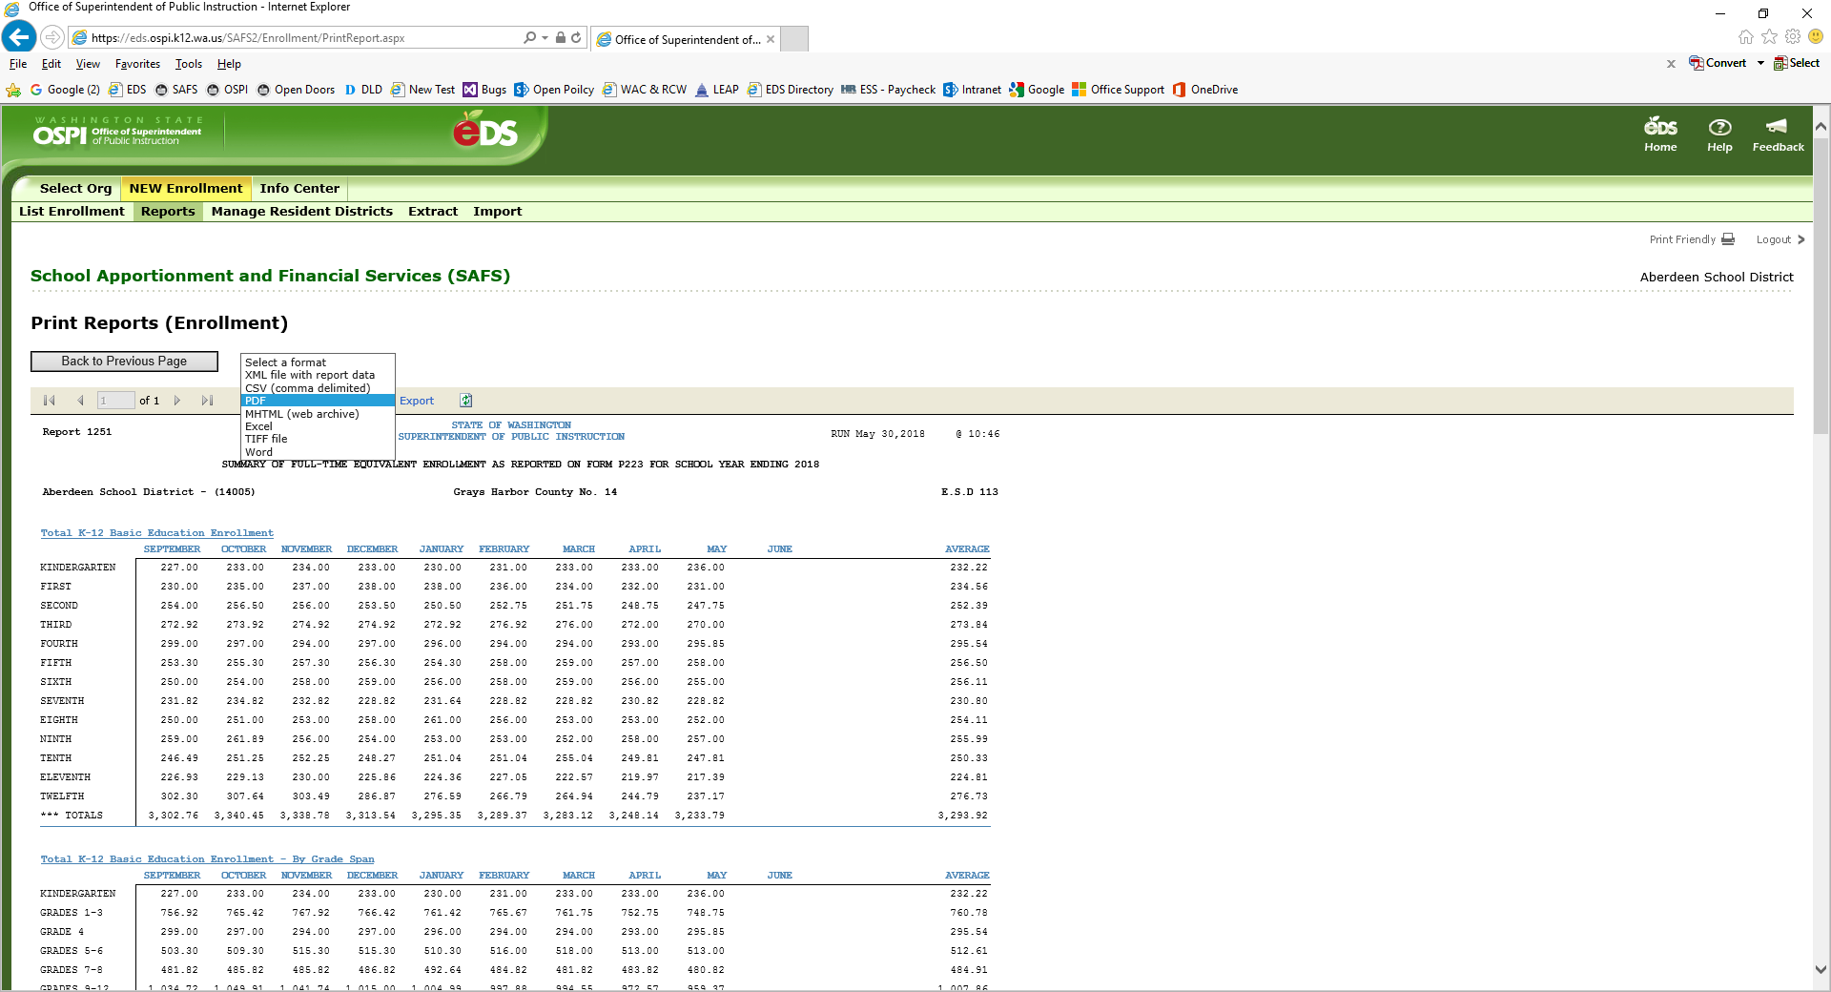Report will become a PDF file.

1. **Running Extracts**

Extracts can be run to view the school level data. To run an extract, select “Extract” from the second top green bar.

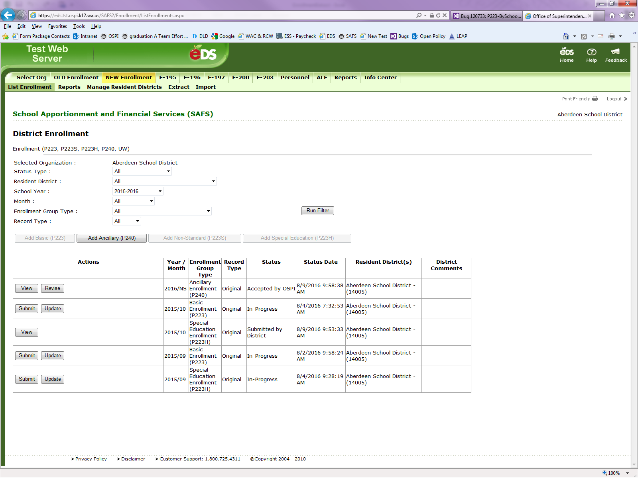

The following options are available for running an extract:

1. Select the school year for the extract.
2. Select the most recent month for the extract.
3. Select the “Only Approved by OSPI” button if the extract should contain the most recently “Accepted by OSPI” data. By not selecting this button, the extract will pull from the most recent non-“Accepted by OSPI” data.
4. Select the “Include Cumulative Months” button if the extract should be a pull of the yearly enrollment data reported as of the month selected in Item #2. By not selecting this button, the extract will pull only the data for the month indicated in Item #2.
5. Select the “School Level” button if the extract should pull school level data. By not selecting this button, the extract will pull data at the district level.
6. Select the “Include Non-Standard” button to include P223S enrollment.
7. Click on “Download Spreadsheet” to create the Extract.

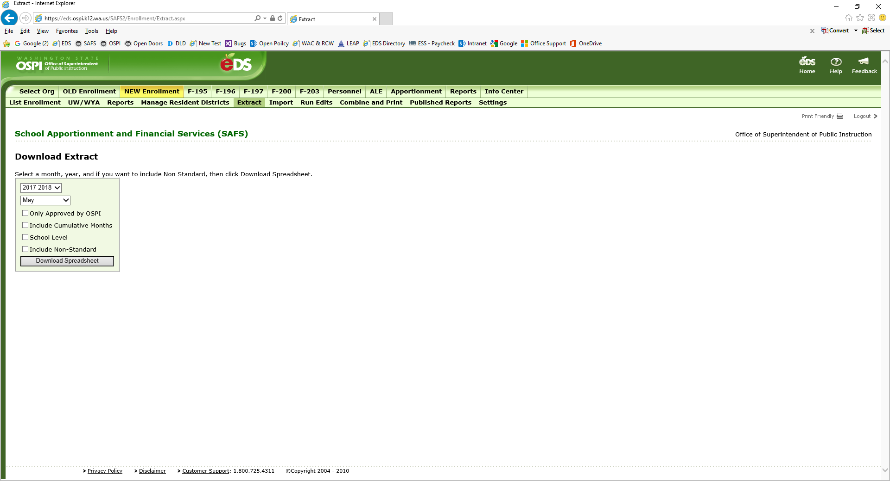

①

②

③

④

⑤

⑥

⑦

The extracts will result in an Excel file with four different worksheets.

1. The worksheet labeled “Grades” contains the following data:
   * K–12 HC – column labeled “IND”
   * K–12 FTE – column labeled “FTE”
   * ALE HC – column labeled “ALE-IND”
   * ALE FTE – column labeled “ALE-FTE”
2. The worksheet labeled “Month” contains the following data:
   * Running Start (RS) HC – column labeled “RUN-IND”
   * RS Only HC – column labeled “RUN-RSO”
   * RS Nonvocational FTE – column labeled “RN-NV-FTE”
   * RS Vocational FTE – column labeled “RS-VOC-FTE”
   * TBIP HC – column labeled “BIL” – *no longer a valid field. Only zeros will appear.*
   * TBIP K–6 HC – column labeled “BIL K–6”
   * TBIP 7–12 – column labeled “BIL 7–12”
   * Exited TBIP HC – column labeled “BIL-EXITED”
   * Open Doors (OD) HC – column labeled “OD-IND”
   * OD Nonvocational FTE – column labeled “OD-NV-FTE”
   * OD Vocational FTE – column labeled “OD-VOC-FTE”
   * 9th–12th Vocational FTE – column labeled “T-VOC-FTE”
   * 9th–12th ALE Vocational FTE – column labeled “T-Voc ALE”
   * 7th & 8th Vocational FTE – column labeled “7-8-VOC-FTE”
   * 7th & 8th ALE Vocational FTE – column labeled “7-8 Voc ALE”
   * Skill Center FTE – column labeled “SKILLS”
   * Skill Center ALE FTE – column labeled “Skills ALE”
   * Special Education Age 3 to 5 – column labeled “AGE-3-5”
   * Special Education Tier 1 K-21 – column labeled “Tier 1 K-21”
   * Special Education Other Tier K-21 – column labeled “Other Tier K-21”
3. The worksheet labeled “Ancillary” contains the following reported on the P240:
   * Ancillary Hours by Grade Group – column labeled “HOURS”
   * Ancillary AAFTE – column labeled “AA-FTE”
4. The worksheet labeled “NS_Summer” contains the data from the P223S:
   * Half Day K HC – column labeled “HalfDayKindHC” *– no longer a valid field. Only zeros will appear.*
   * Half Day K AAFTE – column labeled “HalfDayKindAAFTE” *– no longer a valid field. Only zeros will appear.*
   * Half Day K ALE HC – column labeled “HalfDayALEHC” *– no longer a valid field. Only zeros will appear.*
   * Half Day K ALE AAFTE – column labeled “HalfDayALEAAFTE” *– no longer a valid field. Only zeros will appear.*
   * Kindergarten HC – column labeled “FullDayKindHC”
   * Kindergarten AAFTE – column labeled “FullDayKindAAFTE”
   * Kindergarten ALE HC – column labeled “FullDayALEHC”
   * Kindergarten ALE AAFTE – column labeled “FullDayALEAAFTE”
   * 1st–3rd HC – column labeled “1to3HC”
   * 1st–3rd AAFTE – column labeled “1to3AAFTE”
   * 1st–3rd ALE HC – column labeled “1to3ALEHC”
   * 1st–3rd ALE AAFTE – column labeled “1to3ALEAAFTE”
   * 4th HC – column labeled “4HC”
   * 4th AAFTE – column labeled “4AAFTE”
   * 4th ALE HC – column labeled “4ALEHC”
   * 4th ALE AAFTE – column labeled “4ALEAAFTE”
   * 5th & 6th HC – column labeled “5to6HC”
   * 5th & 6th AAFTE – column labeled “5to6AAFTE”
   * 5th & 6th ALE HC – column labeled “5to6ALEHC”
   * 5th & 6th ALE AAFTE – column labeled “5to6ALEAAFTE”
   * 7th & 8th HC – column labeled “7to8HC”
   * 7th & 8th AAFTE – column labeled “7to8AAFTE”
   * 7th & 8th ALE HC – column labeled “7to8ALEHC”
   * 7th & 8th ALE AAFTE – column labeled “7to8ALEAAFTE”
   * 9th–12th HC – column labeled “9to12HC”
   * 9th–12th AAFTE – column labeled “9to12AAFTE”
   * 9th–12th ALE HC – column labeled “9to12ALEHC”
   * 9th–12th ALE AAFTE – column labeled “9to12ALEAAFTE”
   * 7th & 8th Vocational HC – column labeled “7to8VocHC”
   * 7th & 8th Vocational AAFTE – column labeled “7to8VocAAFTE”
   * 7th & 8th Vocational ALE HC – column labeled “7to8VocALEHC”
   * 7th & 8th Vocational ALE AAFTE – column labeled “7to8VocALEAAFTE”
   * 9th–12th Vocational HC – column labeled “9to12VocHC”
   * 9th–12th Vocational AAFTE – column labeled “9to12VocAAFTE”
   * 9th–12th Vocational ALE HC – column labeled “9to12VocALEHC”
   * 9th–12th Vocational ALE AAFTE – column labeled “9to12VocALEAAFTE”
   * Skill Center HC – column labeled “SkillHC”
   * Skill Center AAFTE – column labeled “SkillAAFTE”
   * Skill Center ALE HC – column labeled “SkillALEHC”
   * Skill Center ALE AAFTE – column labeled “SkillALEAAFTE”
5. **TXT File Requirements**

Enrollment data can be imported electronically by creating a TXT file of the enrollment from your Student Information System. The following information provides the Filename Format and the Record Layout Format requirements.

The NEW Enrollment application’s forms are a fixed width text file using UTF-8 encoding. One TXT file must be created for each monthly form (P223 and P223H) and each annual form (P240 and P223S).

Filename Format

This section outlines the Filename Format required for OSPI’s File Processor to efficiently import enrollment data. The Filename must be consistent and use the following formatting. The Filename Format contains 50 characters.

Note: In the Type column, “N” refers to numeric and “A” to alpha.

| Field Name | Beg. | Len. | Type | Tb | T0 | Lb | L0 | Req. | Exceptions or Constraints |
| --- | --- | --- | --- | --- | --- | --- | --- | --- | --- |
| System Identifier | 1 | 4 | A |  |  |  |  | ✓ | Must Be ‘P223‘ |
| Underscore Filler | 5 | 1 | A |  |  |  |  | ✓ | ‘_’ |
| Enrollment Type | 6 | 2 | N |  |  |  | ✓ | ✓ | 09 = ‘Basic Enrollment – P223’ 10 = ‘Ancillary Enrollment – P240’  11 = ‘Non-Standard Enrollment – P223S’  12 = ‘Special Education Enrollment – P223H’  13 = ‘U of W Enrollment – OSPI Only’ |
| Underscore Filler | 8 | 1 | A |  |  |  |  | ✓ | ‘_’ |
| SchoolYearCode | 9 | 9 | A |  |  |  |  | ✓ | YYYY-YYYY |
| Underscore Filler | 18 | 1 | A |  |  |  |  | ✓ | ‘_’ |
| Month | 19 | 2 | A |  |  |  | ✓ | ✓ | 01-13 EX: 09 – Sept, 12 – Dec, 01 – Jan, 13 – P223S or P240 |
| Underscore Filler | 21 | 1 | A |  |  |  |  | ✓ | ‘_’ |
| District Code | 22 | 5 | N |  |  |  | ✓ | ✓ | ‘CCDDD – County District Code’ |
| Underscore Filler | 27 | 1 | A |  |  |  |  | ✓ | ‘_’ |
| Date | 28 | 10 | A |  |  |  |  | ✓ | ‘YYYY-MM-DD’ |
| Underscore Filler | 38 | 1 | A |  |  |  |  | ✓ | ‘_’ |
| Time | 39 | 8 | A |  |  |  |  | ✓ | ‘HH-MM-SS |
| Period Filler | 47 | 1 | A |  |  |  |  | ✓ | Must be ‘.’ |
| File Extension | 48 | 3 | A |  |  |  |  | ✓ | Must be ‘txt’ |

Example(s):

P223_09_2020-2021_09_34901_2020-12-04_11-25-35.txt

P223_12_2020-2021_10_04251_2020-12-03_05-23-55.txt

P223_11_2020-2021_13_34901_2021-07-02_10-11-54.txt

Record Layout

This section outlines the format needed for each record type. This includes the necessary fields, the rules for the beginning points, length, and justification, and any exceptions or constraints that may apply. Each record layout requires 80 characters.

Note: In the Type column, “N” refers to numeric, “A” to alpha, and “F” to filler.

| Field Name | Beg. | Len. | Type | Tb | T0 | Lb | L0 | Req. | Exceptions or Constraints |
| --- | --- | --- | --- | --- | --- | --- | --- | --- | --- |
| RecordType | 1 | 2 | N |  |  |  |  | ✓ | 09 = ‘Basic Enrollment – P223’ 10 = ‘Ancillary Enrollment – P240’  11 = ‘Non-Standard Enrollment – P223S’  12 = ‘Special Education Enrollment – P223H’  13 = ‘U of W Enrollment – OSPI Only’ |
| Filler | 3 | 1 | F |  |  |  |  | ✓ | Must be one space ‘ ‘ |
| SchoolYearCode | 4 | 9 | A |  |  |  |  | ✓ | YYYY-YYYY |
| Filler | 13 | 1 | F |  |  |  |  | ✓ | Must be one space ‘ ‘ |
| Month | 14 | 2 | A |  |  |  | ✓ | ✓ | ‘01’-‘13’  EX: ‘09’ – Sept, ‘01’ – Jan, ‘13’ – P223S or P240 |
| Filler | 16 | 3 | F |  |  |  |  | ✓ | Must be spaces ‘ ‘ |
| DistrictCode | 19 | 5 | N |  |  | ✓ |  | ✓ | ‘CCDDD – County District Code’ |
| Filler | 24 | 5 | F |  |  |  |  | ✓ | Must be spaces ‘ ‘ |
| SchoolCode | 29 | 4 | N |  |  |  | ✓ | ✓ | EX: ‘0001’, ‘4001’  Use ‘0000’ for district level data3 |
| Filler | 33 | 3 | F |  |  |  |  | ✓ | Must be spaces ‘ ‘ |
| ResidentDistrictCode | 36 | 5 | N |  |  | ✓ |  | ✓ | ‘CCDDD – County District Code’ |
| Filler | 41 | 10 | F |  |  |  |  | ✓ | Must be spaces ‘ ‘ |
| FieldNumber | 51 | 6 | N |  |  |  | ✓ | ✓ | See below screenshots for field numbers. |
| Filler | 57 | 1 | F |  |  |  |  | ✓ | Must be one space ‘ ‘ |
| Amount | 58 | 12 | N |  |  |  | ✓ | ✓ | FTE, HeadCount, Hours (Whole Number) |
| DecimalPoint | 70 | 1 | F |  |  |  |  | ✓ | Must Be ‘.’ (Decimal Point) |
| DecimalAmount | 71 | 2 | N |  | ✓ |  |  | ✓ | For FTE only. |
| Filler | 73 | 8 | F |  |  |  |  | ✓ | Must be spaces ‘ ‘ |

Example(s):

‘09 2020-2021 05 05402 3737 05402 000096 000000000111.50 ‘

‘09 2020-2021 12 34111 1234 34111 000014 000000000001.00 ‘

‘11 2020-2021 13 14005 1775 14028 000174 000000000022.00 ‘

‘12 2020-2021 06 32081 3727 32081 000172 000000000004.00 ‘

Screen Shots With Field Numbers

This section provides screen shots of each form with the field numbers. Each number in the field boxes corresponds with the appropriate field number to use in a TXT file.

P223 fields that are reported on the school screen.

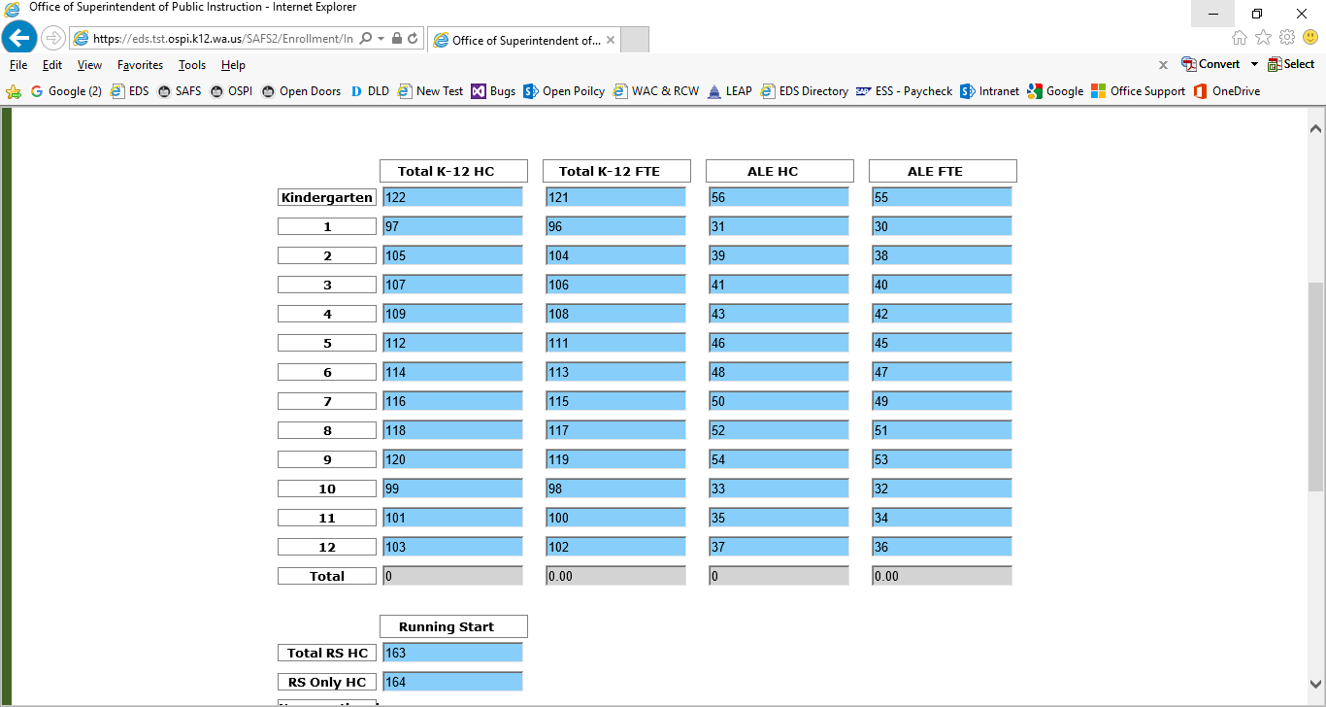

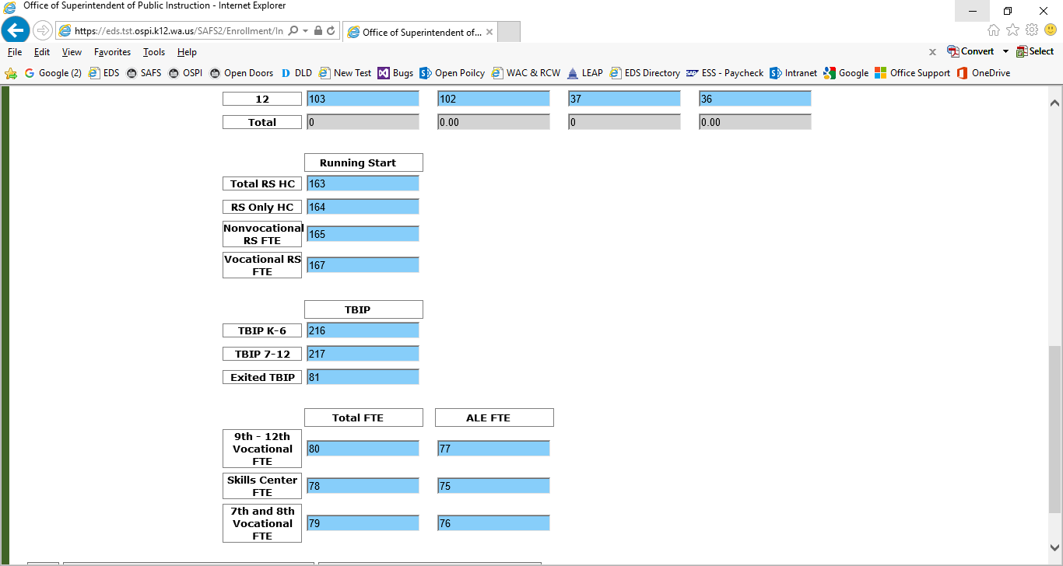

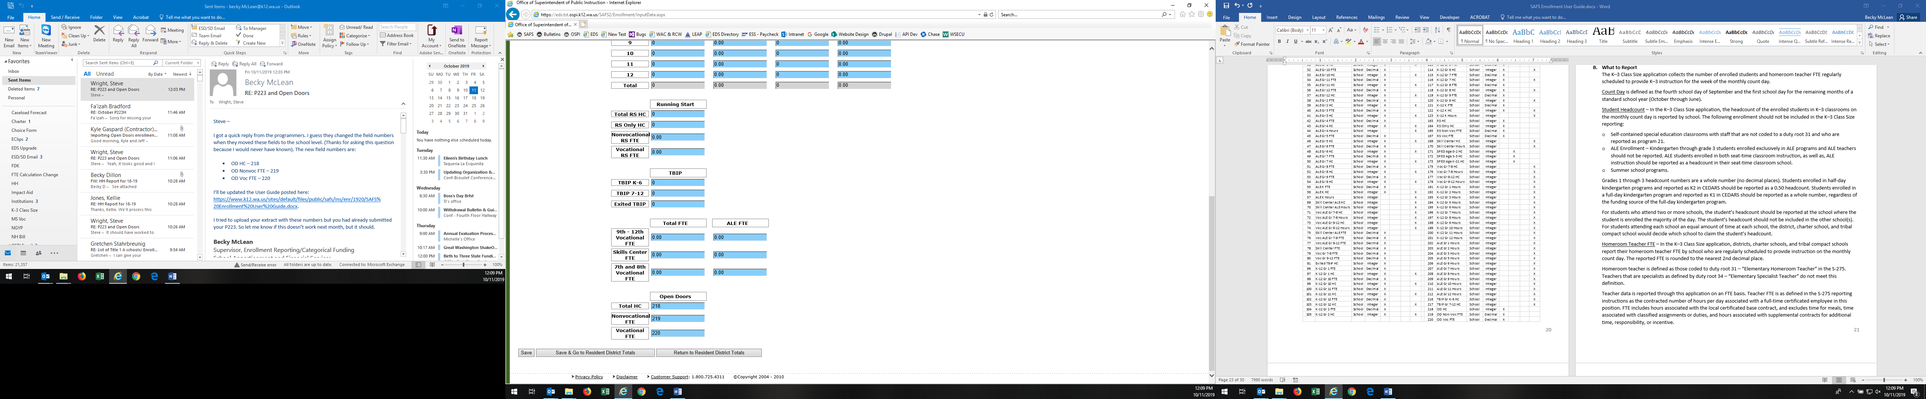

P223H fields that are reported on the school screen.

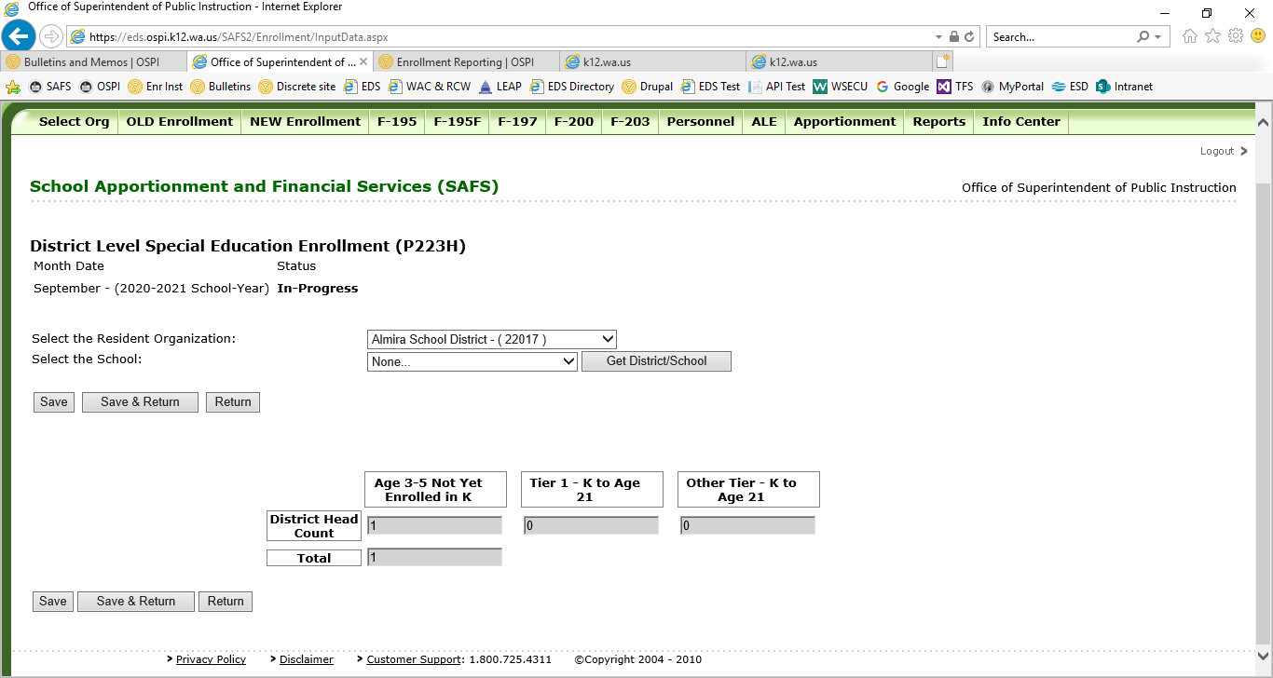

P240 fields that are reported at the district level.

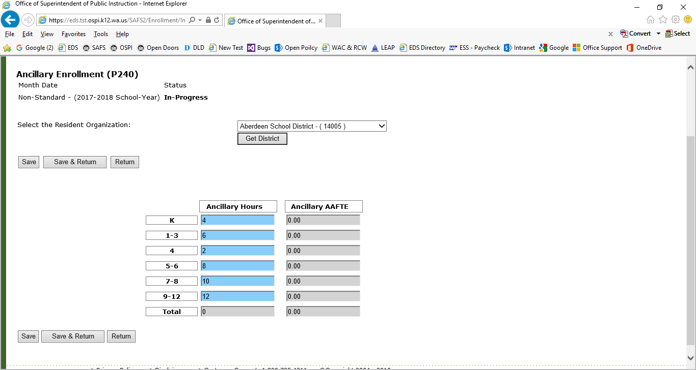

P223S fields are reported on the school screen.

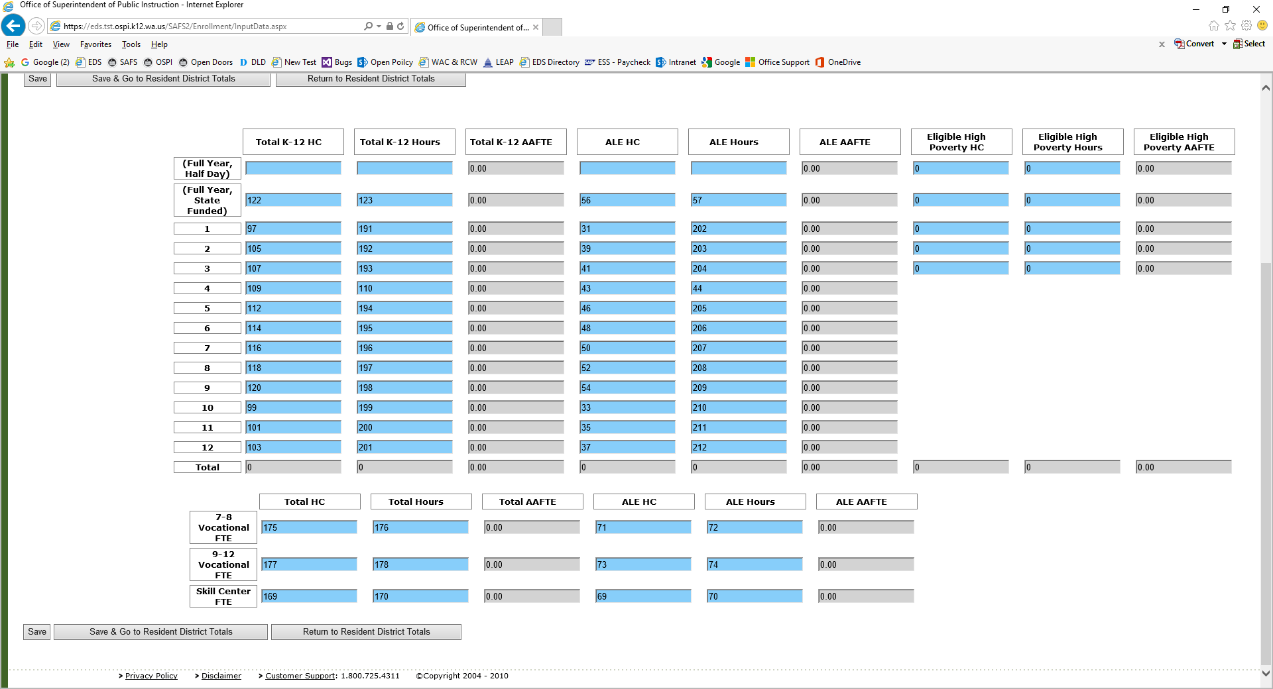

Field Number Details

The table below provides details for each field number including the field name, level that the data will be collected, number format, default value, length precision, scale, and details on which file type contains the field number. Default value for all fields is 0. Length precision for all fields is 18. Scale for all fields is 6.

Field # Table

# **K–3 Class Size Application –** suspended for the 2020-21 school year

Districts, charter schools, and tribal compact schools offering instruction for grades K–3 are required to report monthly their K–3 class size. This data is collected in the K–3 Class Size application and includes the student headcount in grades K through 3 classrooms and the number of homeroom teachers per school. This data collection is for informational purposes only and is not for state funding purposes or used for the K–3 Class Size Compliance calculation.

* + 1. **When to Report**

The K–3 Class Size reporting is submitted monthly. The monthly due dates are the same as the NEW Enrollment application. Refer to Section 5.B. of the Enrollment Handbook posted on the [Enrollment Reporting Instructions](https://www.k12.wa.us/policy-funding/school-apportionment/instructions-and-tools/enrollment-reporting) website for the 2020–21 due dates. As of September 4, 2020, the 2020-21 Enrollment Handbook is not available.

* + 1. **What to Report**

The K–3 Class Size application collects the number of enrolled students and homeroom teacher FTE regularly scheduled to provide K–3 instruction for the week of the monthly count day.

Count Day is defined as the fourth school day of September and the first school day for the remaining months of a standard school year (October through June).

Student Headcount – In the K–3 Class Size application, the headcount of the enrolled students in K–3 classrooms on the monthly count day is reported by school. The following enrollment should not be included in the K–3 Class Size reporting:

* Self-contained special education classrooms with staff that are not coded to a duty root 31 and who are reported as program 21.
* ALE Enrollment – Kindergarten through grade 3 students enrolled exclusively in ALE programs and ALE teachers should not be reported. ALE students enrolled in both seat-time classroom instruction, as well as, ALE instruction should be reported as a headcount in their seat-time classroom school.
* Summer school programs.

Grades 1 through 3 headcount numbers are a whole number (no decimal places). Students enrolled in half-day kindergarten programs and reported as K2 in CEDARS should be reported as a 0.50 headcount. Students enrolled in a full-day kindergarten program and reported as K1 in CEDARS should be reported as a whole number, regardless of the funding source of the full-day kindergarten program.

For students who attend two or more schools, the student’s headcount should be reported at the school where the student is enrolled the majority of the day. The student’s headcount should not be included in the other school(s). For students attending each school an equal amount of time at each school, the district, charter school, and tribal compact school would decide which school to claim the student’s headcount.

Homeroom Teacher FTE–In the K–3 Class Size application, districts, charter schools, and tribal compact schools report their homeroom teacher FTE by school who are regularly scheduled to provide instruction on the monthly count day. The reported FTE is rounded to the nearest 2nd decimal place.

Homeroom teacher is defined as those coded to duty root 31 – “Elementary Homeroom Teacher” in the S-275. Teachers that are specialists as defined by duty root 34 – “Elementary Specialist Teacher” do not meet this definition.

Teacher data is reported through this application on an FTE basis. Teacher FTE is as defined in the S-275 reporting instructions as the contracted number of hours per day associated with a full-time certificated employee in this position. FTE includes hours associated with the local certificated base contract, and excludes time for meals, time associated with classified assignments or duties, and hours associated with supplemental contracts for additional time, responsibility, or incentive.

Teachers with split classes (teaching multiple grades in one class) would have their teacher FTE split based on the number of students in each grade. For example, a teacher with a classroom of 10 first graders and 15 second graders would be reported as a 0.40 FTE (10÷25) first grade teacher and a 0.60 FTE second grade teacher (15÷25).

* + 1. **Completing the K–3 Class Size Application**

When reporting your K–3 Class Size, both the student headcount and teacher FTE for a school must be inputted in order for the data to save. The data will not save if you input only student headcount and no teacher FTE or the opposite, teacher FTE and no student headcount.

For access to the K–3 Class Size application, the user must have either the “SAFS P-223 User” or “SAFS P-223 Submitter EDS” role. Contact your district security manager to be assigned one of these roles.

The application can be found in EDS. Once the user is logged into EDS, “K–3 Class Size” will appear on the list of applications. Clicking this option will take you directly to the data entry screens.

A screen labeled “Input” will appear with all the available schools. Select the appropriate month from the upper left-hand drop-down menu. Wait for the screen to update. Enter the student headcount and the homeroom teacher FTE per grade for each school with grades K–3. Do not enter numbers in schools without these grades.

Hit “Save.” The K–3 Class Size application does not need to be submitted. Rather, by hitting “Save,” the data is available for OSPI to use.

* + 1. **Running Reports**

Districts, charter schools, and tribal compact schools can view their K–3 Class Size reports by selecting “Reports” tab while on the “Input” screen. The “Report” screen will show the calculated class size by grade by school for the selected month. Also, the reported data can be downloaded to an Excel spreadsheet, by hitting the “Download” button on the “Report” screen.

# **SAFS ALE Application**

Districts, charter schools, and tribal compact schools who have reported ALE enrollment on a monthly P223 must restate their monthly ALE enrollment in the SAFS ALE application. In the SAFS ALE application, the ALE enrollment is reported by ALE program and home district.

1. **When to Report**

The due date for the SAFS ALE application is the same as the P223. Refer to Section 5.B. of the 2020–21 Enrollment Handbook posted on the [Enrollment Reporting Instructions](https://www.k12.wa.us/policy-funding/school-apportionment/instructions-and-tools/enrollment-reporting) website for the 2020–21 due dates. As of September 4, 2020, the 2020-21 handbook is not yet available.

1. **What to Report**

In the SAFS ALE application, the ALE enrollment reported on the monthly P223 must be restated by ALE program and by home district.

ALE Program are created by the reporting entities.

Home District is defined as the district the student resides in regardless of choice transfer. This collection of data is different than what is collected on the P223.

EXAMPLE: A student lives in District A but attends District B’s ALE program through a choice transfer. On the P223, the student is reported as a resident of District B. In the SAFS ALE application, the student is reported under the home district of District A.

FTE and Headcount are collected in the SAFS ALE application.

FTE – ALE FTE that was reported on the P223 is reported in the SAFS ALE application based on the program the student attends. The total ALE FTE reported in the SAFS ALE application must match what is reported on the P223 for each month.

Headcount – ALE headcount is reported based on the ALE program(s) the student attends. If a student attends more than one ALE program at the reporting entity, the student’s headcount is counted at each ALE program. The total ALE headcount may be a bit more in the SAFS ALE application, when a student is enrolled in two or more different ALE programs.

1. **Accessing the SAFS ALE Application**

To access the SAFS ALE application, one of the following roles must be assigned by the District Security Manager. Note the difference for each of these roles.

* **SAFS District ALE User**

User with this role can:

* + Create a monthly file.
  + Input data in a monthly file.
  + View ALE reports.
* **SAFS District ALE Submitter**

User with this role can:

* + Create a monthly file.
  + Input data in a monthly file.
  + Submit a monthly file.
  + View ALE reports.
  + Create ALE programs.

Depending on the reporting entity’s size and business service practices, assignment of both roles may not be necessary. Having the “SAFS District ALE Submitter” role allows access to all the necessary features of the SAFS ALE application. Large districts that use clerical staff or an ALE provider to input the enrollment, while supervisors review and submit the enrollment, may find that assigning both roles is more appropriate.

After being assigned one of these roles and once logged into EDS, select “SAFS” from your list of available applications. The following will appear:

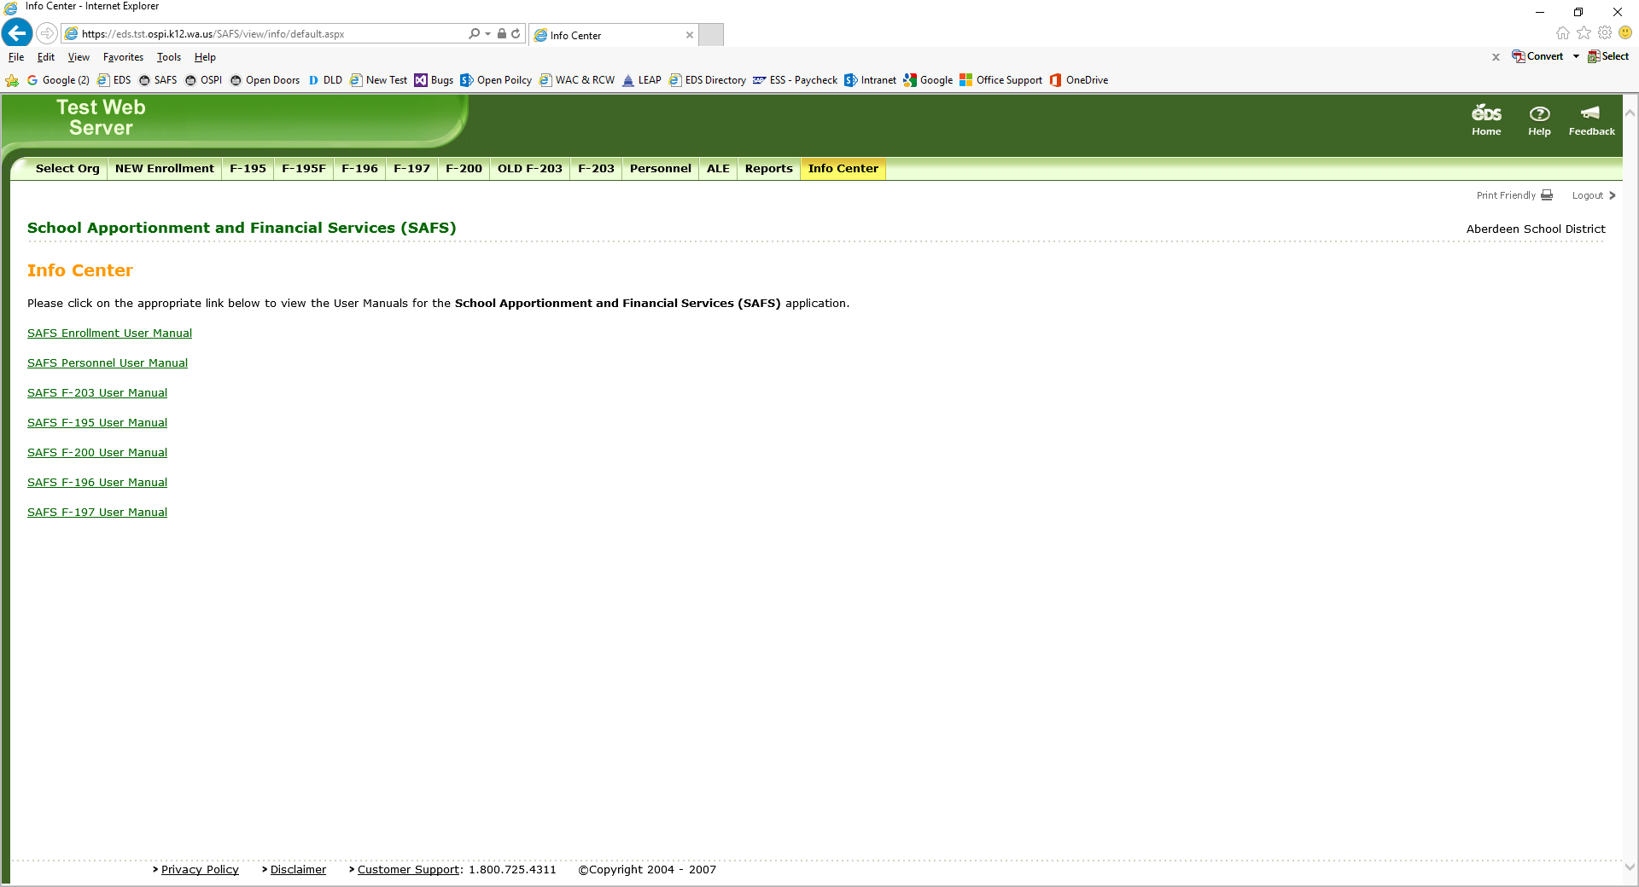

1. **Managing ALE Programs**

Creating New ALE Programs: Reporting entities set up their own ALE programs. To create an ALE program, select “Program Management.” Select “Create New Program.”

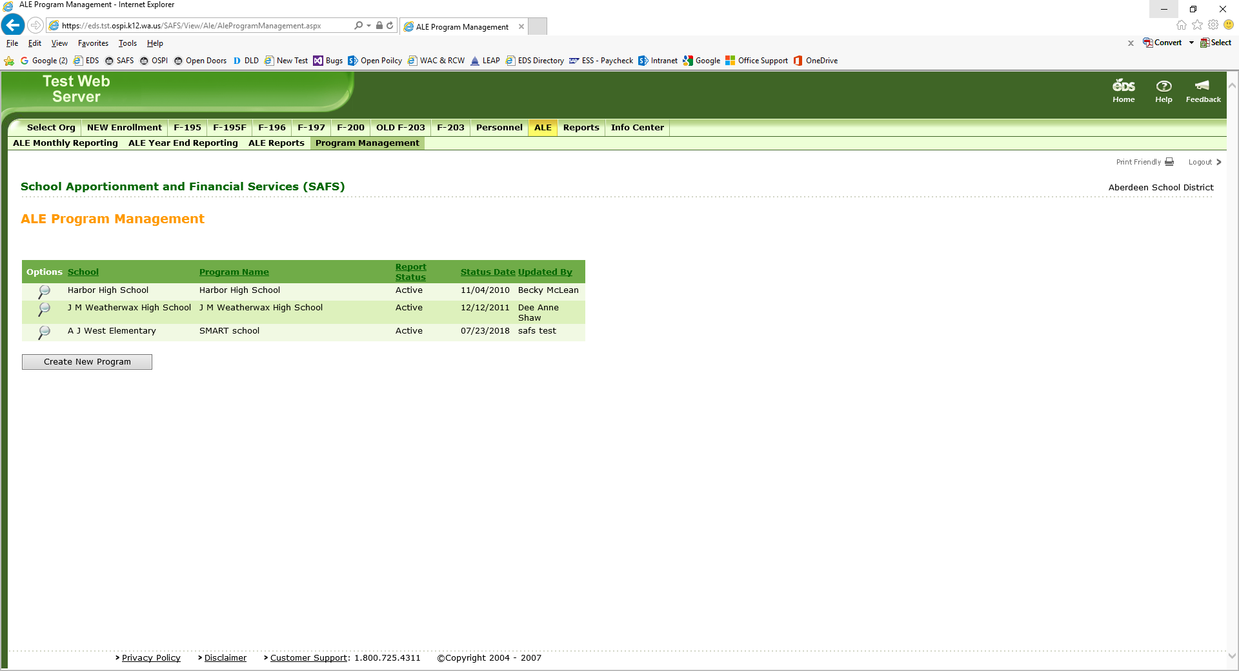

The following screen will appear:

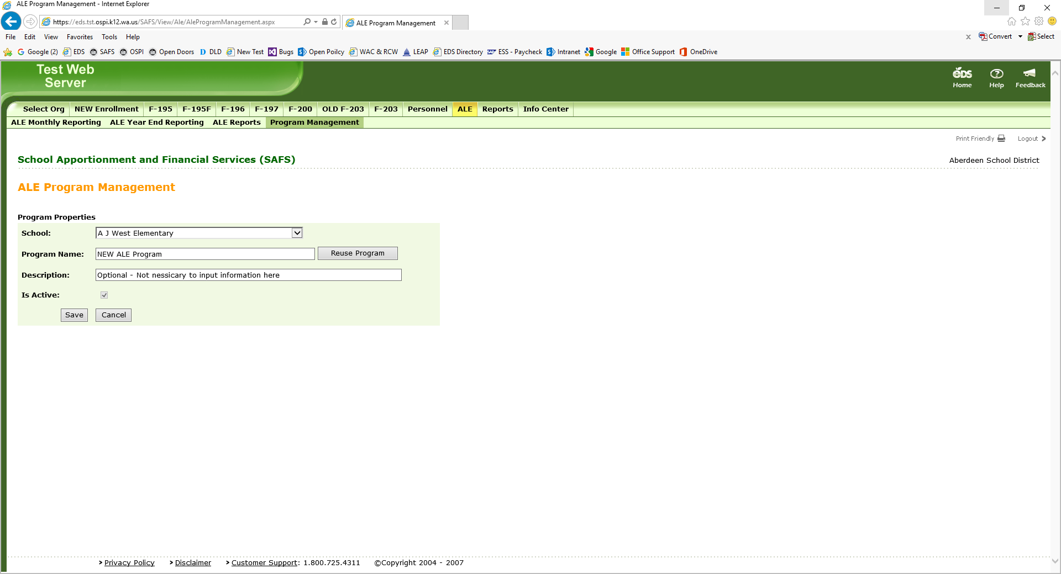

* Select a school from the dropdown menu.
* Provide a program name.
* The description line is optional and is not necessary to be completed.

Once lines have been completed, select “Save.”

Changing an ALE Program: ALE programs’ names can be changed by OSPI. Contact Becky McLean at [becky.mclean@k12.wa.us](mailto:becky.mclean@k12.wa.us) or 360-725-6306 to request a name change. The school associated with an ALE program cannot be changed and would require deleting the ALE program and creating a new program.

Deleting an ALE Program: ALE programs can be deleted at the beginning of the new school year. If a program needs to be deleted, contact Becky McLean at [becky.mclean@k12.wa.us](mailto:becky.mclean@k12.wa.us) or 360-725-6306 before September of the new school year.

1. **Inputting ALE Enrollment**

To report ALE enrollment, select “ALE Monthly Reporting.”

On the left-hand side of the screen, you must first create an ALE document for each month. Select the month and hit the “Create Document” button.

Once created, you will find it listed below.

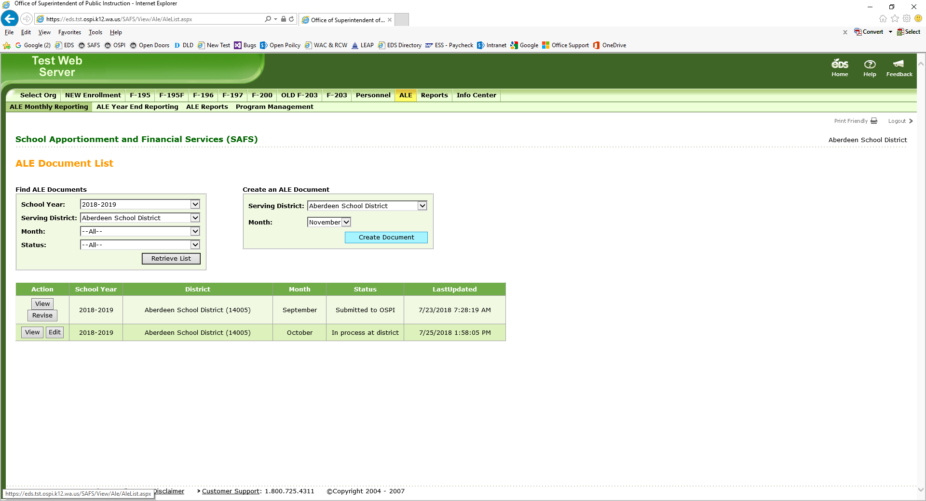

Click on the “Edit” button to input data. Clicking on “View” will allow you to view the data but not input data.

The following screen will appear:

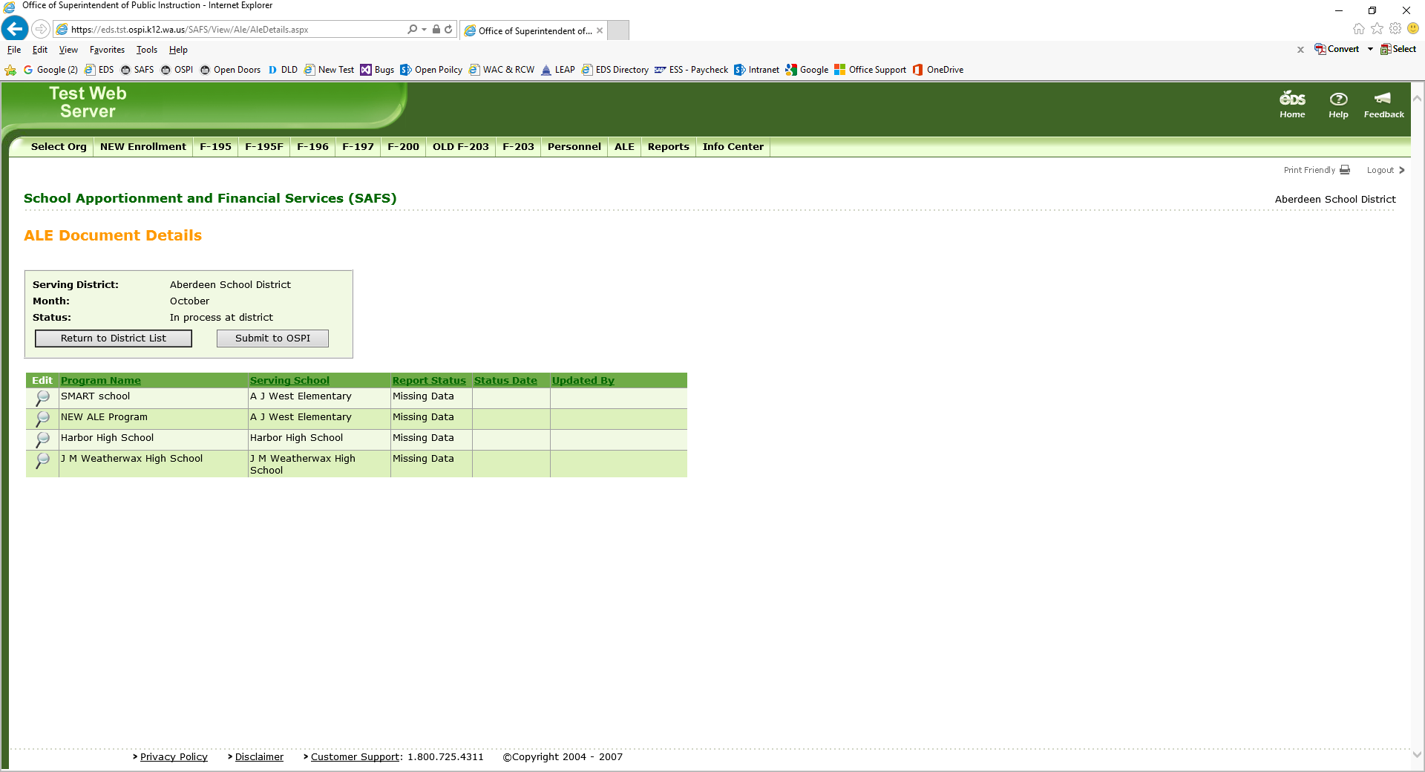

Select the “Magnifying Glass” icon for each ALE program. Note that data must be inputted for every existing ALE program. If there is no enrollment to report at an ALE program, enter zero in one of the fields.

You are next taken to a screen where all the fields are grayed out. You must select a “Home District” and then the fields become open.

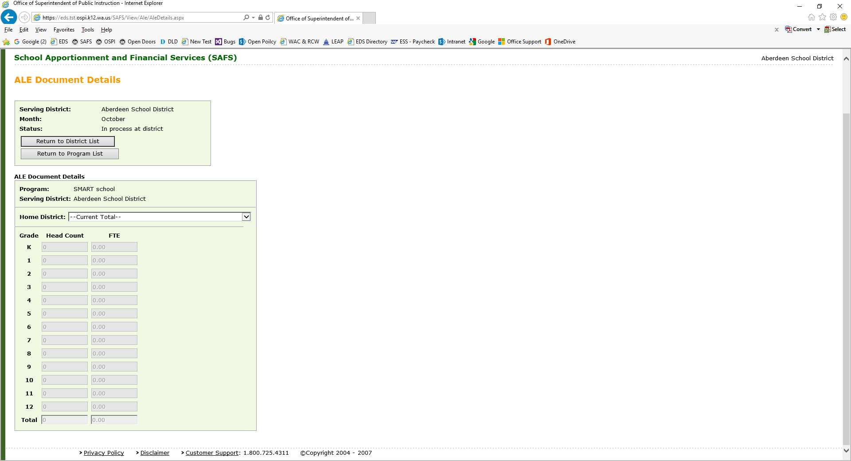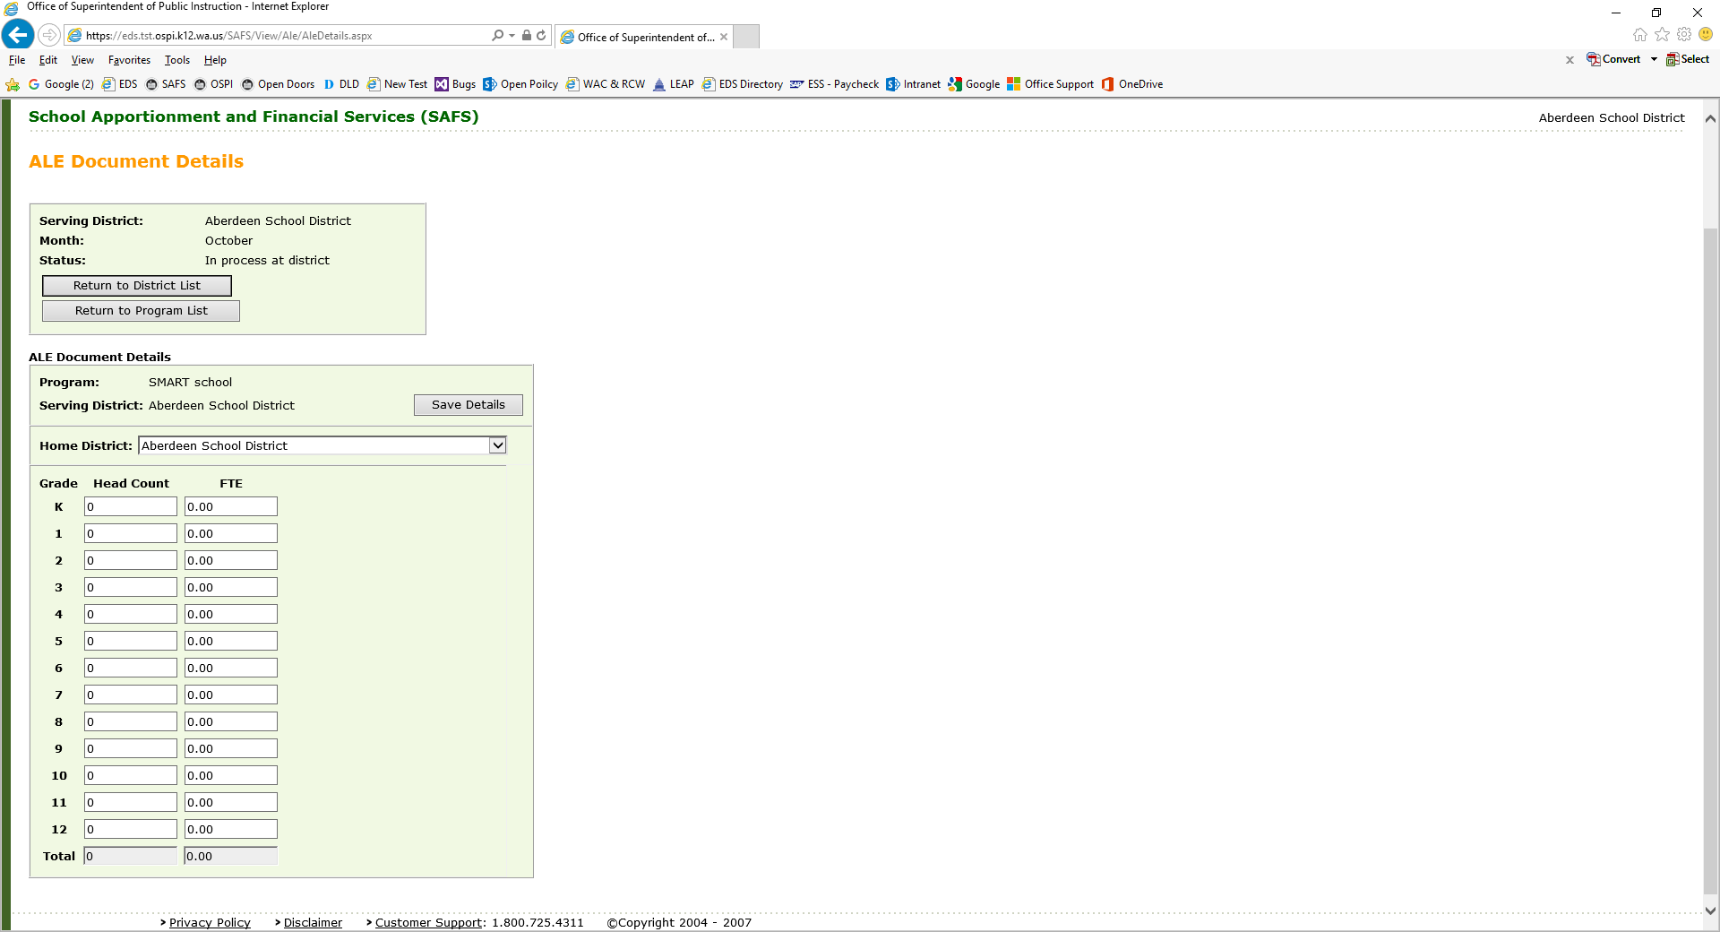

Once data is inputted for that Home District, hit “Save Details”. By not hitting “Save Details”, the data will not be saved.

Next select another “Home District” or select “Return to Program List” if there are no other home districts to report ALE enrollment. Selecting “Return to District List” will take you to the list of your monthly files and you will need to go back into the specific monthly file to submit or edit your file for that month.

Once back at the program list for that month, you can submit your monthly ALE file if you have the EDS role “SAFS District ALE Submitter” and all your ALE programs have data. Hit the “Submit to OSPI” button.

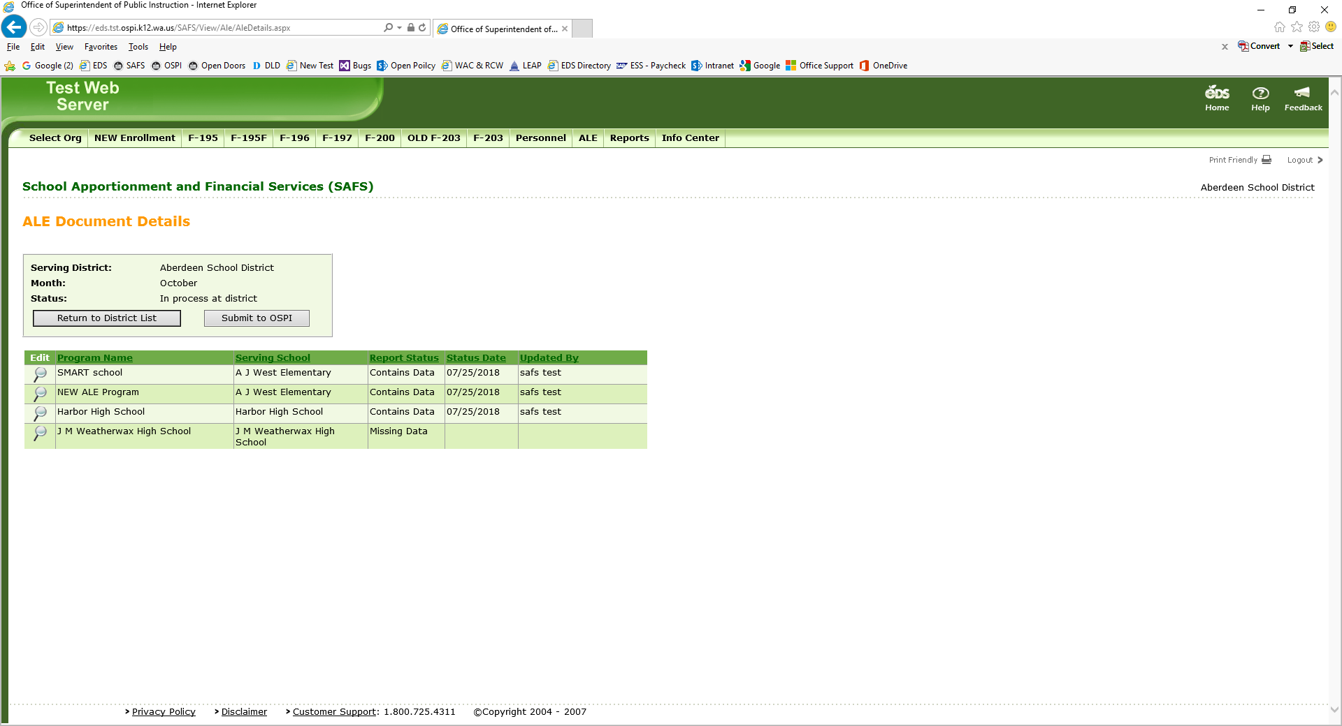

Note that if you do not have enrollment to report for an ALE program, input zero in one of the fields. The application will see that a zero is data. If any ALE program shows “Missing Data” in the Report Status, after hitting the “Submit to OSPI” button, the following message will appear.

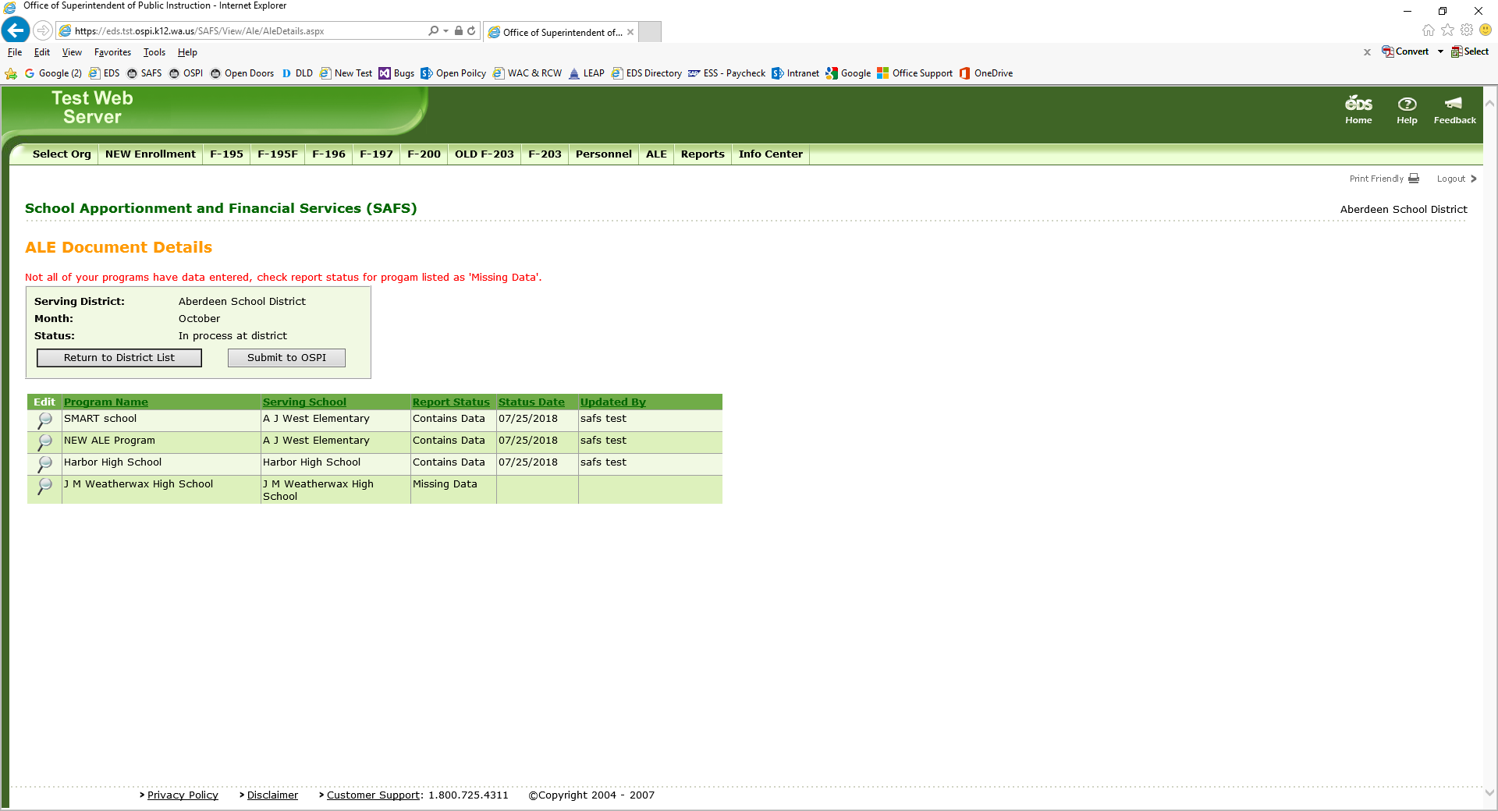

1. **Revising SAFS ALE Reports**

Once a monthly SAFS ALE report has been submitted, it can be revised. To revise a file, you must have the EDS role – SAFS District ALE Submitter. With this role, you should see the “Revise” button next to the file. 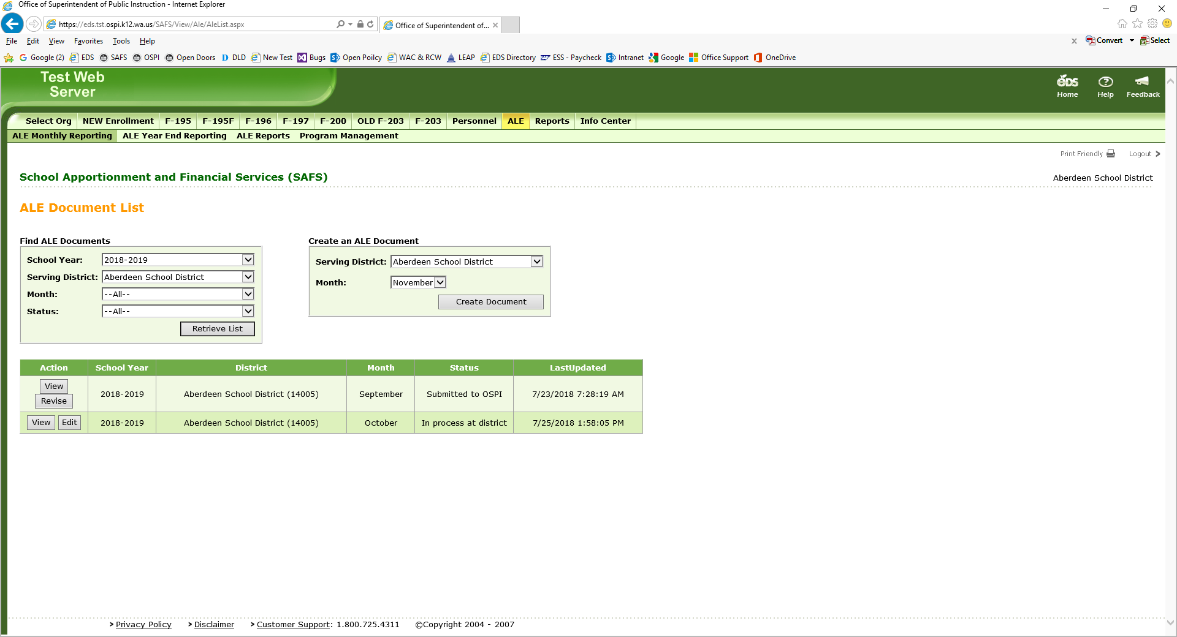

Some users have reported not seeing the “Revise” button even though they have the correct EDS role. If this is the case, contact Becky McLean at [becky.mclean@k12.wa.us](mailto:becky.mclean@k12.wa.us) to open your monthly file for revisions.

1. **Method to Check SAFS ALE Data**

You can review the data inputted in a SAFS ALE monthly file by downloading an Excel spreadsheet of the data. To do so, select “ALE Reports.”

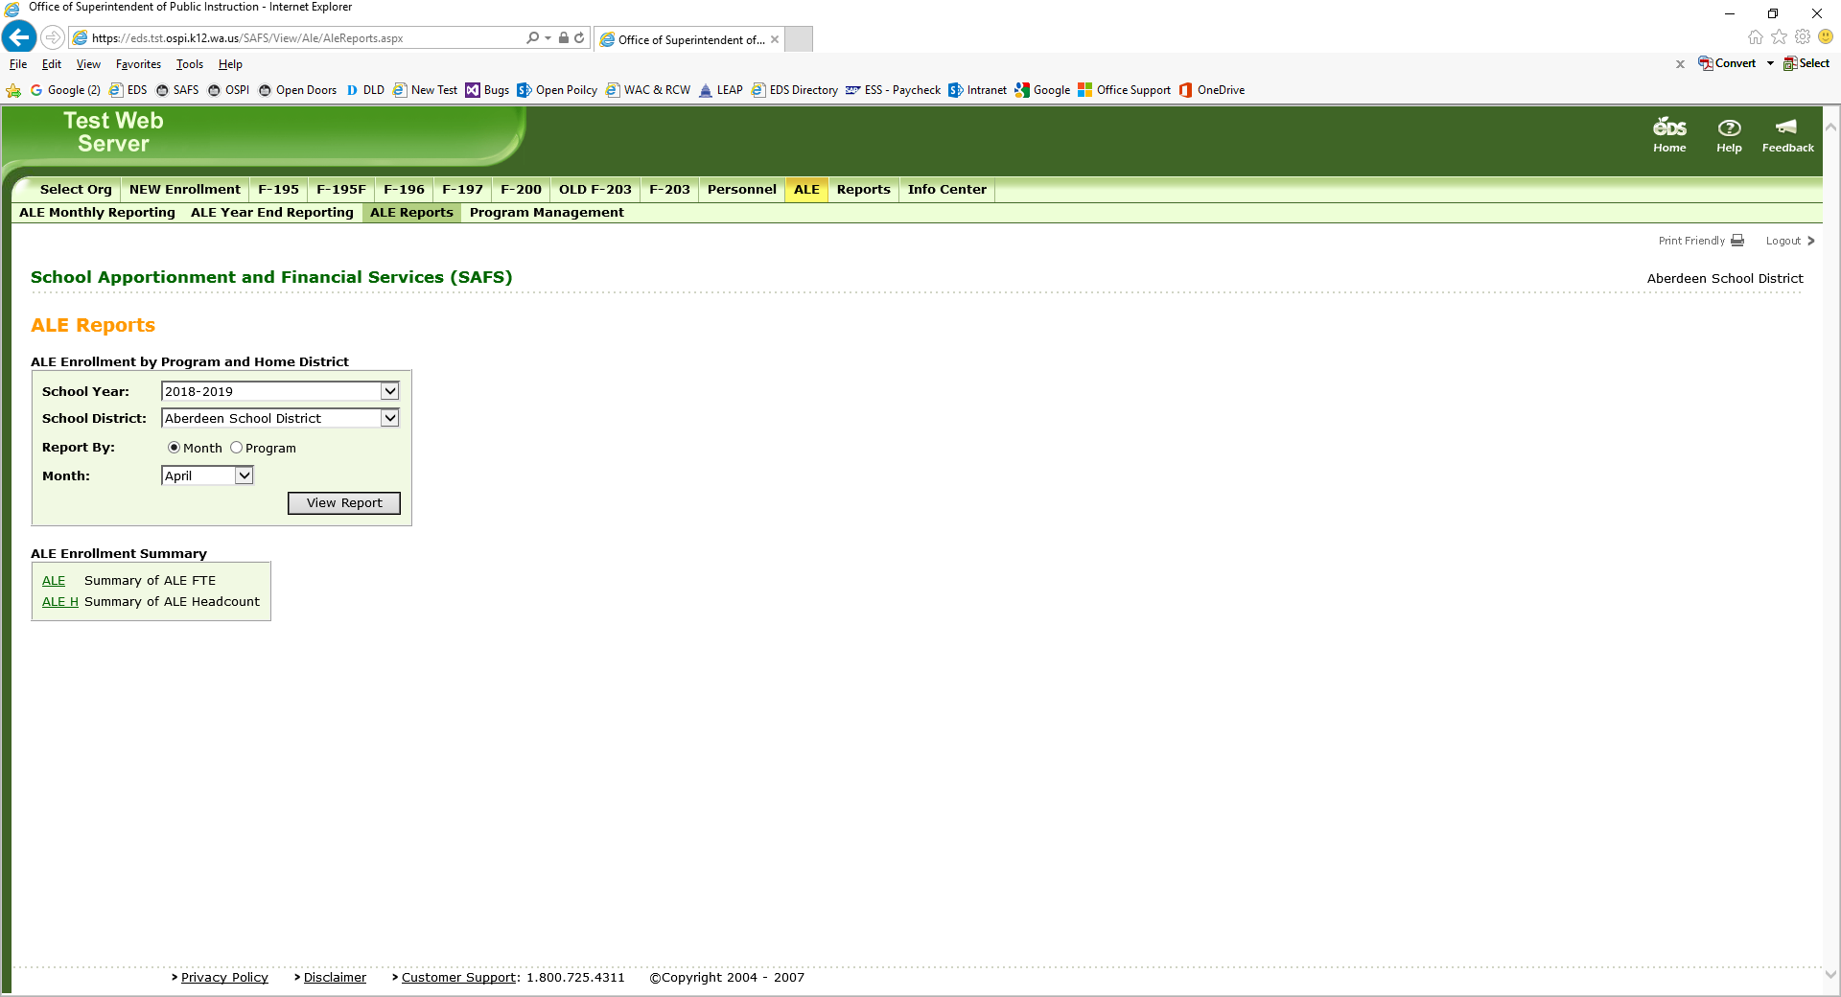

Spreadsheets can be run for a specific month or specific ALE program. Select which one you wish to run by clicking on “Month” or “Program.” For a Month spreadsheet, choose the month. Hit the “View Report” button.

The following screen will appear depending on the choices made:

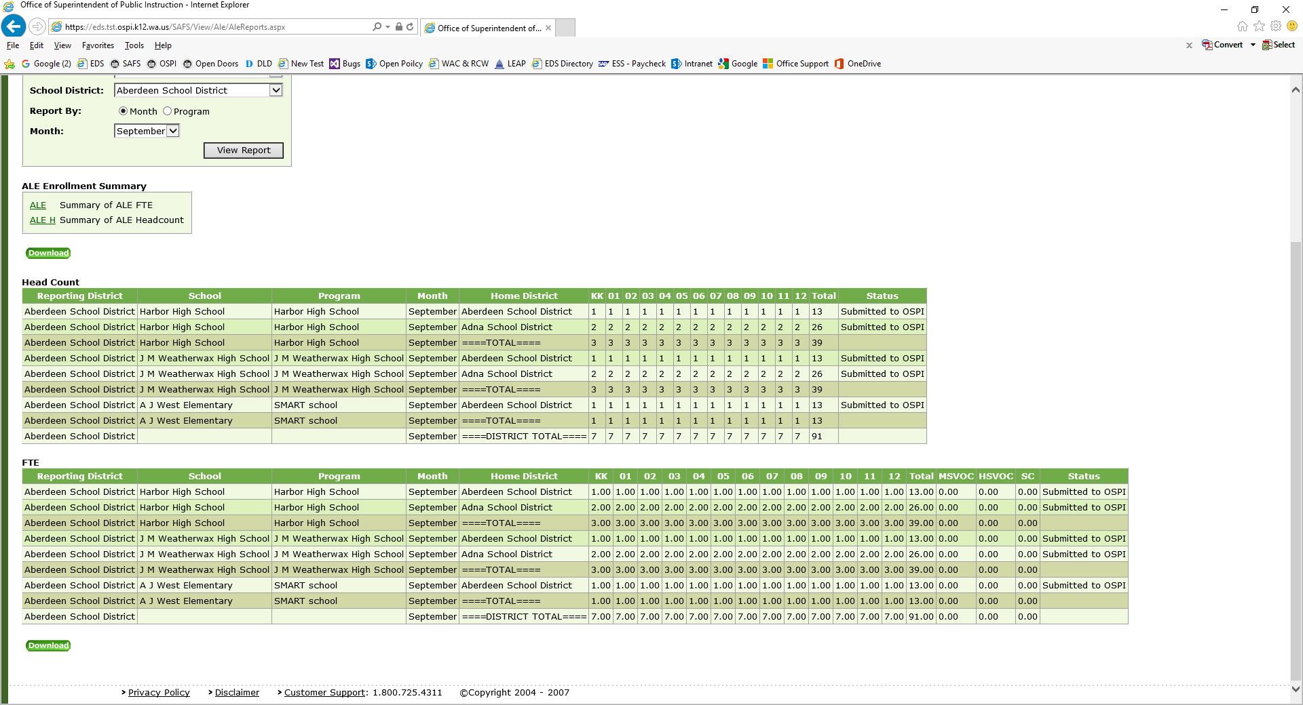

Click on the “Download” button (found in two places), and the data will be downloaded into an Excel spreadsheet.