8.F.A

Define, evaluate, and compare functions.

- Select all tables where y, the dependent variable, is a function of x, the independent variable.
A.
x | –2 | 0 | 1 | 1 | 2
y | –2 | 0 | 1 | 2 | 3

B.
x | –2 | 0 | 1 | 2 | 3
y | –2 | 0 | 1 | 1 | 2
C.
x | 1 | 1 | 1 | 1 | 1
y | –2 | 0 | 1 | 2 | 3

D.
x | –2 | 0 | 1 | 2 | 3
y | 1 | 1 | 1 | 1 | 1

- What shape do you expect the graph of the function described by 3x + 7y = 8 to take? Is it a linear or nonlinear function?

- The table and the equation shown each represent a different linear function.
Function 1:
x | –2 | 0 | 2 | 4 | 6
y | –5 | –2 | 1 | 4 | 7
Function 2:
y = 4x + 3
Which function has the greater initial value? Explain how you know.
8.F.A

Define, evaluate, and compare functions.

- The table shows the time, in seconds, since a stone is dropped off a cliff and the total distance the stone has traveled, in feet.
Number of seconds (x) | Distance traveled in feet (y)
0.5 | 4
1 | 16
1.5 | 36
2 | 64
2.6 | 100
3 | 144
3.5 | 196
4 | 256
Does the data in the table suggest a linear relationship between the time, in seconds, and the distance traveled, in feet? Explain why or why not.

- Alan and Margot drive from City A to City B, a distance of 147 miles. Alan begins driving at 1:40 p.m. and arrives at City B at 4:15 p.m. Margot’s trip from City A to City B can be described with the equation y = 64x, where y is the distance traveled in miles and x is the time in hours spent traveling. Who gets from City A to City B faster? Explain how you got your answer.

- This graph represents a linear function.
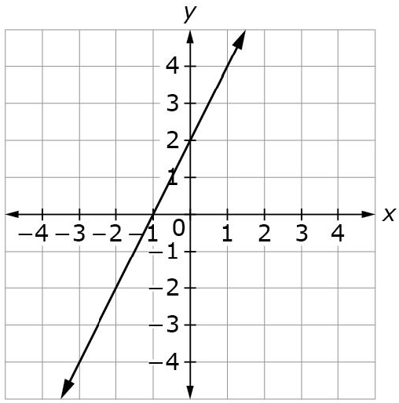
Write an equation for the linear function represented by the graph.

Teacher Material

8.F.A

Define, evaluate, and compare functions.

Question | Claim | Key/Suggested Rubric
1 | 1 | 1 point: Selects B and D
2¹ | 1 | 1 point: Answers will vary. Example: A straight line, so it’s linear.
3 | 3 | 1 point: Function 2 AND describes reasoning. Example: Function 2 because when I put use x = 0 for both functions, Function 1 has a y-value of –2 and function 2 has a y-value of 3.
4 | 1 | 1 point: Identifies the data does not suggest a linear relationship AND provides an explanation. Example: No, the data isn’t linear because from time 1 second to 2 seconds the distance traveled is 48 feet. But from 2 seconds to 3 seconds the distance traveled is 80 feet. Linear data would have the same distance traveled form both times.
5 | 2 | 2 points: Margot AND provides an explanation comparing Alan’s trip to Margot’s trip. Example: Margot get there faster because it take her a little less than 2.3 hours, or 2 hours and 18 minutes. Alan takes 2 hours and 35 minutes.  1 point: Margot AND provides a partial explanation that includes only information for Margot or Alan
6¹ | 1 | 1 point: y = 2x + 2, or equivalent

Adapted from Smarterbalanced.org. Grade 8, Claim 1, Target E Item Specifications. Internet. Available from http://www.smarterbalanced.org/smarter-balanced-assessments/; accessed 11/2015.
Adapted from the Mathematics K–12 Learning Standards. Internet. Available from http://www.k12.wa.us/Mathematics/Standards.aspx; accessed 11/2015.
From EngageNY.org of the New York State Education Department. Grade 8 Mathematics Module 5, Topic A, Lesson 1. Internet. Available from https://www.engageny.org/resource/grade-8-mathematics-module-5-topic-lesson-1; accessed 11/2015.
From EngageNY.org of the New York State Education Department. Grade 8 Mathematics Module 5, Topic A, Lesson 7. Internet. Available from https://www.engageny.org/resource/grade-8-mathematics-module-5-topic-lesson-7; accessed 11/2015.

