4.OA.A

Use the four operations with whole numbers to solve problems.

1. A cat has 2 times as many toys as a puppy. The cat has 10 toys. How many toys does the puppy have?

2. A container holds 750 milliliters of water. Jess drank 90 milliliters of the water. How many milliliters of water remain in the container?

3. Using the diagrams below, create your own word problem. Write an equation for your problem. Find the unknown and answer the question in your problem.

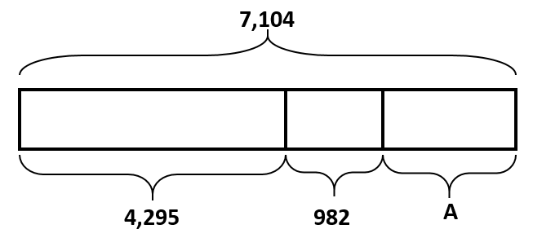

4. A piece of yellow yarn was 230 inches long. After 90 inches had been cut from it, the piece of yellow yarn was twice as long as a piece of blue yarn. At first, how much longer was the yellow yarn than the blue yarn?

5. Norfolk, VA, has a population of 242,628 people. Eddie lives in Fredericksburg, VA, which has a population of 24,286. He says that Norfolk’s population is about 10 times as large as Fredericksburg’s population. Do you agree with Eddie’s thinking? Explain using words and numbers.

6. Quarterback Brett Favre passed for 71,838 yards between the years 1991 and 2011. His all-time high was 4,413 passing yards in one year. In his second highest year, he threw 4,212 passing yards. How many passing yards did he throw in the remaining years?

Teacher Material
4.OA.A
Use the four operations with whole numbers to solve problems.

Question | Claim | Key/Suggested Rubric
1 | 1 | 1 point: 5
2¹ | 1 | 1 point: 660 milliliters
3 | 4 | 3 points: Writes a word problem, writes an equation, and correctly solves the equation.  There are 7104 books in the school library. 4295 are fiction books and 982 are non-fiction books. The rest are reference books. How many reference books are in the school library?  7104 = 4295 + 982 + r  7104 = (5277) + r  7104 – 5277 = 1827  (There are many ways students may choose to write their word problem and many ways they may solve it.)  2 point: Student does two of the tasks needed for three points.  1 point: Student does one of the tasks needed for three points. If an error is made in writing an equation, his/her answer is consistent with the equation.
4 | 2 | 1 point:  230 – 90 = 140  140 = 2 x b  b = 70  230 – 70 = 160 inches longer
5 | 3 | 1 point:  If I round Norfolk’s population it is about 240,000 when I round it to the nearest ten-thousand. If I round Fredricksburg’s population to the nearest thousand it is 24,000. You can easily see that 24,000 x 10 = 240,000 which means Norfolk is about 10 times as big as Fredericksburg.  (Students may round in a number of ways.)
6 | 2 | 1 point:  4413 + 4212 = 8625  71,838 – 8625 = 63,213 yards in the remaining years

From Smarterbalanced.org. Grade 4, Claim 1, Target A Item Specifications. Internet. Available from http://www.smarterbalanced.org/smarter-balanced-assessments/; accessed 11/2015.
From EngageNY.org of the New York State Education Department. Grade 4 Mathematics Module 1, Topic F, Lesson 19. Internet. Available from https://www.engageny.org/resource/grade-4-mathematics-module-1-topic-f-lesson-19; accessed 11/2015.
From EngageNY.org of the New York State Education Department. Grade 4 Mathematics Module 1, Topic F, Lesson 17. Internet. Available from https://www.engageny.org/resource/grade-4-mathematics-module-1-topic-f-lesson-17; accessed 11/2015.
Adapted from EngageNY.org of the New York State Education Department. Grade 4 Mathematics Module 1, end-of-module assessment. Internet. Available from https://www.engageny.org/resource/grade-4-mathematics-module-1; accessed 11/2015.
From EngageNY.org of the New York State Education Department. Grade 4 Mathematics Module 1, Topic E, Lesson 16. Internet. Available from https://www.engageny.org/resource/grade-4-mathematics-module-1-topic-e-lesson-16; accessed 11/2015.

