

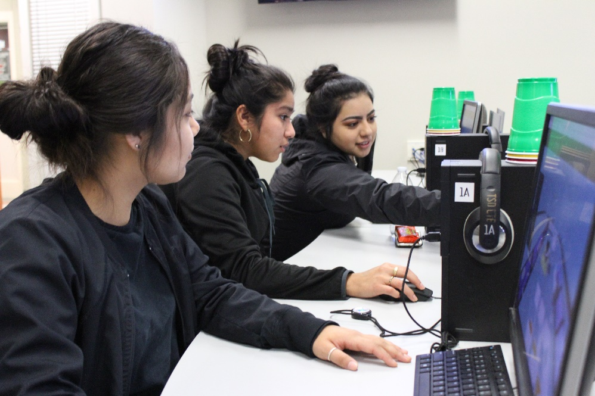**Educational Technology Learning Standards: Grades 6-8**

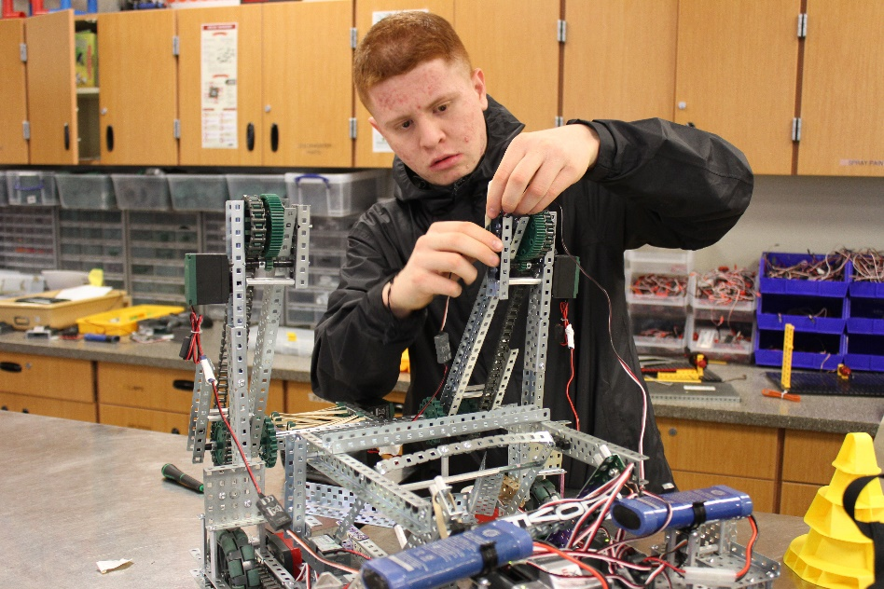

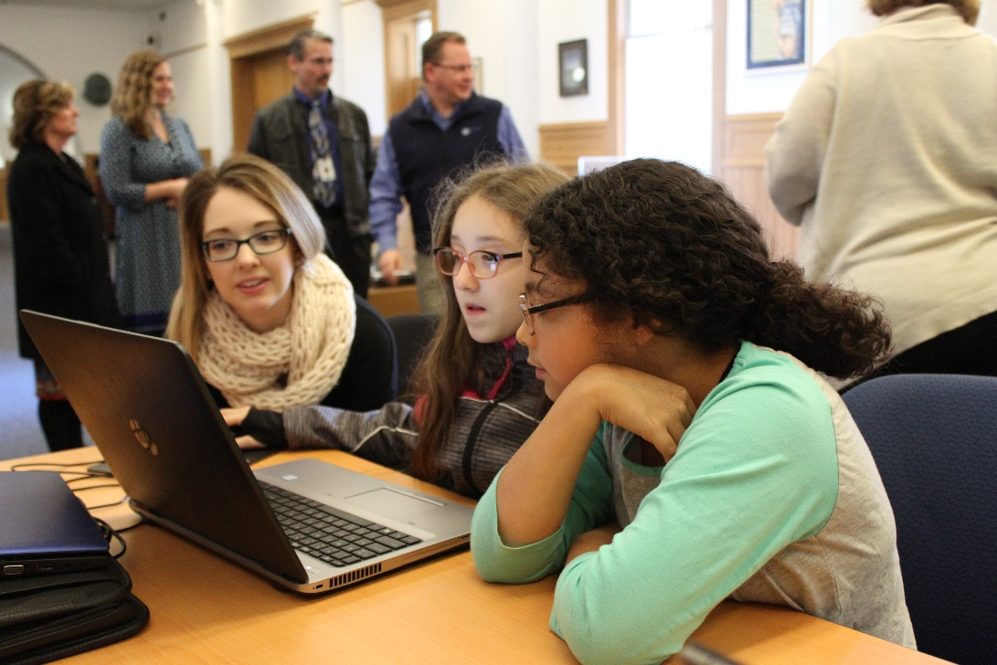

***Adopted May, 2018***

*****Photos: Toppenish High School, Sunnyside High School and OSPI, courtesy of OSPI***

# For complete K-12 Educational Technology Standards go to:

[*http://www.k12.wa.us/EdTech/Standards/default.aspx*](http://www.k12.wa.us/EdTech/Standards/default.aspx)

**Creative Commons Attribution-NonCommercial LIcense Logo (CC BY NC)
**

Except where otherwise noted, the Washington Educational Technology K–12 Learning Standards (<http://www.k12.wa.us/edtech/Standards>) by the Office of Superintendent of Public Instruction (<http://k12.wa.us/>) are licensed under a Creative Commons Attribution Non-Commercial 4.0 International License (<https://creativecommons.org/licenses/by-nc/4.0/>). All logos and trademarks are property of their respective owners.

Portions of this work are based on the 2016 International Society for Technology in Education (ISTE) Standards for Students (<https://www.iste.org/standards/for-students>)

ISTE Standards for Students, ©2016, ISTE (International Society for Technology in Education), iste.org. All rights reserved.

Standards referenced include:

*The College, Career, and Civic Life (C3) Framework for Social Studies State Standards: Guidance for Enhancing the Rigor of K-12 Civics, Economics, Geography, and History.* National Council for the Social Studies (NCSS),Silver Spring, MD, 2013, <https://www.socialstudies.org/c3>

*Common Core State Standards.* National Governors Association Center for Best Practices and Council of Chief State School Officers, Washington D.C., 2010, <http://www.corestandards.org>

*CSTA K-12 Computer Science Standards.* Computer Science Teachers Association*,* Albany, NY, 2017, <http://www.csteachers.org/page/standards>

Next Generation Science Standards: For States, By States.The National Academies Press, Washington D.C., 2013, <https://www.nextgenscience.org>

# 

# 2018 Standards for Technology Literate & Fluent Students

***(Based upon 2016 ISTE Student Standards)***

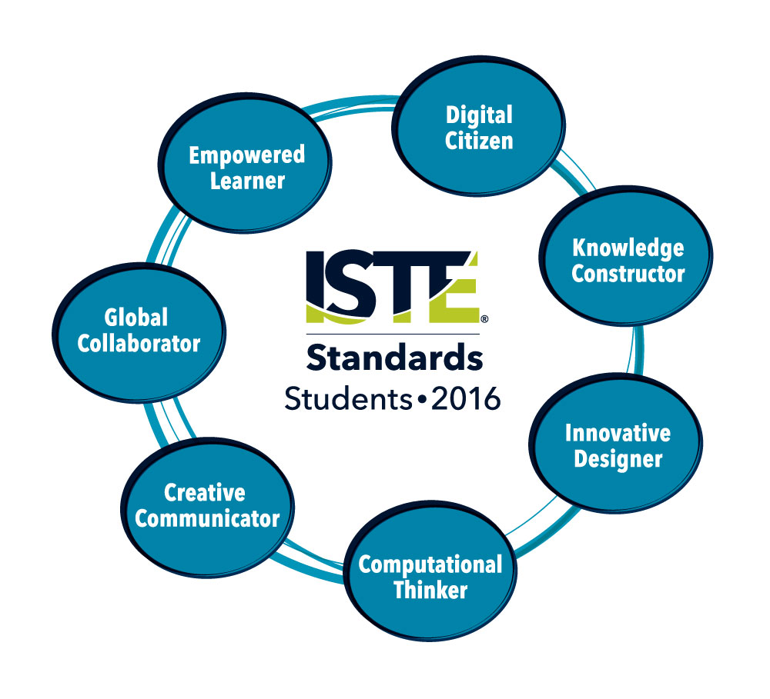

1. **Empowered Learner** - Students leverage technology to take an active role in choosing, achieving and demonstrating competency in their learning goals, informed by the learning sciences.

2. **Digital Citizen** - Students recognize the rights, responsibilities and opportunities of living, learning and working in an interconnected digital world, and they act and model in ways that are safe, legal and ethical.

3. **Knowledge Constructor** - Students critically curate a variety of resources using digital tools to construct knowledge, produce creative artifacts and make meaningful learning experiences for themselves and others.

4. **Innovative Designer** - Students use a variety of technologies within a design process to identify and solve problems by creating new, useful or imaginative solutions.

5. **Computational Thinker** - Students develop and employ strategies for understanding and solving problems in ways that leverage the power of technological methods to develop and test solutions.

6. **Creative Communicator** - Students communicate clearly and express themselves creatively for a variety of purposes using the platforms, tools, styles, formats and digital media appropriate to their goals.

7. **Global Collaborator** - Students use digital tools to broaden their perspectives and enrich their learning by collaborating with others and working effectively in teams locally and globally.

ISTE Standards•S © 2016 International Society for Technology in Education.

# Understanding the Educational Technology Standards Framework

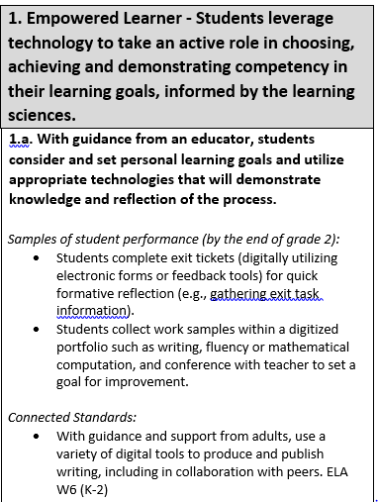

A **Standard**is a broad statement of the learning that applies to Grades K–12.

A **Performance Indicator** is a statement containing the essential content or process to be learned and the cognitive demand required to learn it. Each standard includes developmentally-appropriate grade-band performance indicators, which are considered essential to the standards.

**Samples of student performance** provide specific illustrations of the learning by the completion of the grade band. However, these examples are not exhaustive, and educators are encouraged to find multiple ways by which learners can demonstrate what they know.

**Connected standards** are logical connections to other content areas at approximately the same grade that also have a match in cognitive demand. With this alignment, teachers can expect that when students can demonstrate mastery of one standard (educational technology or other content area), they can also meet the other.

**Connected Standards Codes**

* C3= College, Career, and Civic Life (C3) Framework for Social Studies State Standards (<https://www.socialstudies.org/c3>)
* CS=Computer Science Learning Standards (<http://www.k12.wa.us/ComputerScience/>)
* H=Health Standards (<http://www.k12.wa.us/HealthFitness/Standards.aspx>)
* ELA=English Language Arts Standards (<http://www.corestandards.org/ELA-Literacy/>)
* Math=Mathematics Standards (<http://www.k12.wa.us/Mathematics/Standards.aspx>)
* PE=Physical Education Standards (<http://www.k12.wa.us/HealthFitness/Standards.aspx>)
* Science=Next-Generation Science Standards (<https://www.nextgenscience.org/get-to-know>)
* Social Studies=Social Studies Standards (<http://www.k12.wa.us/SocialStudies/EALRs-GLEs.aspx>)

# Grades 6-8 Standards for Technology Literate and Fluent Students

|  |  |
| --- | --- |
| **1. Empowered Learner - Students leverage technology to take an active role in choosing, achieving and demonstrating competency in their learning goals, informed by the learning sciences.** | |
| **1.a. Students articulate personal learning goals, select and manage appropriate technologies to achieve them, and reflect on their successes and areas of improvement in working toward their goals.**  *Samples of student performance (by the end of grade 8):*   * Students lead teacher-parent conferences using technology tools. * Students create digital portfolios. * Students identify types of technology tools and resources best able to assist them in their learning, and justify the rationale for their selection. * Students set personal learning goals and use online tools to share and reflect on their learning.   *Connected Standards:*   * Using one or more technologies, create short- and long-term goals to establish and track healthy eating patterns. H6.N6.8 * Using one or more technologies, construct a personal workout using the FITT principle and evaluate progress toward goal. PE3.5.8 * Using one or more technologies, maintain and reflect on a personal physical activity and nutrition log and set goals for improvement. PE3.11.8 |
| **1.b. Students identify and develop online networks within school policy, and customize their learning environments in ways that support their learning, in collaboration with an educator.**  *Samples of student performance (by the end of grade 8:*   * Students participate in school-approved online groups to support learning (e.g., online discussion boards through a Learning Management System). * Students use school-approved collaborative and file sharing groups to network and get assistance from teachers and peers. * Students demonstrate awareness that online groups and discussion boards may have biases which should be considered. |

|  |
| --- |
| **1.c. Students actively seek performance feedback from people, including teachers, and from functionalities embedded in digital tools to improve their learning process, and they select technology to demonstrate their learning in a variety of ways.**  *Samples of student performance (by the end of grade 8):*   * Students use interactive digital tools to create online polls or surveys to gather data to help guide and assess information during the learning process. * Students comment on writing projects using online tools (e.g. blogs, online discussions, comments on live documents, etc.). * Using knowledge about target audiences, students create digital presentations that provide opportunities for audience participation and feedback. * Students solicit feedback for their ideas using digital tools. |
| **1.d. Students are able to navigate a variety of technologies and transfer their knowledge and skills to learn how to use new technologies.**  *Samples of student performance (by the end of grade 8):*   * Students use a variety of devices (e.g., mobile devices and computers) to support planning, implementing, and reflecting upon a defined task. * Students apply their knowledge and skills from existing technologies and devices to successfully use new technologies. * Students develop criteria for selecting digital learning tools and resources to accomplish a defined task. * Students identify a product and describe how people from different disciplines combined their skills in the design and production of the product. * Students from a variety of backgrounds are able to use digital technologies with fluency and ease. |

|  |  |
| --- | --- |
| **2: Digital Citizen - Students recognize the rights, responsibilities and opportunities of living, learning and working in an interconnected digital world, and they act and model in ways that are safe, legal and ethical.** | |
| **2.a. Students manage their digital identities and reputations within school policy, including demonstrating an understanding of how digital actions are never fully erasable.**  *Samples of student performance (by the end of grade 8):*   * Students participate in class discussions about media literacy and online safety. * Students demonstrate knowledge of core concepts and key questions of media literacy. * Students demonstrate knowledge of when to share personal information. * Students identify the differences between ethical and unethical online and digital use behavior. * Students identify the consequences of unethical uses of technology. * Students are aware that what goes online is never completely erased, and can be easily replicated and reused for unintended purposes. |
| **2.b. Students demonstrate and advocate for positive, safe, legal and ethical habits when using technology and when interacting with others online.**  *Samples of student performance (by the end of grade 8):*   * Students lead or participate in class discussions about media literacy and online safety. * Students identify the differences between ethical and unethical online and digital use behavior. * Students identify the consequences of unethical uses of technology. * Students explain the positive and negative impact the use of technology can have on personal, professional and community relationships.   *Connected Standards:*   * Understand differences between reliable and unreliable sources of nutrition information. H3.N1.6 * Determine availability of valid and reliable nutrition information, products, and services. H3.N1.7 * Investigate valid and reliable nutrition information, products, and services. H3.N1.8 |
| **2.c. Students demonstrate and advocate for an understanding of intellectual property with both print and digital media- including copyright, permission and fair use-by creating a variety of media products that include appropriate citation and attribution elements.**  *Samples of student performance (by the end of grade 8):*   * Students identify the differences between ethical and unethical online and digital use behavior. * Students comply with copyright law when reusing content or resources from websites. * Students are able to correctly cite copyrighted works in their digital portfolios and online work. * Students describe the impact of unethical and illegal use of technology on individuals and society.   *Connected Standards:*   * Gather relevant information from multiple print and digital sources; assess the credibility of each source; and quote or paraphrase the data and conclusions of others while avoiding plagiarism and providing basic bibliographic information for sources. ELA W8 (6) * Gather relevant information from multiple print and digital sources, using search terms effectively; assess the credibility and accuracy of each source; and quote or paraphrase the data and conclusions of others while avoiding plagiarism and following a standard format for citation. ELA W8 (7-8) |
| **2.d. Students demonstrate an understanding of what personal data is and how to keep it private and secure, including the awareness of terms such as encryption, HTTPS, password, cookies and computer viruses; they also understand the limitations of data management and how data-collection technologies work.**  *Samples of student performance (by the end of grade 8):*   * Students use secure passwords to protect the privacy of information. * Students participate in class discussions about online safety. * Students understand when and when not to click on “pop-ups” and advertisements while using the Internet. * Students understand that ads pop up on certain sites in an attempt to reach and influence a pre-determined target audience. * Students understand and can identify online phishing, spam and malicious emails. * Students demonstrate knowledge of when to share personal information. * Students identify what type of storage (local, cloud, or other) is the appropriate option dependent on data size, sharing needs, etc. * Students can evaluate online tools (e.g., extensions, apps, software, etc.) to determine their safety, privacy policy, and appropriate use.   *Connected Standards:*   * Identify potential dangers of sharing personal information through electronic media. H1.Sa3.6b * Understand potential dangers of sharing personal information through electronic media. H1.Sa3.7b * Describe potential dangers of sharing personal information through electronic media. H1.Sa3.8c * Describe tradeoffs between allowing information to be public and keeping information private and secure. CS 2-IC-2 |

|  |  |
| --- | --- |
| **3. Knowledge Constructor - Students critically curate a variety of resources using digital tools to construct knowledge, produce creative artifacts and make meaningful learning experiences for themselves and others.** | |
| **3.a. Students demonstrate and practice the ability to effectively utilize research strategies to locate appropriate digital resources in support of their learning.**  *Samples of student performance (by the end of grade 8):*   * Students use online library databases to complete a research project of their choice. * Students make effective keyword choices when searching online and are able to explain what terms they used to find their information. * Students are able to use their lived-experiences and work to enhance their learning and research strategies, and to incorporate content from non-traditional media and resources.   *Connected Standards:*   * Write arguments to support claims with clear reasons and relevant evidence. ELA W1 (6-8) * Write informative/explanatory texts to examine a topic and convey ideas, concepts, and information through the selection, organization, and analysis of relevant content. ELA W2 (6-8) * Gather relevant information from multiple print and digital sources; assess the credibility of each source; and quote or paraphrase the data and conclusions of others while avoiding plagiarism and providing basic bibliographic information for sources. ELA W8 (6) * Gather relevant information from multiple print and digital sources, using search terms effectively; assess the credibility and accuracy of each source; and quote or paraphrase the data and conclusions of others while avoiding plagiarism and following a standard format for citation. ELA W8 (7-8) * Conduct short research projects to answer a question, drawing on several sources and refocusing the inquiry when appropriate. ELA W7 (6) * Conduct short research projects to answer a question, drawing on several sources and generating additional related, focused questions for further research and investigation. ELA W7 (7) * Conduct short research projects to answer a question (including a self-generated question), drawing on several sources and generating additional related, focused questions that allow for multiple avenues of exploration. ELA W7 (8) * Creates and uses research questions to guide inquiry on an issue or event. Social Studies 5.2.1 (7) * Gather relevant information from multiple sources while using the origin, authority, structure, context, and corroborative value of the sources to guide the selection. C3 D3.1 (6-8) |

|  |
| --- |
| **3.b. Students practice and demonstrate the ability to evaluate resources for accuracy, perspective, credibility and relevance.**  *Samples of student performance (by the end of grade 8):*   * Students create and publish digital stories online for peer review. * Students use their knowledge of media literacy and multiple criteria to evaluate the validity of information found with digital learning tools and resources. * Students understand that media present value messages and have an inherent bias, and question who produced material and what they may have left out. * Students can cite relevant evidence and resources to support or validate accuracy and perspective.   *Connected Standards:*   * Analyze validity and reliability of health and wellness information and products. H3.W4.7 * Describe how values, media, and technology influence health decisions and behaviors. H2.W3.8 * Write arguments to support claims with clear reasons and relevant evidence. ELA W1 (6-8) * Write informative/explanatory texts to examine a topic and convey ideas, concepts, and information through the selection, organization, and analysis of relevant content. ELA W2 (6 – 8) * Gather relevant information from multiple print and digital sources; assess the credibility of each source; and quote or paraphrase the data and conclusions of others while avoiding plagiarism and providing basic bibliographic information for sources. ELA W8 (6) * Gather relevant information from multiple print and digital sources, using search terms effectively; assess the credibility and accuracy of each source; and quote or paraphrase the data and conclusions of others while avoiding plagiarism and following a standard format for citation. ELA W8 (7-8) * Evaluate the credibility of a source by determining its relevance and intended use. C3 D3.2 (6-8) |

|  |
| --- |
| **3.c. Students locate and collect resources from a variety of sources and organize assets into collections for a wide range of projects and purposes.**  *Samples of student performance (by the end of grade 8):*   * Students create a digital collection of resources on an interactive platform to share with others. * Students create multimedia presentations proposing their solution to a current issue with links or references to supporting resources. * Students create media and digital campaigns for specific purposes. * Students use several resources to find information not usually found in standard texts to confirm or refute statements made in the text.   *Connected Standards:*   * Include multimedia components (e.g., graphics, images, music, sound) and visual displays in presentations to clarify information. ELA SL5 (6) * Include multimedia components and visual displays in presentations to clarify claims and findings and emphasize salient points. ELA SL5 (7) * Integrate multimedia and visual displays into presentations to clarify information, strengthen claims and evidence, and add interest. ELA SL5 (8) * Use technology, including the Internet, to produce and publish writing and link to and cite sources as well as to interact and collaborate with others, including linking to and citing sources. ELA W6 (7) * Use technology, including the Internet, to produce and publish writing and present the relationships between information and ideas efficiently as well as to interact and collaborate with others. ELA W6 (8) * Use technology, including the Internet, to produce and publish writing and present the relationships between information and ideas clearly and efficiently. ELA W6 (6-8) * Integrate information presented in different media or formats (e.g., visually, quantitatively) as well as in words to develop a coherent understanding of a topic or issue. ELA RI7 (6) * Identify evidence that draws information from multiple sources to support claims, noting evidentiary limitations. C3 D3.3 (6-8) |
| **3.d. Students explore real-world issues and problems and actively pursue an understanding of them and solutions for them.**  *Samples of student performance (by the end of grade 8):*   * Students research a current issue using online resources. * Student develop digital materials to promote personal or community-related points of view. * Students demonstrate knowledge that not all online sources are credible.   *Connected Standards:*   * Analyze factors that influence substance use and abuse. H2.Su1.8 * Compare and contrast sources of information on substance use. H3.Su1.8 * Write arguments to support claims with clear reasons and relevant evidence. ELA W1 (6-8) * Write informative/explanatory texts to examine a topic and convey ideas, concepts, and information through the selection, organization, and analysis of relevant content. ELA W2 (6-8) |

|  |  |
| --- | --- |
| **4. Innovative Designer - Students use a variety of technologies within a design process to identify and solve problems by creating new, useful or imaginative solutions.** | |
| **4.a. Students engage in a design process and employ it to generate ideas, create innovative products or solve authentic problems.**  *Samples of student performance (by the end of grade 8):*   * Students investigate and illustrate complex ideas or processes using a digital tool to develop their own thinking. * Students create a digital space to collaborate, innovate, and share ideas. * Students use digital tools to brainstorm and develop collaborative and collective solutions to a shared problem.   *Connected Standards:*   * Apply concepts of statistics and probability (including mean, median, mode, and variability) to analyze and characterize data, using digital tools when feasible. Science SEP 4 (6-8) * Use digital tools and/or mathematical concepts and arguments to test and compare proposed solutions to an engineering design problem. Science SEP 5 (6-8) * Construct an explanation that includes qualitative or quantitative relationships between variables that predict(s) and/or describe(s) phenomena. Science SEP 6 (6-8) * Construct an explanation using models or representations. Science SEP 6 (6-8) * Develop or modify a model—based on evidence—to match what happens if a variable or component of a system is changed. Science SEP 2 (6-8) * Use and/or develop a model of simple systems with uncertain and less predictable factors. Science SEP 2 (6-8) * Develop and/or revise a model to show the relationships among variables, including those that are not observable but predict observable phenomena. Science SEP 2 (6-8) * Develop and/or use a model to predict and/or describe phenomena. Science SEP 2 (6-8) * Plan an investigation individually and collaboratively, and in the design identify independent and dependent variables and controls, what tools are needed to do the gathering, how measurements will be recorded, and how many data are needed to support a claim. Science SEP 3 (6-8) * Conduct an investigation and/or evaluate and/or revise the experimental design to produce data to serve as the basis for evidence that meet the goals of the investigation. Science SEP 3 (6-8) * Collect data to produce data to serve as the basis for evidence to answer scientific questions or to test design solutions under a range of conditions. Science SEP 3 (6-8) |

|  |
| --- |
| **4.b. Students select and use digital tools to support a design process and expand their understanding to identify constraints and trade-offs and to weigh risks.**  *Samples of student performance (by the end of grade 8):*   * Students identify stages in their design process and match one or more tools to each stage. * Students use design tools to illustrate a thought or process. * Students estimate time needed for different phases of a project, and check the accuracy of their predictions at the project’s end. * Students study a design-process framework (e.g., Design Thinking) and articulate tools appropriate to each stage with respect to an assigned project.   *Connected Standards:*   * Develop or modify a model—based on evidence—to match what happens if a variable or component of a system is changed. Science SEP 2 (6-8) * Use and/or develop a model of simple systems with uncertain and less predictable factors. Science SEP 2 (6-8) * Develop and/or revise a model to show the relationships among variables, including those that are not observable but predict observable phenomena. Science SEP 2 (6-8) * Develop and/or use a model to predict and/or describe phenomena. Science SEP 2 (6-8) * Plan an investigation individually and collaboratively, and in the design identify independent and dependent variables and controls, what tools are needed to do the gathering, how measurements will be recorded, and how many data are needed to support a claim. Science SEP 3 (6-8) * Conduct an investigation and/or evaluate and/or revise the experimental design to produce data to serve as the basis for evidence that meet the goals of the investigation. Science SEP 3 (6-8) * Evaluate the accuracy of various methods for collecting data. Science SEP 3 (6-8) * Collect data to produce data to serve as the basis for evidence to answer scientific questions or to test design solutions under a range of conditions. Science SEP 3 (6-8) * Collect data about the performance of a proposed object, tool, process, or system under a range of conditions. Science SEP 3 (6-8) * Use digital tools (e.g., computers) to analyze very large data sets for patterns and trends. Science SEP 5 (6-8) * Use digital tools and/or mathematical concepts and arguments to test and compare proposed solutions to an engineering design problem. Science SEP 5 (6-8) * Apply scientific ideas or principles to design, construct, and/or test a design of an object, tool, process or system. Science SEP 6 (6-8) * Undertake a design project, engaging in the design cycle, to construct and/or implement a solution that meets specific design criteria and constraints. Science SEP 6 (6-8) * Optimize performance of a design by prioritizing criteria, making tradeoffs, testing, revising, and retesting. Science SEP 6 (6-8) * Use flowcharts and/or pseudocode to address complex problems as algorithms. CS 2-AP-10 |
| **4.c. Students engage in a design process to develop, test and revise prototypes, embracing the cyclical process of trial and error and understanding problems or setbacks as potential opportunities for improvement**  *Samples of student performance (by the end of grade 8):*   * Students use criteria developed with guidance to evaluate a new or improved product for its functional, aesthetic and creative elements. * Students create design prototypes to address personal and/or community challenges. * Students are able to use online feedback/comments to evaluate feasibility and practicality of prototypes. * Students are able to use data collected online to test and evaluate designs. * Students understand the design process and are able to digitally illustrate design criteria and constraints.   *Connected Standards:*   * Plan an investigation individually and collaboratively, and in the design identify independent and dependent variables and controls, what tools are needed to do the gathering, how measurements will be recorded, and how many data are needed to support a claim. Science SEP 3 (6-8) * Conduct an investigation and/or evaluate and/or revise the experimental design to produce data to serve as the basis for evidence that meet the goals of the investigation. Science SEP 3 (6-8) * Evaluate the accuracy of various methods for collecting data. Science SEP 3 (6-8) * Collect data to produce data to serve as the basis for evidence to answer scientific questions or to test design solutions under a range of conditions. Science SEP 3 (6-8) * Collect data about the performance of a proposed object, tool, process, or system under a range of conditions. Science SEP 3 (6-8) * Apply scientific ideas or principles to design, construct, and/or test a design of an object, tool, process or system. Science SEP 6 (6-8) * Undertake a design project, engaging in the design cycle, to construct and/or implement a solution that meets specific design criteria and constraints. Science SEP 6 (6-8) * Optimize performance of a design by prioritizing criteria, making tradeoffs, testing, revising, and retesting. Science SEP 6 (6-8) * Refine computational models based on the data they have generated. CS 2-DA-09 |
| **4.d. Students demonstrate an ability to persevere and handle greater ambiguity as they work to solve open-ended problems.**  *Samples of student performance (by the end of grade 8):*   * Students use digital tools to develop thinking, and identify and select information to help make decisions. * Students present solutions to an official group using digital tools to review options and possibly determine best solutions. * Students examine a familiar product or process and suggest improvements to its design. |

|  |  |
| --- | --- |
| **5. Computational Thinker - Students develop and employ strategies for understanding and solving problems in ways that leverage the power of technological methods to develop and test solutions.** | |
| **5.a. Students practice defining problems to solve by computing for data analysis, modeling or algorithmic thinking.**  *Samples of student performance (by the end of grade 8):*   * Students use a variety of tools to model a process. * Students practice breaking down complex tasks to make a process manageable and easily communicated. * Students utilize software and hardware to solve personal and community problems. * Students create simple computational codes to respond to simple commands. * Students create software that guides system input and output.   *Connected Standards:*   * Collect data using computational tools and transform the data to make it more useful and reliable. CS 2-DA-08 * Create algorithms (a series of ordered steps) to solve a problem. Science SEP5 (6-8) |
| **5.b. Students find or organize data and use technology to analyze and represent it to solve problems and make decisions.**  *Samples of student performance (by the end of grade 8):*   * Students gather data, examine patterns, and apply information for decision-making using digital tools and resources. * Students analyze data collected or retrieved from a variety of digital learning tools and resources to determine if patterns or trends are present. * Students use computational thinking (e.g., step-by-step thinking or directions) to solve problems and make decisions.   *Connected Standards:*   * Use digital tools (e.g., computers) to analyze very large data sets for patterns and trends. Science SEP 5 (6-8) * Identify evidence that draws information from multiple sources to support claims, noting evidentiary limitations. C3 D3.3 (6-8) |

|  |
| --- |
| ***5.c. Students break problems into component*** ***parts, identify key pieces and use that information to problem solve.***  *Samples of student performance (by the end of grade 8):*   * Students break down a problem into a logical flow. * Students create a project plan timeline and role descriptions for an upcoming group project. * Students design a solution, articulate the biggest challenges to implementation, and reflect on their process.   *Connected Standards:*   * Use mathematical representations to describe and/or support scientific conclusions and design solutions. Science SEP5 (6-8) |
| ***5.d. Students demonstrate an understanding of how automation works and use algorithmic thinking to design and automate solutions.***  *Samples of student performance (by the end of grade 8):*   * Students create algorithms, or a list of ordered steps, to solve a problem or communicate an idea. * Students demonstrate an understanding of logical processes and use reasoning (e.g., IF-THEN statements) to infer and compare solutions, and draw conclusions in a variety of content areas. |

|  |  |
| --- | --- |
| **6. Creative Communicator** - **Students communicate clearly and express themselves creatively for a variety of purposes using the platforms, tools, styles, formats and digital media appropriate to their goals.** | |
| **6.a. Students select appropriate platforms and tools to create, share and communicate their work effectively*.***  *Samples of student performance (by the end of grade 8):*   * Students use a variety of tools to communicate their learning effectively. * Students evaluate the appropriateness of their chosen platform or tools before, during, and after completion, and are able to justify their choice in light of their audience.   *Connected Standards:*   * Use technology, including the Internet, to produce and publish writing as well as to interact and collaborate with others; demonstrate sufficient command of keyboarding skills to type a minimum of three pages in a single sitting. ELA W6 (6) * Use technology, including the Internet, to produce and publish writing and link to and cite sources as well as to interact and collaborate with others, including linking to and citing sources. ELA W6 (7) * Use technology, including the Internet, to produce and publish writing and present the relationships between information and ideas efficiently as well as to interact and collaborate with others ELA W6 (8) * Analyze the impact of technology and social media on friendships and relationships. H2.Se8.8 * Present adaptations of arguments and explanations on topics of interest to others to reach audiences and venues outside the classroom using print and oral technologies (e.g., posters, essays, letters, debates, speeches, reports, and maps) and digital technologies (e.g., Internet, social media, and digital documentary). C3 D4.3 (6-8) |
| **6.b. Students create original works or responsibly repurpose other digital resources into new creative works*.***  *Samples of student performance (by the end of grade 8):*   * Students create an audio or visual project from resources found online, and are able to correctly cite and give credit to the original creator. * Students reflect on their sources of inspiration for original work, even if not quoted directly. * Students work with librarians and educators in media literacy to understand how to attribute material in a digital product.   *Connected Standards:*   * Integrate information presented in different media or formats (e.g., visually, quantitatively) as well as in words to develop a coherent understanding of a topic or issue. ELA RI7 (6) |
| **6.c. Students communicate complex ideas clearly using various digital tools to convey the concepts textually, visually, graphically, etc.**  *Samples of student performance (by the end of grade 8):*   * Students integrate multimedia and visual displays into presentations to clarify information, strengthen claims and evidence, and add interest. * Students use metaphorical thinking to communicate complex processes, and illustrate their thinking using digital tools. * Students analyze and present data tables and charts to their peers, explaining the significance of each element. * Students use tools to create data visualization that are easily understood by their peers and others.   *Connected Standards:*   * Include multimedia components (e.g., graphics, images, music, sound) and visual displays in presentations to clarify information. ELA SL5 (6) * Include multimedia components and visual displays in presentations to clarify claims and findings and emphasize salient points. ELA SL5 (7) * Integrate multimedia and visual displays into presentations to clarify information, strengthen claims and evidence, and add interest. ELA SL5 (8) * Construct arguments using claims and evidence from multiple sources, while acknowledging the strengths and limitations of the arguments. C3 D4.1 (6-8) * Construct explanations using reasoning, correct sequence, examples, and details with relevant information and data, while acknowledging the strengths and weaknesses of the explanations. C3 D4.2 (6-8) * Present adaptations of arguments and explanations on topics of interest to others to reach audiences and venues outside the classroom using print and oral technologies (e.g., posters, essays, letters, debates, speeches, reports, and maps) and digital technologies (e.g., Internet, social media, and digital documentary). C3 D4.3 (6-8) |
| **6.d. Students publish or present content designed for specific audiences and select platforms that will effectively convey their ideas to those audiences.**  *Samples of student performance (by the end of grade 8):*   * Students evaluate the effectiveness of a digital tool to communicate information with multiple audiences. * Students share what is learned about a topic, problem, or question with multiple audiences. * Students use digital tools to document personal learning experience and receive feedback from peers. |

|  |  |
| --- | --- |
| **7. Global Collaborator - Students use digital tools to broaden their perspectives and enrich their learning by collaborating with others and working effectively in teams locally and globally.** | |
| **7.a. Students use digital tools to interact with others to develop a richer understanding of different perspectives and cultures.**  *Samples of student performance (by the end of grade 8):*   * Students utilize online databases to search for information on cultures other than their own, and consider the biases of each source. * Students interview local elders or other community members, and edit interviews into media presentations to be shared with the community. * Students post book reviews, highlighting the circumstance of the main characters.   *Connected Standards:*   * Use technology, including the Internet, to produce and publish writing as well as to interact and collaborate with others; demonstrate sufficient command of keyboarding skills to type a minimum of three pages in a single sitting. ELA W6 (6) * Use technology, including the Internet, to produce and publish writing and link to and cite sources as well as to interact and collaborate with others, including linking to and citing sources. ELA W6 (7) * Use technology, including the Internet, to produce and publish writing and present the relationships between information and ideas efficiently as well as to interact and collaborate with others. ELA W6 (8) |
| **7.b. Students use collaborative technologies to connect with others, including peers, experts and community members, to learn about issues and problems or to gain broader perspective.**  *Samples of student performance (by the end of grade 8):*   * Students collaborate in an online platform with a variety of peers, experts, and community members. * Students participate in online discussions moderated and assessed by their teacher.   *Connected Standards:*   * Use technology, including the Internet, to produce and publish writing as well as to interact and collaborate with others; demonstrate sufficient command of keyboarding skills to type a minimum of three pages in a single sitting. ELA W6 (6) * Use technology, including the Internet, to produce and publish writing and link to and cite sources as well as to interact and collaborate with others, including linking to and citing sources. ELA W6 (7) * Use technology, including the Internet, to produce and publish writing and present the relationships between information and ideas efficiently as well as to interact and collaborate with others. ELA W6 (8) |
| **7.c. Students determine their role on a team to meet goals, based on their knowledge of technology and content, as well as personal preference.**  *Samples of student performance (by the end of grade 8):*   * Students serve different roles in collaborative projects to determine strengths and weaknesses and allow them to better choose their roles. * Students use a digital project management tool to track team performance on assigned tasks. * Students plan a project using online tools (e.g. assign group roles and establish timelines using an online calendar). |
| **7.d. Students select collaborative technologies and use them to work with others to investigate and develop solutions related to local and global issues**  *Samples of student performance (by the end of grade 8):*   * Students digitally collect and analyze survey data from their communities. * Students create digital products to demonstrate understanding and analysis of global issues. * Students initiate online shared documents and lay ground rules for how to develop them. * Students collaborate together digitally to present their learning and solutions.   *Connected Standards:*   * Using collaborative technologies, determine strategies for responding to harassment, intimidation, and bullying. H5.So5.7 * Using collaborative technologies, advocate for a bully-free school and community environment. H8.So5.8 * Use technology, including the Internet, to produce and publish writing as well as to interact and collaborate with others; demonstrate sufficient command of keyboarding skills to type a minimum of three pages in a single sitting. ELA W6 (6) * Use technology, including the Internet, to produce and publish writing and link to and cite sources as well as to interact and collaborate with others, including linking to and citing sources. ELA W6 (7) |

# Glossary

**Acceptable/Responsible Use Policy (AUP/RUP):** A school or organization’s official policy statement regarding the use of the Internet or other computer networks.

**Algorithm**: A process or set of steps to be followed in calculations or other problem-solving operations, especially by a computer.

**Authentic Problem:**

A genuine, real or original problem to be solved.

**Blogging:** The process of writing a blog (also known as a Weblog), an online journal in which the writer shares their thoughts about a particular subject with readers.

**Cloud computing:** The practice of storing and accessing data and programs over the Internet rather than a local server or a personal computer (e.g., iCloud, Google Cloud, OneDrive and Dropbox).

**Cookie**: A piece of code or data created by a web server and stored on a user's computer. It is used to keep track of the user's usage patterns and preferences.

**Creative Commons:** Creative Commons licenses are designed to facilitate and encourage more versatility and flexibility in copyright law.

**Cybersecurity:** Measures taken to protect networks, computers, programs and data from attack, damage or unauthorized access**.**

**Design Process**: An approach for breaking down a large project into manageable chunks.

**Digital Footprint**: The information about a particular person that exists on the Internet as a result of their online activity A digital identity is an online or networked identityadopted or claimed in cyberspace by an individual, organization or electronic device.

**Digital Portfolio:**  A collection of electronic evidence assembled and managed by a user. Also known as an e-portfolio or an electronic portfolio.

**Digital Stories:** A variety of forms of digital narratives (web-based stories, interactive stories, hypertexts and narrative computer games).

**Digital Tools:** Hardware and software that generate, store and process data.

**Ebook**: An electronic version of a printed book that can be read on a computer or handheld device designed specifically for this purpose.

**Encryption**: The process of converting electronic data to an unrecognizable or encrypted form, one that cannot be easily understood by unauthorized parties.

**Infographic:** A visual image such as a chart or diagram used to represent complex information or data quickly and clearly.

**Learning Management System (LMS):** A software application or Web-based technology used to plan, implement, and assess a specific learning process. Typically, an LMS provides an instructor with a way to create and deliver content, monitor student participation, and assess student performance.

**Makerspace:** A makerspace is a place where students can gather to create, invent, tinker, explore and discover using a variety of tools and materials.

**Malware:** The broad term to describe any malicious software designed by hackers. Malware includes viruses, worms, spyware, trojans, keyloggers, zombie programs and any other software that seeks to do one of four things: vandalize your computer in some way; steal your private information; take remote control of your computer (zombie your computer) for other ends; or manipulate you into purchasing something.

**Microcontroller:** A compact integrated circuit which is dedicated to perform one task and execute one specific application. A typical microcontroller includes a processor, memory and input/output peripherals on a single chip.

**Multimedia:** Digital products that integrate interactive text, images, sound and color. Multimedia can be anything from a simple PowerPoint slide show to a complex interactive simulation.

**Network:** A collection of computers that are linked together for the purpose of sharing information.

**Podcast:** A media file that is distributed over the Internet using syndication feeds, for playback on portable media players and personal computers.

**Pop-ups:** A secondary web browser window of varying size, often containing a form of advertising, which opens outside of the primary web browser window.

**Social Media**: The broad term for any online tool that enables users to interact with thousands of other users (e.g., Facebook, Twitter, LinkedIn, Google+, Instagram, Pinterest, Snapchat, Tumblr and Reddit).

**Virtual Field Trip:** A guided exploration through the World Wide Web that organizes a collection of pre-screened, thematically based web pages into a structured online learning experience.

**Virus:** A piece of programming code inserted into other programming to cause damage. Viruses can be sent in many forms but are often transmitted via email messages that, when opened, may erase data or cause damage to your hard disk. Some viruses are able to enter your email system and send themselves to other people in your list of contacts.

# References

Bailey, Gerald and Mike Ribble. *Digital Citizenship in Schools*. International Society for Technology in Education (ISTE), 2007.

The Center for Universal Design in Education, DO-IT Program, University of Washington, 2018, [www.washington.edu/doit/programs/center-universal-design-education/overview](http://www.washington.edu/doit/programs/center-universal-design-education/overview).

[*Culturally Responsive Teaching: A Guide to Evidence-based Practices for Teaching All Students Equitably*](http://educationnorthwest.org/resources/culturally-responsive-teaching-guide-evidence-based-practices-teaching-all-students). Region X Equity Assistance Center (EAC) at Education Northwest, 2016, [educationnorthwest.org/sites/default/files/resources/culturally-responsive-teaching-508.pdf](http://educationnorthwest.org/sites/default/files/resources/culturally-responsive-teaching-508.pdf).

*ISTE Standards for Students*. International Society for Technology in Education (ISTE), 2016,

[www.iste.org/standards/for-students](http://www.iste.org/standards/for-students)

[*Preparing Teachers for Schools as They Are:*](https://www.google.com/url?q=http://www.k12.wa.us/Compensation/pubdocs/PreparingTeachersforSchoolsAsTheyAre1.PDF&sa=U&ved=0ahUKEwj-gYXGyYPZAhUB62MKHcszAgEQFggFMAA&client=internal-uds-cse&cx=011492945478748372637:4tjnntgeczs&usg=AOvVaw3dyqtdSxAjkPqT7RlreJ6W) *Recommendations for Cultural Competence for all Teachers in Washington State*. Cultural Competency Work Group to the Professional Educator Standards Board, 2009,[drive.google.com/file/d/0BzB1kJv-8a4iN2pzZUlYVnJVOWM/view](https://drive.google.com/file/d/0BzB1kJv-8a4iN2pzZUlYVnJVOWM/view)

*Standards for the 21st Century Learner.* American Association of School Librarians (AASL),

American Library Association, 2008.

*What is Universal Design for Learning?* Center for Applied Special Technology (CAST), 2017,

[www.udlcenter.org/aboutudl/whatisudl](http://www.udlcenter.org/aboutudl/whatisudl)