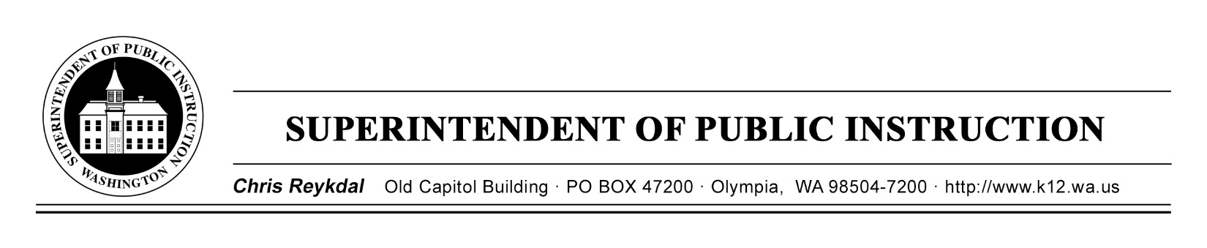
Dyslexia Advisory Council | October 21, 2019 | ESD 113
Implementing E2SSB 6162
Time | Focus | Resources | Notes
12 PM | Sign In and Technology Check
12:30PM | Welcome and Introductions
 | Review Agenda
 | Review Norms
 | State of the State | Council Correspondence, Webinars, Supplemental Decision Package, and Newsletters
 | Developing Coherence
2:30PM | Break
 | Expectations of the Year
 | Break Into Workgroups
 | Begin Creating Workgroup Action Plan | Action Plan Template
5 PM | Working Dinner -Discuss Upcoming Outreach
5:45 PM | Public joins the Dyslexia Advisory Council
 | Public Comment | FAQ for Review
6:45PM | Wrap Up the Day
7 PM | Good Bye

