Administering Medication per Gastrostomy Button
Bolus Method

School staff______________________________________ Date___________________

School Nurse/Trainer______________________________ Date___________________

SKILL | Training Date | Observation
State name and purpose of procedure. | Click or tap here to enter text. | Click or tap here to enter text.
PREPARATION. | Click or tap here to enter text. | Click or tap here to enter text.
Review student’s individual health plan (IHP) for specific instructions. | Click or tap here to enter text. | Click or tap here to enter text.
Follow the Six Rights of Medication Administration; Right student, Right medication, Right dose, Right time, Right route and Right documentation. | Click or tap here to enter text. | Click or tap here to enter text.
Assemble materials outlined in the IHP, including the medication. | Click or tap here to enter text. | Click or tap here to enter text.
Prepare the medication as ordered. | Click or tap here to enter text. | Click or tap here to enter text.
Explain the procedure to the student. | Click or tap here to enter text. | Click or tap here to enter text.
Position student sitting or lying on right side with head elevated at a 30° angle. | Click or tap here to enter text. | Click or tap here to enter text.
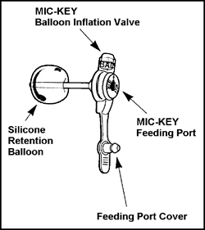 | 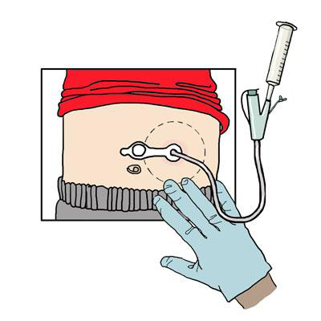
ADMINISTRATION: | Click or tap here to enter text. | Click or tap here to enter text.
During entire procedure ensure student’s privacy. | Click or tap here to enter text. | Click or tap here to enter text.
Wash hands and put on gloves. | Click or tap here to enter text. | Click or tap here to enter text.
Check the area around the G-tube for signs of swelling or redness. Notify RN if indicated. | Click or tap here to enter text. | Click or tap here to enter text.
Remove the plug or cap on the tube. | Click or tap here to enter text. | Click or tap here to enter text.

ADMINISTRATION CONTINUED: | Click or tap here to enter text. | Click or tap here to enter text.
With the plunger removed from the syringe, connect the syringe to the G-tube, allow bubbles to escape. | Click or tap here to enter text. | Click or tap here to enter text.
Flush the tubing with water as directed. | Click or tap here to enter text. | Click or tap here to enter text.
Administer the medication into the tubing. | Click or tap here to enter text. | Click or tap here to enter text.
Flush the tubing again with clear water as directed. | Click or tap here to enter text. | Click or tap here to enter text.
Remove the syringe, put the cap or plug back on the G-tube and secure as needed. | Click or tap here to enter text. | Click or tap here to enter text.
Clean the equipment with soapy water, rinse and allow to air dry. | Click or tap here to enter text. | Click or tap here to enter text.
Store the medication and equipment as directed. | Click or tap here to enter text. | Click or tap here to enter text.
Remove gloves and wash hands. | Click or tap here to enter text. | Click or tap here to enter text.
Document medication administration and any observations. | Click or tap here to enter text. | Click or tap here to enter text.
Check the student’s IHP for specific follow-up procedures. | Click or tap here to enter text. | Click or tap here to enter text.

I have voluntarily received training and had an opportunity to ask questions about the above information.
I understand my responsibility and voluntarily agree to administer medication as outlined above during the
____________________school year.

________________________________________________ ___________________
Staff signature Date

This staff member has received the above training and demonstrated sufficient understanding and skill in administration medication by G-tube.

________________________________________________ ___________________
Registered Nurse signature Date

Administering Medications BY G-Tube
First, Check … The Correct Form of Medication for MIC-KEY*

Use
- Medication should be in liquid form when possible. If the liquid is thick, thin it with water so it doesn't clog the tube as indicated.
- If medication is only available in a pill or capsule, ask your specialist or pharmacist if it's one you can crush and mix with water. (Not all pills and tablets can be taken this way.)
- If you can do this, crush the medication finely, and make sure it is well dispersed in the water.
- Do not mix medication with formula unless your specialist tells you to do this.

To Administer
- You'll generally use a bag and extension set, attaching the extension set's medication port to the bag instead of to its feeding port.
- For small amounts of medication, you may be able to eliminate the need for extension tubing by using a syringe:
- Dilute the medication with water in a Luer slip syringe.
- Inject directly into the MIC-KEY* feeding port.
- When finished, flush the port with at least 10 ml of water as directed.

I have voluntarily received training and had an opportunity to ask questions about the above information.
I understand my responsibility and voluntarily agree to administer medication as outlined above
during the ________________school year.

______________________________________________________ ___________________
Staff signature Date

This staff member has received the above training and demonstrated sufficient understanding and skill in administration of medication by G-tube.

______________________________________________________ ___________________
Registered Nurse signature Date

