6.EE.B

Reason about and solve one-variable equations and inequalities.

1. Select all equations that have y = 2 as a solution.
A. 7 $×$ y = 14
B. y $÷$ 8 = 4
C. 3 – y = 1
D. y + 10 = 12
- Candice is building a rectangular piece of a fence according to the plans shown. One of the angles is not labeled. What is the value of x?
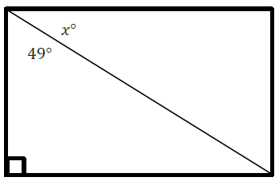
- Rita makes cakes for a bakery. On Monday she had orders for 32 cakes. Rita knows she needs at least 4 days to make all 32 cakes. Write an inequality to represent the number of cakes Rita makes each day, d.
- Examine the tape diagram shown, and write the equation it represents. Then, use the equation to determine the value of q.
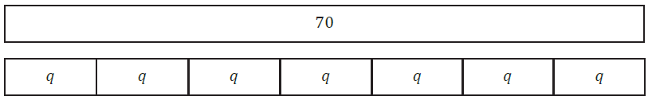
- On the number line, graph all the solutions to the inequality x $≤$ 2.

6.EE.B

Reason about and solve one-variable equations and inequalities.
- Select the set of numbers that are solutions to the inequality x > 4.
A. {–5, 8, 18}
B. {5, 8, 18}
C. {5, –8, 18}
D. {5, 8, –18}
- Write an equation that represents the statement “The product of a number, n, and 8.4 is 21.” Then solve the equation to determine the value of n.
- In the following inequalities, w, x, y, and z are integers.
w > x
x $≤$ y
z > w
Determine whether each inequality is Always True, Sometimes True, or Never True.
 | Always True | Sometimes True | Never True
z > x
w < y

Teacher Material

6.EE.B

Reason about and solve one-variable equations and inequalities.

Question | Claim | Key/Suggested Rubric
1 | 1 | 1 point: Selects A, C, and D
2 | 2 | 1 point: 41
3 | 4 | 1 point: 4d ≤ 32, or equivalent
4 | 1 | 2 points: 7q = 70, or equivalent AND 10  1 point: 7q = 70, or equivalent OR 10
5 | 1 | 1 point:
6⁵ | 1 | 1 point: Selects B
7¹ | 1 | 2 points: 8.4n = 21, or equivalent AND 2.5  1 point: 8.4n = 21, or equivalent OR 2.5
8⁵ | 3 | 1 point:  Always True Sometimes True Never True  z > x x  w < y x

From Smarterbalanced.org. Grade 6, Claim 1, Target F Item Specifications. Internet. Available from http://www.smarterbalanced.org/smarter-balanced-assessments/; accessed 11/2015.
From EngageNY.org of the New York State Education Department. Grade 6 Mathematics Module 4, Topic H, Lesson 30. Internet. Available from https://www.engageny.org/resource/grade-6-mathematics-module-4-topic-h-lesson-30; accessed 11/2015.
From EngageNY.org of the New York State Education Department. Grade 6 Mathematics Module 4, Topic H, Lesson 34. Internet. Available from https://www.engageny.org/resource/grade-6-mathematics-module-4-topic-h-lesson-34; accessed 11/2015.
From EngageNY.org of the New York State Education Department. Grade 6 Mathematics Module 4, Topic G, Lesson 27. Internet. Available from https://www.engageny.org/resource/grade-6-mathematics-module-4-topic-g-lesson-27; accessed 11/2015.
Adapted from the Mathematics K–12 Learning Standards. Internet. Available from http://www.k12.wa.us/Mathematics/Standards.aspx; accessed 11/2015.

