Washington Access to Instruction & Measurement (WA-AIM)
  - Test Administration Manual
  - 2019–2020

Contents
Introduction 5
Purpose of the Washington Access to instruction & Measurement (WA-AIM) 5
Overview of the WA-AIM 5
Content and Grades Assessed 7
Participation Guidelines 7
Engagement Rubric 8
Student registration 8
Administration Windows 9
Spring Accountability Administration 9
Fall High School Retakes 9
What’s New for the 2018–2019 ADMINISTRATION 9
Test and Student Information Security 9
Secure Storage 10
DRC Data Security Policy 10
Accommodations 10
adaptations 11
Assessment Components and Resources 11
Essential Elements 11
Science Essential concepts 12
Access Point Frameworks 12
Anatomy of an Access Point Framework 14
Performance Tasks 14
Requirements: 15
Restrictions 15
Example Items: 16
Answer Key: 16
Note to Teacher 16
Glossary Terms: 17
Assessment Administration 17
Who Administers the Assessment 17
Test Administrator 17
Observer 18
Before Administration-Getting Ready 18
Step 1: Identify and confirm students to be assessed with WA-AIM 18
Step 2: Familiarize yourself with the WA-AIM materials 19
Step 3: Gather required material and student supports for administration of performance tasks 19
Step 4: Identify and Schedule required observer 19
Step 5: Access INSIGHT(eDirect) Test Management 19
Administering WA-AIM 20
Step 6: Administer baseline performance tasks 20
Step 7: Provide instruction 20
Step 8: Administer final performance task 20
Step 9: Enter Final information in the WA-AIM Data Collection Platform 20
Scoring and Reporting 21
Scoring 21
Reporting 22
Contact Information 22
Appendix A 23
IEP Team Decision Making Guidelines Regarding Student Participation in Statewide Assessments 23
General Criteria 23
Alternate Assessment 24
Appendix B 27
Engagement Rubric Guidance and Directions for Use 27
Guidance 27
Directions for Use and Submission 27
1: Identify and register students taking WA-AIM (teachers and District Assessment Coordinators) 27
2: Administer Engagement Rubric activities (teacher) 28
3: Upload Engagement Rubric to the Data Collection Platform 28
Appendix C 31
WA-AIM Spring Student Registration 31

Introduction

Purpose of the Washington Access to instruction & Measurement (WA-AIM)
The Individuals with Disabilities Education Improvement Act of 2004 (IDEA) articulates requirements related to the assessment of students with disabilities, as well. The IDEA also requires the participation of students with disabilities in grade-level state and district‐wide assessments. Specific IDEA requirements include the following.

- Students with disabilities are included in general state‐ and district‐wide assessment programs, with appropriate accommodations, where necessary (Sec. 612 (a) (16) (A)). The term “individualized education program” or “IEP” means a written statement for each child with a disability that is developed, reviewed, and revised in accordance with this section and that includes . . . a statement of any individual modifications in the administration of state‐ or district‐ wide assessments of student achievement that are needed in order for the child to participate in such assessment; and if the IEP Team determines that the child will not participate in a particular state‐ or district‐wide assessment of student achievement (or part of such an assessment), a statement of why that assessment is not appropriate for the child; and how the child will be assessed (Sec. 614 (d) (1) (A) (V) and VI)).

- The State must ensure that all children with disabilities are included in all general State and district-wide assessment programs, including assessments described under section 1111 of the ESEA, 20 U.S.C. 6311, with appropriate accommodations and alternate assessments, if necessary, as indicated in their respective IEPs.

The Every Student Succeeds Act (ESSA) reauthorizes the Elementary and Secondary Education Act (ESEA), the nation's national education law and longstanding commitment to equal opportunity for all students. The ESSA’s requirements concerning students with disabilities include:
- schools are accountable to the public for the educational achievements of all students;
- all students participate in grade-level assessments in order to meet this expectation of accountability; and
- assessments provide reasonable adaptations and accommodations for students with disabilities in order to measure the academic achievement of students on grade‐level standards.

Overview of the WA-AIM
The Washington-Access to Instruction & Measurement (WA-AIM) is a performance task assessment aligned to the Washington K-12 Learning Standards in English language arts, mathematics, and science.

Each standard is assessed through the administration of a Performance Task related to the key knowledge and skills of the standard. The Performance Tasks for each standard are available at three different complexity level (More Complex, Intermediate Complex, and Less Complex) to provide students a continuum of entry points along which to show their knowledge and skills aligned to the Washington K-12 Learning Standards. The educator most familiar with the student will determine which complexity level each performance task is administer at for each student.

Each Performance Task requires that the student be administered five unique items, which in totality, meet the Requirements set forth for each individual performance task. The Intermediate Complex Access Point Performance Task was developed to contain the mastery level of knowledge, skills, and abilities for the standard.

Teacher chooses appropriate level Performance Task for each standard to administer to the student.

In short, a student will be assessed on five standards per required content area through one Performance Task each (5 Performance tasks total per content area). After that the student’s performance on each unique item on the Performance Task is submitted for scoring. In total, a student will be administered 10 Performance Tasks for ELA and Math, and an additional five Performance Tasks in grades where science is required.

The WA-AIM is designed to be a baseline and final assessment with a minimum of six weeks of instruction between the baseline and final administration. The baseline can be formal or informal and is intended to assist the educator in determining the appropriate complexity level to focus instruction, and ultimately help determine the best performance task complexity level to submit for scoring. The WA-AIM is administered in a 1:1 setting between the test administrator and student. The student’s performance is submitted for scoring through WA-AIM Data Collection Platform.

Content and Grades Assessed
English Language Arts: Grade 3–8 and 10
Mathematics: Grades 3–8 and 10
Science: Grades 5, 8, and 11

Participation Guidelines
School districts are required to include all students in state assessments, including students with the most significant cognitive disabilities. States are charged with developing alternate assessments aligned to alternate achievement standards so that students with the most significant cognitive challenges may meaningfully participate in the academic assessment program.

The OSPI defines a significant cognitive challenge as:
Students with cognitive disabilities means those students who require intensive or extensive levels of direct support that is not of a temporary or transient nature. Students with significant cognitive disabilities also require specially designed instruction to acquire, maintain or generalize skills in multiple settings in order to successfully transfer skills to natural settings including the home, school, workplace, and community. In addition, these students score at least two (2) standard deviations below the mean on standardized, norm-referenced assessments for adaptive behavior and intellectual functioning.
The alternate assessment is designed for a small percentage, approximately 1%, of the total school population for whom, even with accommodations, are unable to access the regular assessments. Each student’s IEP team will determine the most appropriate assessment. Guidance for IEP teams has been developed, IEP Team Decision Making Guidelines Regarding Student Participation in Statewide Assessments and can be found in Appendix A.

Engagement Rubric
For a student who meets the WA-AIM participation guideline, and who functions at an awareness level, the IEP team may decide that in lieu of participating in the Performance Task aspect of the alternate assessment, a student’s engagement with the mathematical, literacy, or science activities taking place in the classroom may be measured and reported on. Since the Engagement Rubric measures pre-academic skills, a student will be placed in achievement level one (L1) for individual, school, district, and state reporting.

Students for whom the Engagement Rubric is appropriate must use the Engagement Rubric for all content areas. High School students for whom the Engagement Rubric is appropriate will automatically be granted an Awareness Waiver from the state testing proficiency requirement for graduation purposes.

The student must meet some or all of the criteria below for the IEP team to consider using the Engagement rubric for a content area of the alternate assessment:

- The student communicates primarily through cries, facial expressions, change in muscle tone but has no clear use of objects/textures, regularized gestures, picture signs, etc.

- The student alerts to sensory input from another person (auditory, visual, touch, movement, etc.) but requires actual physical assistance to follow simple directions; or the student’s response to sensory stimuli (e.g., sound/voice; sight/gesture; touch; movement; smell) is unclear.

- Parents and teachers must interpret child’s state from behaviors such as sounds, body movements, and facial expressions.

See Appendix B for guidance and direction for use.

Student registration
Students eligible to take the WA-AIM must be registered through the Washington Assessment Management System (WAMS) by the District Assessment Coordinator (DAC).

Administration Windows

Spring Accountability Administration
The spring administration window will run from mid-October to early April annually. The results from the spring administration are used for accountability reporting and the state report card. All students are required to be assessed annually towards grade level achievement standards in grades 3 through 8 and 10 for English language arts and math and grades 5, 8, and 11 for science.

Fall High School Retakes
This window will open mid-September and run through mid-November annually. Students in grades 11 or 12 who are eligible to take the WA-AIM may choose to use the fall window for a retake opportunity to fulfill their Certificate of Individual Achievement. These students may retest using the following assessments:
- ELA/Math: grade 3 , 6, or High School

Test and Student Information Security
District Test Coordinators (DTC), School Coordinators (SC), and Test Administrators (TA) share the responsibility for ensuring that all WA-AIM test materials and student responses are handled securely and confidentially in accordance with state and vendor security procedures. The WA-AIM tests are to be administered on a one-to-one basis by professional staff members or para-educators who have been instructed in the proper test administration procedures. All tests must be administered in the presence of another staff member who will observe and attest that the student was assessed without prompting from the TA. The observer may be a Teacher, Paraprofessional, Administrator or Service Provider.

The student responses are to be viewed only by those individuals directly responsible for test administration.

The WA-AIM tests rely on the measurement of individual achievement. Any deviation from testing procedures meant to ensure validity and security (e.g., group work, teacher coaching, pre-teaching or prerelease of the test items) would be a violation of test security.

While some of the guidelines below apply mainly to Test Administrators, it is important for all personnel involved in testing to be aware of these procedures.

- Do not discuss, disseminate, or otherwise reveal the student responses to anyone.

- Do not coach or provide feedback in any way, including prompting or answering any questions related to the contents during the administration of Performance Tasks.

- Do not alter, influence, or interfere with a test response in anyway.

Secure Storage
Individuals responsible for the WA-AIM administration must keep all WA-AIM in a predetermined, locked, secure storage area at both the district and school levels. Secure materials must never be left unattended or in open areas. Any documents that include student data (student name, SSID, date of birth) must be securely maintained at all times.

The test session rosters generated in INSIGHT (eDIRECT) contain secure student log-in information. If a TA prints the roster, it must be securely destroyed at the close of testing as it contains secure student and login information.

DRC Data Security Policy
DRC ensures that student data remain confidential and secure at all times. Our practices adhere to the federal Family Educational Rights and Privacy Act (FERPA) regulations for the security and confidentiality of student data, and our systems provide data privacy safeguards throughout every step of an assessment process. DRC follows stringent procedures to protect data containing personally identifiable information (PII) and frequently verifies these procedures to confirm adherence. All DRC staff members receive training on data security and confidentiality requirements.

Accommodations
The WA-AIM was developed to allow the most flexibility to teachers in designing and creating items that meet each student’s unique learning and communication style. The assessment is standardized through Requirements and Restrictions located on each Performance Task. Teachers are encouraged to use the Example Items provided as they appear OR to adapt them into formats which are more accessible to each individual student. In the front of each grade level set of Performance Tasks, teachers will find a list of suggested adaptations which may be utilized for any content, standard, or specific Performance Task, unless the Performance Task specifically restricts it.

adaptations
All examples and items presented in the Performance Tasks are allowed to be adapted to meet each individual student’s learning style and preferred mode of receptive and expressive communication. Teachers are encouraged to present the Performance Task components in styles that most closely resemble how daily instructional materials are presented to the student. Below are typical adaptations and ideas for presenting the Performance Tasks. This is not an all-inclusive or exhaustive list.
- Use graphics and/or physical models
- Enlarge text/graphics
- Simplify text/directions
- Use tactile graphics
- Use pictorial/word/object representations for numbers and graph parts
- Written material may be read aloud (unless the PT specifically requires the student to read)
- Reenactments or computer simulations may be used to represent scenarios
- For items that require the student to do physical tasks, teacher may do the physical tasks if directed by the student (ie-MS PS3-3)
- Replace provided graphics with graphics commonly used by student
- Teacher can use real-life objects when asking questions
- Text and vocabulary can be tailored to the student’s vocabulary in cases where the vocabulary is not a key element of the concept

Assessment Components and Resources

Essential Elements
The Essential Elements are specific statements of knowledge and skills linked to the grade-level expectations identified in the Washington K–12 Learning Standards. The purpose of the Essential Elements is to build a bridge from the content in the Washington K–12 Learning Standards to academic expectations for students with the most significant cognitive disabilities” (Dynamic Learning Maps Consortium, 2013).

The Essential Concepts are the equivalent of Essential Elements specific to science.

The Essential Elements and address each strand of the Washington K–12 Learning Standards across Mathematics and English Language Arts for grades Kindergarten through High School. The Essential Elements:
- Are differentiated by grade – identify the key elements essential for each grade level
- Address both content knowledge and skills-based expectations
The Essential Elements define differences from grade to grade in:
- cognitive demand
- content knowledge
- skills-based expectations

The Essential Elements are not curriculum and do not define what instruction should look like. The Essential Elements do not:
- Cover the entire range of learning experiences or ways a student can demonstrate her knowledge and skills.
- Mandate specific modes of communication. “Students’ opportunities to learn and to demonstrate learning during assessment should be maximized by providing whatever communication, assistive technologies, augmentative and alternative communication (AAC) devices, or other access tools that are necessary and routinely used by the student during instruction” (DLMC, 2013).

Science Essential concepts
Like the Essential Elements, the Essential Concepts serve as a bridge linking the knowledge, skills, and abilities found in the Access Points to the regular education standard.

Access Point Frameworks
The Access Point Frameworks are expanded frameworks that provide students with significant cognitive disabilities entry points to the grade level K-12 Learning Standards.

The Access Point Framework documents are organized by content area and then by grade. At the start of each new grade, a map (see Figure 3) of the standards expanded into Access Point Frameworks is presented.
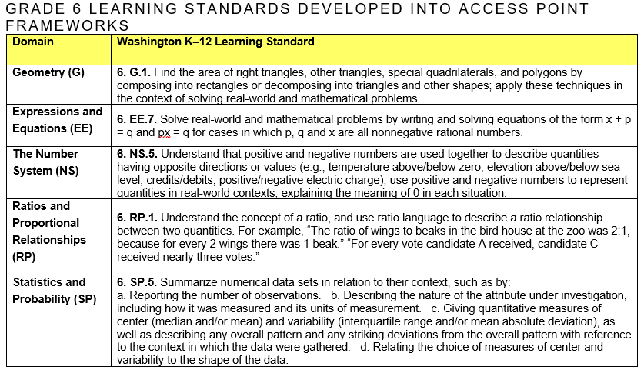
Figure 3 Grade Level Standards Map
The Access Point Framework, Figure 4 Access Point Framework, provide three points of varying complexity allowing students to engage in the assessed grade level academic content at each student’s most appropriate level. The Access Point Frameworks follow a similar design: the Washington K–12 Learning Standard is presented on the left, with the associated Essential Element or Essential Concept directly to the right. The three Access Points follow. The Access Points on each framework move from More complex on the left to Intermediate complexity, to Less complex. The layout of the Access Point Frameworks presents the continuum of assessed grade level content for students, working from the grade level standard on the left to the less complex Access Point on the right. The Intermediate complexity Access Point defines the on grade level knowledge and skills of the assessed standard. The Access Points Frameworks are stand-alone documents by content area which encompass the full scope of the instruction and assessment knowledge and skills from grade 3–high school for each content.

Anatomy of an Access Point Framework
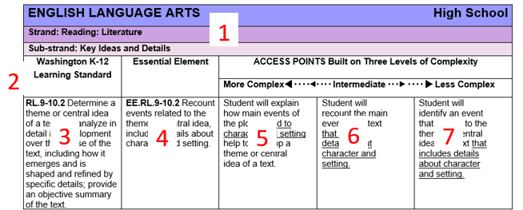
Figure 4 Access Point Framework
- The top three rows of the Access Point Framework will identify the content, standard and grade or grade band
- The fourth row moving from left to right contains the headers for the K-12 Learning Standard, the standard’s Essential Element, followed by the three Access Point levels in the following order: More, Intermediate and Less.
- This is the regular K-12 Learning Standard that the specific Access Point Framework is developed for.
- This is the Essential Element of the K-12 Learning Standard.
- This is the More Complex Access Point. The content defines the knowledge and skills that will be assessed by the corresponding Performance Task at the More Complex level.
- This is the Intermediate Complex Access Point. The content defines the knowledge and skills that will be assessed by the corresponding Performance Task at the Intermediate Complex level.
- This is the Less Complex Access Point. The content defines the knowledge and skills that will be assessed by the corresponding Performance Task at the Less Complex level.

Performance Tasks
The Performance Task documents are presented by grade level. Each grade level set contains the Access Point and related Performance Tasks for all required content and standards applicable to that grade level (see Figure 5). Student performance on the skills and knowledge defined in the Access Point Frameworks will be measured through one teacher administered Performance Task, available at three different complexity levels, for each standard.
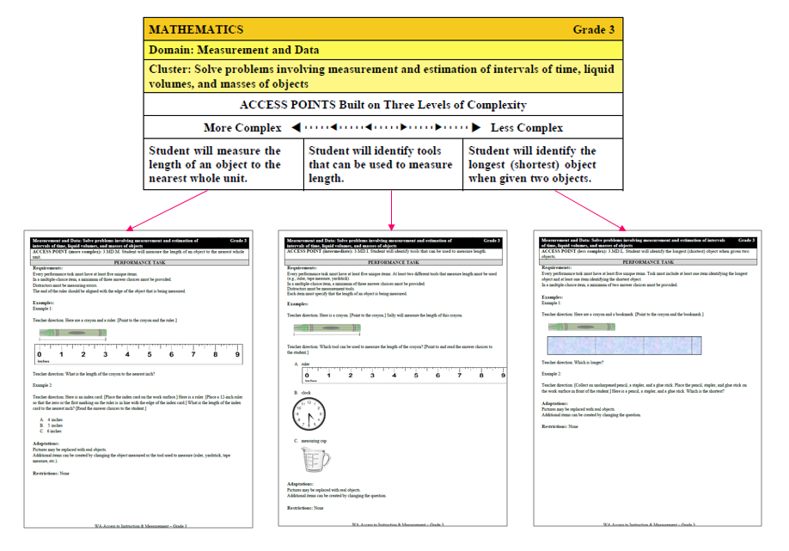
Figure 5 Access Point with Three Levels
All of the Performance Tasks are structured identically. The top of each Performance Task (see Figure 6) contains a header table identifying the following information:
- Washington K–12 Learning Standard and grade level
- Access Point Complexity Level and Access Point

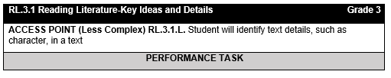
Figure 6 Header Table

All Performance Tasks contain the following:
Requirements: This section details what requirements are necessary in order to accurately measure the Access Point. All Performance Tasks are required to have five unique items. The Requirements outline what knowledge, skills, and/or abilities must be demonstrated within the set of five items administered to the student.

Restrictions: The section details any materials, procedures or accommodations that are restricted as they would violate the key knowledge and/or skills being measured by the Performance Task.

Example Items: This section provides model items/questions that teachers can administer as they appear. Teachers are also encouraged to use the example items as models or templates for their own item creation. All example items and graphics should be adapted to meet each student’s unique learning and communication style. Further examples/items/questions developed and vetted by teachers can be found under the Access Points, Performance Tasks & Examples link on the WA-AIM website.

Answer Key: An answer key is provided for all example items. The purpose is provide teachers an idea of what would count as a correct answer if using that example item.

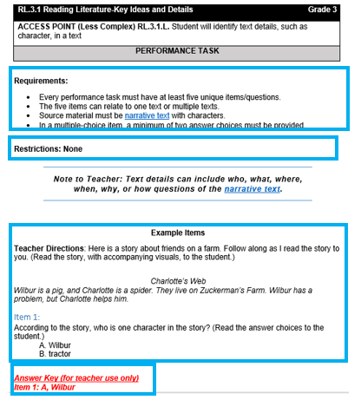
Figure 7 Performance Task Example

Additionally, some Performance Tasks also include:
Note to Teacher: These notes are generated based on patterns noted from our vendor’s hand-scoring team. They include information to clarify, define, or call attention to specific components within the Performance Task.

Glossary Terms: Terms that need defining or examples for the teacher are hyperlinked to a grade specific Glossary of Terms at the end of set of grade level Performance Tasks.
Teachers review the three Access Point complexity levels and their related Performance Tasks and use their own professional judgment to determine which complexity level is most appropriate for each student who will be taking the WA-AIM and for each standard.

The Intermediate complex Access Point defines the on grade level knowledge and skills of the alternate achievement standard so it is recommended teacher first look at this Access Point and Performance Task and use their knowledge of the student to determine if this level is appropriate for the student. If the Intermediate complexity is not appropriate for the student, teachers should move to the More or Less complexity and administer the associated Performance Task.

Teachers will administer baseline Performance Tasks for all standards. If a student receives 75% or higher on the baseline assessment for a standard administered at the Intermediate or Less complexity, the student must be moved to next highest Access Point and administered a new baseline on the associated Performance Task. This is to ensure the appropriate instructional level entry point into the standard.

After a minimum of 6 weeks academic instruction towards each standard, teachers will administer the final Performance Task.

Assessment Administration
Full administration for the WA-AIM occurs in two places. All Performance Tasks are administered outside the Data Collection Platform (DCP) in a 1:1 setting between the test administrator and the student. An Observer must be present during the Performance Task administration.

The student’s performance on the Performance Task will be documented and submitted using the WA-AIM Data Collection Platform. When the DCP opens, teachers or observers may document a student’s performance in the Data Collection Platform while working with the student in the 1:1 setting (if appropriate). It is highly recommended that test administrators not wait until the end of the administration window to document and submit student performance.

Who Administers the Assessment

Test Administrator
The Test Administrator (TA) is the person who will administer the Performance Tasks to the student. Typically the test administrator will be the student’s teacher who is in charge of the student’s IEP.

Who can be Test Administrator?
- The TA must be an educational professional who is most familiar with the student.
- The TA must be an employee of the district and can be another teacher, paraprofessional, related service provider (e.g., speech language pathologist), or administrator (e.g., principal or special education director).

What are the roles and the duties of the TA?
- Create items which adhere to the Performance Task Requirements and Restrictions.
- Administer all required Performance Tasks and related items for a baseline assessment.
- Provide, or oversee, a minimum of 6 weeks of targeted instruction on the knowledge and skills the WA-AIM assesses against.
- Administer all required Performance Tasks and related items for a final assessment.
- Enter all required information regarding Performance Task administration and student performance into the WA-AIM Data Collection Platform.

Observer
The administration of every Performance Task must be accompanied by an attestation of an outside observer. The role of the observer is to observe the teacher administering the Performance Task to a student being assessed with the WA-AIM.

Who can be an observer?
- The observer must be an educational professional who is not the teacher administering the test.
- The observer must be an employee of the district and can be another teacher, paraprofessional, related service provider (e.g., speech language pathologist), or administrator (e.g., principal or special education director).

What are the roles and the duties of the observer?
- The observer must be familiar with the Performance Task the student is being assessed with.
- The observer watches the teacher administer the Performance Tasks to the student being assessed.
- The observer then reviews the performance data entered into the WA-AIM Data Collection Platform to ensure the accuracy of the documentation of student responses.
- If the observer believes the data on the performance screen accurately captures the student’s performance, then the observer will enter her/his first and last name and indicate her/his role, thereby attesting that the assessment data presented is accurate.

Before Administration-Getting Ready

Step 1: Identify and confirm students to be assessed with WA-AIM
- Alternate Assessment is indicated in the student’s IEP under Participation in State and Districtwide Assessments of Student Achievement.
- The student meets the all the criteria for participation in alternate assessments located in the IEP Team Decision Making Guidance document (Appendix A) and/or the Engagement Rubric criteria.
- District Test Coordinator has pre-ID any students eligible to take the WA-AIM, as indicated in their IEP, in the Washington Assessment Management System (WAMS). (Appendix B)

Step 2: Familiarize yourself with the WA-AIM materials
- Access Point Frameworks- Guiding document that outlines the standards to be assessed through WA-AIM as well as the various access points Performance Tasks were designed around.
- Performance Tasks- The WA-AIM assessment tasks by grade level for all content areas.
- WA-AIM Test Administration Manual –This document.
- INSIGHT (eDirect) User Guide and module- Guiding document and module for using the INSIGHT (eDirect) User and Test Management Systems.
- Data Collection Platform User Guide- Screen shot directions for entering student assessment information into the Data Collection Platform. Found as an Appendix in the INSIGHT (eDirect) User Guide.
- Test Administration Training Modules-Recorded modules that detail the components of WA-AIM. Trainings are developed to meet a wide range of training needs. It is a local determination which trainings are required. Participation in training is required for teachers who will administer WA-AIM.

Step 3: Gather required material and student supports for administration of performance tasks
- Review the requirements of the appropriate access point Performance Task
- Select and/or create materials and supports that match your student’s receptive and expressive communication mode.

Step 4: Identify and Schedule required observer
- All Performance Tasks must be administered in view of the designated Observer. The Observer is required to attest within the WA-AIM data collection platform to the accuracy of the Performance Task and student response.
- See Observer section for detailed information on the Observer’s Role and Responsibilities.

Step 5: Access INSIGHT (eDirect) Test Management
- See INSIGHT (eDirect) User Manual
- Create Test Sessions
- Add Students and Assign Teacher to Test Sessions
- View/Print Test Session Roster login student level credentials

Administering WA-AIM

Step 6: Administer baseline performance tasks
- Choose the access point complexity (less, intermediate, most) performance task that is most appropriate to the student’s current academic level for each standard required to be assessed.
- If a student receives 75% or higher on the baseline assessment for a standard administered at the Intermediate or Less complexity, the student must be moved to next highest Access Point Performance Task and administered a new baseline on the associated Performance Task.
  - Access Point complexity levels (less, intermediate, more) can be different across the five standards for a content area

Step 7: Provide instruction
- A minimum of 6 weeks of academic instruction must occur between administration of the baseline Performance Tasks and administration of the final Performance Tasks
- Student performance on the baseline Performance Tasks should be used as the entry point for instruction

Step 8: Administer final performance task
- Arrange a time to administer final Performance Tasks to each student with the designated Observer present.
- For each required standard to be assessed, administer 1 Performance Task at the appropriate complexity level.

Step 9: Enter Final information in the WA-AIM Data Collection Platform
- Teachers are required to provide the following information
  - Access Point Level of the Performance Task administered (less, intermediate, more)
  - Item Type
  - Performance-when the student answers through an action (e.g., measures a pencil, reads a word, completes a graph, etc.
  - Constructed- when the student generates an answer (e.g., writes a sentence, creates a graph, fills out a table, etc.
  - Selected Response- when the student answers from an array of choices (i.e., multiple-choice)
  - Materials/Manipulative Used
  - Teacher Directions-Teacher enters what was done with the student. This should be specific to the student and Performance Task. Generic language that can be applied to any student, any content, and any standard should be avoided. (e.g. “asked student question.”)
  - Student Performance- correct or incorrect and a short indication of the student’s answer
  - Observer Attestation

Scoring and Reporting

Scoring
During the administration of the Washington-Access to Instruction & Measurement (WA-AIM) educators determine the most appropriate Access Point and administer the associated Performance Tasks. Five items/questions are required for each Performance Task. Educators will enter a score for each item based on a student’s response. Final scores for each standard are based on the number of items correct for the Performance Task and the weighted value of the Access Point complexity level at which the Performance Task was administered. The WA-AIM final score and resulting achievement level is not based on growth between the baseline and final assessments.

Access Point Complexity Level | Weight
Less | 0.7
Intermediate | 1.7
More | 4.0

The scores on the items for each of the final Performance Tasks are the scores that will be evaluated and confirmed, along with the other required information that is documented in the WA-AIM Data Collection Platform and an appropriate number correct score will be assigned. The number correct scores for each standard are multiplied by the appropriate Access Point weight to produce the final standard score. The final standard scores are then summed to obtain the Total Content Score. This score is rounded to the nearest whole number and add to 100 to produce a scale score between 100 and 200. The scale score is then used for reporting of proficiency.

Example of Score Generation for Sally Student in Grade 3
Standard | Access Point Level | Access Point Level Weight | Number Correct | Final Score of Each Standard
RL 3.1 | Less | .7 | 4 | (.7 x4)=2.8
RI 3.5 | Intermediate | 1.7 | 2 | (1.7 x2)=3.4
RF 3.3 | Less | .7 | 3 | (.7 x3)=2.1
W 3.3 | More | 4 | 1 | (4 x 1)= 4
SL 3.2 | Intermediate | 1.7 | 5 | (1.7 x 5)=8.5
 |  |  | Total Content Score | 2.8+3.4+2.1+4+8.5=20.8
 |  |  | Rounded Total Content Score | 21
 |  |  | + 100 | 21+100=121
 |  |  | Final Scale Score for this student | 121

Reporting
In a typical year, results reports will be available to districts in June. Copies of Individual Student Reports (ISRs) will be provided to schools along with Parent Guides to send home to families that explain student scores on the assessment. Electronic ISRs can also be obtained in the INSIGHT (eDirect) system under the Report Delivery menu.

Contact Information
Please consult the training and support documents posted to the WA-AIM section of the OSPI website at http://www.k12.wa.us/Assessment/WA-AIM/Trainings.aspx.

For inquiries related to WA-AIM policies and procedures, please contact OSPI at wa.aim@k12.wa.us.

For all inquiries related to administering the WA-AIM on the DRC Data Collection Platform, please contact DRC Customer Care at:

Phone: 1-800-569-2667
Email: waaimhelpdesk@datarecognitioncorp.com

WA-AIM Website: https://www.k12.wa.us/student-success/testing/state-testing-overview/assessment-students-cognitive-disabilities-wa-aim

Appendix A

IEP Team Decision Making Guidelines Regarding Student Participation in Statewide Assessments
The Individualized Education Program (IEP) team makes many important decisions regarding the program and services available for students eligible for special education and related services. One of those important decisions involves a determination of how a student will participate in (1) the general student assessment system in grades 3-8 plus once in high school, with or without allowable accommodations, or (2) if the student will participate in the Alternate Assessment. Essential to an appropriate decision by the IEP team regarding a student’s participation at any level of the statewide assessment system is a fundamental belief in the integrity of the overall IEP process.

IEP teams should begin this decision-making process with the proposition that all students, including all students eligible for special education, can learn grade level content and should participate in the general assessment system to the maximum extent possible. However, there are times in which the IEP team can decide that the alternate assessment is necessary and appropriate for a relatively small segment (approximately 1%) of the total tested population, or roughly 10% of the total number of special education eligible students being tested.

For example, if the total tested population in a school district is 4,000, then 40 students would represent 1% of the total tested population. Similarly, if 400 students eligible for special education were tested in the same school district, then 40 would represent 10% of the students eligible for special education that were tested.

General Criteria
The decision about how an eligible student participates in the statewide assessment is an IEP team decision, and not an administrative decision. The IEP team should use the following criteria for determining the extent to which a student can participate in the general assessment, with or without accommodations, or if the student should participate in the alternate assessment system (WAC 392-
172A-03090 through 03110).
- The student must be eligible for special education and must have an individualized education program (IEP) in effect at the time of the decision.
- IEP team decisions regarding a student’s participation in the statewide assessment must be based on both current and historical evaluation and instructional data relevant to the student.
- IEP team decisions should be based on the student’s present levels of educational performance, need for specially designed instruction, annual goals, learner characteristics and access to the general education curriculum.
- IEP Team decisions regarding a student’s participation in statewide assessments must be made at a scheduled IEP team meeting that precedes administration of the statewide assessment.

Alternate Assessment
The alternate assessment is a statewide testing option in lieu of the regular assessment. It is an option only for students with significant cognitive challenges. The term “significantly cognitively challenged” does not represent a new or separate category of disability. It is a designation applied to a small number of students (generally 10% or less) eligible for special education and related services participating in the statewide testing program.
For purposes of the alternate assessment, students who are significantly cognitively challenged means those students who require intensive or extensive levels of direct support that is not of a temporary or transient nature. Students with significant cognitive challenges also require specially designed instruction to acquire, maintain or generalize skills in multiple settings in order to successfully transfer skills to natural settings including the home, school, workplace, and community. In addition, these students score at least two (2) standard deviations below the mean on standardized, norm-referenced assessments for adaptive behavior and intellectual functioning.

For a student to be considered as having a significant cognitive challenge and therefore, appropriate for consideration as a candidate for the alternate assessment, ALL of the following statements should be carefully considered by the student’s IEP team:
- The student’s demonstrated cognitive functioning and adaptive behavior in school, work, home and community environments are significantly below chronological age expectations, even with program modifications, adaptations and accommodations.

- The student requires extensive direct instruction and/or extensive supports in multiple settings to acquire, maintain and generalize academic and functional skills necessary for application in school, work, home and community environments.

- The student demonstrates complex cognitive disabilities and poor adaptive skill levels determined to be significantly (at least two standard deviations) below chronological age expectations by the student’s most recent individualized eligibility determination which prevents the student from meaningful participation in the standard academic core curriculum or achievement of the appropriate grade level expectations.

- The student’s inability to complete the standard academic curriculum at grade level is not primarily the result of: (a) poor attendance, excessive or extended absences, (b) lack of access to quality instruction, (c) social, cultural, linguistic, or economic differences, (d) below average reading or achievement levels, expectations of poor performance, (f) the anticipated impact of the student’s performance on the school/district achievement scores, and (g) the student’s disability category, educational placement, type of instruction, and/or amount of time receiving special education services.

When an IEP team determines that the student should take an alternate assessment, the team must document why the student cannot participate in the regular assessment, and why the alternate assessment is appropriate for the student. Please note that an IEP team could document and justify that the alternate assessment could be an appropriate statewide assessment for an individual not necessarily meeting all of parameters of the state definition of significantly cognitively challenged on a case by case basis.

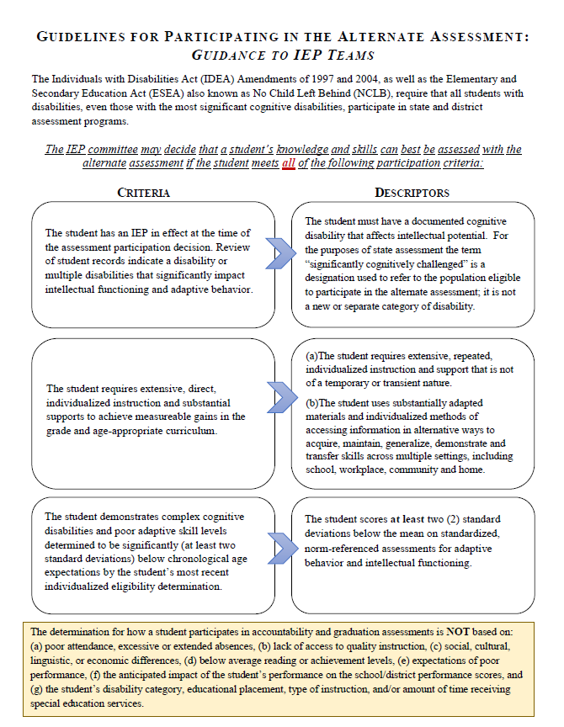

Appendix B

Engagement Rubric Guidance and Directions for Use

Guidance
For a student whose level of cognitive development would be considered awareness and is unable to participate even minimally in the Performance Tasks at the lower complexity level for any standard within a content area, the IEP team may consider using an Engagement rubric to measure a student’s engagement and attention to academic activities.

For a student who meets the below criteria, the IEP team may decide that in lieu of participating in the Performance Task aspect of the alternate assessment, a student’s engagement with the mathematical, literacy, or science activities taking place in the classroom may be measured and reported on. Since the student is being observed on pre-academic skills, a student will be placed in achievement level one (L1) for individual, school, district and state reporting.

Students for whom the Engagement Rubric is appropriate must use the Engagement Rubric for all content areas. High School students for whom the Engagement Rubric is appropriate will automatically be granted an Awareness Waiver for the purpose of exemption from the state testing proficiency requirement for graduation purposes.

The student must meet some or all of the criteria below for the IEP team to consider using the Engagement rubric for a content area of the alternate assessment:

- The student communicates primarily through cries, facial expressions, change in muscle tone but no clear use of objects/textures, regularized gestures, picture signs, etc.

- The student alerts to sensory input from another person (auditory, visual, touch, movement, etc.) but requires actual physical assistance to follow simple directions; or the student’s response to sensory stimuli (e.g., sound/voice; sight/gesture; touch; movement; smell) is unclear.

- Parents and teachers must interpret child’s state from behaviors such as sounds, body movements, and facial expressions.

Directions for Use and Submission

1: Identify and register students taking WA-AIM (teachers and District Assessment Coordinators)
- Teacher identifies and communicates to District Assessment Coordinators (DACS) all students who will participating in the WA-AIM through the Engagement Rubric.
- DACs registers students taking WA-AIM through the Engagement Rubric in WAMS:
  - Assessment Operations> Pre-ID> WA-AIM Registration
    - Engagement Rubric: To register a student who will participate in the WA-AIM through an Engagement Rubric, select the radio button under “Engagement Rubric” in the registration screen.
    - Download blank Engagement Rubric from INSIGHT (eDirect)> General Information>Documents

2: Administer Engagement Rubric activities (teacher)
- Teacher administers baseline content specific activity and documents activity description (Part 1) and Student’s Response to Activity (Part 2) on Engagement Rubric.
- Teacher administers final content specific activity and documents activity description (Part 1) and Student’s Response to Activity (Part 2) on Engagement Rubric.
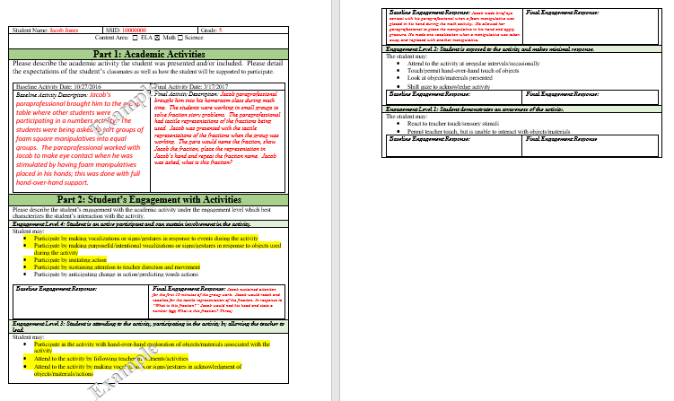

3: Upload Engagement Rubric to the Data Collection Platform
The Engagement Rubric must be uploaded in PDF format

- Log into INSIGHT (eDirect)

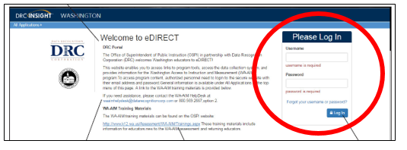

- Follow link to the Data Collection Platform
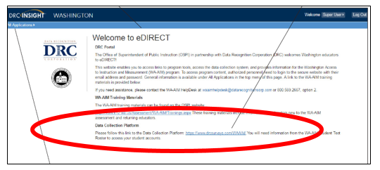

- Log in to student’s test session using login information from WA-AIM Student Test Roster (located in INSIGHT (eDirect)>Test Management)
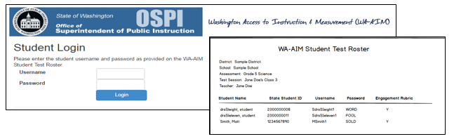
- Confirm student-before continuing make sure all bolded fields are correct. If errors exist, contact your District Assessment Coordinator immediately and do not proceed until all errors are corrected.
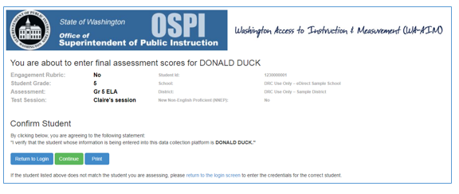

- Upload and submit Engagement Rubric

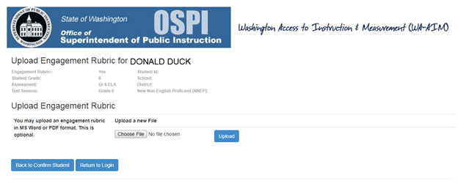

- Confirm upload
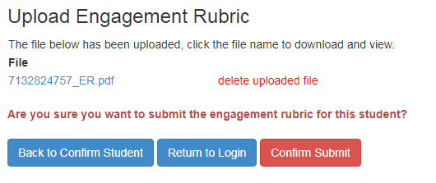

Appendix C

WA-AIM Spring Student Registration
WA‐AIM student registration will take place in WAMS through the Students Receiving Services application and can be accessed by clicking the “Pre‐ID” tab, then the “Students Receiving Services” in the left margin of the page. The pre‐requisite for a student to show up in the WA‐ AIM registration application is that a student must have an active CEDARS record, that the student’s CEDARS record indicate the student is receiving Special Education services, and that the student be in grades 3–8, 10, 11, or 12. District Assessment Coordinators can begin registration for Spring after their first CEDARS submission to the state for the current school year.
With a year‐long registration, OSPI will update student records in INSIGHT (eDirect), the WA‐AIM administration platform, on a nightly basis beginning in mid‐October. Registration in students receiving services allows users to indicate whether or not the student will or will not need a record in TIDE for interim assessments or to access other assessments that require a TIDE record. Other critical changes to be aware of that require the use of this application:
1. Engagement Rubric: To register a student who will participate in the WA‐AIM through an Engagement Rubric, select the radio button under “Engagement Rubric” in the registration screen. The actual Engagement Rubric to use with those students can be downloaded INSIGHT (eDirect)> General Information>Documents
2. Late Enrollment and NNEP: Students who ought to take the WA‐AIM per their IEPs but either:
A) enroll too late in the testing window to administer both the baseline and final data collection within the minimum gap between the administrations (students enrolling after February 10, 2020).
B) are Limited English Proficient and in their first year (365 calendar days from the deadline to submit the final assessment) in a US school (50 states plus DC) and have not used an NNEP exemption in a previous year should be registered as ‘WA‐AIM’ through this application.
The appropriate late enrollment and/or NNEP exemption will be calculated for aggregate reporting using the student’s school and district enrollment dates and, as applicable, the student’s LEP Program eligibility status and first date enrolled in a US school.

The Elementary and Secondary Education Act (ESEA) as amended by Every Student Succeeds Act (ESSA).
Students with disabilities are those students eligible for special education and related services who have an Individualized Education Program (IEP). This does not include students eligible for 504 plan services.
Dynamic Learning Maps Consortium (2013). Dynamic Learning Maps Essential Elements for Mathematics. Lawrence, KS: University of Kansas. Dynamic Learning Maps Consortium (2013). Dynamic Learning Maps Essential Elements for English language arts. Lawrence, KS: University of Kansas.

