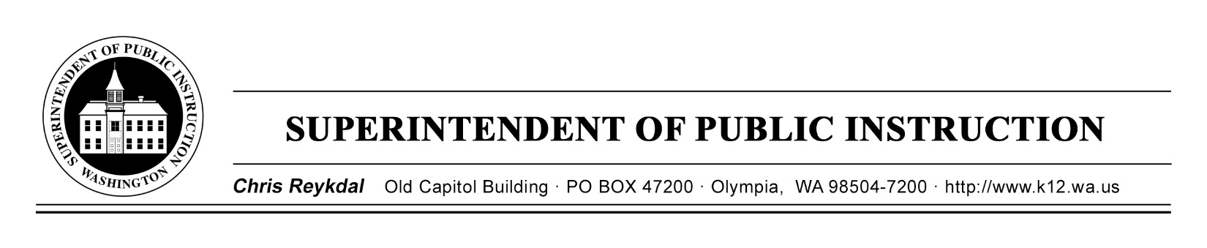
Dyslexia Advisory Council | October 22, 2019 | ESD 113
Implementing E2SSB 6162
Time | Focus | Resources | Notes
8 AM | Coffee and Sign In
8:30 AM | Welcome and Introductions
 | Expectations of the Day
 | Review Norms
 | Discuss Recommended Grade Band and Literacy Skill Screening Timeline Matrix | Recommended Grade Band and Literacy Skill Screening Timeline Matrix
10:30 | Break
Continue Discussion about
Recommended Grade Band and Literacy Skill Screening Timeline Matrix

 | Work Group Time
12 PM | Working Lunch-Review Supplemental Budget Request
 | Continue with Work Groups | Action Plan
2:30 PM | Share “Work Group” Action Plan
3:45 PM | Final Questions
4 PM | Good Bye and Safe Travels

