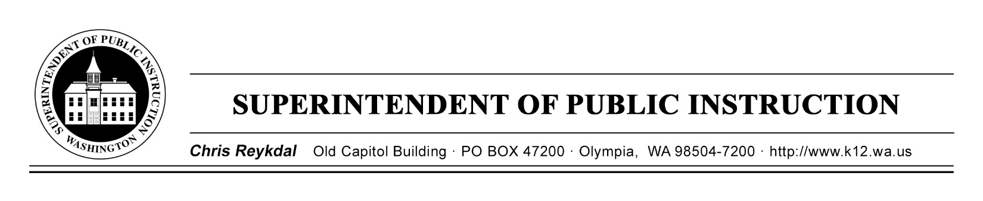
Dyslexia Advisory Council-Work Session | April 15, 2019
Sea -Tac Conference Center
Implementing E2SSB 6162

Time | Focus | Resources | Notes
9 AM | - Sign In  - Technology Check
9:30 AM | - Welcome  - Introductions  - Map of the Day | Agenda  Conflict of Interest Forms
 | - Expectations of the Review Process  - Review Rubric  - Practice Review | Rubric  Electronic Entry
11 AM | Begin Evaluating RFQQ Proposals | RFQQ Proposals
12:30 PM | Lunch
1:15 PM | Continue Reviewing RFQQ Proposals
3:30 PM | Break
4:30 PM | Closing Out the Day
5 PM | Have a good evening!

Dyslexia Advisory Council-Work Session | April 16, 2019
Sea -Tac Conference Center
Implementing E2SSB 6162
Time | Focus | Resources | Notes
8:30 AM | Sign In  Technology Check
9 AM | Welcome  Map of the Day | Agenda
9:30 AM | Review RFQQ Proposals | RFQQ Proposals
11:30 AM | Lunch
12:30 PM | Proposal Rating Discussion
1:45 PM | Break
2 PM | Looking Ahead  Class Photo
3 PM | Closing Out the Day
3:30 PM | Safe Travels and Thank You

