6.RP.A

Understand ratio concepts and use ratio reasoning to solve problems.

- In a classroom, the ratio of boys to girls is 6:7. Select all the statements that must be true about the classroom.
A. There are exactly 6 boys.
B. There is exactly 1 more girl than boy.
C. The ratio of girls to total students is 7:13.
D. The ratio of total students to boys is 6:13.
E. The total number of students is a multiple of 13.
- The ratio of x to y is $\frac{2}{3}$. Fill in the boxes to form a table with the given ratio.
x | y

- Adia is chopping logs. She chops 14 logs in 5 minutes. Adia’s younger brother creates the following double number line to show how long it would take Adia to chop 60 logs at the same rate.
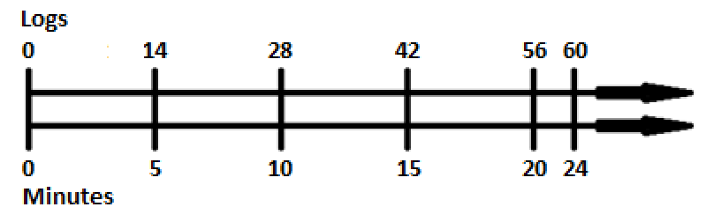
What error did Adia’s younger brother make in his double number line? Describe how Adia’s brother could fix the error.

- At the 6th grade school dance, there are 132 boys, 89 girls and 14 adults. Write each ratio in
3 different ways.
a. The ratio of girls to boys
b. The ratio of adults to students

6.RP.A

Understand ratio concepts and use ratio reasoning to solve problems.
- Frank drove for 3 hours at a constant speed. He traveled 195 miles. Frank wants to know how long it will take him to drive a total of 455 miles, assuming he maintains the same constant speed. Draw a double number line or tape diagram to show how many hours it will take to drive 455 miles.

- Mason and Laney run on the long-distance running team. The ratio of the distance Mason runs to the distance Laney runs is 2 to 3. One day, Mason ran 4 miles. How many miles did Laney run? Draw a tape diagram to demonstrate how you found the answer.

- Determine if Ratio A is equivalent to Ratio B. If the two ratios are not equivalent, write a ratio equivalent to Ratio A.
Ratio A | Ratio B | Ratio A is equivalent to Ratio B | Ratio A is not equivalent to Ratio B. Write a ratio equivalent to Ratio A.
5 to 7 | 2 to 3
$$\frac{1}{6}$$ | $$\frac{10}{15}$$
0:5 | 0:20

- Ryan has a recipe for lemonade. In the recipe, the ratio of lemon juice to water is 1:12. The ratio of water to sugar is 10:1. Ryan wants to make 4 gallons of lemonade. How much lemon juice, water, and sugar should Ryan use?

Teacher Material

6.RP.A

Understand ratio concepts and use ratio reasoning to solve problems.

Question | Claim | Key/Suggested Rubric
1 | 1 | 1 point: Selects C and E
2¹ | 1 | 1 point: Answers will vary. Example:  x y  2 3  20 30  4 6  $$\frac{2}{3}$$ 1
3 | 3 | 2 points: Identifies the error AND describes how to correct the error. Example: Adia’s brother added 4 to both the number of logs and the number of minutes at the end. He should only add 4 to 56 to get 60 and add 4 ($\frac{5}{14}$) to the 20 minutes because it take Adia $\frac{5}{14}$ minutes to chop one log.  1 point: Identifies the error OR describes how to correct the error
4 | 1 | 2 points: Writes 5 or 6 correct ratios. Examples: 89:132, 89 to 132, $\frac{89}{132}$ AND 14:221, 14 to 221, $\frac{14}{221}$.  1 point: Writes 3 or 4 correct ratios
5 | 4 | 1 point: Answers will vary. Example:  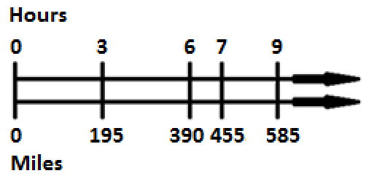
6 | 2 | 1 point: Answers will vary. Example:  AND 6
7 | 3 | 1 point: Answers will vary. Example:  Ratio A is equivalent to Ratio B Ratio A is not equivalent to Ratio B. Write a ratio equivalent to Ratio A.  2.5 to 3.5  $$\frac{10}{60}$$  x
8 | 4 | 2 points: $\frac{20}{71}$ gallons of lemon juice, $\frac{240}{71}$ gallons of water, and $\frac{24}{71}$ gallons of sugar, or equivalent  1 point: A combination of lemon juice, water, and sugar in the ratio 5 to 60 to 6 that does not sum to 4 gallons

From Smarterbalanced.org. Grade 6, Claim 1, Target A Item Specifications. Internet. Available from http://www.smarterbalanced.org/smarter-balanced-assessments/; accessed 11/2015.
Adapted from the Mathematics K–12 Learning Standards. Internet. Available from http://www.k12.wa.us/Mathematics/Standards.aspx; accessed 11/2015.
From EngageNY.org of the New York State Education Department. Grade 6 Mathematics Module 1, Topic A, Lesson 1. Internet. Available from https://www.engageny.org/resource/grade-6-mathematics-module-1-topic-lesson-1; accessed 11/2015.
From EngageNY.org of the New York State Education Department. Grade 6 Mathematics Module 1, Topic B, Lesson 12. Internet. Available from https://www.engageny.org/resource/grade-6-mathematics-module-1-topic-b-lesson-12; accessed 11/2015.
From EngageNY.org of the New York State Education Department. Grade 6 Mathematics Module 1, Topic A, Lesson 3. Internet. Available from https://www.engageny.org/resource/grade-6-mathematics-module-1-topic-lesson-3; accessed 11/2015.
Adapted from the Mathematics K–12 Learning Standards. Internet. Available from http://www.k12.wa.us/Mathematics/Standards.aspx; accessed 11/2015.
Adapted from Smarterbalanced.org. Grades 6–8, Claim 4 Item Specifications. Internet. Available from http://www.smarterbalanced.org/smarter-balanced-assessments/; accessed 11/2015.

