ACADEMIC ELIGIBILITY

LESSON 12-21 FULFILLING REQUIREMENTS IN 12TH GRADE

GRADE LEVEL FOCUS
Because of the importance of this topic, this lesson spirals itself each year from 8th through 12th grade, with a combination of consistent content and new content.
The focus for this Fulfilling Requirements Lesson is as follows:
- Grade 8: Introduction to requirements
- Grade 9: Awareness of requirements
- Grade 10: Comparing admission requirements and high school requirements
- Grade 11: Meticulous credit check
- Grade 12: Researching specific post-secondary requirements at school of interest

LEARNING GOALS/OUTCOMES

- Students will describe the minimum course requirements to graduate from high school.
- Students will describe how course requirements can differ between graduation, college entrance and selective college entrance.
- Students will identify their progress toward meeting high school graduation requirements.

MATERIALS NEEDED

- Student Handouts:
- Credit Check Worksheet
- Family Handouts:
- Fulfilling Requirements Worksheet
- Electronic Devices for research and /or Computer with projection device

CLASSROOM ACTIVITIES

Grade 12 Focus: Researching specific post-secondary requirements at school of interest
Since this lesson spirals (repeats itself from grade to grade), a recommended focus for 12th grade is to have students focus specific requirements of their post-secondary program of interest. These can be both admission requirements or post-secondary graduation requirements.

- Discuss students’ progress so far in high school. Divide students into groups of three or four. Have them discuss the classes they are taking this year, and what they plan to take next year. Students can compare notes on electives, honors classes, CTE programs, and dual credit or off-campus opportunities.

- Distribute the High School Graduation Requirements Handout with your school district’s requirements added, and ask students to complete it and share it with their families. Note: this is an important time to make sure all requirements are met. If it is obvious they are on track, challenge students with researching post-secondary requirements.

- Help students get started by reviewing high school graduation requirements. To ensure the most up-to-date information is provided, please refer to “Additional Resources” section and be sure your school district requirements are added to the family and student handouts.

- Promote discussion. Discuss different types of requirements with your students, focusing on the course credit requirements. Sample questions:
  - How many students were already aware of the graduation requirements?
  - How many students believe they are on track to meet the high school graduation requirements? How many are not sure?
  - What types of classes will students they need during their senior year to be prepared for their postsecondary plan – 2-year college, 4-year college, technical college, certificate program, apprenticeship, or military training?

Distribute the High School Graduation Requirements: Family Handout. Discuss the information in each column in more detail.

- Complete a Credit Check. Distribute the Credit Check Worksheet and have each student complete a worksheet based on the courses they’ve taken to date and the courses they plan to take over the next several years. Ask for volunteers to share their choices with the class.

Discuss the requirements students must meet to be accepted to a Washington State four-year public college or university. These requirements are called the CADRs (College Academic Distribution Requirements). Students should note that these requirements are higher than the minimum needed to graduate. In addition, please point out that if they want to aim for an even more selective college they should earn the credits listed on the right-hand column, which are even higher than the four-year college admission minimums.

Remind students that, no matter what their goals for life after high school, they should be aware of their course credit needs: whether they want to earn the graduation minimum (state/district); the public four-year college admission minimum; or the selective four-year college admission recommendations.

Discuss how students’ choices today will affect their postsecondary choices. For example, outline the differences between admissions processes and degrees earned through two and four-year schools. This website has helpful information on 2 year schools (http://www.sbctc.edu/) and this site for four-year (http://www.wsac.wa.gov/college-admissions) End the discussion by encouraging students to take advantage of the opportunities available to them in high school

- Provide course counseling. If possible, have a school counselor meet with your students and review the course options they will have for next year, and the registration process they need to complete. Schools may also create videos and/or live broadcasts to ensure consistent information is available to ALL students. Students should make course choices in the context of their postsecondary plans, as well as course credit requirements. Students may not fully understand the implications of these requirements, so may need help reviewing their credit check and planning for next year. Help may be needed to explain how fulfilling requirements with student’s Personalized Pathway based on their High School & Beyond Plan.

STUDENT PRODUCTS

- Completed Fulfilling Requirements Worksheet to be shared with family
- Completed Credit Check Worksheet

ADDITIONAL RESOURCES AND OTHER INFORMATION

Graduation Requirements

- The Washington State Board of Education
http://www.sbe.wa.gov/documents/GradRequirements/GradReqVisualsAug2014.pdf
Minimum requirements for Washington State

http://www.sbe.wa.gov/HSBeyondPlan.php#.V3084eT2ZaQ
Personalized Pathway Requirement based on High School & Beyond Plan

- OSPI
www.k12.wa.us/graduationrequirements/
Graduation Requirements and High School and Beyond Plan Information, Including

www.k12.wa.us/graduationrequirements/GraduationToolkit.aspx
Graduation Toolkit

College Admission Requirements

- Washington Student Achievement Council
http://www.wsac.wa.gov/college-admissions
Overview of college admissions information for WA State

http://www.wsac.wa.gov/sites/default/files/2015.CADRs.Appendix.pdf
College Academic Distribution Requirements (CADR) for four-year colleges

- Washington State Board of Community and Technical Colleges
http://www.sbctc.edu/
Home page

http://www.sbctc.edu/becoming-a-student/counselor/default.aspx
Counselor’s Guide to Community College Resources

ACADEMIC ELIGIBILITY

LESSON 12-21 FAMILY HANDOUT

FULFILLING REQUIREMENTS WORKSHEET

To graduate from high school in Washington State, a student must fulfill credit and other requirements. Note that these requirements are subject to change, so it is best to refer to the most up-to-date information provided through the following:
- WA State Board of Education
- OSPI (High School Graduation Requirements)
- Your school district requirements

What courses should you take to earn the required high school credits? There are several different standards: there is a minimum needed to graduate in Washington State, a minimum needed to graduate in your school district, a minimum needed to apply to a Washington State four-year public college or university, and the recommended amount for highly selective colleges and universities. For more information and to complete the table, see: www.k12.wa.us/graduationrequirements.

SUBJECT | WA STATE GRADUATION REQUIREMENTS  (# credits) | MINIMUM REQUIREMENTS FOR WA PUBLIC COLLEGES | RECOMMENDED FOR HIGHLY SELECTIVE COLLEGES  (varies by college. Ranges are indicated)
ENGLISH |  |  | 4 credits
MATH |  |  | 3-4 credits
SCIENCE (1 Lab) |  |  | 3-4 credits
SOCIAL STUDIES |  |  | 3-4 credits
WORLD LANGUAGE or Personalized Pathway Requirement (PPR) |  |  | 3-4 credits
ARTS (or PPR) |  |  | 2-3 credits
HEALTH/FITNESS |  | *Your school district’s requirements may be higher than the state minimums. Students must have at least a 2.0 GPA to be admitted to a public college or university in Washington State. TOTAL OF 24 credits class of 2019 and beyond.
CAREER & TECHNICAL EDUCATION
GENERAL ELECTIVES
Total

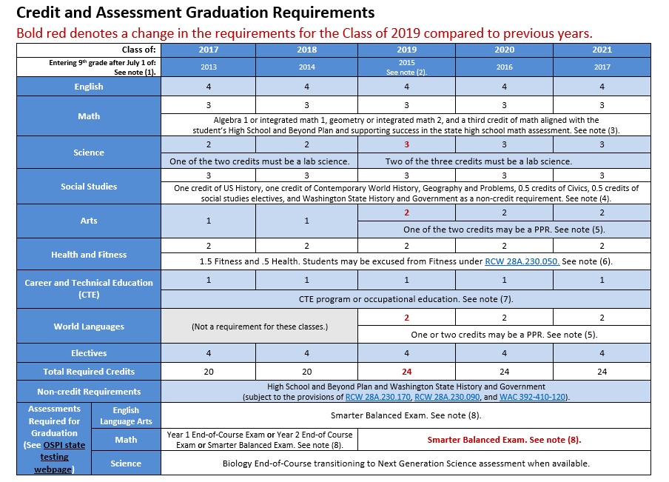

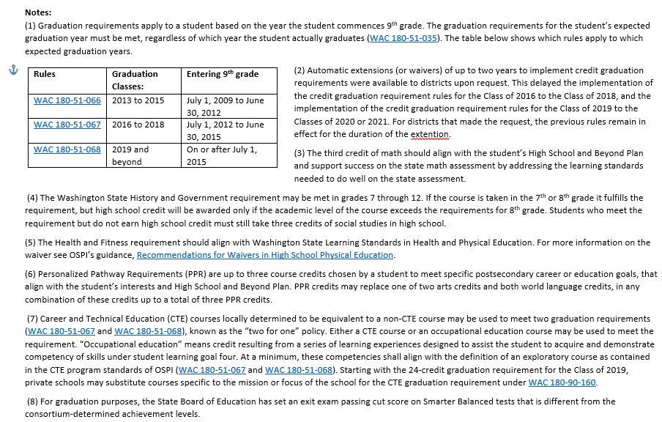

ACADEMIC ELIGIBILITY

LESSON 12-21 STUDENT HANDOUT

CREDIT CHECK WORKSHEET

Instructions: Please fill out the grid below. First, list the required credits for your preferred plan (either the minimum graduation requirements for your district, the minimum admission requirements for Washington State public, four-year colleges, or the recommended credits for your preferred postsecondary program). Next, list the credits from courses you have already taken or are taking this year, and the courses you plan to take over the next few years in high school. Then total up your credits to see how you are doing. (PPR is Personalized Pathway Requirement.)

SUBJECT | REQUIREMENTS  I MUST MEET  (For HS or postsecondary) | COURSES I HAVE ALREADY  TAKEN (Completed or currently enrolled) | COURSES  PLANNED  FOR THE FUTURE | TOTAL CREDITS I HAVE OR  WILL EARN | CREDITS I STILL NEED
English
Math
Science
(including Labs)
Social Studies
Health / Fitness
Career and Technical Education (CTE)
World Language or PPR
Arts or PPR
General Electives
TOTAL CREDITS
For more information, visit the OSPI web site at: www.k12.wa.us/graduationrequirements
Many schools/districts may have their own credit check processes or digital tools. Be sure to ask your school leaders.

